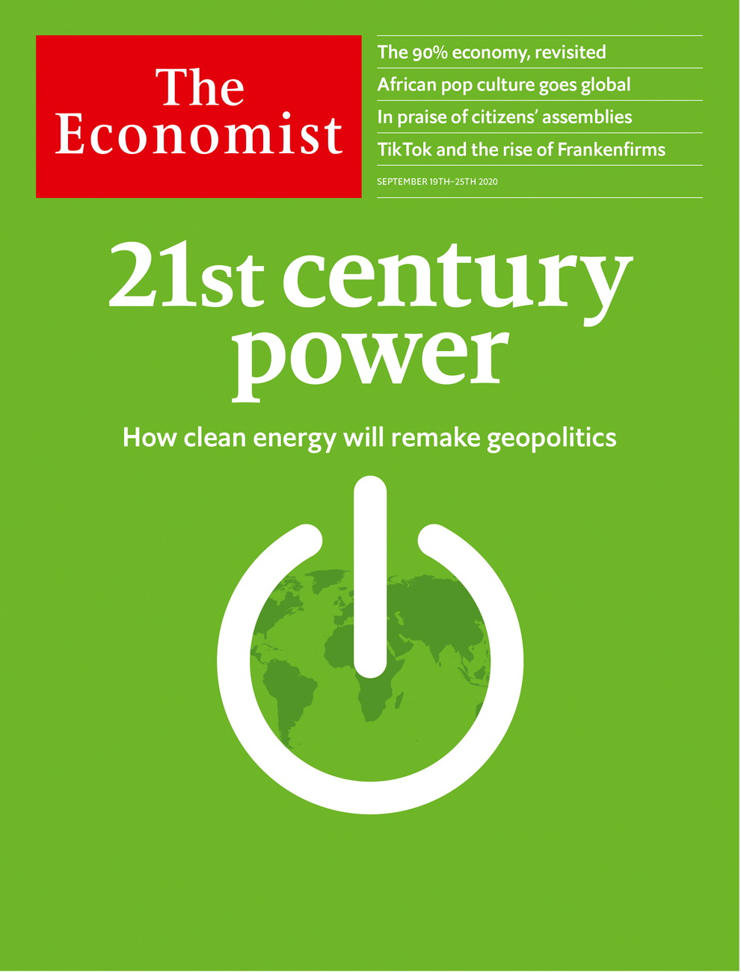

# Table of Contents

The world this week

Politics this week

Business this week

KAL’s cartoon

Leaders

The new energy order: Power in the 21st century

Inflation: Off target

Multinational business and protectionism: Birth of the Frankenfirm

Deliberative democracy: Amateurs to the rescue

Abortion: Pills by post

Letters

Letters to the editor: On dementia, the Beatles, scientific management

Briefing

Energy’s new world order: Petrostate v electrostate

Asia

After Abe: Searching for Suga-san

The Afghan peace negotiations: Clearing their throats

Labour in Singapore: Aggrieved Parti

Liberals, Nationals, marsupials: Koalition politics

Pacific plebiscites: No island is an island

Banyan: No pay, no rights, no recourse

Bangladesh and China: Two-timing

Indian politics and media: Covid? What covid?

China

Wuhan’s recovery: Washing away the tears

Social class: The landlords are back

Chaguan: The politics of poverty

United States

Donald Trump’s record: The master’s bidding

HBCUs: Historically back

Resort towns: The virus in paradise

The 2020 campaigns: Following the money

Abortion by pill: No scrubs

Lexington: Fire and ice

The Americas

Colombia: Fight crime, not war

Barbados: Bajan bye-bye

Bello: The return of the Monroe doctrine

Middle East & Africa

Ethnic tensions and state violence: Ethiopia’s transition is in peril

Public spending in Ghana: High noon for half-bridges

Politics in Uganda: Divided we stand

Banning names: Sorry, you’re not on the list

Israel and the Arab world: End of the illusion

Europe

Russia’s local elections: Winning from death’s door

Spanish history: A law to fight Franco

The eastern Mediterranean: Anchors awry

Germany’s economic recovery: Zombie dawn

Charlemagne: Europe’s asylum compromise

Britain

Britain after Brexit: Opening the taps

Abortion: Call to action

Covid-19: Flunked

Northern Ireland: Up(load) the RA

Unemployment: Pain in unexpected places

Public art: For God’s sake

Threats to Britain: Into the greyzone

Bagehot: Boris v the blue blob

International

Deliberative democracy: Some assembly required

Special report

Business and climate change: The great disrupter

Physical impact: A grim outlook

Regulation: Costs of carbon

Carbon offsets: Cheap cheats

Technology: Green machines

The future: Directing the disruption

Business

The future of carmaking: Journeys in the Teslaverse

Electric altercations: Short circuit

Not quite beyond petroleum: A less oily BP

Chipmaking: Integrating circuits

Sino-American tech tussles: Trump card

Bartleby: The only way is ethics

The database business: Steam engine in the cloud

Schumpeter: The perils of stakeholderism

Finance & economics

The world economy: The 90% economy, revisited

China’s recovery: One-armed fighter

International trade: Continuity candidate

Climate finance: The meaning of green

One-woman show: Women on Wall Street

European stock exchanges: Shotgun wedding

Buttonwood: McJobbers and brokers

Free exchange: Altered vistas

Science & technology

Planetary science: A sniff of life?

Biodiversity: We started the fire

Cloud computing: Better down where it’s wetter

Cyber-power: Digital dominance

Books & arts

Africa goes pop: From Nollywood to Netflix

Banlieue cinema: The dancer and the dance

Richard Wagner: A hateful beauty

Energy and politics: Maps about chaps

Johnson: Cawfee break

Economic & financial indicators

Economic data, commodities and markets

Graphic detail

Investing: Value judgment

Obituary

Joan Feynman: Getting to know the Sun



### Friday, September 18, 2020

|  |  |
| --- | --- |
| The world this week | 3 |
| Leaders | 5 |
| Letters | 1 |
| Briefing | 1 |
| Asia | 8 |
| China | 3 |
| United States | 6 |
| The Americas | 3 |
| Middle East & Africa | 5 |
| Europe | 5 |
| Britain | 8 |
| International | 1 |
| Special report | 7 |
| Business | 8 |
| Finance & economics | 8 |
| Science & technology | 4 |
| Books & arts | 5 |
| Economic & financial indicators | 1 |
| Graphic detail | 1 |
| Obituary | 1 |

|  |  |  |
| --- | --- | --- |
|  | Sections | Leaders |

The world this week

Politics this week

.

Business this week

.

KAL’s cartoon

.

|  |  |  |
| --- | --- | --- |
|  | Sections | Leaders |

|  |  |  |  |
| --- | --- | --- | --- |
|  | Articles | Sections | Next |

# Politics this week

Sep 19th 2020 |

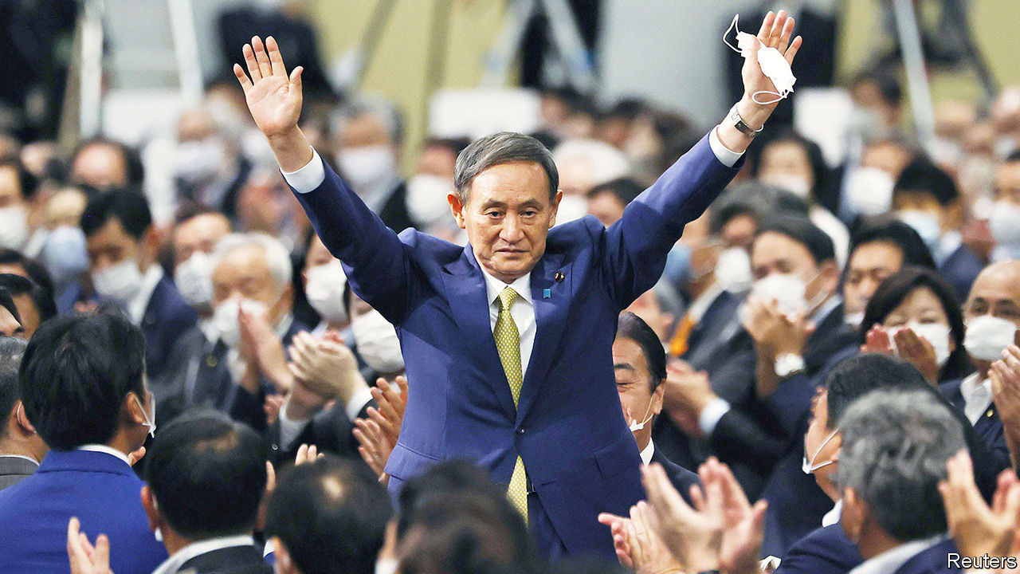

Suga Yoshihide became Japan’s 99th prime minister. He won the leadership of the Liberal Democratic Party with 377 votes of a possible 535, following Abe Shinzo’s resignation due to ill health in August. Mr Suga, who served as Mr Abe’s chief cabinet secretary, has promised continuity. But his background and stated priorities suggest a narrower focus on the economy. See article.

Thailand became the first South-East Asian country to loosen tourism restrictions introduced during the pandemic. Visitors who agree to a 14-day quarantine and a minimum stay will be allowed to enter. Malaysia’s prime minister, by contrast, said he would tighten controls at borders. Singapore will give all adult residents vouchers worth S$100 ($73) to spend on local hotels and sights.

European Union leaders held an online meeting with China’s president, Xi Jinping. They urged Mr Xi to open China’s markets and end repression in Xinjiang and Hong Kong. Mr Xi rejected interference in China’s affairs.

Police in Ningxia, in north-west China,detained three wildlife-conservation activists for “picking quarrels and provoking troubles”—charges often levelled against protesters. One, Li Genshan, has been a prominent campaigner against pollution in the Tengger, one of the country’s largest deserts.

Regional and municipal elections were held in parts of Russia. Candidates backed by the country’s de facto opposition leader, Alexei Navalny, did well, denying the pro-Kremlin United Russia party majorities in Novosibirsk and Tomsk. But the inroads Mr Navalny can make are limited, not least because he is still suffering from the effects of Novichok poisoning last month. He is now breathing without a ventilator, and has vowed to return to Russia from Germany where he is being treated. See article.

Belarus’s embattled president, Alexander Lukashenko, met Vladimir Putin in the Russian resort of Sochi. He got the promise of a €1.5bn ($1.78bn) loan, but what strings were attached was unclear.

Boris Johnson reached a deal with rebels in his own party over the internal-market bill, which if passed would give the British government the power to break parts of its Brexit withdrawal treaty. Mr Johnson agreed to give MPs the final say over any changes to the agreement. As well as Conservative MPs, the bill was criticised by Democrats in Washington, DC, putting a future trade deal with America at risk. See article.

Democratic leaders rejected a $1.5trn covid-19 relief plan put forward by a group of 50 bipartisan legislators. The proposal is less ambitious than America’s last stimulus round, passed in May. Negotiations between congressional Democrats and administration officials over new stimulus are yet to bear fruit.

Wildfires devastated parts of America’s west coast. More than 5m acres have burned across California, Oregon and Washington state. This year is already California’s most-destructive fire season to date. See [article](https://www.economist.com/united-states/2020/09/17/global-warming-and-the-presidential-election).

The Atlantic Ocean was graced by five named tropical cyclones, which has only happened once before. Paulette hit Bermuda on Monday and Sally hit America as a hurricane on Wednesday, bringing floods to Alabama, Louisiana and Florida. Teddy seems headed for Newfoundland; Rene and Vicky petered out.

The killing of a taxi driver, Javier Ordóñez, by police in Bogotá, Colombia’s capital, triggered violent protests in several cities. Mr Ordóñez had been drinking alcohol on the street. At least 13 people died in the protests and 400 were injured, half of them police. See article.

The government of Barbados announced that it will become a republic. A “throne speech” delivered by the governor-general but written by the prime minister, Mia Mottley, announced that the country will remove Queen Elizabeth II as its head of state by November next year. See article.

Toots Hibbert, widely regarded as the founding father of reggae music, died aged 77. He was the lead singer of Toots and the Maytals. “Do the Reggay”, a song he wrote that was released in 1968, gave the genre its name.

Coup leaders in Mali refused to hand power to an interim civilian administration by a deadline of September 15th set by ECOWAS, the west African regional bloc. ECOWAS had previously said it would tighten sanctions if the deadline was not met.

Paul Rusesabagina, a critic of Rwanda’s government known for saving more than 1,200 people during the genocide in 1994, appeared in court in Kigali, the capital, on charges of terrorism. Human Rights Watch said his arrest amounted to “enforced disappearance”, a breach of international law, since it was not done through lawful extradition.

Donald Trump hosted delegations from Israel, Bahrain and the United Arab Emirates at the White House to sign agreements that normalise relations between Israel and the two Gulf states. According to Mr Trump the deals would “serve as the foundation for a comprehensive peace across the entire region”. Palestinian militants in Gaza fired rockets at Israel shortly after the ceremony took place. See article.

## Coronavirus briefs

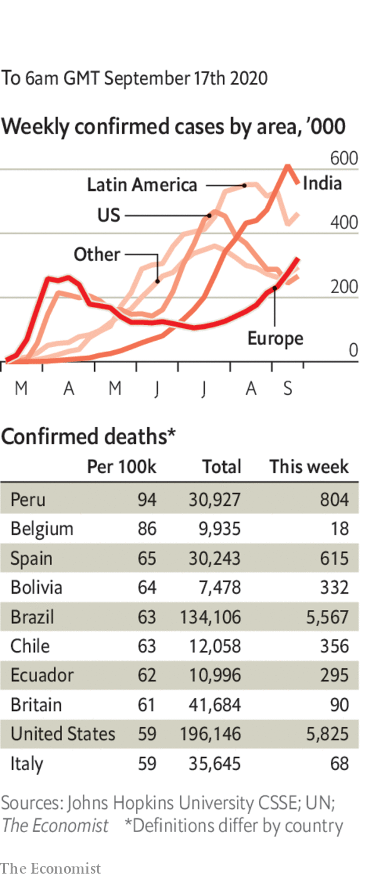

Israel imposed a new lockdown. It will overlap with Jewish holidays, such as Rosh Hashanah and Yom Kippur. An ultra-Orthodox government minister resigned in protest.

India’s accumulated cases passed 5m, less than two weeks after they reached 4m. See article.

France jumped past 10,000 cases a day. Jean Castex, the prime minister, warned that there had been a “clear deterioration” of the situation.

Boris Johnson’s government promised to speed up the processing of covid-19 tests in England after it emerged there was a backlog of 185,000. See article.

AstraZeneca and the University of Oxford resumed their clinical trial of a vaccine following a short postponement when a volunteer fell ill. Eli Lilly, another pharmaceutical company, said that an experimental drug it has produced has an antiviral effect.

This article was downloaded by calibre from <https://www.economist.com/the-world-this-week/2020/09/19/politics-this-week>

|  |  |  |  |
| --- | --- | --- | --- |
|  | Articles | Sections | Next |

|  |  |  |  |
| --- | --- | --- | --- |
| Previous | Articles | Sections | Next |

# Business this week

Sep 19th 2020 |

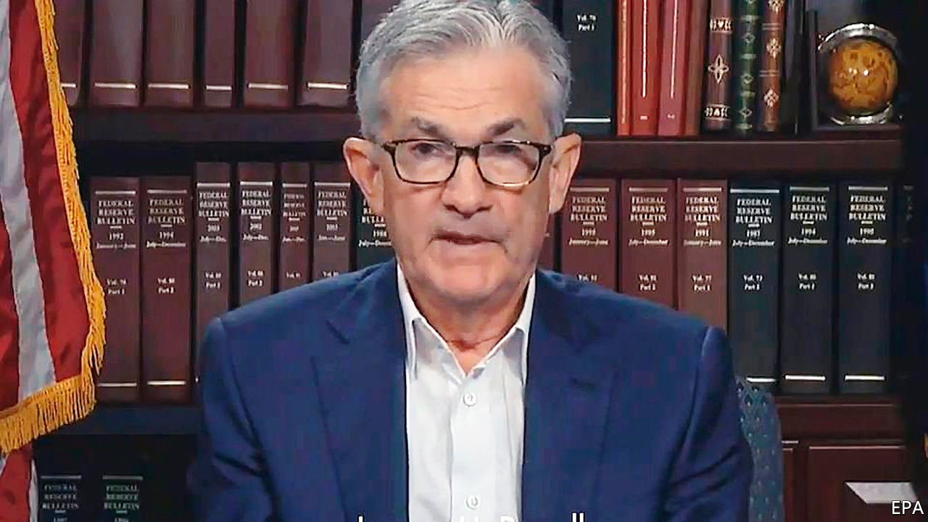

The Federal Reserve announced it will keep interest rates pinned near zero. In a policy statement, the central bank also said it would keep them there until inflation is on track to “moderately exceed” its target of 2% “for some time”. Jay Powell, the chairman of the Fed, commented that America’s economic recovery is expected to slow and that the economy will require continued support from the central bank as well as from extra government spending.

American retail-sales growth slowed to just 0.6% month-on-month in August, a lower figure than what economists had forecast. The unexpected softening in consumer demand followed the expiration of extra emergency jobless benefits worth $600 a week at the end of July.

Worries that Britain is at risk of deflation grew after the annual rate of inflation fell to 0.2% in August, down from 1% the previous month. The effect of the government’s discount scheme for restaurants in August may have contributed up to 0.5 percentage points of the drop.

## In the recovery ward

In its quarterly economic forecast, following its most recent one in May, the Organisation for Economic Co-operation and Development revised up growth forecasts for most countries it tracks. The intergovernmental think-tank said public spending was needed to support the economic recovery from the covid-19 lockdowns into 2021, albeit in a more targeted way, and that tax increases should be delayed. See [article](https://www.economist.com/node/21791871).

Bayer, a German chemicals firm, settled 15,000 lawsuits relating to Roundup, a weedkiller alleged to cause cancer, as part of an $11bn settlement. Bayer has estimated it faces a total of 125,000 filed and unfiled claims over Roundup.

President Donald Trump threatened to “do something” about the World Trade Organisation after it deemed that tariffs imposed by America on China in 2018 broke its rules. The WTO rejected America’s argument that the measures were justified by Chinese business practices, such as the theft of intellectual property, questioning whether the Chinese products in question had really benefited from them.

Oracle confirmed that it is ByteDance’s preferred American partner for TikTok. The impending deal comes after Mr Trump insisted that TikTok’s American arm be divested by ByteDance, the Chinese owner of the short-video platform, citing worries about national security. News reports suggest the firms hope that a proposal for Tiktok’s global operations to become an American-based company, with Oracle taking just a minority stake, will be enough to satisfy the White House. See article.

The Trump administration announced restrictions on imports suspected of being made using forced labour in China’s Xinjiang region. Goods subject to sanctions include cotton and clothes; Xinjiang accounts for the vast majority of the country’s cotton production. China stands accused of human-rights abuses, such as interning an estimated 1m ethnic Uighurs in gulags, which it calls “re-education centres”.

## Seattle, we have a problem

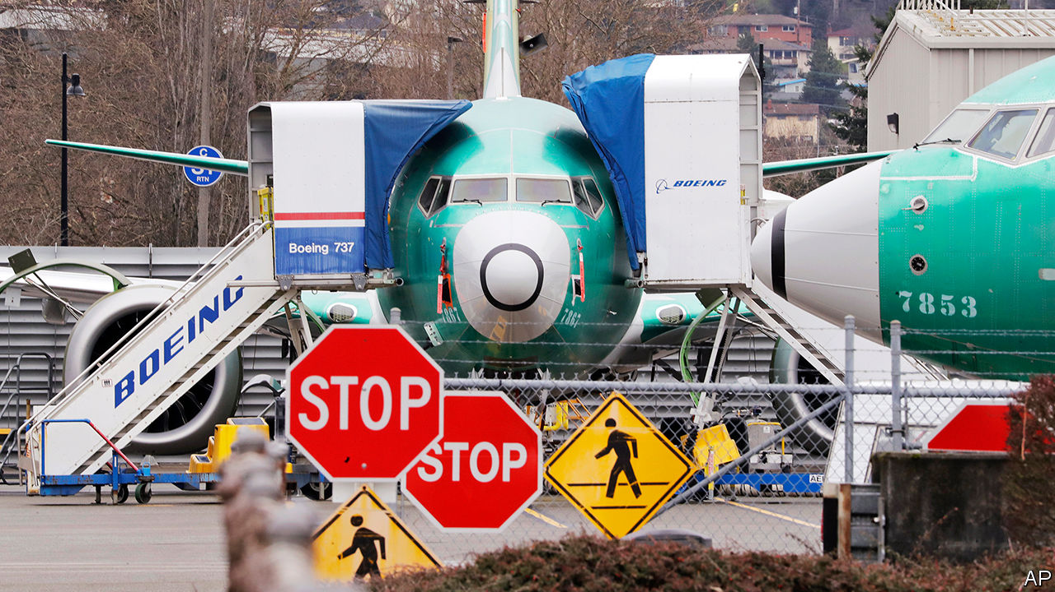

The transportation committee of America’s House of Representatives published a critical report into the failures that led to two Boeing 737 MAX jets crashing in just five months, killing 346 people. Design errors, lax government oversight of Boeing and a lack of transparency at the planemaker and its regulators “point to a company culture that is in serious need of a safety reset”, the report said.

Shares in Hennes & Mauritz surged by 11% on the day it revealed better-than-expected third-quarter results. The world’s second-largest fashion retailer, which has its headquarters in Sweden, said profits in the three months to the end of August were around SKr 2bn ($222m), more than ten times higher than the average analyst forecast of just SKr 191m.

SoftBank, a Japanese tech firm, agreed to sell Arm to Nvidia, an American chipmaker. The takeover values the British chip designer, whose microprocessor blueprints are used in most of the world’s smartphones, at up to $40bn. Four years ago SoftBank bought Arm for $32bn. Nvidia has also promised to protect jobs at Arm and keep its headquarters in Cambridge. See article.

## Not such a snowflake

The value of shares in Snowflake leapt by more than 110% on its first day on the New York Stock Exchange. The flotation of the fast-growing cloud-computing firm is the world’s largest-ever software IPO. See article.

This article was downloaded by calibre from <https://www.economist.com/the-world-this-week/2020/09/19/business-this-week>

|  |  |  |  |
| --- | --- | --- | --- |
| Previous | Articles | Sections | Next |

|  |  |  |  |
| --- | --- | --- | --- |
| Previous | Articles | Sections | Next |

# KAL’s cartoon

Sep 17th 2020 |

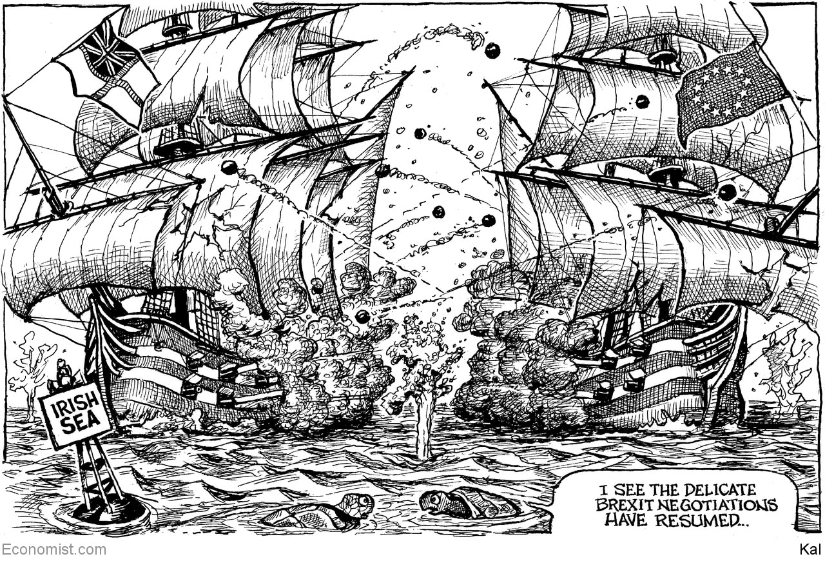

This article was downloaded by calibre from <https://www.economist.com/the-world-this-week/2020/09/17/kals-cartoon>

|  |  |  |  |
| --- | --- | --- | --- |
| Previous | Articles | Sections | Next |

|  |  |  |
| --- | --- | --- |
| The world this week | Sections | Letters |

Leaders

The new energy order: Power in the 21st century

.

Inflation: Off target

.

Multinational business and protectionism: Birth of the Frankenfirm

.

Deliberative democracy: Amateurs to the rescue

.

Abortion: Pills by post

.

|  |  |  |
| --- | --- | --- |
| The world this week | Sections | Letters |

|  |  |  |  |
| --- | --- | --- | --- |
|  | Articles | Sections | Next |

#### The new energy order

# Is it the end of the oil age?

Power in the 21st century

Sep 17th 2020 |



For more coverage of climate change, register for The Climate Issue, our fortnightly [newsletter](https://www.economist.com/theclimateissue/), or visit our [climate-change hub](https://www.economist.com/news/2020/04/24/the-economists-coverage-of-climate-change)

OIL FUELLED the 20th century—its cars, its wars, its economy and its geopolitics. Now the world is in the midst of an energy shock that is speeding up the shift to a new order. As covid-19 struck the global economy earlier this year, demand for oil dropped by more than a fifth and prices collapsed. Since then there has been a jittery recovery, but a return to the old world is unlikely. Fossil-fuel producers are being forced to confront their vulnerabilities. ExxonMobil has been ejected from the Dow Jones Industrial Average, having been a member since 1928. Petrostates such as Saudi Arabia need an oil price of $70-80 a barrel to balance their budgets. Today it is scraping along at just $40.

There have been oil slumps before, but this one is different. As the public, governments and investors wake up to climate change, the clean-energy industry is gaining momentum. Capital markets have shifted: clean-power stocks are up by 45% this year. With interest rates near zero, politicians are backing green-infrastructure plans. America’s Democratic presidential contender, Joe Biden, wants to spend $2trn decarbonising America’s economy. The European Union has earmarked 30% of its $880bn covid-19 recovery plan for climate measures, and its president, Ursula von der Leyen, used her state-of-the-union address this week to confirm that she wants the EU to cut greenhouse-gas emissions by 55% over 1990 levels in the next decade.

The 21st-century energy system promises to be better than the oil age—better for human health, more politically stable and less economically volatile. The shift involves big risks. If disorderly, it could add to political and economic instability in petrostates and concentrate control of the green-supply chain in China. Even more dangerous, it could happen too slowly.

Today fossil fuels are the ultimate source of 85% of energy. But this system is dirty. Energy accounts for two-thirds of greenhouse-gas emissions; the pollution from burning fossil fuels kills over 4m people a year, mostly in the emerging world’s mega-cities. Oil has also created political instability. For decades petrostates such as Venezuela and Saudi Arabia, with little incentive to develop their economies, have been mired in the politics of handouts and cronyism. In an effort to ensure secure supplies, the world’s big powers have vied to influence these states, not least in the Middle East, where America has roughly 60,000 troops. Fossil fuels cause economic volatility, too. Oil markets are buffeted by an erratic cartel. Concentration of the world’s oil reserves makes supply vulnerable to geopolitical shocks. Little wonder that the price has swung by over 30% in a sixth-month period 62 times since 1970.

A picture of the new energy system is emerging. With bold action, renewable electricity such as solar and wind power could rise from 5% of supply today to 25% in 2035, and nearly 50% by 2050. Oil and coal use will drop, although cleaner natural gas will remain central. This architecture will ultimately bring huge benefits. Most important, decarbonising energy will avoid the chaos of unchecked climate change, including devastating droughts, famine, floods and mass dislocation. Once mature, it should be more politically stable, too, because supply will be diversified, geographically and technologically. Petrostates will have to attempt to reform themselves and, as their governments start to depend on taxing their own citizens, some will become more representative. Consuming countries, which once sought energy security by meddling in the politics of the oil producers, will instead look to sensible regulation of their own power industry. The 21st-century system should also be less economically volatile. Electricity prices will be determined not by a few big actors but by competition and gradual efficiency gains.

Yet even as a better energy system emerges, the threat of a poorly managed transition looms. Two risks stand out. Autocratic China could temporarily gain clout over the global power system because of its dominance in making key components and developing new technologies. Today Chinese firms produce 72% of the world’s solar modules, 69% of its lithium-ion batteries and 45% of its wind turbines. They also control much of the refining of minerals critical to clean energy, such as cobalt and lithium. Instead of a petrostate, the People’s Republic may become an “electrostate”. In the past six months it has announced investments in electric-car infrastructure and transmission, tested a nuclear plant in Pakistan and considered stockpiling cobalt.

China’s leverage depends on how fast other economies move (see Briefing). Europe is home to giant developers of wind and solar farms—Orsted, Enel and Iberdrola are building such projects around the world. European firms are leading the race to cut their own emissions, too. America’s trajectory has been affected by the rise of shale oil and gas, which has made it the world’s largest oil producer, and by Republican resistance to decarbonisation measures. If America were to act on climate change—with, say, a carbon tax and new infrastructure—its capital markets, national energy laboratories and universities would make it a formidable green power.

The other big risk is the transition of petrostates, which account for 8% of world GDP and nearly 900m citizens. As oil demand dwindles, they will face a vicious fight for market share which will be won by the countries with the cheapest and cleanest crude. Even as they grapple with the growing urgency of economic and political reform, the public resources to pay for it may dwindle. This year Saudi Arabia’s government revenue fell by 49% in the second quarter. A perilous few decades lie ahead.

Faced with these dangers, the temptation will be to ease the adjustment, by taking the transition more slowly. However, that would bring about a different, even more destabilising set of climate-related consequences. Instead, as our special report in this issue explains, the investments being contemplated fall drastically short of what is needed to keep temperatures within 2°C of pre-industrial levels, let alone the 1.5°C required to limit the environmental, economic and political turmoil of climate change. For example, annual investment in wind and solar capacity needs to be about $750bn, triple recent levels. And if the shift towards fossil-fuel-free renewable energy accelerates, as it must, it will cause even more geopolitical turbulence. The move to a new energy order is vital, but it will be messy. ■

This article was downloaded by calibre from <https://www.economist.com/leaders/2020/09/17/is-it-the-end-of-the-oil-age>

|  |  |  |  |
| --- | --- | --- | --- |
|  | Articles | Sections | Next |

|  |  |  |  |
| --- | --- | --- | --- |
| Previous | Articles | Sections | Next |

#### Off target

# The ECB’s lack of credibility could hamstring Europe’s recovery

A strong currency is both cause and consequence of the ECB’s failures

Sep 19th 2020 |

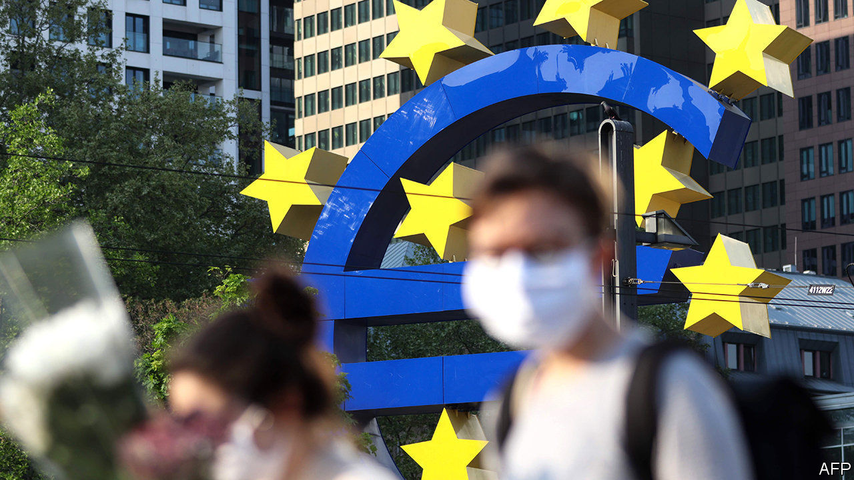

AT POINTS IN the past decade the European Central Bank (ECB) was the only institution standing between the euro zone and financial oblivion. Europe’s problem was budgetary inhibition and insufficient risk-sharing. Monetary policymakers were the only game in town. No longer. Earlier this year the European Union agreed to issue joint debt to fund a fiscal response to the pandemic, sending confidence in the currency union surging. Now the most pressing problem in euro-zone economic policy stems from Frankfurt. It is that hardly anyone believes the ECB is serious about hitting its inflation target of “below, but close to, 2%”.

Covid-19 continues to leave most of the world with a 90% economy in which activity is depressed (see article). Disinflation is the natural consequence. In August euro-zone prices fell for the first time in four years. But it is the job of policymakers to ensure that shocks do not become prolonged disinflationary slumps. The ECB’S own forecasts, released after its monetary-policy meeting on September 10th, show that it is failing. Inflation will rise over the next three years—but only to 1.3%. Financial markets expect it will stay around that level for most of the next decade. Professional forecasters are only a little more optimistic. The latest force holding down prices is a strong euro. The single currency has appreciated by 5.4% against the dollar this year.

A central bank that took its target seriously would fight tooth and nail to improve this outlook. Depressed inflation expectations are a dangerous malady. They keep real interest rates—that is, rates minus expected inflation—higher than they otherwise would be. This is a problem when, as today, nominal rates cannot fall much further. And central banking is a confidence game: the more a target loses credibility, the harder it is to hit. So concerned is America’s Federal Reserve about inflation expectations that it has promised to allow inflation to overshoot its target temporarily to make up for shortfalls, ensuring that inflation averages 2% over the long term.

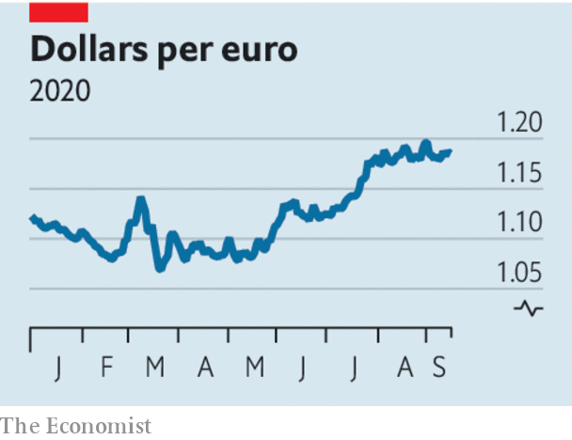

The ECB, by comparison, seems unperturbed. Instead of injecting new stimulus last week, it held back. The problem is not a lack of means. It insists that it could cut interest rates below today’s level of -0.5%, offer funding to banks on looser terms or expand its purchases of government debt. But it has done none of these things. After last week’s meeting Christine Lagarde, the bank’s president, said that increased asset purchases had not even been discussed. That pushed the euro up further, showing that the bank’s insouciance is adding to the currency’s strength and making expectations of low inflation self-fulfilling. Perhaps Ms Lagarde, not for the first time, gave too hawkish an impression. In a seemingly corrective blog post the next day, Philip Lane, the bank’s chief economist, struck a more doveish tone. The ECB will probably act in December. But it remains an institution that appears to view inflation shortfalls as a minor annoyance, not a test of its mettle.

Some would have it that the problem remains fiscal. Europe’s budgetary stimulus is smaller than America’s, and the ECB has already played an enormous role in markets this year. But the view that looser purse strings are needed to “ease the burden” on monetary policy is dangerous. If the practical effect of budgetary loosening is to let the central bank take a breather, the chances are that the exchange rate will appreciate, offsetting some or all of the stimulus. The monetary taps must stay fully open for the extra fiscal stimulus to have the desired effect. That is what is happening in America.

There is nothing inherently wrong with a strong euro. Many models, including our Big Mac index, suggest that it is warranted. But at present it partly reflects a suspicion that the ECB is willing to live with a lower rate of inflation than its official target demands. That risks damaging both the central bank’s credibility and also the euro zone’s recovery. ■

This article was downloaded by calibre from <https://www.economist.com/leaders/2020/09/19/the-ecbs-lack-of-credibility-could-hamstring-europes-recovery>

|  |  |  |  |
| --- | --- | --- | --- |
| Previous | Articles | Sections | Next |

|  |  |  |  |
| --- | --- | --- | --- |
| Previous | Articles | Sections | Next |

#### Corporate contortions

# Will TikTok survive?

The contortions at TikTok and Arm are an unfortunate sign of things to come

Sep 19th 2020 |

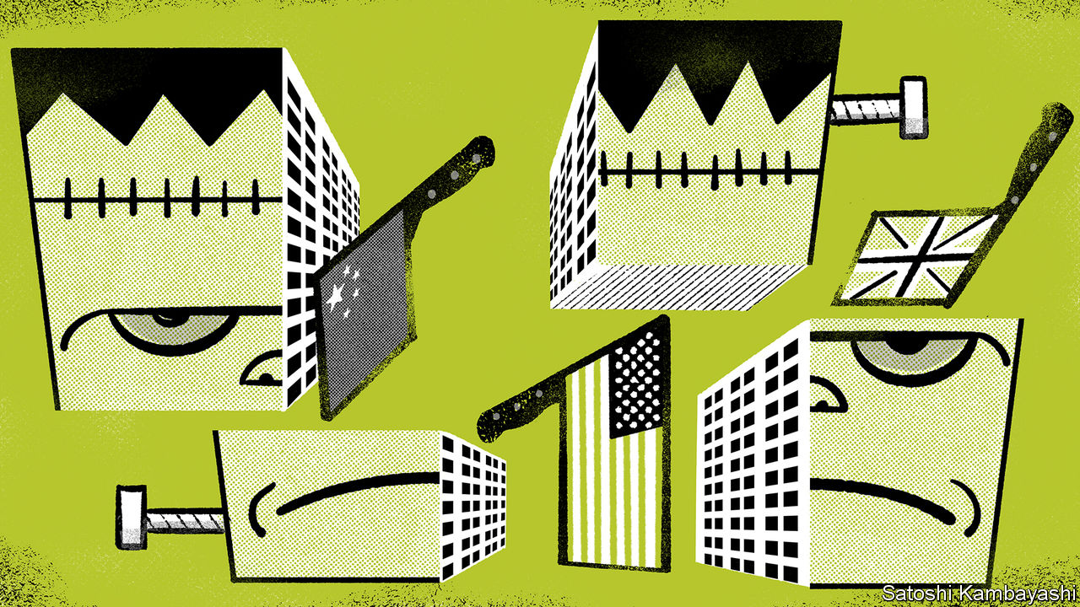

ON AUGUST 6TH, when the White House told TikTok that it had 45 days to shut down or find an American buyer, there was a risk that the Chinese-owned video app would disappear from America, infuriating its 100m users there and destroying billions of dollars of investors’ wealth. Now a last-minute fudge seems to have been found. TikTok has said it will enter a complex partnership with Oracle, an American tech giant, that is designed to show it is more under American sway. The day before Nvidia, an American semiconductor company, bid $40bn for Arm Holdings, a British-based chip-design firm, triggering a storm in Britain about how to stop its tech champion from being dragged into America’s trade war. Far from being oddities, the two episodes offer a preview of how the new age of nationalism will change the way multinational firms are run—for the worse.

Both companies straddle geopolitical divides and are at the heart of the digital economy (see [article](https://www.economist.com/node/21791912)). TikTok is owned by ByteDance, a Chinese tech star. The White House says it fears that users’ data are being sent to China, where Big Brother can spy on them, and that the algorithm which selects videos is vulnerable to Chinese manipulation. Arm’s designs are used worldwide, not least in America and China, its two largest markets. Britain’s government worries that a takeover will see key activity shifted abroad (in 2016 Arm was bought by SoftBank, a Japanese firm, which promised to keep the firm’s base in Britain until 2021). A further concern is that, under American ownership, Arm will no longer be a “neutral” supplier, instead becoming an instrument of Uncle Sam’s expanding sanctions regime.

Throughout history companies have adapted to geopolitics. In the freewheeling era of globalisation that began in the 1980s, the idea took hold around the world that all firms should be treated equally, regardless of their nationality. That made it efficient to operate as a global firm with a unitary management, capital structure and system of production. By contrast the 1930s and 1940s were plagued by wars and protectionism. Businesses such as General Motors responded by allowing their foreign operations to become semi-autonomous. Rather than merge, many firms co-operated across borders through alliances and cartels.

The proposed TikTok deal shows how business is heading in a 1930s direction. Although the details are not yet public, the firm’s ownership will probably change, with American shareholders, including Oracle, and possibly Walmart, holding a large minority stake, perhaps with rights to veto some decisions. The location of key assets will shift, with the headquarters moving to America and Oracle managing the data-storage there (and monitoring the algorithm). Arm, meanwhile, has already contorted its structure once to deal with geopolitics: in 2018 it sold a 51% stake in its China operation to mainly Chinese investors, including state-backed funds. Now it may face a new metamorphosis. The British government, for example, may demand further legal guarantees that it is run autonomously in Britain. That would be part of a push to bolster the country’s industrial base, which has triggered a row with the European Union (see [article](https://www.economist.com/node/21791880)).

These corporate contortions have glaring limitations. Politicians get to play God: President Donald Trump seems to favour Oracle—whose chairman, Larry Ellison, is a Trump supporter—rather than a bid by Microsoft, which made slightly more commercial sense. Mr Trump may now demand more concessions, and any deal will also need approval from the newly beefed up investment-screening regimes in America and China. Subdividing businesses into national silos duplicates costs, and complex structures can leave it unclear where control lies. Arm is locked in a bitter dispute with a Chinese executive over who is really in charge of its Chinese joint venture.

Despite this, expect more multinational manoeuvres as globalisation unwinds. Australia’s government is asking for Rio Tinto, a scandal-prone global mining firm, to be run by an Australian. European tech firms may bifurcate, with one production line serving Chinese clients and another American ones. Chinese companies may have to make do with buying minority stakes abroad, not full control. Firms crippled by sanctions—Huawei, say—may dissolve, with their intellectual property and best people migrating to competitors that do not face such constraints. Geopolitics is twisting global business into a form that is less efficient and less free. That is to be lamented.■

This article was downloaded by calibre from <https://www.economist.com/leaders/2020/09/19/will-tiktok-survive>

|  |  |  |  |
| --- | --- | --- | --- |
| Previous | Articles | Sections | Next |

|  |  |  |  |
| --- | --- | --- | --- |
| Previous | Articles | Sections | Next |

#### Amateurs to the rescue

# Politicians should take citizens’ assemblies seriously

Panels of ordinary people can solve problems that the professionals fear to tackle

Sep 19th 2020 |

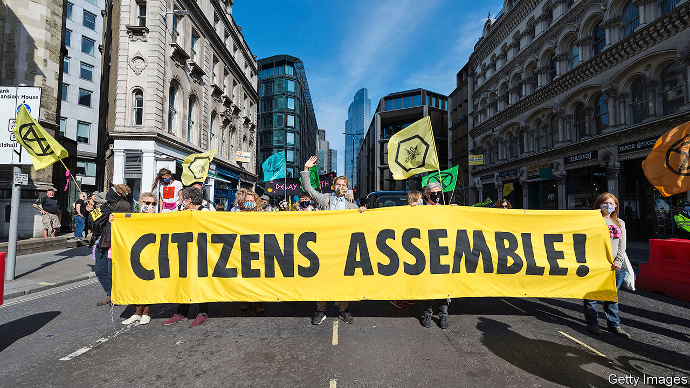

IN 403BC Athens decided to overhaul its institutions. A disastrous war with Sparta had shown that direct democracy, whereby adult male citizens voted on laws, was not enough to stop eloquent demagogues from getting what they wanted, and indeed from subverting democracy altogether. So a new body, chosen by lot, was set up to scrutinise the decisions of voters. It was called the nomothetai or “layers down of law” and it would be given the time to ponder difficult decisions, unmolested by silver-tongued orators and the schemes of ambitious politicians.

This ancient idea is back in vogue, and not before time. Around the world “citizens’ assemblies” and other deliberative groups are being created to consider questions that politicians have struggled to answer (see [article](https://www.economist.com/node/21791841)). Over weeks or months, 100 or so citizens—picked at random, but with a view to creating a body reflective of the population as a whole in terms of gender, age, income and education—meet to discuss a divisive topic in a considered, careful way. Often they are paid for their time, to ensure that it is not just political wonks who sign up. At the end they present their recommendations to politicians. Before covid-19 these citizens met in conference centres in large cities where, by mingling over lunch-breaks, they discovered that the monsters who disagree with them turned out to be human after all. Now, as a result of the pandemic, they mostly gather on Zoom.

Citizens’ assemblies are often promoted as a way to reverse the decline in trust in democracy, which has been precipitous in most of the developed world over the past decade or so. Last year the majority of people polled in America, Britain, France and Australia—along with many other rich countries—felt that, regardless of which party wins an election, nothing really changes. Politicians, a common complaint runs, have no understanding of, or interest in, the lives and concerns of ordinary people.

Citizens’ assemblies can help remedy that. They are not a substitute for the everyday business of legislating, but a way to break the deadlock when politicians have tried to deal with important issues and failed. Ordinary people, it turns out, are quite reasonable. A large four-day deliberative experiment in America softened Republicans’ views on immigration; Democrats became less eager to raise the minimum wage. Even more strikingly, two 18-month-long citizens’ assemblies in Ireland showed that the country, despite its deep Catholic roots, was far more socially liberal than politicians had realised. Assemblies overwhelmingly recommended the legalisation of both same-sex marriage and abortion.

Perhaps because citizens’ assemblies reflect the population, their conclusions seem to appeal to it, too. Same-sex marriage and abortion were both legalised in Ireland when whopping majorities in referendums demonstrated that the country had reached a new consensus after years of fighting. And assemblies are not just for engaged middle-class types. One European study found that people with less education, as well as those who are most mistrustful of politicians, are keenest on the idea.

Citizens’ assemblies are good, in short, at coming up with solutions to thorny or polarising issues in which politicians have been captured by their party’s extremes. But they work best if they follow some rules. To start with, national politicians must embrace them. So far, most have been at the local or state level. A recent Climate Assembly in Britain was set up by a series of parliamentary committees; the government had no part in it.

Assemblies must also have a clear question to debate. Should gay marriage be legalised? How can our city live within its means? The current citizens’ assembly in Scotland is an example of what to avoid. It has a series of thumb-sucking questions to ponder, including, “What kind of country are we seeking to build?”—inviting an equally thumb-sucking answer.

Lastly, the politicians who set up citizens’ assemblies must genuinely be open to their conclusions. They cannot simply be looking for an endorsement of their own preconceptions. Nicola Sturgeon, Scotland’s first minister, dented the integrity of the assembly there by launching it at the same time as she renewed her party’s goal of independence, making the whole process suspect in the eyes of those who do not share her beliefs. The assemblies should instead be set up in the spirit of open debate, experiment, and a willingness to listen to other points of view.

And politicians should promise to put the recommendations of a citizens’ assembly to a vote in parliament or, when appropriate, a referendum, whatever the outcome. If they claim to represent the people, they should take the people seriously. ■

This article was downloaded by calibre from <https://www.economist.com/leaders/2020/09/19/politicians-should-take-citizens-assemblies-seriously>

|  |  |  |  |
| --- | --- | --- | --- |
| Previous | Articles | Sections | Next |

|  |  |  |  |
| --- | --- | --- | --- |
| Previous | Articles | Sections | Next |

#### Women’s health

# The pandemic shows a better way to handle abortion

It is safe and efficient for early terminations to take place at home

Sep 19th 2020 |



FOR MOST women deciding how or when to give birth, covid-19 has been a nightmare. Fertility treatments have paused, sexual-health clinics closed and partners been banned from delivery rooms. Yet the pandemic has brought one silver lining. It has shown a better way to carry out early-stage abortions.

Abortion is legal in most of the world, and relatively straightforward in most rich countries. But obstacles remain. They include compulsory waiting times and mandatory counselling. Perhaps the most common obstacle is that the first step in medical abortions (which involve drugs rather than surgery) must take place in clinics. Yet temporary measures set up during the pandemic suggest this is often unnecessary. These temporary measures should now become permanent.

At-home procedures are available only to women in the first trimester of pregnancy—which includes most of those who have abortions today. Two medicines are needed: mifepristone (which blocks the effects of the pregnancy-enabling hormone progesterone) and misoprostol (which induces contractions). They are taken a couple of days apart, and the pregnancy normally ends four to six hours after the second one is administered. In most of Britain, before the pandemic, the drugs were handed out after an ultrasound and an in-person consultation at a clinic. The mifepristone had to be administered by a doctor; the misoprostol was taken at home.

Covid-19 has changed that. In March Britain’s health secretary approved a rule change which, in effect, gave a woman’s home the same status as an abortion clinic. Instead of visiting a doctor, women could arrange an abortion by phone and have the pills delivered by post. Ireland introduced similar rules. France extended the limit for an at-home abortion from the seventh to the ninth week of pregnancy, though the pills must still be collected from a doctor or pharmacy. In July a federal judge in America lifted regulations that required women to collect abortion pills from a surgery, clinic or hospital, ruling that this was a “substantial obstacle in the path of women” during a pandemic.

None of these countries have yet decided if these kinds of approaches will last. In America, the Trump administration has asked the Supreme Court to overturn it. A decision is expected soon (see [article](https://www.economist.com/node/21791885)). In Britain the government has said that it will launch a public consultation on whether to keep the new approach. Ireland and France are also uncertain about whether to make the changes permanent.

Some people take a principled position that abortion at any time during pregnancy is wrong. For everyone else, however, the decision turns on two questions. Will removing medical supervision endanger women’s health? And will it lead to many more abortions? Take each in turn.

There is no evidence that at-home terminations are dangerous, and plenty to suggest that they are not. The World Health Organisation has said that early-term abortions can be carried out safely outside a clinic. In Britain the British Medical Association and Royal College of Obstetricians and Gynaecologists have both called for the changes to be made permanent. Recent data there show that they have resulted in women having abortions earlier, and thus more safely. From January to June, 25% more than in the previous year were carried out at less than seven weeks’ gestation.

This increase is explained by a surge in early abortions not in the overall total. Britain has seen only a 4% rise in terminations carried out in the first half of the year. That could reflect a straitened economy, say, or stressed relationships in lockdown and less access to contraception as well as easier abortion. The Guttmacher Institute, a pro-choice research group, finds no link between abortion restrictions in American states and changes in their abortion rate—whether the states make abortion easier or harder.

More important, if there ends up being an increase in the number of terminations that may be for a good reason. Some women are poor, live in regions with few clinics, or have a spouse or parent from whom they need to hide their abortion. For them the new rules have removed barriers that they might otherwise have found insurmountable. The changes to the abortion regime introduced as a result of the pandemic do not create new rights; they give a woman access to her existing rights more safely and efficiently. As with any citizen, that is welcome. ■

This article was downloaded by calibre from <https://www.economist.com/leaders/2020/09/19/the-pandemic-shows-a-better-way-to-handle-abortion>

|  |  |  |  |
| --- | --- | --- | --- |
| Previous | Articles | Sections | Next |

|  |  |  |
| --- | --- | --- |
| Leaders | Sections | Briefing |

Letters

Letters to the editor: On dementia, the Beatles, scientific management

.

|  |  |  |
| --- | --- | --- |
| Leaders | Sections | Briefing |

|  |  |  |  |
| --- | --- | --- | --- |
|  | Articles | Sections | Next |

#### On dementia, the Beatles, scientific management

# Letters to the editor

A selection of correspondence

Sep 19th 2020 |

Letters are welcome via e-mail to letters@economist.com

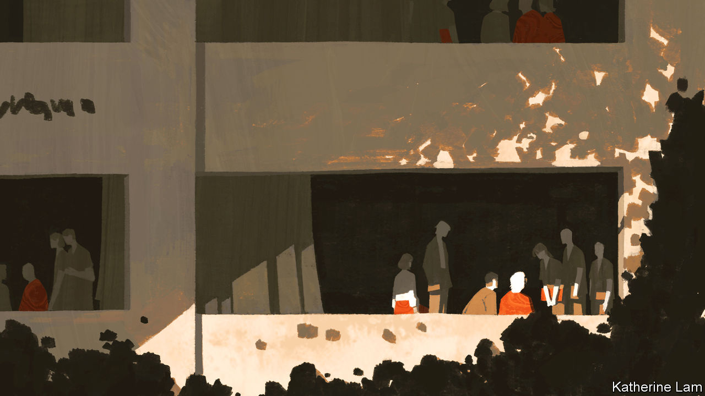

## The challenge of dementia

Your excellent leader and special report on dementia ([August 29th](https://www.economist.com/special-report/2020/08/27/as-humanity-ages-the-numbers-of-people-with-dementia-will-surge)) were most timely. The idea that dementia can be prevented is fairly new. At a G8 meeting organised by David Cameron in 2013, a letter from 111 scientists in 36 countries stated that dementia (including Alzheimer’s disease) can be prevented, and urged the G8 to devote resources to this quest. As you pointed out, we now believe that up to 40% of dementia is preventable mainly by public-health measures, and yet the sums spent on these measures are tiny compared with the billions of dollars spent by drug companies looking for a cure.

There will not be a cure for this disease since the brain is far too damaged at the time of diagnosis. But there is already evidence that certain interventions, like those you mentioned and in addition the consumption of certain nutrients, can slow down the disease process. There is an urgent need for governments to fund research into prevention since this is our only chance of averting the huge problems in the future that you identified.

A. DAVID SMITH  
Emeritus professor of pharmacology  
University of Oxford

Some 12% of ostensible cases of dementia are due to cognitive side-effects of medication, which is reversible. Others are due to depression, causing reversible pseudodementia. An often overlooked type of dementia is frontotemporal dementia (FTD), constituting 10% or more of cases. It often begins earlier in life than Alzheimer’s. Half of patients with FTD have the behavioural variant. Memory loss is not a prominent early symptom; instead, patients may exhibit decreased judgment, poor problem-solving skills, impulsivity, hypersexuality, lack of empathy, binge-eating, decreased attention span, mental rigidity, perseveration and language problems such as impaired syntax, leaving out words and a preference for partial phrases. Accompanying neuromuscular disease can lead to weakness in the arms and legs, and tremor.

RICHARD WAUGAMAN  
Clinical professor of psychiatry  
Georgetown University  
Washington, DC

Without question, the “rising prevalence of dementia is a global emergency” (“[The memory hole](https://www.economist.com/leaders/2020/08/27/the-rising-prevalence-of-dementia-is-a-global-emergency)”, August 29th). But to say that “smoking less, exercising more and losing weight in middle age has reduced the risk of dementia” completely misses the problem: we are outliving the evolutionary lifespan of our brains.

To think America is on the verge of licensing a drug “to stem cognitive decline in Alzheimer’s patients” is like buying the magic beans of Donepezil, which may do wonders for recuperating pharmaceutical losses in drug development, but in the end just gives a lot of old folks diarrhoea. Most disheartening is your perverse conclusion that it would be a good idea to require “everyone aged 40-65 to pay a premium…as it avoids penalising the young”. Let those who want to live out a decade of dementia in a nursing home buy what insurance they wish. I think I’ll spend my savings enjoying a life I can still appreciate.

CLAYTON WILEY  
Director of neuropathology  
UPMC Presbyterian Hospital  
Pittsburgh

I am 89. No one considered the effects of medical advances. I take my blood-pressure pills obediently. I do not want to have a stroke, but can honestly say an efficient fatal heart attack would be welcome. I have the right to refuse life-extending drugs when I am presumably deemed to be mortally ill. It seems I do not have that freedom any earlier.

I am not the only old person unafraid of dying. Most of my life has been great, but I have been here long enough and am scared of becoming demented. A lot of people are bound to get dementia—God help us. We have forgotten that death used to come when one’s body failed. It was meant to be a release, both for the loved one dying and their loving relatives and friends, who suffer watching them.

JILL MCCALLUM  
Olney, Buckinghamshire

So signs of Alzheimer’s were detected in Ronald Reagan’s speech patterns long before his diagnosis. An interesting footnote to this is provided by Oliver Sacks in “The Man Who Mistook His Wife for a Hat” published in 1985. Sacks relayed the story of a ward of aphasia patients who were moved by a speech made by Reagan “apparently, mainly to laughter”. He attributed this, not to syntax, but to something wrong in Reagan’s “tones and cadences”. Sacks concluded that his aphasic patients were “undeceived and undeceivable by words”.

PAUL KINZIE  
Bossier City, Louisiana

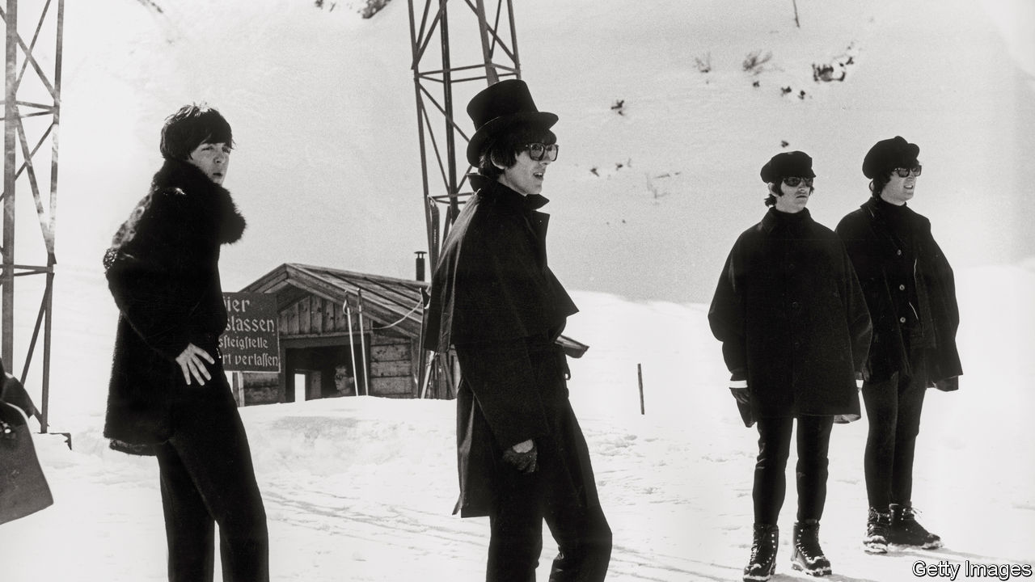

## Influences on the Beatles

Although I’m far from wearying of “Rubber Soul”, I agree that “Help!” gets insufficient love from snootier Beatles fans, a group in which I must include myself (“[Send for ‘Help!’](https://www.economist.com/books-and-arts/2020/08/27/the-therapeutic-properties-of-help)”, August 29th). If the former was their departure album, they were already packed and ready to board with the latter. I’m surprised, though, that your article failed to point out that the title track highlights what was to become a defining characteristic of John Lennon and Paul McCartney’s work with George Martin: their liberal use of eclectic musical references. “When I was younger, so much younger than today” is sung to a tune from the intermezzo of the “Karelia Suite” by Jean Sibelius. Even Lennon’s grandfather was young when that was written.

DAVE MORRIS  
London

Another overlooked aspect of this album is Paul McCartney’s rather interesting lyrical sleight of hand in “I’ve Just Seen a Face”. Here the second line of the song is completely ungrammatical on its own, but makes grammatical sense when the object of the first line (“I can’t forget”) becomes the subject for the second line. Mr McCartney seems to have been the first lyricist to perform such legerdemain, and the performance is so seamless as to be almost unnoticeable: “I’ve just seen a face/I can’t forget the time or place/Where we just met.” The only other song that I know that consciously does the same sort of thing is Love’s “Between Clark and Hilldale”.

JORDAN MOAR  
Waterloo, Canada

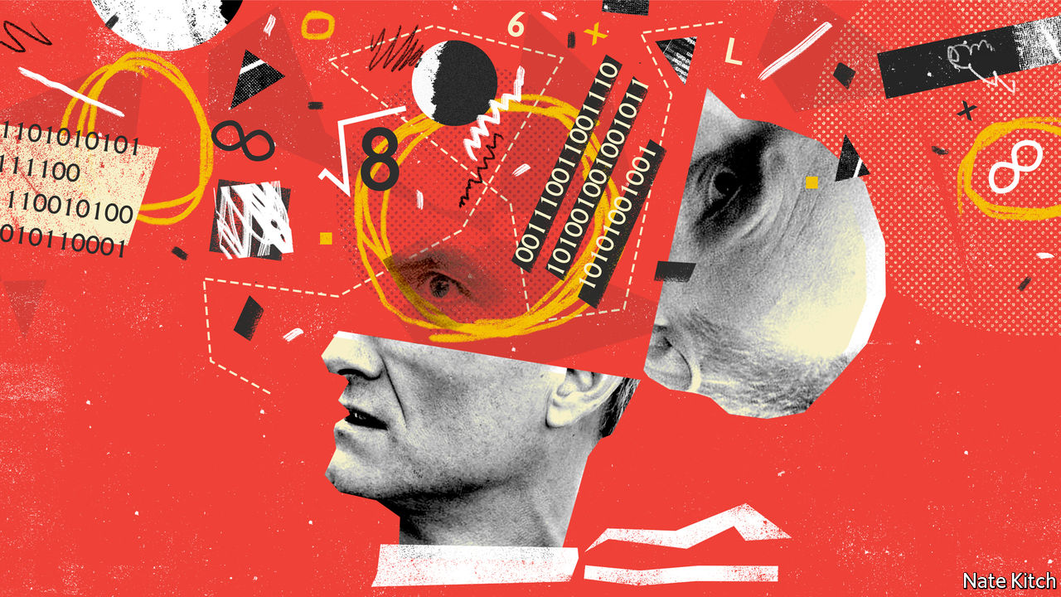

## Not Taylor made

Bagehot reported that the term “scientific management” was coined by Frederick Taylor, an American management guru ([August 22nd](https://www.economist.com/britain/2020/08/20/how-the-british-government-rules-by-algorithm)). Taylor is rightly associated with the term, since he popularised it. However, it was actually coined by Louis D. Brandeis, the “people’s lawyer”, who gained fame as a champion of consumers against monopolists. He first used the expression “scientific management” in 1910, in testimony before the Interstate Commerce Commission, when it was considering requests by the railroads for rate increases. Taylor then picked up on the expression. Brandeis went on to a long and distinguished service on the Supreme Court.

STEPHEN NEFF  
School of Law  
University of Edinburgh

That “scientific management” bungled the algorithm for children’s exam results, verifies a maxim attributed to J.R. Searle, an American philosopher: if you have to add “scientific” to a field, it probably ain’t.

A.D. PELLEGRINI  
Bloomington, Minnesota

This article was downloaded by calibre from <https://www.economist.com/letters/2020/09/19/letters-to-the-editor>

|  |  |  |  |
| --- | --- | --- | --- |
|  | Articles | Sections | Next |

|  |  |  |
| --- | --- | --- |
| Letters | Sections | Asia |

Briefing

Energy’s new world order: Petrostate v electrostate

.

|  |  |  |
| --- | --- | --- |
| Letters | Sections | Asia |

|  |  |  |  |
| --- | --- | --- | --- |
|  | Articles | Sections | Next |

#### The changing geopolitics of energy

# America’s domination of oil and gas will not cow China

Being an importer of fossil fuels and an exporter of renewable technology is not so bad

Sep 17th 2020 | NEW YORK

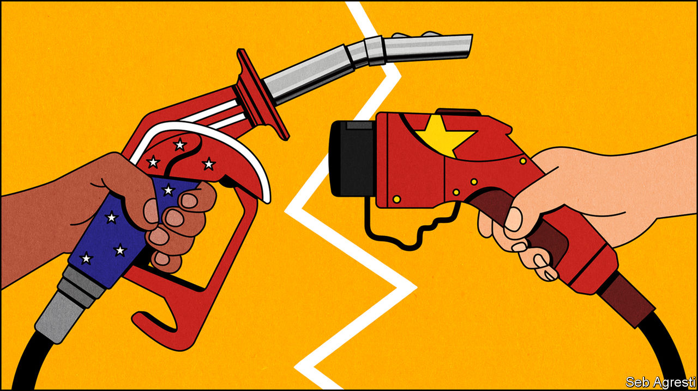

For more coverage of climate change, register for The Climate Issue, our fortnightly [newsletter](https://www.economist.com/theclimateissue/), or visit our [climate-change hub](https://www.economist.com/news/2020/04/24/the-economists-coverage-of-climate-change)

“THE UNITED STATES OF AMERICA is now the number-one energy superpower anywhere in the world,” President Donald Trump told oilmen in Midland, Texas this summer, from a stage decorated with gleaming black barrels. The sheer volume of hydrocarbons that such American oilmen have released from the shale beneath Midland and previously unforthcoming geology elsewhere gives substance to his boast (see chart 1). Over the past decade America’s oil output has more than doubled and its gas production increased by over 50%. America is now the world’s top producer of both fuels.

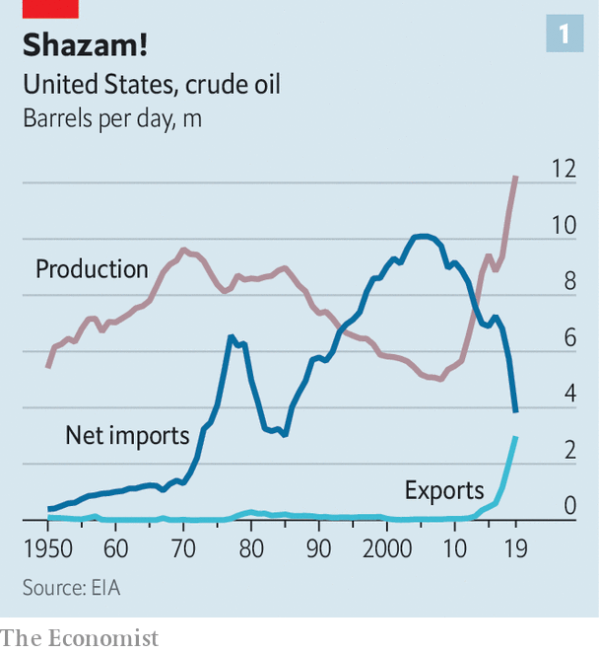

Had they heard Mr Trump say that “We will never again be reliant on hostile foreign suppliers,” presidents from Franklin Roosevelt on might have nodded in envious approval. After the second world war America’s unmatched ability to consume oil outstripped its unmatched ability to produce it. Ensuring supplies from elsewhere became an overriding priority. The oil shock of the 1970s had a profound effect both on the economy and on geopolitics, driving much of America’s subsequent involvement in the Middle East. The surge in domestic supply in the 2010s both boosted the economy and opened up new geopolitical opportunities. America can apply sanctions to petrostates such as Iran, Venezuela and Russia with relative impunity.

But what it might mean to be an energy superpower is changing, thanks to three linked global shifts. First, fears about fossil-fuel scarcity have given way to an acknowledgment of their abundance. Not least because of what has been achieved in America, the energy industry now knows that it will be lack of demand, not lack of supply, which will cause production of oil, coal and, later, gas to dwindle. In its latest “World Energy Outlook”, published on September 14th, BP, an oil company which has recently said it plans to go carbon neutral, argues that demand for oil may already have peaked, and could go into steep decline (see chart 2 ).

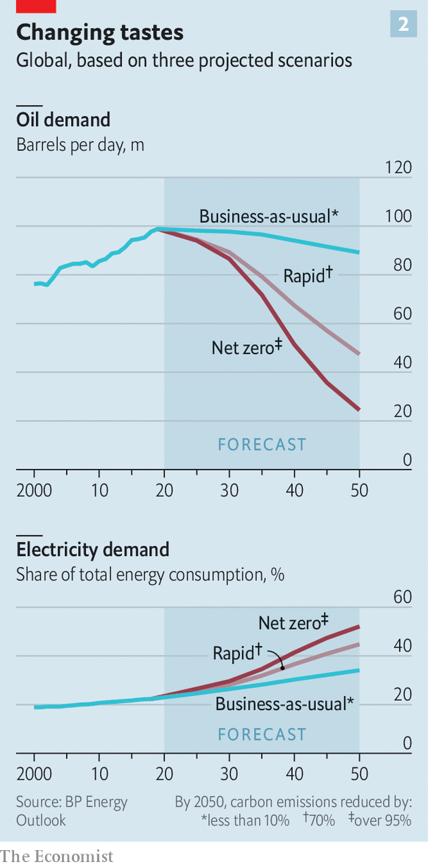

This is because of the second shift: an acknowledgment by most countries that, for the sake of the climate, reliance on fossil fuels needs to come to an end. And that leads to the third shift: electrification. Fossil fuels provide heat that is mostly used to move things, be they vehicles or electric generators. Solar panels and wind turbines provide energy as electricity straight off. Maximising their emissions-free benefits means processes and devices that now rely on combustion must in future use currents and batteries instead. The BP analysis argues that in a world going all out for decarbonisation the share of energy used in the form of electricity would rise from about a fifth in 2018 to just over half in 2050.

Falling demand for fossil fuels will tilt the balance of power away from producers and towards consumers—though there will doubtless be reversals now and then along the way. And in a world which needs to generate much more fossil-free electricity, mass production of the means whereby to do so will become crucial, as will government backing and know-how in deployment. Being a mighty pumper of oil will do a lot less for America under such conditions than once it might have done. But China, the world’s biggest fossil-fuel importer as well as its leading exponent of renewable energy at gigawatt scales, will have the wind, as it were, at its back.

The covid-19 pandemic has provided a dramatic preview of a world in which demand for oil falls instead of rising. When the globe stopped spinning in March, its thirst for oil suddenly subsided. Petrostates dependent on pricey oil for their spending now face gaping deficits. Investors have fallen out of love with oil companies. For all Mr Trump’s grateful boosterism, the value of America’s shale sector has fallen by more than 50% since January. ExxonMobil, an oil company included in the Dow Jones Industrial Average since 1928, has been kicked off it. With a market capitalisation of $155bn it is worth considerably less than Nike, a shoemaker with a swoosh.

In the face of this turmoil China’s demand for oil imports, already the largest in the world, continues to grow—providing some welcome stability. The country’s independent refiners—the “teapots”—have become large enough that they help set oil’s price floor. “They are essentially the vacuum cleaner of the crude market,” says Per Magnus Nysveen of Rystad Energy, a consultancy. Michal Meidan, who leads China energy studies at Oxford University, points out that the trading arms of state-owned oil giants SINOPEC and China National Petroleum Corporation are now two of the three largest traders of crude cargoes priced on the Platts Dubai futures contract, which means they influence the price of crude bound for Asia. Low prices also allow China to build up its strategic reserves.

Big finds off the coasts of Brazil and Guyana and the development of Australia’s liquefied natural gas (LNG) capacity, along with America’s shale boom, add to China’s opportunities; a buyers’ market is a good place to be the biggest buyer, notes Kevin Tu of Columbia and Beijing Normal Universities. There are plenty of bullish oilmen who think that, BP to the contrary, peak demand has yet to be reached. But even they recognise that the supply of oil below ground outstrips the thirst above it, and that competition for customers is likely to heat up.

In some instances competition for Chinese demand may be straightforward. When it embarked on a price war with Russia this spring, Saudi Arabia slashed prices on shipments bound for China. The country’s biggest refiners are mulling a plan for a buying consortium to strengthen their negotiating power with the Organisation of the Petroleum Exporting Countries. China will probably also flex its financial muscle as petrostates buckle under debt. It has issued oil-backed loans to crude-rich countries such as Angola and Brazil for more than a decade.

China’s position as a buyer also allows it to undercut America’s attempts to squeeze oil exporters. Chinese buyers long continued to import Iranian and Venezuelan crude. Its energy alliance with Russia is particularly important.

## A different strength

As energy expert Daniel Yergin points out in “The New Map” (see article) Vladimir Putin realised the significance of energy relations with China early on; but the pivot to China became more urgent after the financial crisis of 2007-09. In 2009 the China Development Bank lent two state-controlled Russian companies, Rosneft, an oil producer, and Transneft, a pipeline builder and operator, $25bn in exchange for developing new fields and building a pipeline which would supply China with 300,000 barrels of oil a day.

In 2014 Western sanctions over Crimea inspired Gazprom, another Russian energy giant, to commit to a long-haggled-over gas pipeline, the Power of Siberia, which opened last December. Tying in Chinese custom gives Russia a large market unmoved by calls for sanctions at a time when European demand is faltering. But as Erica Downs of Columbia University points out, “As soon as a pipeline is built, the balance of power shifts from supplier to buyer.” After the first oil pipeline was built, China refused to pay the agreed price.

All this power in the market, though, cannot mask the geopolitical downside of relying on imports. Being a large importer may give you more power than being a smaller one; but it still leaves you vulnerable. China is acutely aware that much of its oil comes through the straits of Hormuz and Malacca, which could be closed by third-party conflicts or, in extremis, the US Navy. In recent months China’s concern about energy security has risen as relations with America have declined, notes Ms Meidan—for all the current talk of decoupling, China has been buying lots of LNG from America, as well as crude for its stockpiles. Communist Party documents for China’s new five-year plan emphasise the need for a more flexible, reliable energy system.

What China lacks in oil and gas supplies it makes up for with industrial policy, which it has long been using to support domestic coal production and nuclear power as well as what is now by far the world’s largest renewables sector. Chinese companies have invested in mines from the Democratic Republic of Congo (DRC) to Chile and Australia, securing access to the minerals needed for solar panels, electric vehicles and the like. Unable to be a petrostate, it is becoming what one might call an electrostate, investing strategically all along the chain from mine to meter.

This is not in itself anything like a triumph for climate action. China has more than 1,000 gigawatts (GW) of coal-fired generating capacity. This installed base, with which it generates 49% of the world’s coal-fired electricity, makes it the world’s biggest carbon-dioxide emitter. And its coal use is set to expand in the years to come.

Its wind and solar capacity of 445GW, vast though it is by most standards, is less than half coal’s total, and those renewables typically run at a much smaller fraction of their capacity than coal plants do. But China also has 356GW of hydropower capacity, more than the next four countries combined. It has been building nuclear power plants faster than any other country—the average age of the 48 reactors in its fleet is less than a decade—and intends to go on doing so; nuclear, which now produces less than 5% of the country’s electricity, is set to produce more than 15% by 2050.

The evolution of China’s nuclear, wind, solar and battery sectors varies somewhat, but the basic formula remains the same: learn from foreigners and then use massive investment and authoritarian dictat to support deployment on a very large scale. Subsidies at home and abroad have helped. Support for renewables in Europe in the 2000s created a demand for solar panels only Chinese firms, liberally aided by the state, could meet. Chinese battery giants, led by CATL, benefited from a policy that subsidised electric vehicles only if they used batteries from domestic suppliers.

Fossil-fuel free as they are, these technologies still require raw materials. Wind and solar power need a lot more of some non-ferrous metals—notably, if unsurprisingly, copper—than systems which burn fossil fuels; batteries require niche materials in ways that fuel tanks do not. Generally, the world has plenty of these necessary commodities—but less capacity to get them to market than rapid decarbonisation requires. As Andy Leyland of Benchmark Minerals Intelligence, a research firm, puts it, “There’s no geological shortage. It’s a financing shortage.” Mines which frequently go over budget and are too often delayed, sited in countries prone to instability, are not overwhelmingly alluring to most Western investors.

Chinese companies have helped fill the gap. Some of this is through domestic investment. China produces 60% of the world’s “rare earths”, which have properties that make them useful in electric motors, among other things. They are not, generally, rare in a geological sense, but they can be in short supply. (They are also often mined in ways that do great damage to the local environment.)

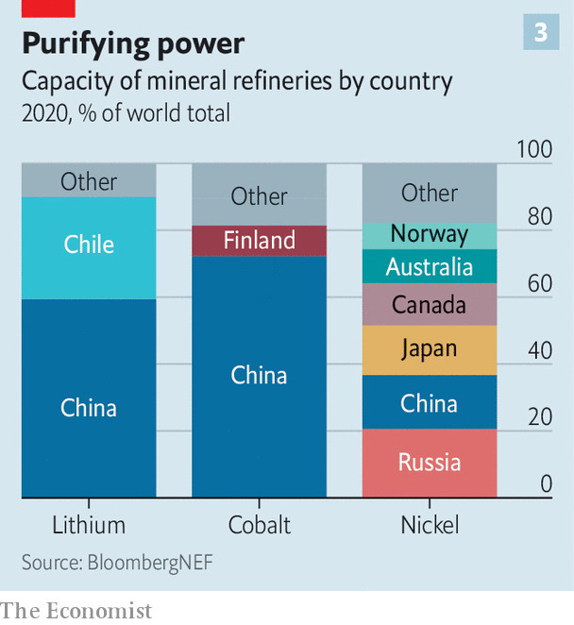

For other metals China mostly has to look further afield. Tianqi, a private company, has a minority stake in SQM, Chile’s biggest miner of the lithium on which batteries depend. Tsingshan has invested in battery-grade-nickel projects in Indonesia. The DRC’s copper and cobalt have attracted Chinese investors for over a decade, and mines owned by others often send their output to China anyway. China refines more than twice as much lithium and eight times as much cobalt as any other country, according to BloombergNEF, a research outfit (see chart 3).

Ivanhoe Mines, led by Robert Friedland, a veteran American miner, has had backing from two Chinese companies, CITIC and Zijin Mining, to build the world’s largest new copper mine in the DRC. Mr Friedland argues that Chinese investors look further into the fewer-fossil-fuels future than Western ones. “What do the batteries look like? Where is the supply chain?” These are questions, Mr Friedland says, where the Chinese “are probably ten years ahead”.

Politicians in America, Europe and Australia have expressed concern at Chinese control of minerals critical to not just energy but defence. A company backed by Bill Gates and other billionaires plans to search for cobalt in Quebec. America’s Development Finance Corporation is, for the first time, taking equity stakes in mining companies. One beneficiary is TechMet, which is betting that some investors will prefer mines independent of Chinese control. “It’s a very significant strategic issue for the United States and the West,” says Admiral Mike Mullen, a former chairman of America’s Joint Chiefs of Staff and now the head of TechMet’s advisory board. “I almost liken it to Huawei. We wake up and they’re in control of the world.”

## Here comes everyone

China now produces more than 70% of the world’s solar modules. It is home to nearly half its manufacturing capacity for wind turbines. It dominates the supply chain for lithium-ion batteries, according to BloombergNEF, controlling 77% of cell capacity and 60% of component manufacturing. With its industries at such a scale, and support costs ballooning, subsidies for them have been cut. Last year China eased restrictions on foreign battery-makers, too

The rest of the world has benefited—the costs of solar panels and batteries have dropped by more than 85% in the past decade. “We will invest continuously in research to make sure we retain our leadership—in research and in mass production,” says Li Zhenguo, president of LONGi, a giant producer of solar modules. China is keen to set technical standards across a range of industries, hoping to shape the playing field for further innovation. For clean-energy technologies in particular, says Mr Tu, it has an edge.

Though it has successful and influential innovators such as Tesla (see article), in this part of the energy world Mr Trump’s superpower looks like an also-ran. His rival in this November’s election, Joe Biden, promises to get back in the race. Developed countries elsewhere are further along. Panasonic in Japan and LG Chem in South Korea are both making innovations in battery technology. Europe’s generous support has provided a big market for the world’s top wind turbine manufacturers, Siemens Gamesa, which has its headquarters in Spain, and Vestas of Denmark.

And Europe’s green ambitions are growing. In her state-of-the-EU address on September 16th, Ursula van der Leyen said that the European Commission, of which she is president, will be pressing for carbon emissions 55% below those of 1990 by 2030. This means European utilities are expected to provide both a large increase in capacity and a near-zero-emissions future. To do so they will have to buy yet more hardware from China. But Europe’s aggressive strategy gives them an opportunity to take the lead in developing the systems which put that kit to work, both at home and abroad, as well as in technologies China has yet to master.

Visit a wind farm in America’s heartland and you may well find an office of Electricité de France (EDF) nestled among the corn. Enel, a utility which has its headquarters in Italy, is the single largest investor in wind and solar projects in developing countries, according to BloombergNEF, with France’s Engie and Spain’s Iberdrola not far behind. Orsted, a Danish firm, is the world’s top developer of offshore wind.

China’s national champions have invested ambitiously in power projects abroad, too. Of the roughly $575bn invested or promised under China’s Belt and Road Initiative as of 2019, nearly half has gone to energy projects, according to the World Bank. But most of this has been on coal plants, nuclear reactors and dams. And nations wary of China’s influence and motives treat its advances with suspicion. Efforts by State Grid, the world’s biggest utility, to buy stakes in European electricity companies have been rebuffed. In Britain, state-owned China General Nuclear Power Group (CGN) has minority stakes in two nuclear plants being built by EDF, but a plant to be built by CGN itself is years away from approval which may not come at all.

Nevertheless Chinese companies are starting to invest more in wind and solar power abroad. China Three Gorges, a big power company, said in August that it would buy half a gigawatt of Spanish solar capacity from X-Elio, a developer based in Madrid. Last year CGN bought more than 1GW of wind and solar farms in Brazil.

To maximise its electrostate power China needs to combine its renewable, and possibly nuclear, manufacturing muscle with deals that let its companies supply electricity in a large number of countries. The International Renewable Energy Agency has suggested that such “infrastructure diplomacy” might prove as important to Chinese power in the 21st century as the protection of sea lanes was to American power in the 20th. If it uses it deftly, the energy transition could bring it advantages beyond any achievable with rigs, derricks and pipelines.■

This article was downloaded by calibre from <https://www.economist.com/briefing/2020/09/17/americas-domination-of-oil-and-gas-will-not-cow-china>

|  |  |  |  |
| --- | --- | --- | --- |
|  | Articles | Sections | Next |

|  |  |  |
| --- | --- | --- |
| Briefing | Sections | China |

Asia

After Abe: Searching for Suga-san

.

The Afghan peace negotiations: Clearing their throats

.

Labour in Singapore: Aggrieved Parti

.

Liberals, Nationals, marsupials: Koalition politics

.

Pacific plebiscites: No island is an island

.

Banyan: No pay, no rights, no recourse

.

Bangladesh and China: Two-timing

.

Indian politics and media: Covid? What covid?

.

|  |  |  |
| --- | --- | --- |
| Briefing | Sections | China |

|  |  |  |  |
| --- | --- | --- | --- |
|  | Articles | Sections | Next |

#### Searching for Suga-san

# Suga Yoshihide, Japan’s new prime minister, promises continuity

But Abe Shinzo’s successor also represents change

Sep 19th 2020 | TOKYO

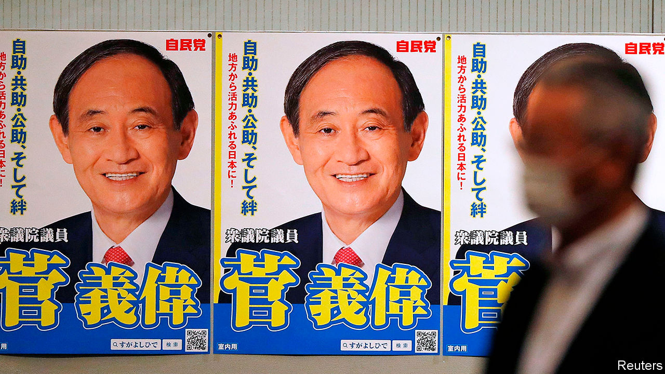

HISTORICAL ROLE models say a lot about political leaders. Suga Yoshihide’s is Toyotomi Hidenaga, the younger brother and right-hand man of Toyotomi Hideyoshi, the better-known warlord who united Japan in the 16th century. As Abe Shinzo’s loyal chief cabinet secretary for nearly eight years, Mr Suga played a similar behind-the-scenes part, excelling at mobilising Japan’s sprawling bureaucracy. Despite his powerful position, he was unrecognisable to many voters until last year when he revealed the name of Japan’s new imperial era, earning the moniker “Reiwa Ojisan”, or Uncle Reiwa.

Following Mr Abe’s resignation due to ill health on August 28th, Mr Suga has taken centre stage. “Now I am aiming for Hideyoshi,” he told a chapter of the ruling Liberal Democratic Party (LDP) during the brief campaign to replace Mr Abe as party leader. On September 14th he won a resounding victory in the LDP’s internal contest, collecting 377 of the 535 possible votes. Two days later he was sworn in as Japan’s 99th prime minister. Promising continuity and stability amid the covid-19 pandemic, he secured the support of party heavyweights. More than half of his cabinet are holdovers from the Abe administration; the newcomers include Mr Abe’s brother, Kishi Nobuo, as defence minister.

Although Mr Suga and Mr Abe’s fates have long been intertwined, their paths to power could not be more divergent. Mr Abe is a princeling, the son of a foreign minister and the grandson and great-nephew of prime ministers. Mr Suga is the son of a farmer and a schoolteacher from Akita prefecture, a rural backwater in the north of Japan. He is the first LDP leader since the party’s founding in 1955 who does not belong to any faction. He is also the first in nearly 30 years who did not inherit his seat in parliament from a relative.

After leaving home for Tokyo, Mr Suga first worked in a cardboard factory. He entered politics as a secretary to a politician in Yokohama, and eventually rose through the city council to the national Diet.

Those backgrounds also shaped the two leaders’ priorities. Mr Abe’s mission was reviving Japan’s standing on the world stage and revising Japan’s constitution to legalise its armed forces. He saw his plans for economic revival as a means to those greater ends. For Mr Suga, economic revival is a goal unto itself. As chief cabinet secretary, he pushed for more competition in agriculture and telecoms, advocated free-trade agreements and worked to stimulate inbound tourism. He also championed measures to admit more foreign workers. “His passion is on the domestic side,” says Gerald Curtis of Columbia University.

Mr Suga will need all the passion he can muster. Mr Abe imbued Japan’s economy with dynamism after decades in the doldrums. But covid-19 has set it back and deflationary fears have returned. Mr Suga promises to stick with “Abenomics”, including expansionary monetary policy and fiscal stimulus. Yet the Bank of Japan has little room for manoeuver left. So the “third arrow” of structural reform will become ever more essential, says Muguruma Naomi of Mitsubishi UFJ Morgan Stanley Securities, a financial joint venture.

Along with curbing the pandemic, that will be Mr Suga’s mission as prime minister. “I don’t think he will use the expression ‘third arrow’,” says Niinami Takeshi, CEO of Suntory Holdings, a giant drinks company, and an adviser to the government. “But he will work on deregulation and structural reforms.” The mix might include measures to boost workers’ productivity, digitise government services and improve co-ordination between ministries.

Such changes will face fierce resistance. Success will depend on Mr Suga’s ability to manage three challenges. First is the outside world. Mr Suga has shown little interest in foreign affairs, an area where Mr Abe shone. Second is his own party. Not belonging to a faction may afford Mr Suga some flexibility. But it may also leave him vulnerable to intraparty machinations if he stumbles, especially as next year’s LDP election draws closer. Third is the public. Mr Suga lacks charisma and has a combative relationship with the media.

Mr Suga has sought to shape a new image, emphasising his hardscrabble life story and his fondness for pancakes. “As the eldest son born on an Akita farm, I want to cherish rural regions,” he declared in his first press conference as prime minister. His chance to forge a new compact with voters may come sooner rather than later. The Diet’s mandate lasts until next autumn, but talk of an early election is rampant. It would be a perilous move amid the pandemic. But it would also be a statement that Mr Suga is ready to leave the shadows and embrace the limelight. ■

This article was downloaded by calibre from <https://www.economist.com/asia/2020/09/19/suga-yoshihide-japans-new-prime-minister-promises-continuity>

|  |  |  |  |
| --- | --- | --- | --- |
|  | Articles | Sections | Next |

|  |  |  |  |
| --- | --- | --- | --- |
| Previous | Articles | Sections | Next |

#### When will the real talks begin?

# As America draws down it troops, Afghans clear their throats

The two sides have yet to grasp the heart of the matter

Sep 19th 2020 |

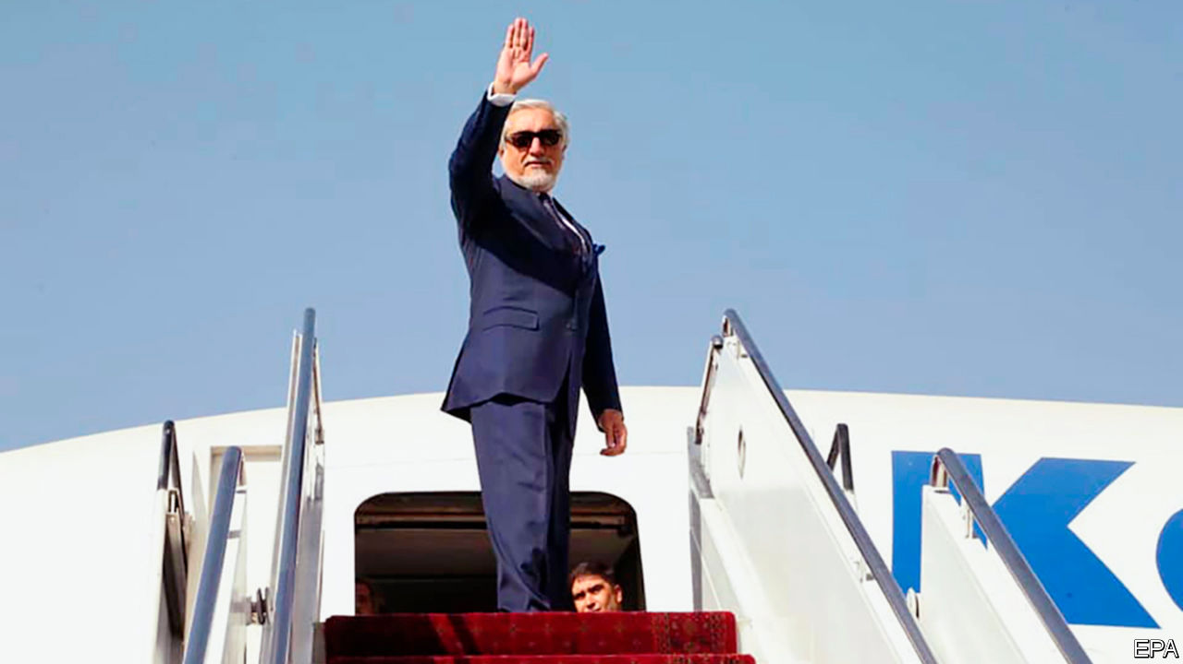

AFTER SIX months of intransigence and delay, the Taliban and Afghan government leaders at last sat down together on September 12th in Doha, the capital of Qatar, to seek an agreement on how to run their country. An accord in February between America and the Taliban mainly concerned the promised withdrawal of American troops by next May, as long as the Taliban guarantees not to harbour terrorists like al-Qaeda.

The Afghan government was not part of that deal. The talks that have just begun will focus on the shape of the country once the Americans have gone. Grievance and bloodshed have mounted over the four decades since a coup overthrew the monarchy in 1978. Millions have been displaced and hundreds of thousands killed. The meddling of foreign powers has made matters much worse. “The current conflict has no winner through war and military means,” said Abdullah Abdullah (pictured), the head, in effect, of the government’s negotiating team. “But there will be no loser if this crisis is resolved politically and peacefully through submission to the will of the people.”

Both sides were on their best behaviour as the talks opened in a plush hotel ballroom. Opponents greeted each other like old friends. General Austin Miller, commander of NATO forces in Afghanistan and a past target of Taliban assassins, exchanged pleasantries with his foes. Some saw hints of a less fractured country, as Masoom Stanekzai, leading the government team, and Sher Muhammad Abbas Stanekzai, the Taliban’s deputy chief negotiator, hail from the same tribe and province.

The sessions began gently, setting ground rules and an agenda. Both sides called for patience and warned against spoilers trying to sabotage the talks. The government’s priority is a ceasefire. Scores of civilians are being killed and wounded every week. Hopes that violence would subside after America’s deal with the Taliban were dampened in the summer. A study by the Afghanistan Analysts Network, a research group, found that both sides have become more restrained in proclaiming offensives; more attacks are occurring without claims of responsibility. The killing, however, has been largely undiminished. Violence is the Taliban’s biggest bargaining chip, so they will be loth to give it up. They know that force of arms is what has won them a seat at the negotiating table.

At some point the thorniest issues must be tackled. How should the country be governed? How to allocate power? What rights will be enshrined in a constitution? These issues may take months, if not years, to resolve. The Taliban have given little detail of what they want. Mullah Abdul Ghani Baradar, their deputy leader, merely declared in the opening ceremony that his side wanted “a free, independent, united and developed country...with an Islamic system in which all tribes and ethnicities find themselves without any discrimination and live their lives in love and brotherhood.”

Pressed on women’s rights, the Taliban have previously said only that they will be protected under Islam. Such vagueness has not reassured many Afghan women. After all, the Taliban claimed to protect them in the 1990s while forbidding them to work or go to school. Now they must spell out how far they have shifted from their fundamentalism. Rifts may emerge between moderate factions and doctrinaire stalwarts who want to restore their former “emirate”. Nor has the Afghan government submitted many details. Ashraf Ghani, the president, has merely called for “a sovereign, democratic and united republic”.

The talks are behind closed doors, without foreign officials. America, as the Afghan government’s main backer, still looms large, but its influence is waning and changing. The delays in getting the talks going plus intelligence that the Taliban are still chummy with al-Qaeda could have given President Donald Trump an excuse to slow his troop withdrawal. But the number fell from 13,000 in February to 8,600 in June—and is expected to fall to 4,500 before the American presidential election in November, letting Mr Trump tell voters he has kept his promise to end the war. His opponent, Joe Biden, is not keen on America’s Afghan venture either. The GIs are clearly on their way out—but it is not clear what they are leaving behind. ■

This article was downloaded by calibre from <https://www.economist.com/asia/2020/09/19/as-america-draws-down-it-troops-afghans-clear-their-throats>

|  |  |  |  |
| --- | --- | --- | --- |
| Previous | Articles | Sections | Next |

|  |  |  |  |
| --- | --- | --- | --- |
| Previous | Articles | Sections | Next |

#### Aggrieved Parti

# A domestic worker takes on her Singaporean boss—and wins

A rare victory in court reveals a rotten system

Sep 19th 2020 |

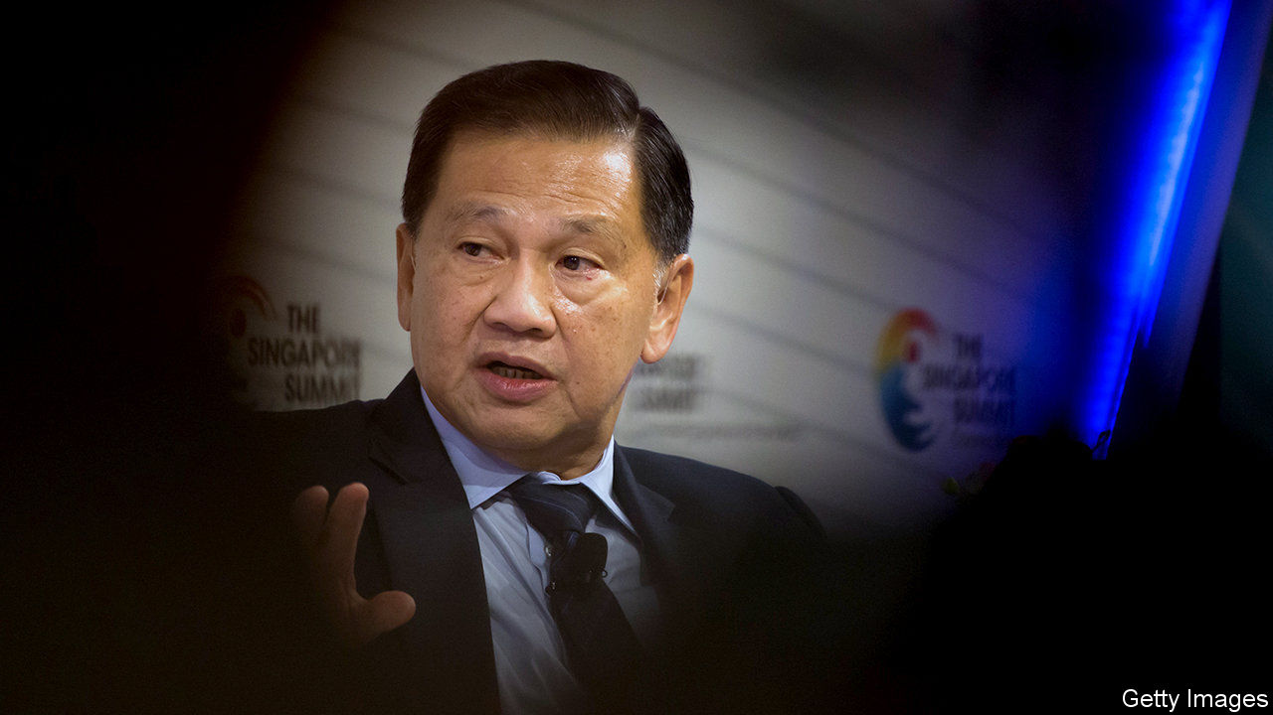

THE CASE should have been thrown out. The police investigation was botched. The accuser’s testimony was riddled with inconsistencies. But on March 20th last year Parti Liyani, an Indonesian maid accused by her Singaporean employer of attempted theft, was convicted and sentenced to 26 months in jail. That is where she would be now, were it not for her successful appeal to the High Court—a rare feat for a foreign domestic worker. On September 4th she was acquitted by Justice Chan Seng Onn, whose ruling declared her employer’s motive for filing charges “improper” and reminded the lower-court judge “that an accused person is presumed innocent” until proven otherwise.

The ordeal began in 2016, when Ms Liyani was summarily sacked by Karl Liew, the son of Liew Mun Leong, her employer and a powerful figure in business who, among other things, was chairman of the state-owned Changi Airport Group. Ms Liyani threatened to inform the Ministry of Manpower (MOM) that the Liew family had broken the terms of her contract by having her regularly clean Karl’s home and office. She was escorted from the premises before she could finish packing. The next day the Liews claimed that they found $50,000-worth of their stuff in Ms Liyani’s boxes.

The police issued a warrant for Ms Liyani’s arrest, but did not visit the scene of the crime for over a month and did not seize the evidence for more than a year. The trial judge disregarded such irregularities and imposed a greater burden of proof on the defendant than on the plaintiffs, according to Justice Chan. He ruled that the prosecution “failed to dispel the reasonable doubt raised by the defence”, who argued that the Liews framed Ms Liyani to stop her from reporting them to the MOM.

The police, the MOM and the attorney-general’s chambers are reviewing their handling of the case. On September 10th the elder Mr Liew resigned from his public posts. That will be small comfort to the 260,000 foreign domestic workers in Singapore. A quarter of those assisted over the past three years by HOME, a charity, say they have been illegally deployed. But most do not know their rights, rely on the goodwill of their employers to remain in the country and cannot afford legal fees. Those who do complain sometimes face retribution. It is “a known defensive measure”, Ms Liyani’s lawyer said in court, for employers to try to silence aggrieved maids with false accusations. Ms Liyani knows that all too well. She has been out of work since she was fired by the Liews. ■

This article was downloaded by calibre from <https://www.economist.com/asia/2020/09/19/a-domestic-worker-takes-on-her-singaporean-boss-and-wins>

|  |  |  |  |
| --- | --- | --- | --- |
| Previous | Articles | Sections | Next |

|  |  |  |  |
| --- | --- | --- | --- |
| Previous | Articles | Sections | Next |

#### Koalition politics

# Koalas almost bring down an Australian state government

The disagreement does not bode well for the country’s oldest political alliance

Sep 19th 2020 | SYDNEY



EVERYONE LIKES koalas. Lots of people worry about their dwindling numbers. When fires tore along Australia’s east coast last summer, some humans risked their lives to rescue them. Strange, then, that a dispute about their conservation almost blew up a harmonious coalition government in New South Wales.

Its two contingents, the Liberals and the Nationals, have governed in a conservative partnership for generations. This falling out was triggered by an obscure policy which makes it somewhat harder for landowners to cut down trees in which koalas might live. The rules came into force months ago and greens view them as far too weak. But to the Nationals, who represent farmers, they are “the epitome of overbearing bureaucracy”.

On September 10th their leader in the state, John Barilaro, announced that his MPs would stop voting with the state government until the policy was pared back. That would have left the Liberals in the minority in the state assembly. The mutiny crumbled when the premier, Gladys Berejiklian, threatened to strip the Nationals of their ministries. But the underlying problems persist.

As a pair, the Liberals and Nationals win more elections than the opposition Labor party. But support for the Nationals is waning. Their rural strongholds are scorched by drought and compete with one another for water from near-dry rivers. Many supporters feel ignored. Populists have exploited these frustrations for years. The latest threat comes from the prosaically named Shooters, Fishers and Farmers Party.

Mr Barilaro’s answer is to shout more loudly that “we cannot allow city-centric politics to dictate our way of life in the bush”. Rural Australians have never liked being preached to about the evils of felling trees and the like. But concerns about such things are growing in more populated, suburban Liberal-voting areas. Neither side can win elections alone. But it is getting harder, says Paul Williams of Griffith University, “to maintain the façade of a happy marriage”.

This article was downloaded by calibre from <https://www.economist.com/asia/2020/09/19/koalas-almost-bring-down-an-australian-state-government>

|  |  |  |  |
| --- | --- | --- | --- |
| Previous | Articles | Sections | Next |

|  |  |  |  |
| --- | --- | --- | --- |
| Previous | Articles | Sections | Next |

#### No island is an island

# Referendums in the Pacific are attracting attention faraway

France, China and Taiwan are all involved

Sep 19th 2020 | WELLINGTON

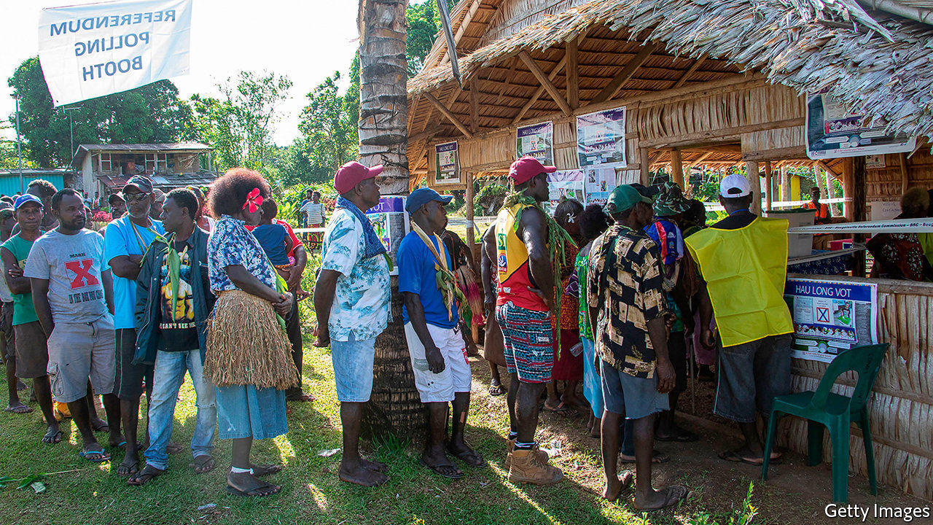

TESTING THE popular will does not come naturally to Melanesian governments. Policy decisions are normally taken behind closed doors, away from the prying eyes of the general public. That may now be changing. New Caledonia, still a French possession, and Bougainville, an island at the eastern end of Papua New Guinea (PNG), held referendums on independence in 2018 and 2019. New Caledonia will hold a second such vote on October 4th. Enthusiasm for direct democracy is becoming infectious. The premier of tiny Malaita, the most populous province in the Solomon Islands, now wants to hold his own referendum on secession in protest against his national government’s overtures to China.

Bougainville’s 250,000 people are in the midst of their first election since the referendum of 2019, when 97.7% voted for independence. But that vote was non-binding, requiring only that the PNG government open negotiations on the island’s future status. PNG’s prime minister, James Marape, is adamant that Bougainville lacks the economic clout to survive as an independent state. Bougainville once boasted one of the world’s largest copper mines, but it was closed down in the civil war of 1988-97, leaving the island devoid of profitable exports. The front-runner in the contest to lead its autonomous government, Ishmael Toroama, once commanded the Bougainville Revolutionary Army, which fought bloodily for independence from PNG in the early 1990s.

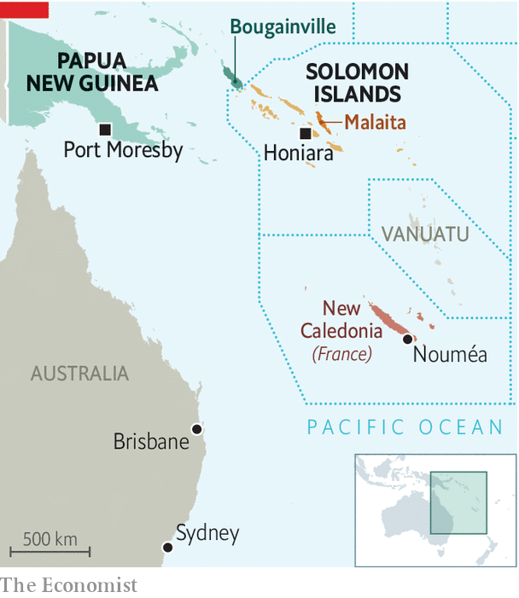

Whereas Bougainvilleans opted emphatically for independence, New Caledonians voted against it in 2018, by 57% to 43%. That was the first of three scheduled referendums on whether to split from France, the territory’s colonial ruler since 1853. Since then, fervent French loyalists have regrouped, taking control of the local government. The French government is not neutral. It has let loyalists hoist the French tricolour on the campaign trail. On a visit to the territory in 2018, President Emmanuel Macron waxed lyrical about the vast stretches of the Pacific that remain a part of France.

Geostrategic rivalries are shaping Oceania’s local struggles. The Solomon Islands shifted diplomatic recognition from Taiwan to China last year. Malaita’s premier, Daniel Suidani, rejected that switch, condemning China for its communism and atheism. Despite the border being closed against covid-19, a direct flight from Guangzhou arrived on September 2nd, carrying Chinese workers hired to prepare facilities for the Pacific Games in 2023. “We will be closing access to Malaita,” Mr Suidani declared angrily, promising at the same time to shut down stores run by ethnic Chinese on the island.

Taiwanese diplomats stirred the pot by meeting Malaitan officials in Australia in March. Since then Taiwan has sent consignments of surgical masks, bags of rice and thermal-imaging equipment. Whether or not they are independent, the islands of the Pacific will not be insulated from big-power rivalry. ■

This article was downloaded by calibre from <https://www.economist.com/asia/2020/09/19/referendums-in-the-pacific-are-attracting-attention-faraway>

|  |  |  |  |
| --- | --- | --- | --- |
| Previous | Articles | Sections | Next |

|  |  |  |  |
| --- | --- | --- | --- |
| Previous | Articles | Sections | Next |

#### Banyan

# Asia’s migrant workers are having a rough time under covid-19

An already ill-treated class is all but abandoned by authorities

Sep 19th 2020 |

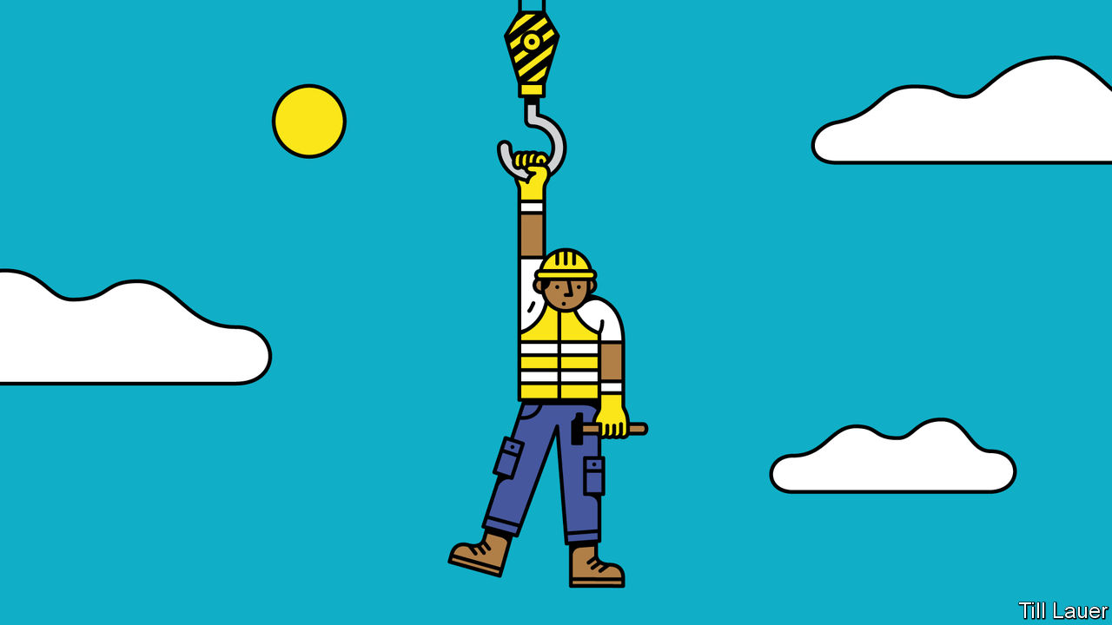

THE 200-ODD Bangladeshi and Indian men engaged to build a new resort on Baa atoll in the Maldives were becoming increasingly desperate. Since covid-19 closed the island nation to tourists in March, migrant workers had been forced to work without pay. They were living in cramped, squalid conditions and were short of food, clean water, medical attention and even soap. In May they aired their grievances in a silent protest. In a confused event a while later, they briefly took a few locals hostage—apparently believing they were mobsters sent to threaten them. In July they took their protests to the capital, Malé. The authorities’ response? To brand the workers a threat to national security and deport dozens of them. They were at least able to return home.

The Maldives has perhaps 230,000 legal and illegal foreign workers, or nearly one for every two Maldivians. Many have their passports confiscated by employers, have to pay exorbitant fees to employment agencies or are, in effect, trafficked, with no clear knowledge of whom they are working for. Now, thanks to the pandemic, they have lost their jobs or are denied pay.

Across the Asia-Pacific region, which is the world’s biggest supplier and user of foreign migrant labour, the details vary, but the general picture is depressingly familiar. Asia’s 33m-plus migrants—those who build the gleaming cities and resorts, clean and cook for the growing middle classes, and keep a billion toilets clean—lead lives that were hard before the pandemic. (One Filipina domestic helper in Hong Kong whom Banyan knows was forbidden a day off for a month because she shrank her boss’s designer T-shirt in the dryer.) They have become only more precarious.

Most Asian states like their foreign workers to be out of sight when they are not doing something useful. In Singapore 323,000 labourers, most from South Asia, are housed in dormitories on the edge of town. Early in the pandemic the government soaked up praise for its deft handling of covid-19. But it had a blind spot: the crowded dorms. Soon, the virus was spreading fast among foreign workers, who now account for 94% of nearly 58,000 cases in the city-state.

At least the authorities were quick to test foreign workers and to improve their conditions. Workers have been given Wi-Fi, extra food and medical attention. In neighbouring Malaysia the picture is bleaker. The country has 4m-6m regular and irregular migrant workers, notably from Indonesia, Myanmar and Bangladesh. Huge numbers lost their jobs as malls, factories and construction sites closed. Under Malaysia’s “movement control order” the army barricaded a vast area around the Selayang wholesale market on the edge of the capital, Kuala Lumpur, locking in thousands of migrant workers, refugees and potential asylum-seekers who had found work there. Conditions in Malaysia remain appalling, with many migrants sleeping in shifts in plywood shanties. The government has given little aid to migrants, a bedrock of the economy. Nor have cash-strapped embassies been much help. “In Singapore,” says Alex Ong, of Migrant Care, an NGO, “at least they have beds.”

As economies open up, conditions are improving. At the peak, Migrant Care was distributing food to 2,300 migrants. Now it is feeding fewer than 100, mainly mothers and small children. Work is returning: for instance, global demand for Malaysian-made rubber gloves is booming. But returning, too, is labour abuse. Factory bosses are forcing foreigners to work excessive hours without breaks. Meanwhile, millions of migrant workers remain in Kafkaesque limbo. Many who are still unable to find work also struggle to return home, because of closed borders, an absence of transport routes or a lack of money. That puts them, unwittingly, on the wrong side of the law as residency permits expire.

Back in the Maldives, there is perhaps a bright spot. The police have accused the company that recruited the protesting workers, which is owned by a local MP, of trafficking and other labour abuses. In Malaysia Mr Ong says the recovery provides a “golden opportunity” to overhaul the system of recruitment of migrant workers, and especially to do away with politically connected operators. These grow fat securing government quotas for workers whom they, in effect, sell on to employers in need of them. One of the worst abuses of the colonial era in Asia was the coolie system of labour. But contemporary Asian governments preside over something eerily similar.

Editor’s note: Some of our covid-19 coverage is free for readers of The Economist Today, our daily [newsletter](https://my.economist.com/user#newsletter). For more stories and our pandemic tracker, see our [hub](https://www.economist.com/news/2020/03/11/the-economists-coverage-of-the-coronavirus)

This article was downloaded by calibre from <https://www.economist.com/asia/2020/09/19/asias-migrant-workers-are-having-a-rough-time-under-covid-19>

|  |  |  |  |
| --- | --- | --- | --- |
| Previous | Articles | Sections | Next |

|  |  |  |  |
| --- | --- | --- | --- |
| Previous | Articles | Sections | Next |

#### Two-timing

# As Bangladesh’s relations with India weaken, ties with China strengthen

But the government is keen to string both Asian giants along

Sep 19th 2020 |



SYLHET, A CITY in north-eastern Bangladesh, is some 50km from the border with India. But when the government awarded a $250m contract in April to build a new airport terminal in the city, the Indian bidder lost out to a Chinese firm, the Beijing Urban Construction Group. In June China granted duty-free access to 97% of Bangladesh’s exports. And this month Bangladesh, seemingly despairing of a decade-long negotiation with India on a water-sharing pact for the Teesta river, asked China to finance a $1bn water-management project instead.

Bangladesh came into being thanks in part to India: in 1971 its army intervened on the side of separatists battling the Pakistani army in what was then East Pakistan. Ever since, ties between the two countries have been close. But many Bangladeshis have come to see India as a patronising and presumptuous ally. “They don’t really believe that we are independent,” says a Bangladeshi journalist. “They interfere in everything. They think our bureaucrats work for them.” The various anti-Muslim policies of the current Indian government have exacerbated misgivings in Bangladesh, which is 90% Muslim.

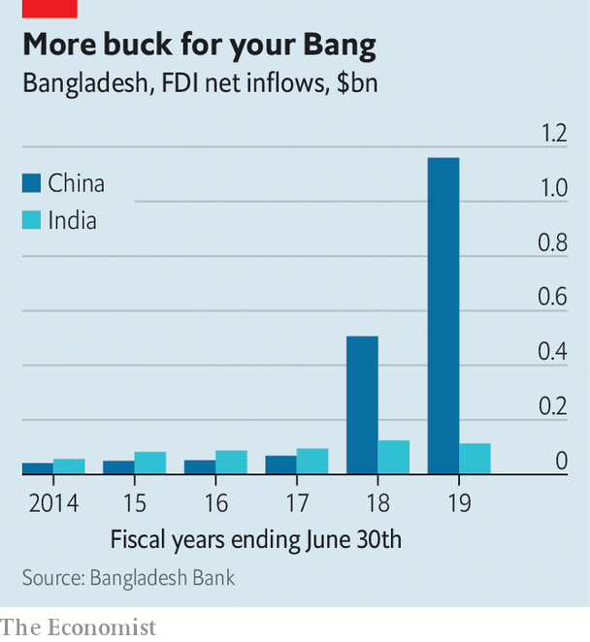

Cue a Chinese charm offensive. China has built seven “friendship bridges” in Bangladesh in recent years. In 2018 it supplanted India as the country’s biggest source of foreign investment (see chart). It is also Bangladesh’s biggest trading partner. On a state visit in 2016 Xi Jinping, China’s president, promised to spend more than $20bn on 27 infrastructure projects. “Chinese businesses are all over infrastructure development, power and telecoms,” says Zahid Hussain, a former lead economist with the World Bank in Bangladesh.

As well as deep pockets, China has fewer scruples than most Western benefactors, notes Ali Riaz of Illinois State University. In 2013 Bangladesh rejected a $1.2bn loan from the World Bank to finance a bridge spanning the Padma river, after the bank started investigating accusations of corruption. China stepped in.

The number of Bangladeshis studying in China has grown exponentially in the past few years, says Mr Riaz. The media, too, is being courted. “Seventy percent of the journalists at my paper have been to China,” says a reporter at a financial newspaper, who himself spent ten months in China on a fellowship in 2018. Almost as soon as covid-19 arrived in Bangladesh, so did a team of Chinese doctors sent to help fight the epidemic.

The wooing is working. The Chinese government bullies its Muslims far more systematically than India’s does. It was also slower to grant duty-free access to Bangladeshi goods. Yet China is the target of much less criticism in the Bangladeshi media.

Bangladesh’s government is a little more circumspect. It is wary of becoming too indebted to China, and is careful not to snub India. Narendra Modi, India’s prime minister, had been due to visit in March, until the coronavirus scuppered his trip. Having such a huge and powerful neighbour nonetheless rankles. “India’s policymakers and its press cannot stop incessantly reminding Bangladesh that it is smaller and less important,” says Mr Riaz. “China does not do that.” ■

This article was downloaded by calibre from <https://www.economist.com/asia/2020/09/19/as-bangladeshs-relations-with-india-weaken-ties-with-china-strengthen>

|  |  |  |  |
| --- | --- | --- | --- |
| Previous | Articles | Sections | Next |

|  |  |  |  |
| --- | --- | --- | --- |
| Previous | Articles | Sections | Next |

#### Covid? What covid?

# A real-life Bollywood tragedy becomes a political farce

A fallen star. A villainous girlfriend. An outspoken heroine. Inept cops. Three-letter agencies. It’s a blockbuster

Sep 17th 2020 |

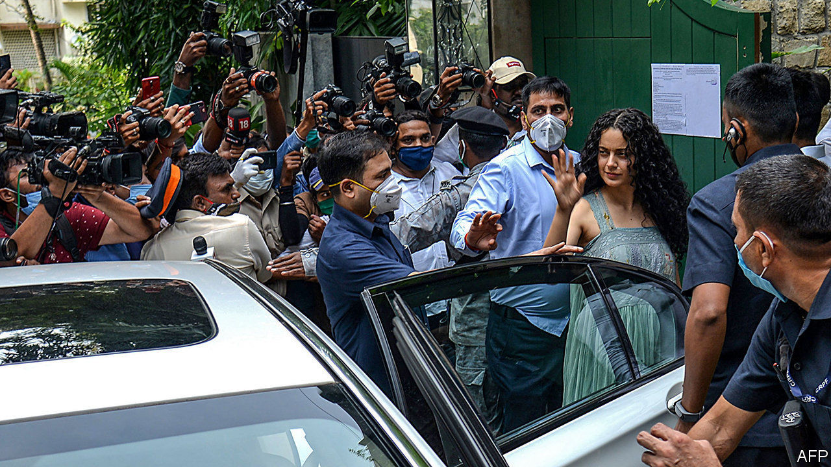

WHAT STORY should top the news? That covid-19 cases are rising by nearly 100,000 a day? That the economy shrank by a shocking 23.9% last quarter? Or perhaps that an increasingly bellicose China is massing troops on the border? No! Even with the darkest prospects in decades looming over India’s 1.3bn people, the spotlights of its main TV news channels have in recent weeks focused instead on the private lives of a clutch of Bollywood stars.

This great distraction began on June 14th, when the body of Sushant Singh Rajput, a 34-year-old actor, was found in his flat in Mumbai. The suicide provoked a media frenzy. Mr Rajput’s rise from the obscurity of Bihar, India’s poorest state, to screen fame as the hero of a biopic about a revered cricket captain was itself a filmi tale. His apparent slide into depression raised just the kind of questions about the underside of the film industry that India’s raucous chat shows and gossipy social media love to chew over.

Yet when an ambitious actress and members of Mr Rajput’s family began to air charges that the actor had been corrupted by an entourage of drug pushers, fleeced of his earnings and perhaps even driven to kill himself, the story took on a sinister hue. The more sensationalist news channels trained their sights on Rhea Chakraborty, a 28-year-old actress and Mr Rajput’s girlfriend, turning her into the villain of the piece. Politicians, too, swiftly spotted opportunities.

State elections in Bihar, to be held before December, represent the biggest political test for Narendra Modi, the prime minister, and his Bharatiya Janata Party (BJP) since this year’s multiple crises began. The state is India’s third most populous, and is famed for the caste-infected complexity of its politics. The party’s strategists appear to have seen the actor’s suicide as a chance to pose as upholders of rustic Bihari virtue in contrast to the wickedness of Mumbai.

There are political stakes in the big city too. Promoting Kangana Ranaut, the actress who spoke out about celebrity drug culture, as a paragon of virtue, the BJP and its media toadies raised a ruckus about the supposed ineptitude of the city’s police. The subtext is that, since elections last year, Mumbai and its surrounding state of Maharashtra have been controlled by a coalition that includes former ideological allies and now bitter opponents of the BJP.

The Supreme Court waded into the affair, ordering the Central Bureau of Investigation, a national agency, to take over the Rajput case. Two more federal bodies, the Enforcement Directorate, which combats financial crimes, and the Narcotics Control Bureau (NCB), have launched their own investigations. The drug enforcers have been the fastest to concoct a case, arresting some 18 people, including Ms Chakraborty. She and her brother, also arrested, have been denied bail.

Mr Rajput’s relations have cheered the swift action. Yet to many, the campaign smacks of mob justice. And, just as Biharis are being told to take umbrage over Mr Rajput’s demise, many people in Ms Chakroborty’s home state of West Bengal have been disgusted by her persecution. The BJP is determined to wrest that state from opposition control in an election next year. Its strategy in the Rajput affair has certainly diverted public attention from the real and numerous problems facing India. But Mr Modi may come to regret its impact on Bengali voters. The drama, as Bollywood fans like to say, is not over yet. ■

This article was downloaded by calibre from <https://www.economist.com/asia/2020/09/17/a-real-life-bollywood-tragedy-becomes-a-political-farce>

|  |  |  |  |
| --- | --- | --- | --- |
| Previous | Articles | Sections | Next |

|  |  |  |
| --- | --- | --- |
| Asia | Sections | United States |

China

Wuhan’s recovery: Washing away the tears

.

Social class: The landlords are back

.

Chaguan: The politics of poverty

.

|  |  |  |
| --- | --- | --- |
| Asia | Sections | United States |

|  |  |  |  |
| --- | --- | --- | --- |
|  | Articles | Sections | Next |

#### Washing away the tears

# The bruised city of Wuhan has become a showcase for China

Despite their outrage early in the pandemic, many of its citizens now accept the party line

Sep 19th 2020 | WUHAN

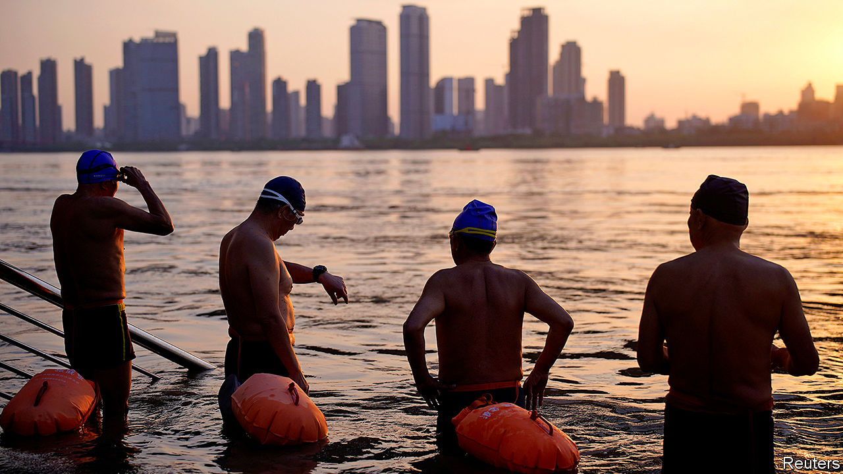

Editor’s note: Some of our covid-19 coverage is free for readers of The Economist Today, our daily [newsletter](https://my.economist.com/user#newsletter). For more stories and our pandemic tracker, see our [hub](https://www.economist.com/news/2020/03/11/the-economists-coverage-of-the-coronavirus)

IN A CANDID online diary of life under quarantine, Fang Fang, a celebrated author living in Wuhan, recorded her worry that residents’ memories of the agony would fade too quickly. “We can’t let the sadness of the situation consume us,” she wrote on day 12 of the city’s lockdown. But, she added, “I just hope we can remember...those who suffered a wrongful death, remember these grief-stricken days and sorrowful nights, remember just what it was that interrupted our lives...”

Less than six months after Wuhan emerged from a gruelling 76-day lockdown, only the heartless would deny its people the chance to celebrate and relax. The central city, where covid-19 was first detected and 3,869 died with the coronavirus—four-fifths of the country’s total covid-related death toll—has recorded no cases since mid-May. That month a tiny flare-up led to a vast drive to screen Wuhan’s 11m residents within two weeks—an example of China’s mass-campaign approach to the epidemic that has proved effective, even if harsh.

The testing helped boost confidence. Revellers now throng shopping streets and spill out of karaoke joints. The carefree doff their masks in the open air. Swimmers take dips in the Yangzi river, which bisects Wuhan (in July residents were in terror of another disaster: widespread floods). Visitors pack the city’s famous Yellow Crane Tower. “They all think Wuhan is a city of heroes and want to come and see us,” beams Zhang Hanye, a tourism worker. A survey by an official think-tank in late April—soon after the lockdown was lifted—found that Wuhan was China’s most popular destination, up from eighth before the virus hit.

All this is propaganda manna for China’s government, which early in the pandemic was widely criticised even within China for silencing doctors in Wuhan who had warned of a new virus, and for bungling its initial response. When images spread last month of thousands of people at a music festival at a water park in Wuhan—cheek-by-jowl and maskless—Global Times, a state mouthpiece, crowed that it was “never too late to learn from Wuhan”.

This month the Chinese People’s Association for Friendship with Foreign Countries, a state-linked body, hosted the bosses of 20 multinational firms on a highly choreographed, three-day tour of the city. The trip’s aim, in the words of Lin Songtian, the association’s president, was to “witness the full recovery of Wuhan”.

The itinerary included a makeshift hospital—now emptied of beds and equipment—a fancy supermarket (billed as a “wet-market 3.0”) and an elite primary school. Those interviewed gushed with praise for the Communist Party. Liu Tiezhu, a district official, showed off a mobile hospital that was converted from a wedding venue. He said covid-19 had made everyone realise that “the people cannot pull through without the party”.

Such cheer is shared by many ordinary citizens. A 50-year-old driver, who served in a fleet that ferried doctors, food and medicine during quarantine, described the decision-making of Xi Jinping, China’s leader, as “remarkable”. Young volunteers at a lakeside jog arranged for the visitors said they were “chill” about the risk of a second wave. As they pressed colourful “Wuhan, we can” tattoos onto the arms of passers-by, they repeated a new catchphrase: “Wuhan is the safest place now.” Philippe Klein, a French doctor who stayed in Wuhan during lockdown, says many people in the city want to “forget that we were at the origin of the disaster”. A young father sums up a commonly held feeling: “Why think of the unpleasant?”

The instinct to move on has been shrewdly exploited by the state’s relentless spin doctors. In the officially sanctioned narrative Li Wenliang, a doctor who was harassed by police for sounding the alarm about covid-19 before dying of it, is now a fallen patriot. The party’s belated and grudging embrace of him has defused much of the public anger that once surrounded his demise. Zhang Hai, a local whose father died of covid-19, has abandoned a crowdfunded project to build a memorial to Wuhan’s victims—calling it “too difficult” (police had questioned him).

Amid America’s fumbling of the pandemic, Chinese are readier to accept the party line. Fang Fang, the 65-year-old online diarist (her real name is Wang Fang), was soon vilified by state media for exposing only the “dark side”. Despite her millions of online followers, readers turned against her in startling numbers. One critic is a 28-year-old student counsellor at one of Wuhan’s universities, who says that Fang Fang’s “negative information” does not “do much good to the public psyche”.

The mood of Wuhan’s citizens was a topic that Fang Fang turned to repeatedly in her diary. She wrote of a “strange, unspeakable stress” in the city during lockdown. On day 40, in early March, she wrote that residents were “reaching their psychological breaking point”. Elsewhere she noted that everyone had been “traumatised” by the outbreak. “Looking back, none of us feel lucky, we just feel like survivors.”

She is right that the city was scarred. One destination for the bosses was Tongji hospital, which has set up a recovery unit for covid-19 survivors with mental-health conditions and other after-effects. The hospital’s director confirmed that some who had avoided covid-19 were also coming in with signs of depression. He would not give numbers. The visitors were shown only the entrance hall and were stopped from speaking to staff or patients.

At Changchun primary school the group was shown how pupils were being encouraged to draw as a way of coping with trauma. A display of their artwork evinces a strong preference for catharsis-by-patriotism. In one painting, a smiling Mr Xi looks down on Wuhan, with the line: “In the battle against the epidemic, Grandpa Xi is with us.” There are numerous portraits of Zhong Nanshan, a lung doctor picked by the party to deliver the news that the virus was spreading between people. There is also one of the whistleblower, Li Wenliang.

Amid the elation, there are signs of fear and suffering. Few people are willing to give their names to foreign journalists. It is hard to overlook still-darkened shops with for-sale signs. Daily metro trips are still only three-quarters what they were last September. An engineer in his mid-30s, living in one of the districts that was hardest hit, says he has stockpiled masks at his home. “You have to be prepared,” he says quietly. In public, this is a city raring to go. Privately, many in Wuhan may recall Fang Fang’s words of warning: “We still have many more tears left to cry.” ■

This article was downloaded by calibre from <https://www.economist.com/china/2020/09/19/the-bruised-city-of-wuhan-has-become-a-showcase-for-china>

|  |  |  |  |
| --- | --- | --- | --- |
|  | Articles | Sections | Next |

|  |  |  |  |
| --- | --- | --- | --- |
| Previous | Articles | Sections | Next |

#### The landlords are back

# The families of China’s pre-Communist elite remain privileged

The old elite suffered under Mao, but their descendants are prospering

Sep 19th 2020 | BEIJING

THESE DAYS the Chinese Communist Party prefers to play down the horrors unleashed by Mao Zedong’s Cultural Revolution of the 1960s and 1970s. But a rare chronicle of the period by a writer based in China, “The World Turned Upside Down”, describes the chairman’s harsh campaign to reorder Chinese society in vivid detail. (An English version will be published in January; like the Chinese original, it will be banned in mainland China.) The title of Yang Jisheng’s book well conveys the experience of those who enjoyed privilege in the pre-Communist era, who were brutally persecuted under Mao.

The old elite began to suffer almost as soon as the Communist Party won the Chinese civil war in 1949. China’s new rulers quickly set about seizing land from people in the countryside, redistributing it among the landless, confiscating private businesses and executing many rural landlords and people who had worked for the overthrown Nationalist regime. The Cultural Revolution appeared to be the nail in the coffin of an entire social class.

But in a working paper titled “Persistence through Revolutions”, a group of scholars based in America, Britain and China find that Mao’s social re-engineering had a less lasting impact than might be supposed. The grandchildren of the pre-Communist elite have largely regained the status their families once enjoyed. They are a lot more educated and wealthy than other households. Their values and attitudes also differ from the descendants of those who had lower social standing before 1949. They are less bothered by inequality, more entrepreneurial, more pro-market, and more inclined toward individualism and a belief in success through hard work.

Led by Alberto Alesina of Harvard University (who died in May), the academics mined data from household surveys, census reports and land records. They found that by 2010 the incomes of descendants of the pre-Communist elite were 16-17% higher than those born into families that were underprivileged before 1949. They were also more likely to have completed secondary and tertiary education. They performed significantly better in maths tests.

The scholars offer several possible explanations for the relatively swift restoration of advantage to the old elite. Hidden wealth—hoarded by relatives outside mainland China—may have helped. But more important was the enduring strength of family networks inside the country. The rebound of wealth among descendants of the former elite, the scholars write, has been found almost exclusively in villages with a strong clan-based social structure (there are many such in China). The researchers suggest that despite the upheavals of the Mao era, parents were still able to transmit their high-status mindsets to their offspring. Less than 45 years after Mao’s death, the toppled elite have managed to seize society’s summit again.

This article was downloaded by calibre from <https://www.economist.com/china/2020/09/19/the-families-of-chinas-pre-communist-elite-remain-privileged>

|  |  |  |  |
| --- | --- | --- | --- |
| Previous | Articles | Sections | Next |

|  |  |  |  |
| --- | --- | --- | --- |
| Previous | Articles | Sections | Next |

#### Chaguan

# China’s anti-poverty drive is not disinterested charity

It is about transforming people’s thoughts

Sep 19th 2020 |

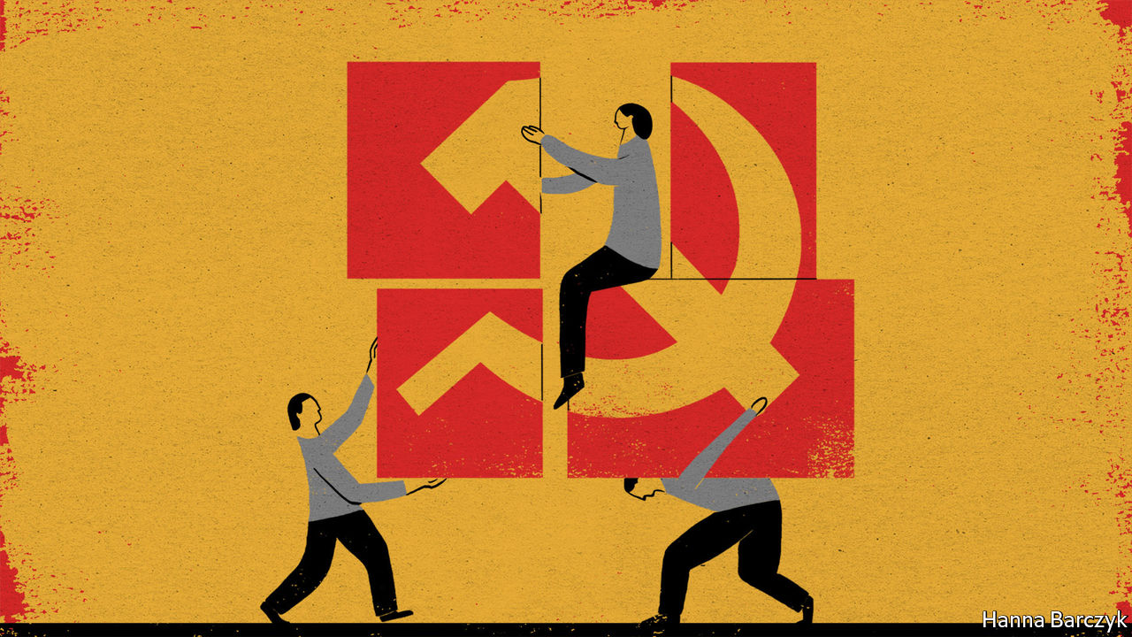

STRIVING TO OBEY an order from President Xi Jinping—namely, that extreme poverty must be eliminated in China by the end of 2020—officials have given many things to Jizi Arimo, a 47-year-old widow and mother of four. Chaguan met Ms Jizi last week in a newly built apartment block in Yuexi, a once-remote rural county in the south-western province of Sichuan.

One way to tell Ms Jizi’s story is with economic statistics. In her old home, high in the mountains, she was officially deemed impoverished. The poverty line varies a bit by region, but is set at around 2,300 yuan ($340) a year. As this year began, roughly 5m Chinese still needed to cross that line for Mr Xi’s promise to be kept. Officials in Sichuan paid the lion’s share of the costs of Ms Jizi’s relocation, and now employ her as a cleaner at her housing complex, paying her 550 yuan a month.

Yet poverty alleviation is about more than numbers. Like much else in Mr Xi’s China, it is also a strikingly political endeavour. Ms Jizi’s home was one stop on a recent government tour of poverty-related work, organised for foreign and domestic journalists. This was not a trip for verifying government claims independently, or for probing reports that some rural folk have been kept off poverty registers by bureaucrats anxious to hit targets. Officials stood over Ms Jizi as she answered questions. Throughout the visit, minders followed journalists who tried to break from the pack.

A frail figure in a checked overcoat and hat, Ms Jizi spoke perched on a sofa, beneath a colour poster of Mr Xi with the caption: “Be grateful to the party. Listen to the party. Follow the party”. A member of the Yi minority, she is hesitant in Mandarin Chinese. To approving nods from officials, she declared: “If it weren’t for General Secretary Xi, I wouldn’t have such a lovely home.” Every flat visited by the press was decorated with the same photograph of Mr Xi. A second poster on display in each apartment featured photographs of residents’ old and new homes, and slogans like “Relocation warms our hearts and we are forever grateful to the party” and “Welcoming a new life with a smiling face”. The whole housing estate is hung with party slogans and banners. Home to 6,660 relocated villagers, its name is “Gratitude Community”.

Ms Jizi’s new home is not exceptional. Other model communities visited on the tour were also plastered with posters praising the party and Mr Xi. The party secretary of Sichuan province, Peng Qinghua, told reporters that encouraging thankfulness was part of poverty-alleviation work. “Conservative and outdated thinking is the root cause of poverty,” he explained. In his telling, the party’s focus on moral education is a unique advantage of socialism with Chinese characteristics. In particular, he charged that the Yi, of whom about 2.5m live in Sichuan, needed to be led away from such “undesirable habits” as paying lavish dowries for brides, or holding extravagant funerals despite “not caring for their elderly parents while they are still alive”. Mr Peng praised party members who lead by example. He paid tribute to officials killed in mountain car-crashes, and told of a party secretary who, rather than quit a rural posting and return to her home city to look after a newly widowed mother, brought her mother to live in the country.

That vision of party members as self-sacrificing, secular missionaries, leading the masses towards more productive lives, comes from the top. State media never tire of showing Mr Xi touring rural areas to inspect the latest cash-generating crops and industries, like an austere but benevolent monarch. Almost four decades ago the countryside was freed from misery by the abolition of collective farms, as Deng Xiaoping, the then paramount leader, allowed peasants to choose which crops to grow and to start their own businesses. In the Xi era officials seem confident, once more, that the government knows best. Technocrats interviewed in Liangshan prefecture, where Ms Jizi lives, deny that they are returning to central planning. They describe a hybrid model harnessing both state resources and market discipline. In many places, villagers are encouraged to rent their small plots of land to agricultural co-operatives, creating larger, more efficient farms which may then employ some of them as herdsmen or to pick crops. Government bodies and state-owned enterprises in the prosperous east are urged to buy Liangshan-grown apples, walnuts or buckwheat tea, as a patriotic duty.

In part, poverty alleviation is an urbanisation scheme. In the past two years alone, nearly 10m Chinese have been physically relocated from rural homes deemed “inhospitable”. Officials say that all choose to move, with only a few older folk struggling to adjust. Some families move to cement-walled houses a short walk from their former homes of wood and mud. Others leave for apartments many miles away. Lots of youngsters head farther afield to work as migrants. The Yi are strong and unafraid of heights, enthuses an official. That makes them sought-after workers when electricity lines need stringing between pylons.

## Coming down from the mountains

Young children learn Mandarin as well as the Yi language in the kindergartens now found in each village, readying them for the workforce. In Liangshan the government is building new boarding schools, some with subsidised books and accommodation. Lin Shucheng, Liangshan’s party chief, is proud of outdoor “night schools” that teach farmers modern agricultural techniques, and village women embroidery and other handicrafts. If the poor are not educated and given incentives to work, he says, they will “sit in the sunshine in a corner, waiting for a government cheque”.

The past should not be romanticised. Not long ago, farmers in Liangshan lived harsh, isolated lives. For all that, poverty alleviation is not an act of disinterested charity. China’s poorest are being integrated into the national economy and trained to thank the party for it. Putting money in people’s pockets is one measure of success. The greater prize is putting ideas in people’s heads. ■

This article was downloaded by calibre from <https://www.economist.com/china/2020/09/19/chinas-anti-poverty-drive-is-not-disinterested-charity>

|  |  |  |  |
| --- | --- | --- | --- |
| Previous | Articles | Sections | Next |

|  |  |  |
| --- | --- | --- |
| China | Sections | The Americas |

United States

Donald Trump’s record: The master’s bidding

.

HBCUs: Historically back

.

Resort towns: The virus in paradise

.

The 2020 campaigns: Following the money

.

Abortion by pill: No scrubs

.

Lexington: Fire and ice

.

|  |  |  |
| --- | --- | --- |
| China | Sections | The Americas |

|  |  |  |  |
| --- | --- | --- | --- |
|  | Articles | Sections | Next |

#### The master’s bidding

# Assessing Donald Trump’s use of the Homeland Security department

A shallow institutional culture and lots of troops make DHS an appealing plaything

Sep 19th 2020 | WASHINGTON, DC

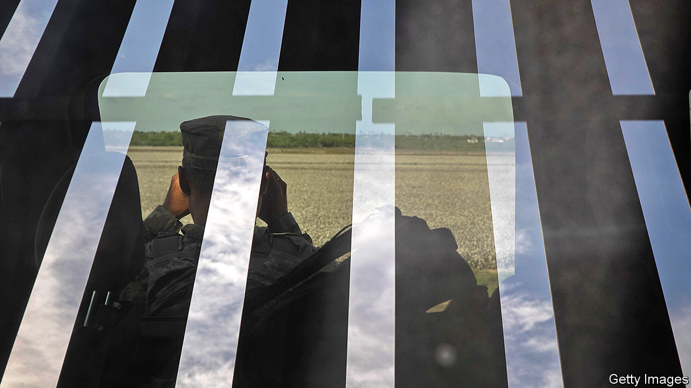

GEORGE W. BUSH and Barack Obama each had three secretaries of the Department of Homeland Security (DHS) in their eight years in office—two Senate-confirmed, and an acting secretary between. In less than four years, Donald Trump has had five. The last Senate-confirmed secretary, Kirstjen Nielsen, resigned in April 2019. Mr Trump reportedly told her she was “not tough enough” and did not “look the part”.

She had been chief of staff for the other Senate-confirmed secretary, John Kelly, who became Mr Trump’s chief of staff, and whom Mr Trump now describes as “totally exhausted” and “unable to function”. Chad Wolf, a former lobbyist, has been acting head for more than the 300 days allowed by federal law, having replaced another acting secretary, Kevin McAleenan, who resigned after complaining about the “tone [and] message” of the president’s immigration policy. Mr Trump does not seem minded to remove Mr Wolf. Acting secretaries, the president has said, give him “more flexibility”, and few cabinet departments have pursued his political goals as flexibly and relentlessly as the DHS.

Created in the wake of the September 11th attacks, the DHS is the youngest of America’s 15 executive departments; it opened its doors in 2003. Unlike other departments, it does not have a long-established institutional culture. Designed to bolster America’s defence against terrorist attacks, disasters and other large-scale threats, it now includes Customs and Border Protection, the Federal Emergency Management Agency, Immigration and Customs Enforcement, the Transportation Security Administration and the Secret Service, making it America’s largest federal law-enforcement agency, with more than 60,000 officers and agents.

Presidents stamp their priorities on it as they do on any other cabinet department. The first mission listed in the act of Congress creating the department was to “prevent terrorist attacks within the United States”. Paul Rosenzweig, a former deputy assistant secretary for policy at the DHS and now a senior fellow at the R Street Institute, a think-tank, recalls that Mr Bush held “Terrorism Tuesdays”, at which senior officials would brief him on threats. That posed by al-Qaeda receded during Mr Obama’s presidency, leaving him free to focus more on cyber-security and immigration. As Carrie Cordero of the Centre for a New American Security puts it, the DHS really is “an all-hazards department”.

It particularly interests Mr Trump because of its role in immigration enforcement. It has carried out several of his most controversial policies, including building bits of the border wall, separating migrant parents from children, implementing sweeping travel bans and deploying paramilitary forces against protesters in Portland, Oregon and Washington, DC. None of these uses clearly exceeds Mr Trump’s statutory authority; presidents have broad powers and discretion to define and respond to matters of national security.

But, Mr Rosenzweig argues, “this president has taken his discretionary authorities and used them in distorted ways that were never reasonably within the contemplation of those who created those authorities in the first place”. For instance, presidents can deploy BORTAC, the border agency’s paramilitary troops, to help the Federal Protective Service guard federal property, as Mr Trump did by executive order on June 26th. But none has previously deployed paramilitary forces against the wishes of a state governor—as Mr Trump did in Oregon, where, wearing uniforms without names or identification, they appeared to arrest people far from the buildings they were ostensibly guarding—nor sent them to “sanctuary cities”, from Boston to Los Angeles, in a show of force.

Presidents worry about border security and deterring illegal immigration. But Miles Taylor, a lifelong Republican and former DHS chief of staff, says that Mr Trump “deliberately told us, on multiple occasions, to implement policies that would maim, tear-gas and injure innocent, unarmed civilians” trying to cross the border. Mr Taylor told a podcast hosted by the Bulwark, a right-leaning website, that Mr Trump wanted the border wall topped with spikes that would “go through their hands and their arms and pierce human flesh”.

## A long way from 9/11

Under Mr Trump, the DHS has also been the subject of complaints by whistle-blowers. Brian Murphy, who ran the intelligence office, alleged that Mr Wolf told him to downplay reports of Russian electoral interference because they “made the president look bad”, (a DHS spokesman denies the allegation). Dawn Wooten, a nurse at an immigration-detention centre in Georgia, alleged that doctors underreported covid-19 cases and refused to test detainees with symptoms. She says one doctor performed hysterectomies on detained immigrants without their full consent (the doctor accused denies the allegation).

Mr Trump’s use of the department has led some on the left to press for its abolition—an outcome this is both politically unlikely and, in the amount of structural reorganisation it would require, unwise. Should Mr Trump lose in November, Democrats may suggest consolidating congressional oversight (more than 100 congressional committees have some homeland-security purview), press for more transparent operational guidelines and try to reduce the number of political appointees, rather than getting rid of it.

And what if Mr Trump wins? The DHS would remain dedicated to his political goals, meaning more federal officers facing off against protesters and more immigration enforcement designed to terrify. The president would find more inventive uses for this malleable bureaucracy.■

Dig deeper:  
Read the [best of our 2020 campaign coverage](https://www.economist.com/us-election-2020) and our [presidential-election forecast](https://projects.economist.com/us-2020-forecast/president), then sign up for Checks and Balance, our [weekly newsletter](https://www.economist.com/checksandbalance/) and [podcast](https://www.economist.com/podcasts/2020/09/04/checks-and-balance-our-weekly-podcast-on-american-politics) on American politics.

This article was downloaded by calibre from <https://www.economist.com/united-states/2020/09/19/assessing-donald-trumps-use-of-the-homeland-security-department>

|  |  |  |  |
| --- | --- | --- | --- |
|  | Articles | Sections | Next |

|  |  |  |  |
| --- | --- | --- | --- |
| Previous | Articles | Sections | Next |

#### Historically back

# Why is interest growing in America’s black colleges and universities?

The death of George Floyd and the presidency of Donald Trump have both played a part

Sep 19th 2020 | CHICAGO

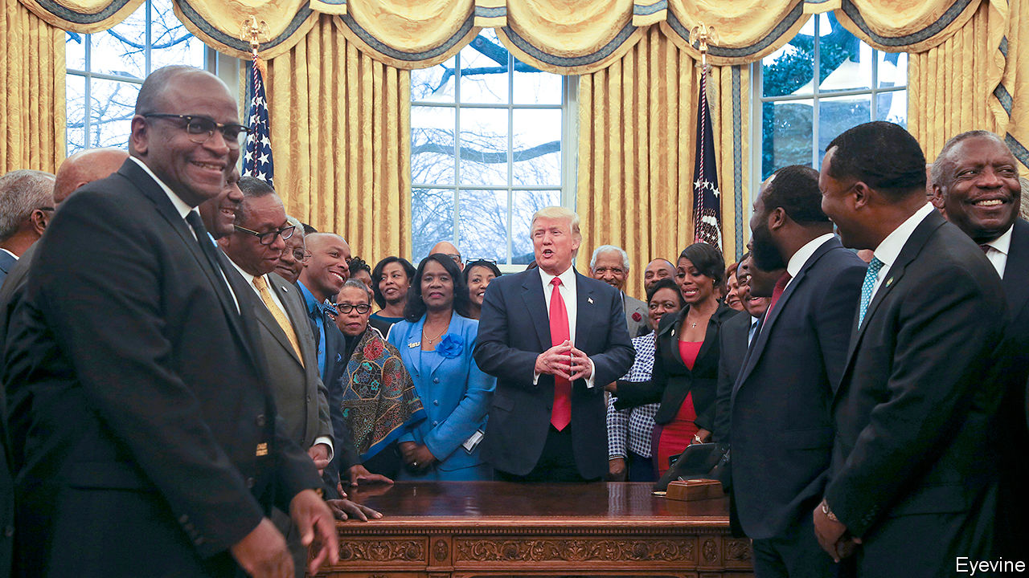

SIX MONTHS ago prospects looked dire for many historically black colleges and universities (HBCUs): around 100 institutions, mostly in the South, which together boast 290,000 students. A few stars in the sector dazzled, such as Howard University in Washington (where both Kamala Harris and the actor Chadwick Boseman studied) or Morehouse in Georgia. But expectations for many were low.

Most have a distinguished history, founded after the civil war to educate freed slaves who were denied entry to white-only colleges. They trained the bulk of black doctors, lawyers and teachers and so helped create the African-American middle class. They still turn out over a tenth of all black graduates, but they are struggling. Overwhelmingly, their students are poor and new to higher education. Harry Williams, head of the Thurgood Marshall Fund, which helps the 47 public HBCUs (containing the bulk of students), says 73% qualify for Pell Grants, aid for the poorest.

Many colleges face worsening finances. Roslyn Artis, president of 150-year-old Benedict College in South Carolina, says enrolment there has slumped over the past seven years, partly for a welcome reason: predominantly white colleges have become much nimbler at recruiting black students. Even after she slashed tuition fees at her private college, she watched enrolment crash by 14% this year. “Benedict won’t get bailed out,” she says. If she has to cut her $50m budget more, then subsidies for poorer students may go, hurting “the ones we were built to serve”.

That is not unusual. Jarrett Carter, who runs HBCU Digest, a website, estimates that nearly half the colleges are under stress, and many (especially private ones) might “not be here in one to three years”. Most squeezed are the smallest, with trifling or no endowments and no rich alumni to tap. State funding for public ones has tumbled in the past two decades. A government report two years ago noted that nearly half their buildings need serious repair or replacing. “These institutions have been struggling for many years,” says Jourdan Sutton of EY Parthenon, a consultancy. He says too few find new ways, like luring foreign students, to plug funding gaps.

The pandemic has caused upheaval. William Harvey, president of Hampton University in Virginia, says he cut $43m from his $200m annual budget this year, as the entire college moved online. Another president says he trimmed 11% from his. Yet some colleges that expected students to abandon campus, and braced for less revenue, then found that young people from poorer or unstable families were desperate to return as covid-19 hit African-American homes especially hard.

Ruth Simmons, the president of Prairie View A&M in Houston, says she braced for enrolment falling by 5% this year, but it has risen “as people wait out the economic downturn”. She met students who slept in cars nearby, anxious to get back early. Quinton Ross, president of Alabama State University, says he budgeted for 400 fewer students; instead numbers rose by 1,000. Not all are back on campus, but as 15% of his students—notably in rural Alabama—have no internet at home, they demanded to get back. “HBCUs have been shelters in a storm for years,” he says.

A tumultuous summer has also stirred interest. More debate on racial justice may be spurring some students to choose black colleges over mostly white ones. National politicians from both parties are paying HBCUs more attention. The CARES Act, passed by Congress in March, set aside $960m for the colleges to pay for laptops, covid tests, protective gear and other stuff. That probably saved some from closure. “We’ve never had that type of engagement, that intensity before,” says Mr Williams, of politicians’ interest. He is working with leaders of both parties in Congress to obtain another round of federal help.

President Donald Trump brags that he “saved” the HBCUs. Such talk annoys some presidents, but they also praise him. He has “been beating the drum on HBCUs as a cornerstone of his education platform from month one of his time in office”, says M. Christopher Brown, president of Kentucky State University. “The action and the money don’t lie,” says Mr Williams. Many like the fact that Mr Trump met and spoke thoughtfully to HBCU leaders, and that he forgave loans to some hard-hit colleges. “These seeds have been sprinkled under him,” says Mr Brown. He may be reviled, says Mr Carter, but “he did some substantive things”.

Just as striking is a surge of interest from companies and donors, especially since the killing of George Floyd in May. Mr Williams says this year will easily see the largest-ever number of donations to HBCUs, perhaps well over $500m. Many colleges have seen “the largest single gift they have ever received” in recent months, says Mr Sutton. Hampton, for example, will get $30m from MacKenzie Scott, Jeff Bezos’s ex-wife. Tony Allen, president of Delaware State University, says he has held 20 meetings with companies and chambers of commerce this summer to manage a surge of requests to go into partnership with HBCUs, as firms seek ways to show interest in racial matters.

## Paid a call to see Dubois

One challenge is to brush off token efforts, says a college president. Firms must show long-term plans to support HBCUs, not offer a small, one-off gift for the sake of public relations. Some heads of smaller colleges also quietly grumble that the best-known ones always get the lion’s share, as when this month Michael Bloomberg gave $100m to four historically black medical colleges. Howard University alone will get one-third of the pot. That is hard to avoid: it looks inevitable that bigger gaps, in enrolment, corporate partnership, endowments and other measures, will grow between thriving HBCUs and the rest.

In the long run companies, eager to hire non-white staff, could help most by turning to the colleges for recruitment. Mr Allen says Delaware State is now part of a scheme in which JPMorgan Chase plans to sign up 4,000 paid interns from the colleges. EY plans to recruit accountants from four HBCUs. Mr Brown says a “huge pharma company” plans a programme of paid internships, leading to full-time jobs, for his Kentucky graduates. Such pathways to eventual jobs could be the biggest spur for students to enroll and stay on.■

Dig deeper:  
Read the [best of our 2020 campaign coverage](https://www.economist.com/us-election-2020) and our [presidential-election forecast](https://projects.economist.com/us-2020-forecast/president), then sign up for Checks and Balance, our [weekly newsletter](https://www.economist.com/checksandbalance/) and [podcast](https://www.economist.com/podcasts/2020/09/04/checks-and-balance-our-weekly-podcast-on-american-politics) on American politics.

This article was downloaded by calibre from <https://www.economist.com/united-states/2020/09/19/why-is-interest-growing-in-americas-black-colleges-and-universities>

|  |  |  |  |
| --- | --- | --- | --- |
| Previous | Articles | Sections | Next |

|  |  |  |  |
| --- | --- | --- | --- |
| Previous | Articles | Sections | Next |

#### Et in arcadia achoo

# The virus and America’s resort towns

Signs of growing inequality as a result of covid-19 can be detected from cities to countryside

Sep 17th 2020 | WASHINGTON, DC

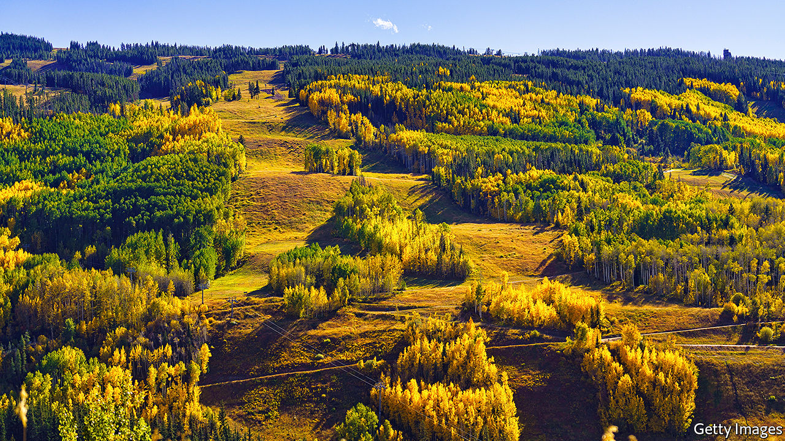

SUN VALLEY, the remote and idyllic swathe of land sandwiched among the mountains of central Idaho, is one of the better places to see out a pandemic. America’s first ski resort, as the place styles itself, has drawn those seeking an alpine retreat since Ernest Hemingway, an author and outdoorsman, first decamped to the town of Ketchum in the 1930s. Now that office work is increasingly remote and cramped city living looks less appealing, the Elysian country life beckons. “We’re seeing almost a fourfold increase in vacant land sales over the last two to three months,” says Harry Griffith, the executive director of Sun Valley Economic Development. The high-end property market boomed throughout lockdown. A 14,000-square-foot mansion was recently sold for $18m—the most expensive residential-property transaction in the region’s history. Local developers have booked enough renovation and construction gigs to last for months.

At the same time as the well-to-do are able to flock to their second homes, the region’s less fortunate have rarely looked more in need. “Our numbers exploded. We saw our need more than double,” says Jeanne Liston, executive director of The Hunger Coalition, which operates a food-distribution programme and community garden in the area. There has always been need in resort towns—the workers who staff restaurants, lodges and ski lifts often do not earn sufficient wages to cover the high rents. United Way, a charity, reckons that half of the residents of Blaine County, which includes Sun Valley, are on the edge of being unable to afford basic necessities—a statistic driven largely by the exorbitant rents. As the usual “shoulder season” of low demand sets in during autumn, the level of need could grow even more.

Nationwide, the effect of covid-19 on economic inequality will remain unclear for some time. But now that most American stockmarkets have completely recovered—even as the cash provisions of the federal stimulus have expired—it may eventually prove to have drifted upwards. Most who consider growing inequality think first of cities, where rich and poor live close together.

These places were hit first and hard, disproportionately affecting the disadvantaged. The Centres for Disease Control and Prevention estimates that African-Americans, Hispanics and Native Americans were three times likelier to be infected and five times likelier to be hospitalised than whites. Office workers with university degrees were largely spared the unemployment that low-paid service-sector workers endured. Disruption to schools is likelier to permanently damage the educational outcomes for the children of the poor than for the children of the rich. Eviction invariably conjures up images of apartment buildings, not cabins in the woods.

Those natural associations obscure what has happened outside cities. This is both because the virus has hit some already down-and-out places especially hard—those living on the Navajo Nation reservation, for example—but also because of its second-order effects on the places that are thriving in spite of the pandemic. In Vail, Colorado, another ski resort, the number of homes sold for more than $1m between July and September of this year was double those of the same period last year. There, the development is welcome. If prices can be contained for the lower end of the market, “we have a huge opportunity to become a hub for location-neutral workers”, says Chris Romer, the president of the Vail Valley Partnership.

Here, too, food-bank usage is up even as high-end properties are snapped up. “The flipside of that is there could be some displacement of traditional long-term rentals and workforce housing,” says Mr Romer. “What that is going to require is political will from our elected officials to encourage inclusionary zoning.”

Prosperous resort towns may have the political will to do something. The town of Vail has set up a rent-relief programme for businesses hurt by the pandemic. Private citizens in Sun Valley raised enough money to allow every pupil to get access to remote schooling, says Sally Gillespie, the executive director of the Spur Community Foundation, a local organisation. Effective action elsewhere would require federal involvement, which hardly looks forthcoming. The lapsed stimulus has triggered an apparent increase in poverty nationwide. And the prospects for a second package that Democrats and Republicans can agree on, which is badly needed, appear dismal. Instead, managing the fallout will be a local affair, decided town by town.■

Editor’s note: Some of our covid-19 coverage is free for readers of The Economist Today, our daily [newsletter](https://my.economist.com/user#newsletter). For more stories and our pandemic tracker, see our [hub](https://www.economist.com/news/2020/03/11/the-economists-coverage-of-the-coronavirus)

This article was downloaded by calibre from <https://www.economist.com/united-states/2020/09/17/the-virus-and-americas-resort-towns>

|  |  |  |  |
| --- | --- | --- | --- |
| Previous | Articles | Sections | Next |

|  |  |  |  |
| --- | --- | --- | --- |
| Previous | Articles | Sections | Next |

#### Following the money

# Reports that the president’s campaign faces a crisis are exaggerated

The Trump campaign has plenty of cash and may have one fundraising advantage

Sep 19th 2020 | WASHINGTON, DC

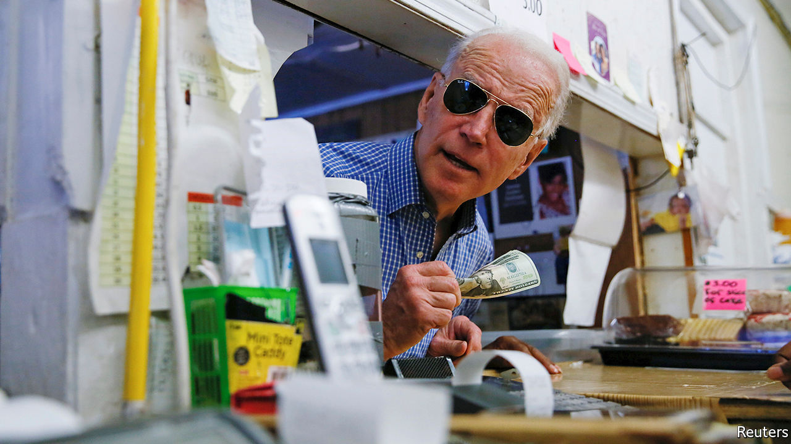

SCENTING BLOOD, Donald Trump’s detractors have leapt on the news that his campaign has run down its huge cash reserves with gusto. After the New York Times reported last week that the campaign had ripped through $800m in the 18 months to July, headline-writers jostled to predict the serially indebted president was headed for yet another “cash crunch”. That seemed to be confirmed by reports this week that his campaign has recently been outspent by Joe Biden’s in most swing states. Yet how much does this actually matter?

As so often with Mr Trump, it is easy to be distracted by the outrageousness of his affairs. In May the Trump campaign’s larger-than-life manager, Brad Parscale, announced that he had spent nearly three years constructing a political “Death Star” and was about to “start pressing FIRE for the first time”. Two months later, with Mr Trump trailing by 10 points and the Death Star leaking allegations of mismanagement and extravagance, Mr Parscale was out on his ear.

He was reported to have issued contracts worth almost $40m to companies he owned. The wife and girlfriend of the president’s two adult sons were collecting $180,000 a year for cheerleading services. The Death Star had spent almost $60m on legal fees, much of which related to Trump scandals—such as the president’s battle to keep his tax records secret—only tenuously related to his campaign. The net sum of such expenditure—after Mr Biden outraised the president by over $150m in August—is that the former vice-president may now have as much cash on hand as Mr Trump. That would be a big turnaround—yet probably electorally insignificant.

No modern presidential election has been decided by campaign spending. That is because both candidates always have enough cash to achieve the single main point of it: near-universal name recognition among voters in the dozen or fewer swing states that determine the outcome.

This is even more obvious than usual this year. The extraordinary stability of the polls (Mr Biden led Mr Trump by roughly seven points last October and the same amount today) suggests most voters long ago made up their minds about them. And if Mr Trump’s campaign is now husbanding its resources a bit, so what? It has ample cash to hammer away at the tiny minority of undecided voters in the states that matter most: Arizona, Florida, Michigan, North Carolina, Pennsylvania and Wisconsin. The president’s campaign raised $210m in August—a vast sum by any measure except Mr Biden’s haul.

Beyond establishing name recognition, there is little evidence that the political ads campaigns splurge on have much effect on voter choice. Most Americans, accustomed to a deluge of pre-election ads, tune them out. That helps explain why Mr Trump beat Hillary Clinton despite his campaign having spent about half as much as hers.

Presidential campaign finance has in this way become a case-study in diminishing returns. The more hyper-partisan and tightly contested elections become, the bigger the sums donors are prepared to throw at them, and the less impact they have. The same pattern is apparent even in congressional races. The rivals in Montana’s current Senate contest, Steve Daines, the Republican incumbent, and Steve Bullock, the state’s Democratic governor, had raised a record $25m between them by the beginning of July. That represented around $35 per registered voter in the state—though both candidates were already well-known there. Given Montana’s low advertising costs, it is unclear how they will even dispose of their cash piles.

At this juncture, the main significance of Mr Trump’s and Mr Biden’s rival cash operations is two-fold. First, because small-dollar donors (who give $200 or less) are extremely likely to vote, the number that a campaign attracts is a useful proxy for voter enthusiasm. And here there is better news for the president. According to the Centre for Responsive Politics, a research outfit, Mr Trump has raised almost $100m more than Mr Biden from such voters, an indication of greater fervour in his base.

Second, where the candidates spend their money points to where their strategists think the race stands. And, sure enough, 85% of the campaigns’ TV advertising spending has been spent in the aforementioned swing states. Mr Biden’s disciplined campaign, that suggests, is not giving much thought to a possible blowout by splurging on Iowa, Georgia or other Democratic fantasies. It is focused on a narrower, but likelier, path to victory.

Mr Trump’s campaign is spending a bit more widely. It is trying to shore up its customary, yet perhaps vulnerable, advantage in Iowa and the rest, while also pushing tentatively into a couple of Democratic states, including Minnesota and New Hampshire. The overall picture is of a tight race, in which Mr Biden’s campaign is holding a steady course, while Mr Trump’s is probing nervously for possible alternative paths. That fits with the picture painted by the polls. It suggests Mr Trump’s campaign is lagging—but not in crisis.■

Dig deeper:  
Read the [best of our 2020 campaign coverage](https://www.economist.com/us-election-2020) and our [presidential-election forecast](https://projects.economist.com/us-2020-forecast/president), then sign up for Checks and Balance, our [weekly newsletter](https://www.economist.com/checksandbalance/) and [podcast](https://www.economist.com/podcasts/2020/09/04/checks-and-balance-our-weekly-podcast-on-american-politics) on American politics.

This article was downloaded by calibre from <https://www.economist.com/united-states/2020/09/19/reports-that-the-presidents-campaign-faces-a-crisis-are-exaggerated>

|  |  |  |  |
| --- | --- | --- | --- |
| Previous | Articles | Sections | Next |

|  |  |  |  |
| --- | --- | --- | --- |
| Previous | Articles | Sections | Next |

#### No scrubs

# Abortion by pill is becoming more widespread in America

Changes to medical technology will change the politics of the country’s original culture war

Sep 19th 2020 | WASHINGTON, DC

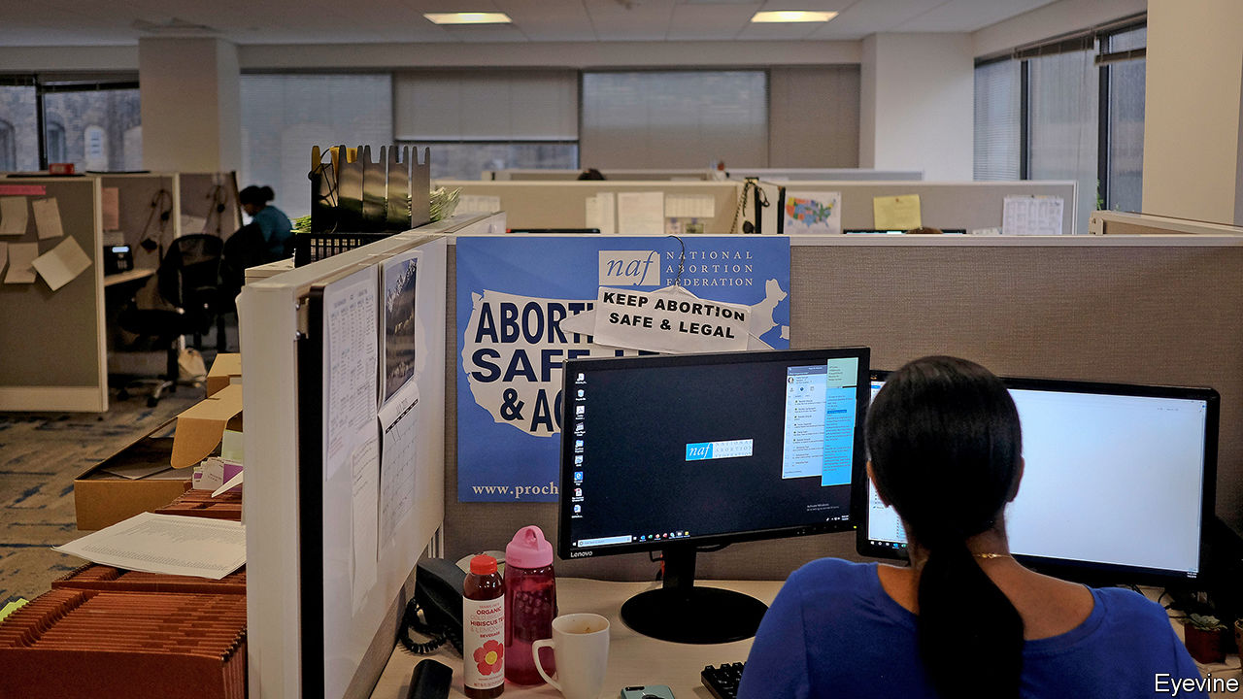

WHEN WOMEN used to tell Susan Long (not her real name), a doctor in Washington state, that they wanted to terminate a pregnancy, she would refer them to an abortion clinic. Today, they need not even walk into her office: after an online consultation, she prescribes two pills, which she posts, along with instructions on how to take them several hours apart.

It is difficult to exaggerate the benefit for “innumerable” women of being able to have an abortion at home, without having to arrange a trip to a clinic, she says, describing some of them. The university student living with her conservative parents, hundreds of miles from the nearest abortion clinic. The woman whose violent husband is vehemently pro-life. Single mothers, strapped for cash and child care. Those whose frail health prevents them risking exposure to covid-19 at a doctor’s office.

Dr Long does this work for Aid Access, a non-profit that prescribes and posts abortion pills, mostly from overseas, to women in America. Many live in states that have restricted access to abortion. The FDA has ordered Aid Access to stop doing this, saying it breaks the law. But it is only since July this year that Dr Long has also been able to legally mail the pills to patients in her own general practice, although she lives in a state which has few abortion restrictions. Previously that was impossible.

That is because although the Food and Drug Administration (FDA) has approved the drugs—mifepristone, which blocks the effects of the pregnancy-enabling hormone progesterone; and misoprostol, which induces contractions—to abort pregnancies of less than ten weeks’ gestation since 2000, it has also imposed more stringent regulations than those that apply to most drugs in America. As a result, despite its relatively low cost, abortion by pill is less prevalent in America than it is elsewhere. In most northern European countries, abortion by this method accounts for more than two thirds of all terminations (see Britain section). In America, the figure is around 40%.

Abortion-rights campaigners and the American College of Obstetricians and Gynaecologists have lobbied the FDA to drop its most burdensome requirement: that women collect one of the drugs, mifepristone, from a doctor’s office or clinic. They argue this is both unnecessary—research suggests the drug is safe—and a barrier to the right to abortion established in Roe v Wade. In July, a federal judge ordered the rule to be lifted during the covid-19 epidemic because it posed a “substantial obstacle” to women seeking an abortion. The Trump administration has asked the Supreme Court to intervene.

It is difficult to argue against the judge’s logic for ditching this rule. During the epidemic, women in many places have had to wait longer than usual for an abortion. A delay of a week or two can be distressing; worse, it can mean the difference between a legal abortion and an illegal one. The problem is particularly acute in America because abortion access has already been so curtailed. Anti-abortion regulations have forced hundreds of clinics to close. Six states have only one left.

Yet barriers to abortion by post remain. The biggest is that the court ruling in July has made little difference in the 15 states that require a doctor’s presence when a woman collects abortion medication. In those states, and wherever else women are unable to find doctors prepared to post the drug to them, demand for Aid Access and other such services will continue to rise.

Research into the non-profit, which was established in 2018, highlights the role that abortion pills by mail can play when health services are stretched. Abigail Aiken of the University of Texas at Austin says that within the first few weeks of the pandemic, demand surged. In Texas, after all abortions were cancelled for several weeks, demand nearly doubled. TelAbortion, an FDA-approved programme run by Gynuity Health Projects, which operates in 13 states, has also seen growing demand.

Most of the women Aid Access helps are poor. An increasing number have been unable to afford the $95 it asks (but does not require) for its services. Doctors say they have prescribed for many women who could not afford to travel to a clinic or cover the cost when they got there. Since 1976 the Hyde Amendment has forbidden the use of federal funds for abortion.

For the majority of Americans, who believe that abortions should be legal in the first trimester but not thereafter, the growth of abortion medication is good news. Research suggests that access to medication using telemedicine leads to fewer second-trimester abortions. Just as ultrasound images of fetuses in the womb foster pro-life views in some, this is a technology likely to shift views in the opposite direction. Anti-abortionists will be keen to downplay this as they move their focus from physical clinics to abortion by pill. In February congressional Republicans introduced a bill banning “teleabortion”. This month, 20 Republican senators wrote a letter to the FDA urging it to take mifepristone off the market because it was “dangerous”.

It will be more difficult to campaign against mail-order abortions than it has been against those done in clinics. A woman taking tablets at home inspires less incendiary rhetoric than a doctor in scrubs performing a dilation and evacuation. It is later abortions, when the fetus is recognisably a baby, that provide the gruesome pictures protesters wave outside clinics. They seem unlikely to start waving them outside women’s homes.■

Dig deeper:  
Read the [best of our 2020 campaign coverage](https://www.economist.com/us-election-2020) and our [presidential-election forecast](https://projects.economist.com/us-2020-forecast/president), then sign up for Checks and Balance, our [weekly newsletter](https://www.economist.com/checksandbalance/) and [podcast](https://www.economist.com/podcasts/2020/09/04/checks-and-balance-our-weekly-podcast-on-american-politics) on American politics.

This article was downloaded by calibre from <https://www.economist.com/united-states/2020/09/19/abortion-by-pill-is-becoming-more-widespread-in-america>

|  |  |  |  |
| --- | --- | --- | --- |
| Previous | Articles | Sections | Next |

|  |  |  |  |
| --- | --- | --- | --- |
| Previous | Articles | Sections | Next |

#### Lexington

# Global warming and the presidential election

Joe Biden is on course to make fighting global warming his signature issue

Sep 19th 2020 |

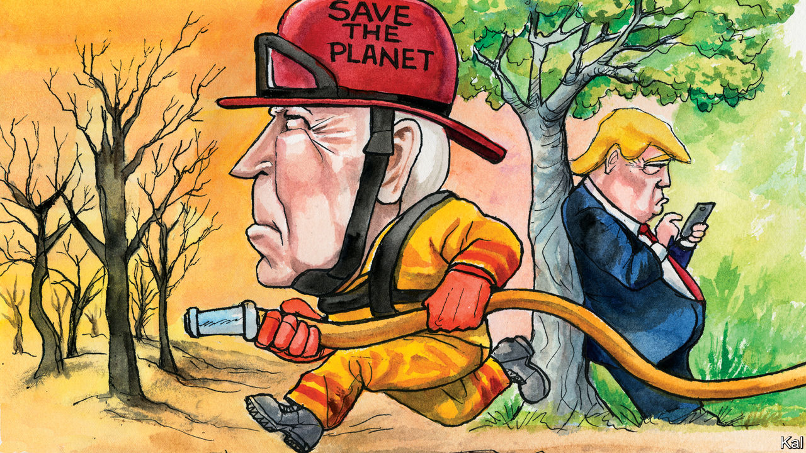

THIS WEEK America’s oldest magazine offered its first-ever presidential endorsement. “We do not do this lightly,” said Scientific American, in explaining its decision to come out for Joe Biden. But what choice did it have? The country is gripped by two science-related catastrophes, a global pandemic and global warming. Donald Trump downplays the first on a good day (as America’s death-count approaches 200,000, he predicts it will soon “go away”) and denies that humans are causing the second. During a visit to Sacramento this week, to acknowledge the wildfires that have so far incinerated over 5m acres of forest and thousands of homes and killed at least 35 people, he assured a roomful of silent, serious Californians that global warming was about to go into reverse.

In a speech delivered in Delaware the same day, Mr Biden meanwhile underlined his determination to introduce at a national level the policies to combat climate change that America, almost uniquely among Western democracies, still lacks. Where Barack Obama made the issue secondary to health-care coverage, and Hillary Clinton put it behind immigration and other promised reforms, Mr Biden promises to make tackling climate change his priority. His proposals, with an important caveat, reflect that degree of urgency. There is no starker contrast between the Republican president and his Democratic challenger than on this issue.

The climate plan Mr Biden released in July includes faster, deeper cuts to America’s carbon emissions than either of his Democratic predecessors envisaged. Mr Biden promises a commitment to decarbonising the electricity grid by 2035. To that end, he pledges among other things to invest $2trn in renewable energy and other technologies over four years. He would also commit America to cutting its emissions to net zero by 2050. Mr Obama’s failure to enshrine a much more modest commitment—an 80% emissions reduction by 2050—indicates how bold that would be. Yet, if backed by a Democratic-controlled Congress, Mr Biden would probably have a much better chance of making progress on the issue than Mr Obama had.

That is chiefly because his party is desperate for him to do so. Before covid-19 hit, the combination of Mr Trump’s denials with ever-worsening wildfires, hurricanes and floods had made Democratic voters increasingly likely to cite climate change as their main concern. And Mr Biden, a master at hewing to his party’s shifting currents, has further hardened this environmental consensus by using it to bridge the rifts exposed by his nomination.

His appointment of John Kerry and Alexandria Ocasio-Cortez—emblems of the centre-left and activist left—to co-chair his climate-policy shop was evidence of that. So is the heterodox nature of his proposals. For example, though he dispensed with the socialism-by-stealth of the left’s Green New Deal—which included guaranteed jobs and Medicare-for-All—he has mollified Ms Ocasio-Cortez’s faction by emphasising environmental justice, as well as with the scale of his ambition. Labour unions are reassured by his stress on job creation in low-carbon industries. Centrists are thrilled that he has bucked the left by remaining open to nuclear power and to the possibility of making fossil fuels safe by capturing the gases they emit when burned.

In a sign of how the climate-policy debate often scrambles ideological positions, moderate Democrats are also largely responsible for limiting the scope of market mechanisms—either a cap-and-trade scheme or a carbon tax—in Mr Biden’s plan. Democratic leaders in Congress consider them desirable but unsellable. Hence the more regulatory approach laid out in a 547-page climate plan released by House Democrats in June. While allowing for the possibility of a nationwide carbon tax—as Mr Biden’s plan does—it lays more emphasis on the sector-by-sector low-carbon standards adopted in California—including zero-emissions from cars, as well as power stations, by 2035. Mr Biden’s plan follows suit.

Implicit in the way it is designed to have maximum Democratic appeal is an assumption that a Biden administration could count on no Republican support. That is a reasonable precaution. While Democrats and independents have become more concerned about climate change, opinion on the right has hardly moved. Like Mr Trump, half of moderate and 75% of conservative Republicans deny the link between human activity and global warming. At the same time, any Republican tempted to break with his or her party should not find Mr Biden’s proposals off-putting. His emphases on growth and technology are hard to argue with. The recent rise of renewables industries—which employ a lot of people in Republican states—has also made them less divisive. And the fact that Mr Biden would probably jam much of his promised $2trn splurge into a broad, post-virus stimulus package would provide moderate Republicans with additional cover on their right flanks.

The politics and economics of climate change may thus, for once, be coming into alignment. The issue has already gone some way to making sense of Mr Biden’s unexciting candidacy. One of its overarching promises is to salvage Mr Obama’s legacy, then improve upon it; the former president’s climate record is in dire need of both services. Another is to rebuild America’s economy at home and reputation abroad; Mr Biden’s climate plan could help do both.

## But there’s no escaping the flames

The lurking caveat to this upbeat prospect is that the regulatory approach he is pushing will almost certainly deliver much slower, more partial and more inefficient progress than he predicts. America is not California. A Biden administration’s sector-by-sector carbon standards would draw a storm of legal challenges, stalling them and making them vulnerable to partisan judges and hostile successors. That is not to knock Mr Biden’s plans unduly; they may well be as bold as is politically feasible. But what is feasible in America’s dysfunctional politics is likely to be much less than the country—and in this instance the world—requires.■

Dig deeper:  
Read the [best of our 2020 campaign coverage](https://www.economist.com/us-election-2020) and our [presidential-election forecast](https://projects.economist.com/us-2020-forecast/president), then sign up for Checks and Balance, our [weekly newsletter](https://www.economist.com/checksandbalance/) and [podcast](https://www.economist.com/podcasts/2020/09/04/checks-and-balance-our-weekly-podcast-on-american-politics) on American politics.

This article was downloaded by calibre from <https://www.economist.com/united-states/2020/09/19/global-warming-and-the-presidential-election>

|  |  |  |  |
| --- | --- | --- | --- |
| Previous | Articles | Sections | Next |

|  |  |  |
| --- | --- | --- |
| United States | Sections | Middle East & Africa |

The Americas

Colombia: Fight crime, not war

.

Barbados: Bajan bye-bye

.

Bello: The return of the Monroe doctrine

.

|  |  |  |
| --- | --- | --- |
| United States | Sections | Middle East & Africa |

|  |  |  |  |
| --- | --- | --- | --- |
|  | Articles | Sections | Next |

#### Fight crime, not war

# Why Colombia’s militarised police need reform

The killing of an ordinary citizen has provoked violent protests, and demands for change

Sep 19th 2020 | BOGOTÁ

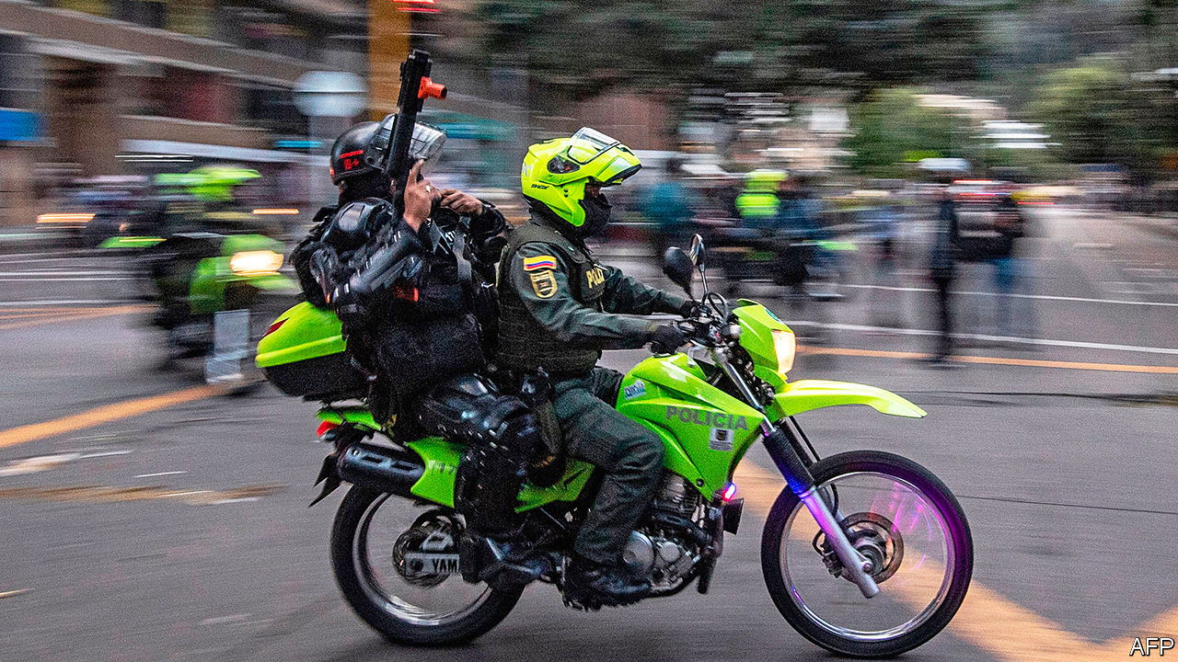

EARLY ON SEPTEMBER 9TH police in Bogotá, Colombia’s capital, arrested Javier Ordóñez, a taxi driver and father of two, for drinking alcohol in the street. A video that went viral shows two officers pinning him down. One pressed his knee against Mr Ordóñez’s back and tasered his hips. The officers stopped the filming, but witnesses say that Mr Ordóñez was unconscious when they took him to the nearest police station. He died hours later.

In the protests that followed, people in Bogotá and other cities burnt buses and police stations. Police fired gunshots and tear gas and beat up bystanders; protesters hurled back stones. By the time the tumult died down, 13 people had died and hundreds of policemen and protesters had been injured. Colombia has never before seen such a display of rage against the police, says David Gómez, a security analyst.

The protests echo those that followed the killing by police in Minneapolis in May of George Floyd, a black man. But the police force against which they are aimed is very different. The United States has nearly 18,000 police forces, most under local control. Colombia, with a sixth of the United States’ population, has just one. It is the only democracy in which all the police are controlled by the defence ministry. Their duties range from flying Black Hawk helicopters to search for coca bushes in the jungle, to cracking down on public boozing. They wear military green, are grouped into military ranks and often carry rifles, whether patrolling city streets or remote rural areas. As long as the police remain part of the defence ministry, they cannot be reformed, says a retired police general.

This blending of soldiery and constabulary began in the 1950s. In response to political violence, in which mayors used police forces against their foes, the then-president, Gustavo Rojas Pinilla, a former army general, put the defence ministry in charge of the police. Their paramilitary status made some sense during Colombia’s war against the FARC, a Marxist guerrilla group, which began in 1964, and its fight against drug lords like Pablo Escobar. Under Plan Colombia the United States gave the government billions of dollars over 30 years to combat drug-trafficking, much of which went to the police. Today the force is 159,000-strong, more than double what it was in the 1990s.

The threats that justified outfitting it in military green have lessened, but not disappeared. Escobar was killed in 1993. The FARC laid down their arms in 2017. Today’s menaces include smaller drug-dealing gangs that have the command structures of guerrilla groups but not their ideologies. These include FARC guerrillas who refused to disarm and the Clan del Golfo, which is composed of demobilised right-wing paramilitaries. This year across Colombia illegal groups have murdered more than 100 community leaders for such affronts as pushing for the restitution of land to peasants. They carried out 15 massacres in August alone, mainly of people they suspected of sympathising with rivals. In parts of the northern department of Córdoba armed groups extort monthly payments from businesses. They, not the police, have imposed lockdown rules and fined those who break them.

Colombian cities, where four-fifths of people live, have the sorts of crime that plague others in Latin America. Three cities are among the 50 with the highest murder rates in the world. “Micro-trafficking” drug gangs dominate poor neighbourhoods and profit from other crimes, such as prostitution. Reported robberies, from pickpocketing to muggings, have risen fivefold over the past decade. Reports of domestic violence have risen by at least 165% during the pandemic. Recorded rape of women and children is the highest it has ever been. More than four-fifths of bogotanos feel unsafe, according to surveys.

Colombia’s police do not make people feel safer. They glorify combat, says Santiago Tobón, a researcher at EAFIT University in Medellín. Preventing crime is “not so sexy”, says Andrés Villamizar, who until 2019 was head of security in Cali, once the headquarters of the “Cali cartel”, now a hotbed of small-scale dealing of drugs and bootleg alcohol. It has Colombia’s highest murder rate and ranks 26th in the world.

Urban policing is based on “quadrants”, designated patrol zones which vary in size depending on how rife crime is in the area. A two-officer team is supposed to be on patrol in each quadrant at all times. But there are too few police to meet that goal, says Alberto Sánchez, a security analyst in Bogotá. A team patrols three or four quadrants, often working overtime. Officers are exhausted. That is one reason for slow responses to reports of crime and the city’s high number of thefts, says Mr Sánchez. Police do a bad job of investigating, bringing charges in just a quarter of murder cases. In Europe the rate is four-fifths.

The problem may get worse. In 2018 a court ruled that many officers could retire after 20 years of service rather than 25. Since then 10,000 have left the force; 15,000 could soon follow. The defence ministry says it plans to recruit 8,500 officers a year.

Abuse by police is widespread. Surveys suggest that most victims do not report it. Nonetheless, from January to August Bogotá’s mayor’s office received 137 complaints of excessive use of force, many from street workers and gay people. The police inspector’s office is supposed to investigate them, but it is not independent and reports to the national police director.

Killings like that of Mr Ordóñez are relatively rare. Last year police killed 90 people, according to the National Institute of Legal Medicine. That is probably an underestimate. Brazilian police killed more than 5,800 in 2019. But Mr Ordóñez’s death has made police reform a big issue. Bogotá’s mayor, Claudia López, has called for the force to be transferred to civilian control, and for wayward police to be tried in ordinary courts rather than military tribunals.

Such changes might help not just to change the mindset of the police, but also to increase their funding. Currently, they compete for resources with the army, which wields more power in the defence ministry. The police receive 27% of the ministry’s budget, about what they did at the height of the war with the FARC. The ministry buys equipment for the armed forces, but leaves it to governors and mayors, most of whom have little cash to spare, to equip the police.

Police officers make the same low salaries as soldiers, which discourages educated people from joining the force. Nearly a tenth of police are conscripts. The system of military ranks encourages obedience rather than independent thought, believes Liliana Mesías of the Ideas for Peace Foundation, a think-tank.

After Colombia ended its war with the FARC, reformers hoped the police would become a conventional constabulary, separate from the defence ministry. Juan Manuel Santos, the president who signed the peace deal, set up a commission to propose reforms, but then lost interest.

The current president, Iván Duque, is hostile. His conservative supporters see police reform as an attack on the security forces, which they have historically defended. While apologising for Mr Ordóñez’s death, the defence minister blamed the burning of police stations on guerrillas.

Some defenders of the status quo say that a militarised police force is still needed to deal with militias such as Clan del Golfo. That makes sense, but does not justify green uniforms on city streets. Crime has changed since Colombia ended its war with the FARC and the likes of Escobar. The tragedy of Mr Ordóñez suggests it is time for policing to change, too.■

This article was downloaded by calibre from <https://www.economist.com/the-americas/2020/09/19/why-colombias-militarised-police-need-reform>

|  |  |  |  |
| --- | --- | --- | --- |
|  | Articles | Sections | Next |

|  |  |  |  |
| --- | --- | --- | --- |
| Previous | Articles | Sections | Next |

#### Bajan bye-bye

# Barbados decides to dump the queen

The path to becoming a republic is not always smooth

Sep 16th 2020 |

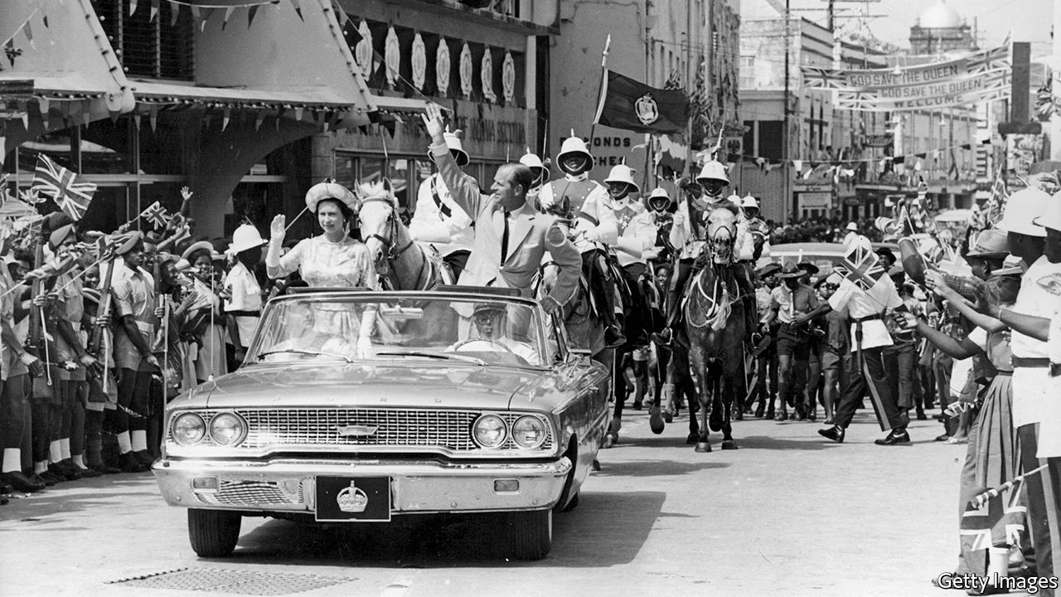

WHEN SANDRA MASON gave her annual “throne speech” to open Barbados’s Parliament on September 15th, she proposed the abolition of her own job. As the country’s governor-general she represents Queen Elizabeth II, its head of state. From November next year, in time for the 55th anniversary of independence from Britain, Barbados will be a republic, Dame Sandra declared. “The time has come to fully leave our colonial past behind,” she said. “Barbadians want a Barbadian head of state.”

Barbados is one of nine Caribbean countries in which the queen fills that role. She also does in Australia, Canada, New Zealand and three Pacific islands. Like other Caribbean people, many Bajans, as Barbadians are also known, find it odd that their ceremonial leader is a white woman who lives an ocean away, however much they like her. Some of the monarchy’s symbols make them queasy. The governor-general is Dame Grand Cross of the Order of St Michael and St George, whose badge depicts a white-skinned angel stomping on a prostrate black-skinned Satan.

Dame Sandra pronounced the words but their author was Barbados’s prime minister, Mia Mottley. Her Barbados Labour Party has all but one of the 30 elected seats in the lower house of Parliament. Ms Mottley will have no problem mustering the two-thirds majority in both houses needed to dump the monarchy. She has not yet made clear how Barbados will choose its future head of state.

Many former British colonies have contemplated the republican idea, only to discover that it is hard to execute. Barbados dithered for nearly a quarter of a century. A constitutional commission proposed in 1998 that the country become a republic. Successive governments promised referendums to confirm public support for the idea, but never held one. Ms Mottley does not think she needs a referendum to get her republic, and is not constitutionally required to hold one.

Other Caribbean monarchies have flirted with republicanism without embracing it. Jamaica’s prime minister, Andrew Holness, proposed a referendum before his election in 2016. He won a second term this month, campaigning on a manifesto that merely promises “consultations” on the issue. Ralph Gonsalves, of St Vincent & the Grenadines, is the only Caribbean prime minister to have held a referendum on adopting a republican form of government. He campaigned for the change in 2009, and lost.

The many U-turns on republicanism are due to the fact that replacing the monarch with a president involves unpicking a country’s constitution. Governors-general are formally appointed in London, but are in fact chosen by the prime minister. But a prime minister can’t simply choose a head of state. A more democratic way must be found, but that risks giving legitimacy to someone who could become a rival. Few prime ministers want that.

The president of Trinidad & Tobago, which became a republic in 1976, is elected by Parliament, and has real powers. In 1997 the prime minister of the day, Basdeo Panday, backed a former one, Arthur Robinson, who became president. In an election four years later both parties won the same number of seats. It fell to Robinson to pick the winner. He chose Mr Panday’s opponent, Patrick Manning, for his “moral and spiritual values”. Furious, Mr Panday and his supporters blocked parliamentary proceedings. Fears of a similar confrontation may have led some Caribbean leaders to reconsider their support for republicanism.

On rare occasions governors-general can be political players. Paul Scoon, who represented the queen in Grenada in the 1980s, cohabited for four years with a pro-Cuban “people’s revolutionary government”. After the prime minister, Maurice Bishop, was deposed (and killed) in 1983 by someone still more radical, Scoon asked the United States, then governed by Ronald Reagan, to invade. The Americans booted out the Marxists and freed Scoon from house arrest. Dame Sandra’s remaining 14 months as the queen’s woman in Barbados are unlikely to be so eventful. ■

This article was downloaded by calibre from <https://www.economist.com/the-americas/2020/09/16/barbados-decides-to-dump-the-queen>

|  |  |  |  |
| --- | --- | --- | --- |
| Previous | Articles | Sections | Next |

|  |  |  |  |
| --- | --- | --- | --- |
| Previous | Articles | Sections | Next |

#### Bello

# The return of the Monroe doctrine

A defeat for a weak and divided Latin America

Sep 17th 2020 |



ONLY A DECADE ago Latin America seemed to be making a mark in the world. Enriched by a commodity boom and with democracy contributing to social progress, many of the region’s governments felt part of “the rise of the south” in a multipolar world. John Kerry, Barack Obama’s secretary of state, said in 2013 that the United States saw its newly self-confident neighbours as equals. “The era of the Monroe doctrine is over,” he declared, referring to an early American president’s warning to European monarchies to keep out of the western hemisphere, which gradually evolved into the belief that the United States was the hegemon of the Americas.

Under President Donald Trump, the Monroe doctrine seems to be back. In 2019 John Bolton, then Mr Trump’s national security adviser, proclaimed it to be “alive and well” in a speech in which he pledged to topple the dictatorships of Venezuela and Cuba. The United States has so far failed in that, but its neo-Monrovianism has now produced a victory. It will take over the presidency of the Inter-American Development Bank (IDB), a big regional lender which, though based in Washington, DC, has been in Latin American hands since its founding in 1959. On September 12th a virtual meeting of the board of governors chose Mauricio Claver-Carone, the Trump administration’s top official for Latin America, as the bank’s president.

He is a controversial choice, and not just because his election breaks with precedent. Until 2017 he was a lobbyist against Cuba’s communist regime. A conservative Republican with limited experience of economic development, he is the chief architect of the sanctions the administration has imposed on Venezuela. He insists that he will be both a reforming president, and one who respects the views of the board of governors. Ojalá (if only), as Latin Americans say.

It is reasonable to assume that if Mr Trump wins a second term in November the IDB will become a tool of United States foreign policy. Mr Claver-Carone shares the obsessions of his political sponsor, Senator Marco Rubio of Florida. One is to overthrow Cuban communism as well as the Venezuelan regime. The other is to drive China out of Latin America. Mr Claver-Carone talks of hiring more staff from small countries in Central America and the Caribbean, where China and Venezuela are influential. More lending to those countries may follow.

Many Latin Americans would like to see democracy come to Cuba and Venezuela, and worry about Chinese influence. But it is hardly in the region’s interest to let these concerns overwhelm others or to divert development money away from needs made even more pressing by the pandemic, such as strengthening health care and education in the countries where most Latin Americans live. For these reasons a few governments—and many of the region’s most distinguished former leaders—opposed Mr Claver-Carone. Yet they failed to unite behind a better qualified candidate; 23 of the region’s 28 governments, including Brazil and Colombia, bowed to Mr Trump’s will.

That it can no longer lead one of its flagship international institutions marks a nadir for Latin America. The region is dis-integrating. For that, the hubris of the Latin American left when in power a decade ago is partly to blame. Hugo Chávez in Venezuela and Luiz Inácio Lula da Silva in Brazil forged integration schemes based on political alignment (and more or less explicit anti-Americanism) rather than abiding national interest. Leftist excess contributed to polarisation and the advent of its opposite. Jair Bolsonaro, Brazil’s hard-right president, used Mr Trump’s victory as a template for his own in 2018. His government has slavishly aligned with his idol’s, out of ideological conviction. That seems to be the case, too, with Iván Duque, Colombia’s president, who describes himself as a moderate but on foreign policy is not.

Another factor is weakness. The pandemic has struck the region hard after years of economic stagnation. Many presidents are in no mood to take risks. Mexico’s Andrés Manuel López Obrador, a bully at home but a coward abroad, first backed and then scotched an Argentine plan to prevent a quorum at the governors’ meeting to stop Mr Claver-Carone. Mr López Obrador mistrusts international financial institutions. Other governments reckoned Mr Claver-Carone was best placed to increase the IDB’s capital and thus its loans. Few want a fight with Mr Trump. They prefer to hide in the wings of the world stage.

This article was downloaded by calibre from <https://www.economist.com/the-americas/2020/09/17/the-return-of-the-monroe-doctrine>

|  |  |  |  |
| --- | --- | --- | --- |
| Previous | Articles | Sections | Next |

|  |  |  |
| --- | --- | --- |
| The Americas | Sections | Europe |

Middle East & Africa

Ethnic tensions and state violence: Ethiopia’s transition is in peril

.

Public spending in Ghana: High noon for half-bridges

.

Politics in Uganda: Divided we stand

.

Banning names: Sorry, you’re not on the list

.

Israel and the Arab world: End of the illusion

.

|  |  |  |
| --- | --- | --- |
| The Americas | Sections | Europe |

|  |  |  |  |
| --- | --- | --- | --- |
|  | Articles | Sections | Next |

#### Ethnic tensions and state violence

# Ethiopia’s democratic transition is in peril

Abiy Ahmed has so far delivered neither democracy nor peace

Sep 19th 2020 | ADDIS ABABA

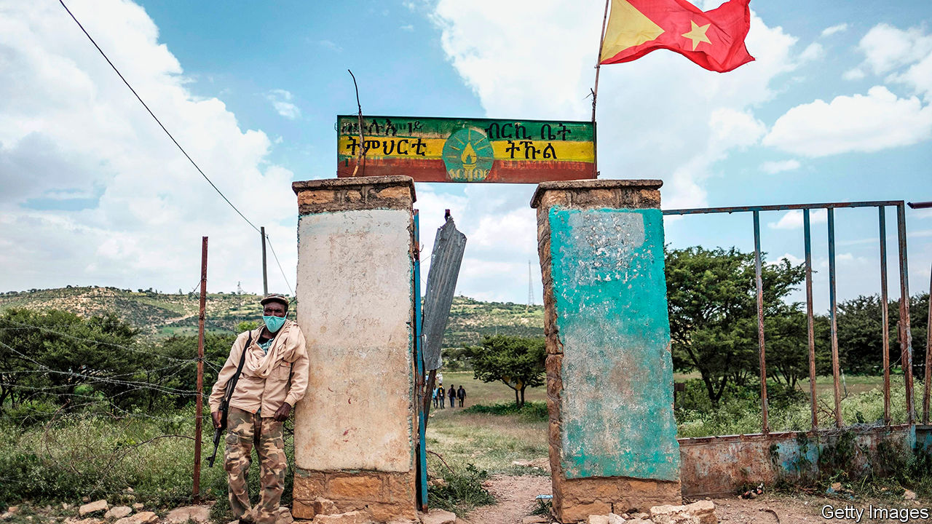

“FREEDOM IS NOT a gift doled out to people by a government,” Abiy Ahmed said in his inaugural address as Ethiopia’s prime minister in 2018. “Rather [it is] a gift of nature to everyone that emanates from our human dignity.” His words marked a remarkable turn for a country that over the past five decades had seen an absolute monarchy, revolutions, civil war and authoritarian rule, but not freedom or democracy. After coming to power on the back of anti-government protests, Abiy freed political prisoners and journalists, welcomed opposition parties back from exile and encouraged rebels to disarm. He made peace with Eritrea, for which he was awarded the Nobel prize last year, and pledged to hold the first free elections in Africa’s second-most-populous country.

Yet Abiy has been unable to patch the deep ethnic fissures that threaten to tear Ethiopia apart, and has not altered the state’s instinct for violence and repression. This year alone at least 147 fatal clashes have left several hundred dead, according to figures compiled by the Armed Conflict Location & Event Data project (see map). In July riots took place across Addis Ababa, the capital, and the Oromia region, after the assassination of Hachalu Hundessa, a musician and activist from Abiy’s own Oromo ethnic group. By one count 239 people were killed, some by mobs, others by security forces. Thousands have since been arrested, including Jawar Mohammed, an Oromo opposition leader considered Abiy’s main rival, who is accused of inciting violence. In August protests calling for his release resulted in yet more deaths.

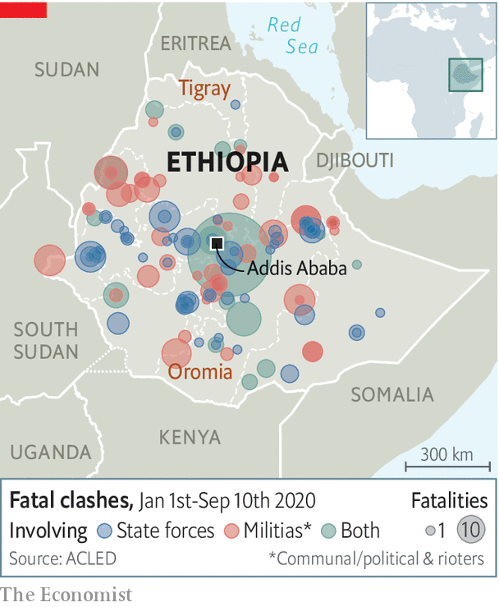

Tensions had been building for months before the latest unrest. The government’s decision to postpone elections because of covid-19 spurred talk of a constitutional crisis. Opponents including the Tigrayan People’s Liberation Front (TPLF), which runs the northern region of Tigray and dominated the federal government for nearly three decades, accused Abiy of trying to extend his time in office.

Abiy and his allies, in turn, blame the TPLF and militant ethnic nationalists for inciting violence. In an opinion piece published online by The Economist this week (see [article](https://www.economist.com/by-invitation/2020/09/17/abiy-ahmed-on-the-threats-to-ethiopias-democratic-transition)), the prime minister warns that Ethiopia’s journey to democracy risks being derailed by those “who are accustomed to undue past privileges” and those trying “to assume power through violence”, allusions to both the TPLF and parts of the previously outlawed Oromo Liberation Front (OLF).

Abiy’s comments are his most explicit admission yet of the difficulties of holding together a fractious federation in which ethnicity is arguably more powerful than national identity. Moreover, he is trying to do so with fast-dissipating legitimacy. Next month the constitutional term limit of this parliament and government will expire. This is adding to tension between the federal government and some of the nine ethnically constituted states, each of which has the right to secede. This month the TPLF defied the centre and held regional elections, which some saw as a first step towards Tigray breaking away.

Yet Abiy insists that his government’s actions do not mark a reversal of its democratic reforms. “What we learn from the fledgling democracies of Europe of the 1920s and 1930s is that democracy has to be defended from violent demagogues and mobs,” he told The Economist in a written response to questions. Tacitly acknowledging brutality, he says, “Given the institutions we have inherited, we realise that law-enforcement activities entail a risk of human-rights violations and abuse.”

Indeed many of those arrested or killed in clashes were perpetrators or instigators of violence. But Abiy himself is responsible for more of the current mess than he admits. Since taking office he has focused on amassing power by sidelining rivals, locking up opponents and monopolising decision-making instead of working with the opposition to lessen tension peacefully.

Although Abiy’s rhetoric differs from his predecessors’, his administration’s conduct looks increasingly familiar. For more than a year security forces have waged a harsh campaign against armed Oromo separatists. A report by Amnesty International alleged torture and summary executions. Instead of promising to investigate, Abiy dismissed the allegations as “fiction”. Responding to The Economist, he admits there may be “isolated incidents where law-enforcement agencies have used disproportionate force”. But he adds that allegations are “taken out of context”.

Meanwhile, opposition figures say political freedoms are being withdrawn. “Time and again they close our offices and detain our members,” says Merera Gudina, an Oromo leader. Even after judges have ordered certain prisoners’ release, the police have rearrested them. Eskinder Nega, an opposition leader blamed by the government for the rioting in the capital in July, was charged with terrorism on September 10th. Eskinder previously spent seven years in prison on trumped-up charges.

The government has repeatedly cut off the internet. Journalists were barred from travelling to Tigray to cover its election. A new law criminalising “hate speech” includes provisions which can be used to lock up peaceful dissidents. At least three broadcasters linked to the opposition, only one of which had aired calls for violence, were closed in July.

A lasting solution to Ethiopia’s crisis is likely to require negotiations with opposition groups and a broader discussion of ethnic versus individual rights. And although Abiy says he is committed to talks, he is wary of the opposition’s calls for a comprehensive “national dialogue”.

Abiy’s vision of a multi-ethnic country whose “destiny lies in our togetherness” is more hopeful than the one offered by militant ethnic nationalists whose break-up of the country would lead to ethnic cleansing and fighting between the regions. But after more than a century of trying to use force to forge a united state, now may be the time to try doing so through consent. ■

This article was downloaded by calibre from <https://www.economist.com/middle-east-and-africa/2020/09/19/ethiopias-democratic-transition-is-in-peril>

|  |  |  |  |
| --- | --- | --- | --- |
|  | Articles | Sections | Next |

|  |  |  |  |
| --- | --- | --- | --- |
| Previous | Articles | Sections | Next |

#### How to spend it

# Sensible budgets are not Ghana’s forte. But there is hope

A new initiative is ranking spending ideas by costs and benefits

Sep 19th 2020 |

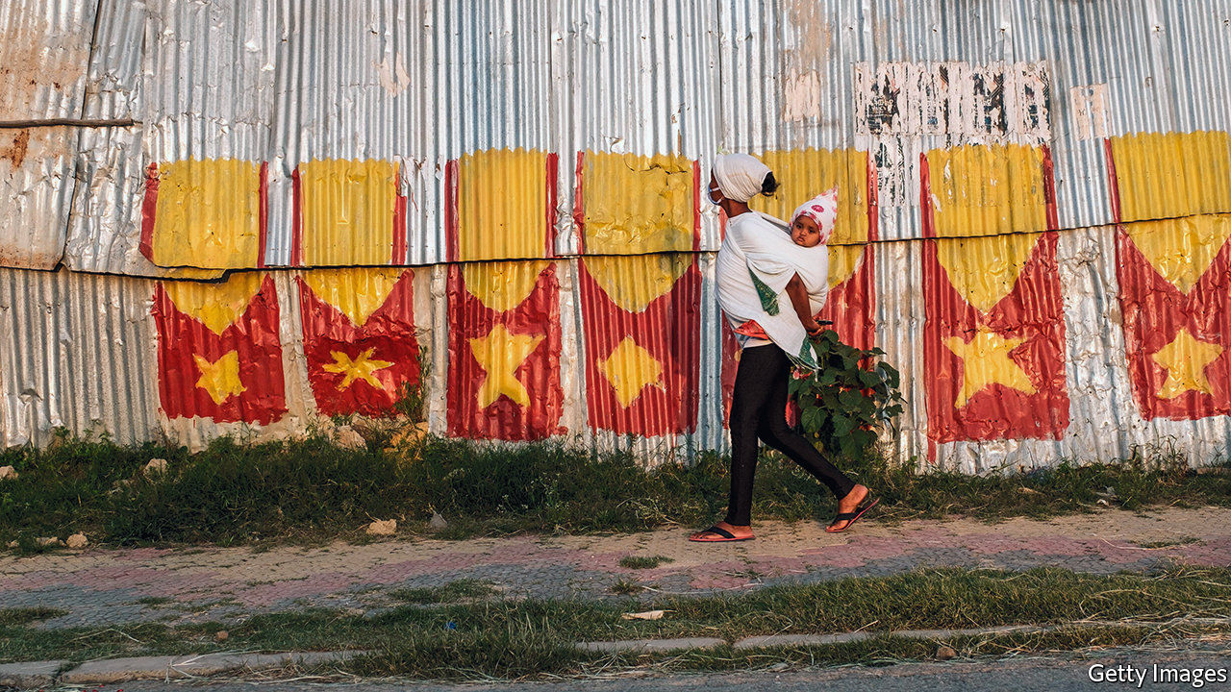

TUBERCULOSIS IS A terrible disease. It destroys lungs from the inside out, leaving sufferers coughing up the bloody remains. In Ghana too few people are diagnosed in time: the disease kills over 15,000 people a year, about 5% of all deaths. But a recent pilot scheme shows that diagnosis can be faster and more accurate simply by whisking samples from clinics that lack the latest testing technology to the nearest well-equipped testing centre. This could save more than 3,000 lives in six years if plans to scale up were followed through. Since the benefits are estimated at 166 times the costs over 20 years, the scheme is patently a fine idea.

Ghana is not famous for spending public money wisely. A study in 2015 found that, once under construction, a third of municipal infrastructure projects are never finished: half-built bridges litter the country. Spending is also highly political. In every election year bar one since 2000 the fiscal deficit has jumped sharply as the government of the day splurged to grab votes. IMF bail-outs and adjustment programmes have tended to follow. Last year Ghana completed its 16th.

Ghana’s National Development Planning Commission (NDPC) and the Copenhagen Consensus, an international think-tank, have teamed up to create a new initiative called the Ghana Priorities. It hopes to steer the government away from pork barrels by using solid evidence to assess which projects give the most bang for each buck.

More than 400 ideas have been narrowed down to 79. The costs and benefits of each have been analysed in peer-reviewed research papers and given a ratio. The best, such as ones for improving TB diagnostics and for universal malaria testing, have benefits worth over 100 times the costs (health schemes tend to score well). A land-title programme to clarify property rights promises benefits more than 90 times greater than the investment required.

Many fairly simple interventions have benefits that are reckoned to be a good 30 or so times higher than their costs. One community health-care programme included extra training for front-line staff, simplified health surveys so data can be used more easily and a flexible budget for local health clinics. These cut the deaths of new-born babies by half, according to a study published in 2019.

Cost-benefit analysis does not capture everything. It does not always identify precisely who benefits and who pays. The quality of the data and the number-crunching varies. The indirect effects of long-term national development projects are tough to analyse. But other methods are worryingly subjective. The team running the initiative asked a panel of economists and Ghana’s ministers for finance and planning to rank the proposals. They promoted R&D spending, which is superficially attractive but has a low benefit-cost ratio of only 1.5, from 62nd to 15th place.

The real test is what happens next. The nominally apolitical NDPC says the findings are already influencing how the government spends in response to covid-19. It also hopes that the research will shape Ghana’s medium-term development plan.

But James Dzansi of the International Growth Centre, a think-tank, says that party manifestos often knock aside such plans. An election beckons in December. Similar initiatives in the past have faltered when governments changed, says Mr Dzansi. The Ghana Priorities has better evidence underpinning it, he says. “Will this also lose momentum when a new government comes to power?” No matter who is in charge, though, wonks themselves may need to keep promoting evidence-based policies over political ones, says Koku Awoonor-Williams, one such wonk. ■

This article was downloaded by calibre from <https://www.economist.com/middle-east-and-africa/2020/09/19/sensible-budgets-are-not-ghanas-forte-but-there-is-hope>

|  |  |  |  |
| --- | --- | --- | --- |
| Previous | Articles | Sections | Next |

|  |  |  |  |
| --- | --- | --- | --- |
| Previous | Articles | Sections | Next |

#### A president who floats above the fray

# Uganda’s ruling party is fractious and disorganised

But it suits President Yoweri Museveni that way

Sep 19th 2020 | SHEEMA

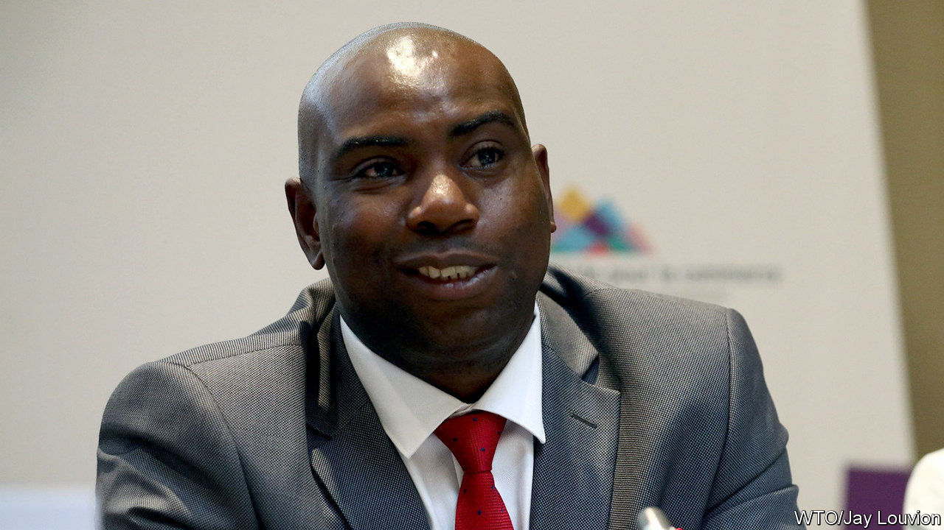

DICKSONS KATESHUMBWA is shaking up politics in Sheema, a district in western Uganda. In his bid for parliament he has repaired boreholes, doled out maize flour and flaunted the wealth he made as a customs official. Fans speed ahead of him on motorbikes, garlanded with leaves; in villages, crowds cheer his name. He says that people have been left poor by “bad leadership”, a reference to the cabinet minister who holds the seat.

But Mr Kateshumbwa is no opposition firebrand. He and his rival are both in the National Resistance Movement (NRM), the ruling party. On September 4th it held primaries to select parliamentary candidates for next year’s general election. Mr Kateshumbwa won, as did many other upstarts: voters kicked out about 120 incumbents, including 15 ministers. For Yoweri Museveni, president since 1986, that is not quite the setback it seems. Regular, disorderly voting is central to his rule. He commands a party in which there is tumultuous competition for every position except his own.

Mr Museveni blames political parties for fomenting regional and religious strife in the first decades of independence. After fighting his way to power he established a system where candidates stood without affiliation. Even after multiparty politics was restored in 2005, the party saw itself as a vehicle “where everybody gets on board”, says David Mafabi, a presidential adviser.

The party and the state are in “a symbiotic relationship”, says Richard Todwong, the NRM’s deputy secretary-general. Lines between the two are blurred. Mr Museveni’s rebel force is now the national army. Resistance councils created in the bush became the basis for village assemblies.

The NRM won two-thirds of seats at the previous election, so its endorsement of candidates is prized. At least six people were killed in the primaries and a minister was charged with attempted murder after allegedly shooting at his rival’s campaign manager. The Citizens’ Coalition for Electoral Democracy in Uganda, a civic alliance, found bribery and organised gangs at half the polling stations it observed.

For voters, the primaries are a chance to kick out incumbents who have not delivered. “They will expect you to bring electricity to every home,” says Mary Karooro Okurut, a vanquished minister, “and of course you will not be able to do that, so then they throw it at you.” Every constituent asks for help with school fees and hospital bills, grumbles Gordon Arinda Kakuuma, another ousted incumbent.

Such gripes reflect popular understandings of a politician’s role. “It is all about lobbying for your area,” explains Rosemary Nyakikongoro, a candidate in Sheema. “If I must lobby anything from government, then I have to be in the ruling party,” explains Abel Kahara, the mayor.

The tussles within the NRM create a vent for popular frustration, leaving Mr Museveni to float above the fray. True, many voters are tired of his authoritarian rule, especially in the swelling cities, and dissent is violently repressed. But many in his rural base still believe, as one voter puts it, that the problem is neither Mr Museveni nor the NRM, merely the rogues within it.

The party’s internal churn is also bringing a younger generation of leaders to the top. Some are ambitious, and Mr Museveni promotes those who protect his power. He is happy to ease out bush-war veterans who have “the character to ask questions”, says Sabiti Makara of Makerere University. Increasingly the only thing holding the NRM together is Mr Museveni himself. ■

This article was downloaded by calibre from <https://www.economist.com/middle-east-and-africa/2020/09/19/ugandas-ruling-party-is-fractious-and-disorganised>

|  |  |  |  |
| --- | --- | --- | --- |
| Previous | Articles | Sections | Next |

|  |  |  |  |
| --- | --- | --- | --- |
| Previous | Articles | Sections | Next |

#### Name games

# Why no one is called Linda in Saudi Arabia

The kingdom still bans some foreign names, but other countries are loosening up

Sep 19th 2020 |

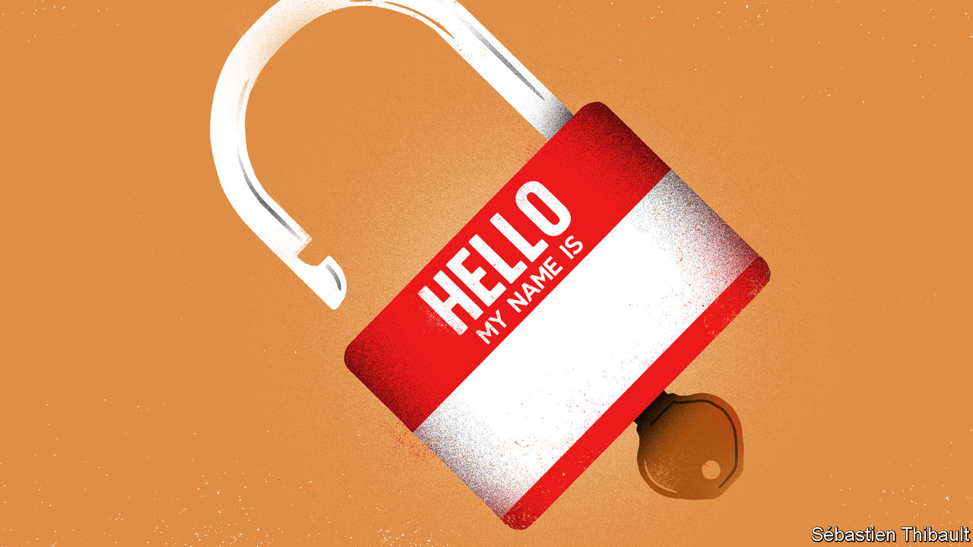

ABDELMADJID LABADI, who lives in Algeria, could have chosen an Arabic name for his daughter. But he wanted one that reflected his Berber ethnicity. His choices were limited: Algeria keeps a list of around 300 approved Berber names, a way of holding the minority in check. Mr Labadi wanted none of them. So for almost four years he left his daughter officially nameless, as he fought in court for the name he preferred. In July he finally won and his daughter formally became Tanila, Berber for dove.

Regimes in the Middle East and north Africa long restricted names as a way of encouraging national unity—usually centred on the majority ethnic group or religion. For example, Turkey banned Kurdish names and non-Turkish suffixes, such as the Armenian “-ian”. Post-revolution Iran banned Western names and balked at pre-Islamic Persian ones. Israeli bureaucrats gave Jewish immigrants from Europe and Muslim countries Hebrew names on arrival. Algeria’s registrars were obliged to ensure that names were “Algerian-sounding”; Morocco said they must sound Moroccan.

But this form of nationalism has been receding in much of the region. Officials who guarded against “cultural separatism” now celebrate diversity. Take Tunisia, which ended its ban on foreign names in July. “What people drink or name their children is their private affair,” said Lotfi Zitoun, the minister who took the decision. Turkey officially ditched its policy of Turkifying names in 2003. The constitution passed by Iraq in 2005 ended the Arabisation of minority names. Israel dispensed with Hebraisation in the 1990s, when a wave of Jews from the former Soviet Union arrived.

Even today, though, official tolerance is limited. Algerian registrars still grimace at names such as Kahina, a Jewish Berber queen who battled the conquering armies of Islam. A Kurd in Turkey can call his child Serwav, which means warrior, but it is likely to invite government scrutiny. Iran’s ayatollahs have grown more comfortable with ancient Persian names, but they frown upon those of old shahs and kings, which might betray a parent’s monarchist leanings. Not long ago Saudi Arabia banned 51 names. Many were favoured by Shia Muslims, who are a minority in the kingdom. But Linda was on the list, too.

Other parts of the world are also restrictive in this way. China bans “extreme” names, such as Muhammad or Islam, in its Xinjiang-region. Until 2017 California prohibited the use of accents in names. An Egyptian parliamentarian once tried to make things simple by banning all foreign names. But he backtracked after being reminded that the widow of Egypt’s longest-serving president, Hosni Mubarak, is called Suzanne.

This article was downloaded by calibre from <https://www.economist.com/middle-east-and-africa/2020/09/19/why-no-one-is-called-linda-in-saudi-arabia>

|  |  |  |  |
| --- | --- | --- | --- |
| Previous | Articles | Sections | Next |

|  |  |  |  |
| --- | --- | --- | --- |
| Previous | Articles | Sections | Next |

#### End of the illusion

# The Arab-Israeli conflict is fading

But that will not resolve the one with the Palestinians

Sep 19th 2020 | BEIRUT

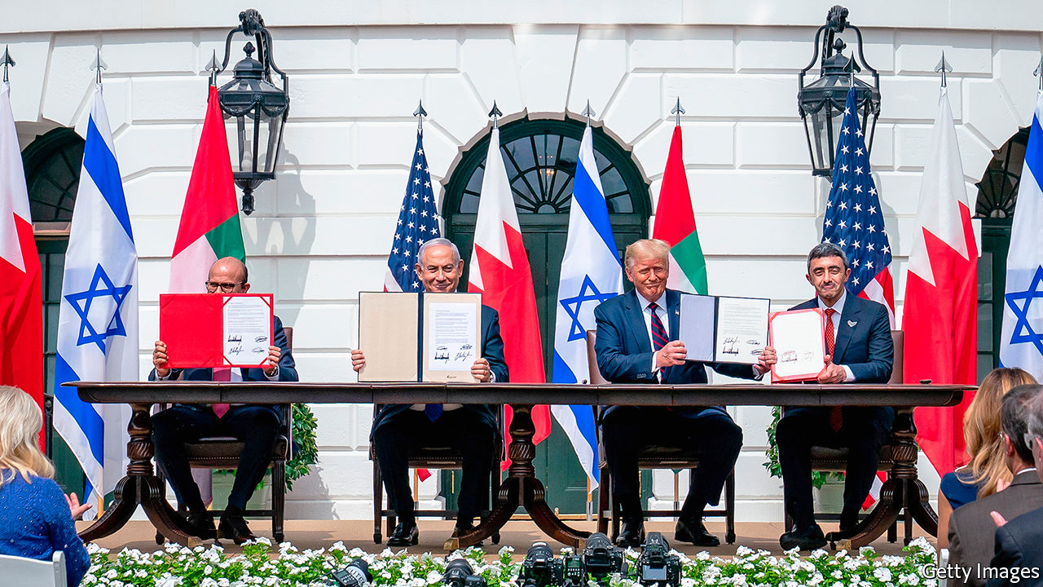

SEVEN DECADES of official ostracism ended with a few strokes of a pen. On September 15th, at a ceremony in Washington (pictured), Bahrain and the United Arab Emirates (UAE) established formal diplomatic relations with Israel. They are the first Gulf states to do so. The documents they signed were thin: details of flights, commerce and the exchange of ambassadors must be worked out. Still, in one afternoon, Israel doubled the number of Arab countries with which it has official ties. It also has informal relations with at least five others, from Oman to Morocco.

It was a genuine achievement for President Donald Trump, whose attempts at high-stakes diplomacy have been marked more often by stalemate than success. For Binyamin Netanyahu, Israel’s prime minister, it validated a long-held belief that his country would not have to make peace with the Palestinians to enjoy better regional ties. (It was also a welcome excuse to get out of Israel, where covid-19 cases are surging and the public is furious about a newly imposed three-week lockdown over Judaism’s holiest festivals.)

There was much talk of peace, as if a long, vicious war had finally ended. “It’s been blood all over the sand for decades and decades,” Mr Trump said. “That’s all they do is they fight and kill people.” In fact, Israel never fought Bahrain or the UAE; neither was even a sovereign state until more than two decades after Israel’s founding. They have been quiet partners for years, brought together by a mutual fear of Iran.

The Emiratis moved first to make that partnership public, but Bahrain’s decision to follow suit may be the more interesting one. The UAE did not have to worry about whether normalisation would be popular. It is strong enough to brush off criticism from countries such as Iran and Turkey (which itself recognised Israel in 1949). At home there is little space for dissent. One prominent Emirati academic, known for past criticism of Israel, tweeted a tearful emoji when the UAE announced its decision last month. He has since reaffirmed his support for the country’s leadership.

Bahrain, by contrast, has a history of protest. The Shia majority has long complained of discrimination by the Sunni royal family. Unrest peaked in 2011 during protests inspired by the Arab spring, which were crushed with the help of troops from other Gulf countries. Opponents of normalisation with Israel have more room to express dissent in Bahrain, although the most strident critics risk arrest. There was an outpouring of discontent on social media in the days before the ceremony.

The reaction will be watched closely in Saudi Arabia. Bahrain relies on its larger neighbour for political and economic support. It would not have made such a consequential decision without the kingdom’s blessing. It may serve as a test run. Mr Trump has hinted that Saudi Arabia could be next. The crown prince, Muhammad bin Salman, may see a way to polish his reputation in Washington, which has been blackened by the war in Yemen and the murder of Jamal Khashoggi, a Saudi journalist. For now, though, King Salman sits on the throne. He hews to the old Arab orthodoxy of offering Israel full relations only if it withdraws from Palestinian lands.

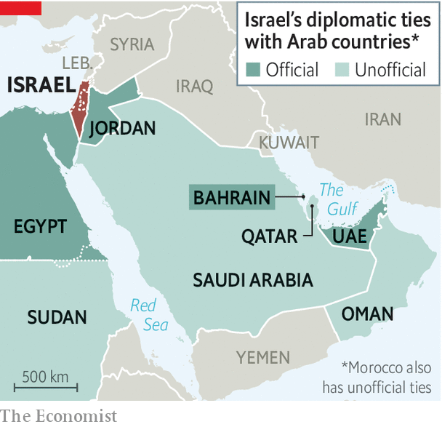

Bahrain and the UAE settled for much less. The Emiratis did extract a promise that Israel would shelve plans to annex parts of the occupied West Bank. In their telling, they now have more leverage to push for a two-state solution. “The policy of the empty chair has not served the Palestinians well, and indeed has not served the Arabs well,” says Anwar Gargash, the UAE’s minister of state for foreign affairs.

History suggests such leverage will count for little, though. Egypt and Jordan signed peace treaties with Israel decades ago but have not brought the Palestinians any closer to statehood. The treaties that Israel signed with Bahrain and the UAE did not even include a nod to a two-state solution, only vague talk of a “just” resolution.

The autocrats who gather at Arab League gabfests still recite paeans to the Palestinian cause. Out in the real world, though, the Arab-Israeli conflict has long since ebbed. Almost four decades have passed since a regular Arab army fought Israel. It is hard to say precisely how the Arab public feels, as dictatorships do not lend themselves to credible polling. Most Arabs no doubt remain sympathetic to the Palestinians. But there has been a gradual softening of opinion. Most Arab states are suffering from political and economic crises, exacerbated by a power struggle between Iran, Turkey and the Gulf states; the Palestinian cause no longer arouses the passions it once did.

Mr Trump thinks there will be more diplomatic announcements to come. “We’ll have at least five or six countries coming along very quickly,” he said. A bit of Trumpian exaggeration, perhaps, although others will surely follow and the Palestinians will find themselves ever more isolated. Yet the loss of Arab support will not compel them to abandon their demands. Strip away the façade of an Arab-Israeli conflict, and the problem remains what it always has been: a territorial dispute between two peoples that only they can resolve. ■

This article was downloaded by calibre from <https://www.economist.com/middle-east-and-africa/2020/09/19/the-arab-israeli-conflict-is-fading>

|  |  |  |  |
| --- | --- | --- | --- |
| Previous | Articles | Sections | Next |

|  |  |  |
| --- | --- | --- |
| Middle East & Africa | Sections | Britain |

Europe

Russia’s local elections: Winning from death’s door

.

Spanish history: A law to fight Franco

.

The eastern Mediterranean: Anchors awry

.

Germany’s economic recovery: Zombie dawn

.

Charlemagne: Europe’s asylum compromise

.

|  |  |  |
| --- | --- | --- |
| Middle East & Africa | Sections | Britain |

|  |  |  |  |
| --- | --- | --- | --- |
|  | Articles | Sections | Next |

#### Winning from death’s door

# Alexei Navalny, Russia’s poisoned opposition leader, has a Siberian success

President Vladimir Putin takes a knock in local elections

Sep 19th 2020 |



LAST MONTH Alexei Navalny, Russia’s main opposition leader, stood in the middle of Novosibirsk, the capital of Siberia and the country’s third-biggest city, explaining how to liberate it from occupation by crooks and thieves. For thus has he famously dubbed the United Russia party. The party is the country’s largest, and the vehicle through which President Vladimir Putin exercises legislative control. “The basis of Putin’s power is not the State Duma as is commonly believed,” said Mr Navalny. “The main strength lies in the fact that the Kremlin’s United Russia has a majority in every legislative assembly in every region and in every major city’s council.”

All these councillors, mayors and governors keep Mr Putin in power and in return are allowed to extract money from the people who live in their territory through a web of corruption that enwraps the entire country, Mr Navalny argues. “If United Russia loses this majority, the power of these villains will instantly melt away,” he explained in a sleek video aimed at mobilising voters in local elections across around a third of Russia on September 13th. “They have always defeated us. Twenty years in a row. But we need to rise and go into battle again,” he said.

By the time his video was posted on YouTube at the end of August, quickly gaining millions of views, Mr Navalny was in intensive care in Berlin, poisoned by a nerve agent. His team carried on working undeterred and, on September 13th, two of Mr Navalny’s closest allies, who head branches of his organisation in Novosibirsk and Tomsk, were elected to their respective city councils. Unlike United Russia candidates, who often tried to conceal their party affiliation, Mr Navalny’s candidates made no secret of being members of his team, and ran not on local issues but on a clear anti-Kremlin message.

Their victories hardly break United Russia’s grip on power. Its candidates won the gubernatorial elections in all 18 of the regions that held them, and retained control of the vast majority of local legislatures too. But the victories of Mr Navalny’s two main candidates in Siberia, which contributed to United Russia losing its majorities on those two councils, set a precedent for the elections to the Duma, Russia’s parliament, next year. They showed that Mr Navalny’s appeal extends well beyond Moscow and that the grip of the pro-Kremlin parties can sometimes be overcome.

They also demonstrate that Mr Navalny’s organisation has become a formidable political force, even though he was not allowed to run in the election and his party does not officially exist. To overcome these obstacles, Mr Navalny has come up with the idea of “smart voting”, where his team identifies the candidate most likely to beat United Russia. In the election on September 13th this deprived United Russia of about a tenth of its seats, despite unprecedented levels of pressure and dodgy tricks. Public-sector workers, who are dependent on the state, were ordered to vote, for instance, and the procedure was stretched out over three days, which made the task of controlling the outcome easier.

The Kremlin’s ability to manipulate elections and maintain control depends on low voter turnout. It reduces the number of people authorities need to mobilise and makes rigging simpler. In Novosibirsk, a city of 1.6m people, the turnout was indeed well below 20%. “People don’t believe that they can change anything and don’t bother to vote,” admits Sergei Boiko, the head of Mr Navalny’s organisation in Novosibirsk, who managed to form a coalition of opposition candidates as well as to get elected to the city council himself.

Ever since Mr Putin came to power 20 years ago, the Kremlin has cultivated cynicism and a sense of helplessness in Russia’s people. In 2006 it abolished an option on ballot papers for voters to reject all candidates, thus preventing protest voting. Unsurprisingly, those who opposed the Kremlin simply did not turn up to vote at all. “People need to see a success story, to start believing they can change things,” says Alexei Mazur, a democracy activist in Novosibirsk.

Yet as Leonid Volkov, Mr Navalny’s chief of staff, explains, a low turnout is a two-edged sword. It only takes a few thousand inspired and motivated voters to change the outcome. Nonetheless, if this election is anything to go by, however unpopular United Russia may be, mobilising people to vote against it is a mammoth task.

This is why Mr Navalny has directed all his energy and charisma into trying to project a sense of hope—and why he was poisoned. His biggest victory has been to survive that assassination attempt. On September 15th he published his first Instagram post since coming out of a coma. It shows him sitting in bed smiling, surrounded by his happy family. “Hi, this is Navalny,” the post read. “I have been missing you…Yesterday I managed to breathe on my own for the entire day…not even a valve in my throat. I liked it very much. It’s a remarkable process that is underestimated by many. Strongly recommended,” he wrote, pledging to return to Russia as soon as possible. Within a few hours his post had gathered more than a million “likes”. All he needs to do now is find a way of turning those “likes” into votes. ■

This article was downloaded by calibre from <https://www.economist.com/europe/2020/09/19/alexei-navalny-russias-poisoned-opposition-leader-has-a-siberian-success>

|  |  |  |  |
| --- | --- | --- | --- |
|  | Articles | Sections | Next |

|  |  |  |  |
| --- | --- | --- | --- |
| Previous | Articles | Sections | Next |

#### A law to fight Franco

# The Spanish government proposes a new law on history

It seeks to dig up the past

Sep 19th 2020 | MADRID

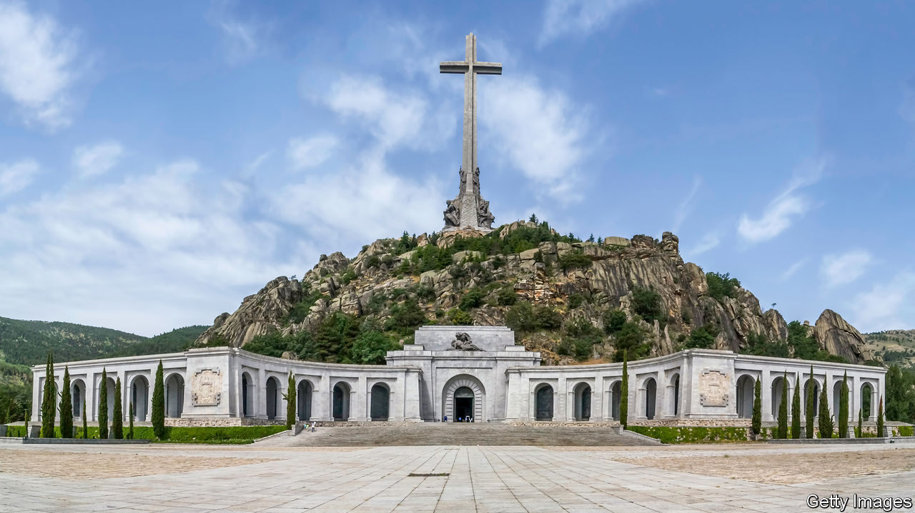

WHEN DEMOCRACY came to Spain in the late 1970s, it arrived through agreements between moderate supporters of the long dictatorship of Francisco Franco, the victor in the Spanish civil war, and a realistic democratic opposition. At their heart was an amnesty law and a broad understanding not to use the past as a political weapon—arrangements often misleadingly dubbed a “pact of forgetting”. This largely seamless transition was widely hailed as a success. But younger generations, mainly on the left, now worry that Spain never acknowledged the crimes of its past.

A first attempt to redress this came with a law of “historical memory” in 2007, which aimed to remove fascist symbols from public buildings and recognise the mistreatment of Franco’s victims, but was only partly implemented. Now the minority left-wing coalition government of Pedro Sánchez has unveiled a draft law of “democratic memory” that would go further.

The draft is a mixed bag. Many welcome a plan to recover the remains of victims of the civil war and the repression that followed its end. The government hopes to find up to 25,000 skeletons in five years or so. The law would also annul the verdicts of Franco’s summary trials and withdraw titles and medals awarded by the dictatorship. The Valley of the Fallen, the grandiose basilica from which Franco’s remains were removed by the government last year, will be redesignated as a civilian cemetery (rather than a church) and run by the state (rather than the Benedictine monks on whom Franco bestowed it).

More questionable are powers to shut down groups that “exalt” or “apologise for” the dictatorship, such as the Francisco Franco Foundation, a private archive for nostalgics run from an obscure Madrid flat. The foundation says this is an “attack on freedom of thought” and threatens to move to the United States. The law would also require schools to incorporate “democratic memory” into the history curriculum. Whether that will lead to good history or official propaganda is unclear.

Most troubling is that the bill sets up a special prosecutor to investigate human-rights abuses from 1936 to 1978. This is largely futile, since most perpetrators are dead. It also comes close to overturning the amnesty law, out of a conviction that justice and truth should retroactively outweigh peace and reconciliation.

The conservative opposition claims the bill is a smokescreen to hide government mismanagement of the pandemic. It objects, too, to the likelihood that it will be approved with the parliamentary votes of Basque and Catalan separatists, who reject the current constitution.

The bill’s defenders contrast Spain’s tolerance of Franco with Germany and Italy. But Spain’s history is different. If the government really wants to resolve unfinished business from the past, it should have tried to agree on the bill with the opposition. For all its virtues, the bill uses the past as a political weapon. And that is bad for Spanish democracy.

This article was downloaded by calibre from <https://www.economist.com/europe/2020/09/19/the-spanish-government-proposes-a-new-law-on-history>

|  |  |  |  |
| --- | --- | --- | --- |
| Previous | Articles | Sections | Next |

|  |  |  |  |
| --- | --- | --- | --- |
| Previous | Articles | Sections | Next |

#### Anchors awry

# Greece’s navy is in need of a refit

Turkey has more and newer ships

Sep 19th 2020 | ATHENS



“WE GAVE THE Turks a lesson in seamanship,” boasts Andreas Stefanopoulos, a reservist in Greece’s navy. The jingoistic mood that swept Athens after a collision in the eastern Mediterranean on August 12th, in which a newish Turkish frigate suffered visible damage while a 40-year-old Greek one was apparently unharmed, is yet to fade. Morale in the armed forces is “the highest I’ve ever seen”, a former Greek defence minister declares. “The navy and air force are both raring to take on the Turks.”

Greece has pockets of naval excellence. Its German-designed submarines are “almost undetectable by Turkish sonar”, says Emmanuel Karagiannis of King’s College London, and its nippy corvettes are armed with French Exocet missiles of the sort that wounded the Royal Navy in the Falklands war. Greece’s navy would have “considerable firepower” in the confines of the Aegean, says Mr Karagiannis. But it “lacks the means to project power in the deep waters of the eastern Mediterranean,” he warns.

Between 1970 and 2020 Greece commissioned 30 attack submarines, frigates and corvettes that are still operational, to Turkey’s 38, according to figures collected by the International Institute for Strategic Studies (IISS), a think-tank in London. The Greek fleet is also ageing, whereas Turkey is churning out modern warships. Cash-strapped Greece has largely given up on buying high-end French frigates or destroyers, opting for smaller and cheaper British corvettes instead.

Greece is especially concerned about the security of Kastellorizo, a small island far from the Greek mainland and just a mile off the Turkish coast. It lies at the heart of the current crisis. Though Turkey does not formally lay claim to the island, it objects to the idea that such a paltry territory should have its own exclusive economic zone, and complains that Greece has violated agreements on the demilitarisation of this and other islands.

Kastellorizo, which Greece’s president visited on September 13th, is not easy to defend. Turkey’s procurement of a helicopter-carrier will also bolster its ability to mount amphibious operations, including the seizure of islands, says Hugo Decis of the IISS.

Mindful of this vulnerability, Greece’s top general has warned that any local conflict would swiftly lead to a full-scale war. A Greek riposte, says Mr Karagiannis, would probably come on more favourable ground, such as the Evros river region that marks the land border between the two countries. But Greek tanks are in bad shape and the border is heavily mined. It is “not really a feasible proposition these days”, says a Western military attaché.

Greece is scrambling to redress the gap. In August the finance minister promised to boost defence spending, which fell precipitously after the financial crisis. Greece spends less than $5bn on defence each year, a third of what Turkey spends. On September 12th its prime minsiter, Kyriakos Mitsotakis, announced plans to buy 18 French Rafale fighter jets, most of them “slightly used”, plus four helicopters and advanced weapons to go with them. He also promised to buy four new frigates and to refurbish old ones. But the first planes will not turn up until next year, and the ships probably later still. Greece will be outgunned for a while yet. ■

This article was downloaded by calibre from <https://www.economist.com/europe/2020/09/19/greeces-navy-is-in-need-of-a-refit>

|  |  |  |  |
| --- | --- | --- | --- |
| Previous | Articles | Sections | Next |

|  |  |  |  |
| --- | --- | --- | --- |
| Previous | Articles | Sections | Next |

#### Zombie dawn

# Germany’s bail-out brings worries about its long-term effects

Has the state been too generous?

Sep 16th 2020 | BERLIN

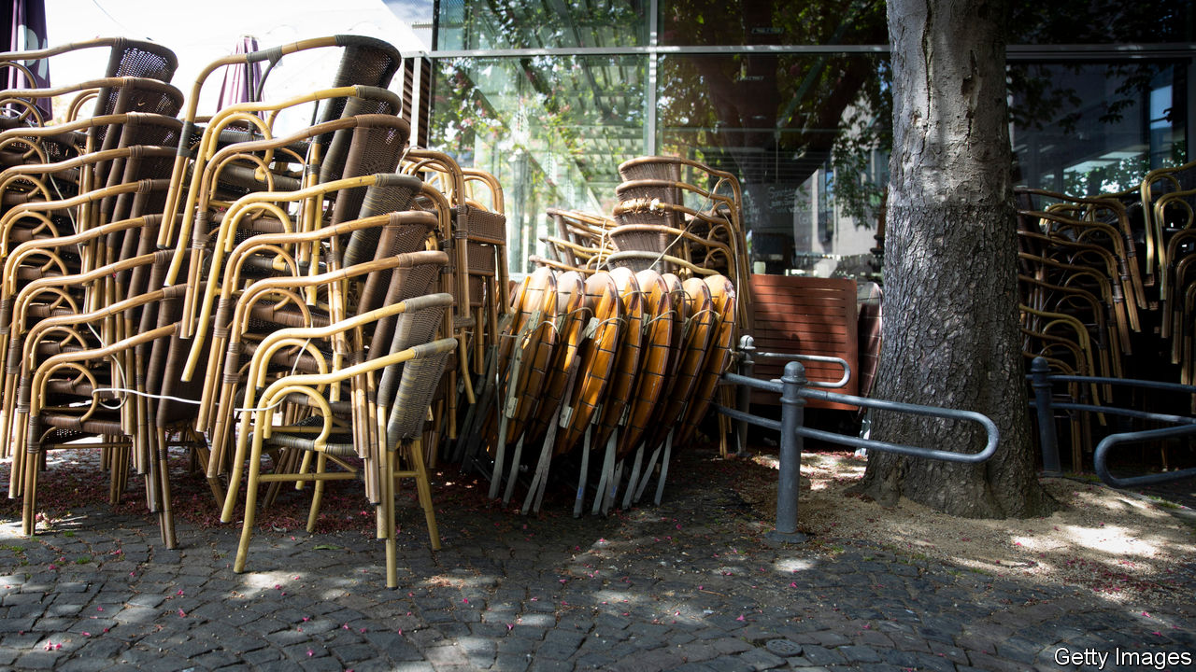

GERMANY’S FAMED Kurzarbeitergeld programme, which funnels government cash to workers whose hours are cut by employers, is the “gold standard” of furlough schemes, reckons the IMF. It has been widely imitated across Europe by governments seeking to protect jobs and incomes from the full ravages of covid-19 lockdowns. In Germany, under relaxed criteria introduced in March that were extended to nearly 7m workers, it has limited the rise in unemployment to around 600,000 and kept consumer spending buoyant.

The extraordinary rescue package assembled by Angela Merkel’s government, which also included bridging loans to firms and a suspension of fiscal rules to allow stimulus spending, was broadly endorsed by Germany’s economic establishment. It has fuelled a more robust recovery than elsewhere in Europe. But two recent decisions have seen that consensus start to fray. The first was an extension of Kurzarbeitergeld payments to 24 months. The second was a further moratorium on Germany’s strict requirement for overly indebted companies to declare bankruptcy.

Such blanket measures, fear some, could spawn vast numbers of “zombie” firms kept alive by a drip-feed of state aid, hindering the redeployment of capital and labour to more productive uses. “Kurzarbeitergeld could tie workers to companies that have no future,” said Jens Weidmann, head of the Bundesbank, on September 2nd. Christian Sewing, the CEO of Deutsche Bank, warned that one in every six German firms risked zombification. The OECD raised similar concerns this week.

In fact there are two dangers. One is that the state props up firms that would have struggled even without the pandemic. The decision to extend Kurzarbeitergeld was not necessarily wrong but taken too early, reckons Andreas Peichl, an economist at the Ifo institute in Munich. He would have preferred changing tax rules to allow companies to offset current losses against pre-pandemic profits. (Olaf Scholz, the finance minister, says fears of zombification are “bloodless textbook speculation”.)

The second risk is that covid-19 causes structural change in economies. A travel agency or music-promotion company that was thriving before the pandemic and now surviving on state support may struggle afterwards if consumer habits shift permanently. But it is too early to know.

A related issue is that state help may encourage some companies—especially in Germany’s crucial car industry, which has disproportionately relied on Kurzarbeitergeld—to postpone some hard choices about their business models. Germany is unusual among rich countries in having focused solely on short-term emergency measures, notes Ludovic Subran, chief economist at Allianz, an insurer, rather than long-term recovery measures like retraining, tax reform or investment. Germany’s well-capitalised firms may actually be at less risk of zombification than their counterparts elsewhere in Europe. But they have not yet been offered much of a guide to the future.

One reason for that may be next year’s election, at which Mrs Merkel will stand down after 16 years in office. Even before the virus struck, some economists had begun to chafe against Germany’s low-deficit, low-investment orthodoxy, especially the currently suspended “debt brake”, which constrains borrowing. Mr Scholz, who is running to succeed Mrs Merkel, says the debt brake should return in 2022, but others in his Social Democratic Party disagree. The Greens, likely to join the next government, will hope to exploit the state’s sudden conversion to activism to press their case for long-term public investment. Conversely, whoever leads Mrs Merkel’s conservatives into the election may push for a return to fiscal restraint and smaller government. Germany’s short-term measures may have long-term consequences. ■

Editor’s note: Some of our covid-19 coverage is free for readers of The Economist Today, our daily [newsletter](https://my.economist.com/user#newsletter). For more stories and our pandemic tracker, see our [hub](https://www.economist.com/news/2020/03/11/the-economists-coverage-of-the-coronavirus)

This article was downloaded by calibre from <https://www.economist.com/europe/2020/09/16/germanys-bail-out-brings-worries-about-its-long-term-effects>

|  |  |  |  |
| --- | --- | --- | --- |
| Previous | Articles | Sections | Next |

|  |  |  |  |
| --- | --- | --- | --- |
| Previous | Articles | Sections | Next |

#### Charlemagne

# Europe’s asylum compromise

Let the humanitarians sound humane and the hardliners sound hard

Sep 19th 2020 |

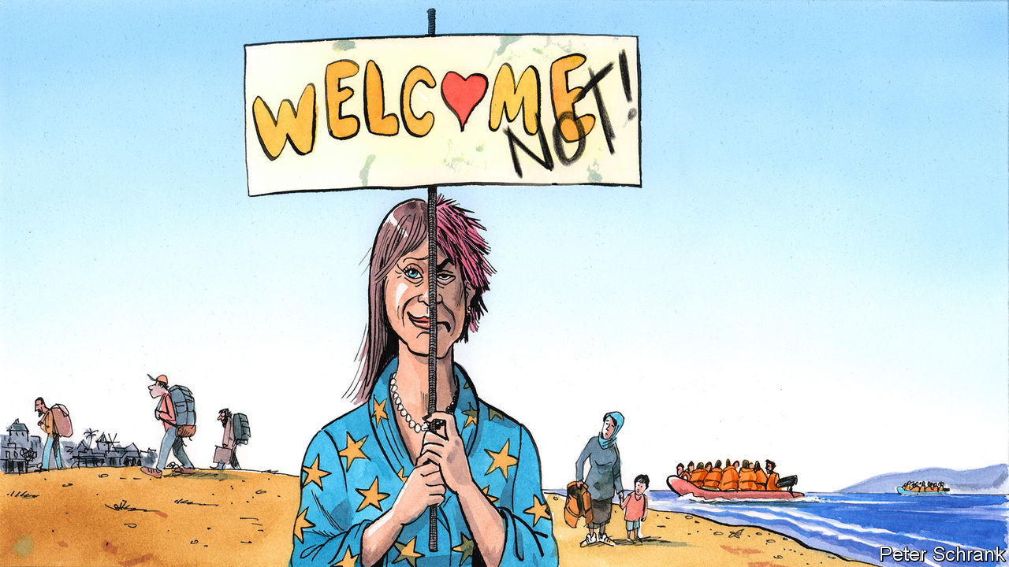

IT TAKES A lot of misery to jolt European politicians into action on migration. Only when bodies started piling up on Lampedusa, an Italian island near Tunisia, did European leaders in 2013 first properly acknowledge the refugee crisis at its border. At its peak in 2015, when 1m people entered the EU, only the very worst stories cut through. In one incident, 71 people—including four children—suffocated inside a meat lorry. Their bodies were discovered beside an Austrian motorway when a policeman noticed their liquefied remains seeping out. Compared with those horrors, the long-running misery of Moria, an overcrowded, squalid refugee camp on the Greek island of Lesbos was a side-story.

Until it burnt down on September 9th. Moria and other camps like it dotted across Greece were supposed to be the fulcrum of the EU’s asylum policy. For hosting them, Greece had received €2bn of EU funding. Yet in mid-September the fire left 13,000 people—including about 4,000 children—searching for shelter. Moria has provided a deeply inauspicious backdrop for the European Commission’s latest efforts to tackle the issue. It is due to unveil a “migration pact” on September 23rd, with a host of policies designed to overhaul the bloc’s asylum and migration rules.

Brussels has a thankless task ahead of it. Migration sits at an unhappy apex of complexity and controversy. Leaders are united only by paranoia. “Every single government can go down because of this,” says one EU ambassador. Populists have long made hay of the topic. On the other side of things, green and leftist parties hammer their mainstream rivals when they become too stern. Old divisions have already emerged from Moria’s ashes. Germany, the de facto head of the EU’s humanitarians, swiftly promised to take in 2,750 asylum-seekers from Greek camps. Austria, the leader of the anti-migration hardliners, insisted it would take none.

Coming up with a compromise between the humanitarians, the hardliners and the front-line states, such as Greece, is the commission’s job. As part of the package, the front-line states must be stricter in registering arrivals. Despite rules to the contrary, asylum-seekers and migrants who arrive in, say, Italy have a habit of ending up in the EU’s north. Under the proposals, an initial sift will see arrivals sorted into categories, with those likely to receive asylum put on one track, whereas those from relatively safe countries will be diverted for rapid deportation. After that, rather than stay in the first port of call, refugees will be distributed across the EU.

The hitch with this plan is that countries such as Hungary have refused point-blank to accept any such scheme. Forced compassion is a recipe for misery. Arrivals do not want to go to Hungary; Hungarians do not want them to come. Wealthy western European countries which have six decades of (often chequered) experience of immigration are tone-deaf when they lecture eastern European voters. Forcing countries with little history of immigration to get used to it in a few years rather than decades is clumsy and unreasonable and will win few converts. The EU is, however, a commons in which freeloaders should not be accepted. The commission is trying to come up with other ways to share out the burden.

One idea being considered by EU officials is for hardline countries to take the lead in removing people without the right to asylum. Deportation—“returns” in the euphemistic jargon—is difficult. It is expensive, legally complicated and requires strong diplomacy. Taking responsibility for deportations would be a serious job. At the moment, only 40% of failed asylum-seekers are actually sent back. Without an effective system of deportation, a dangerous trip to the EU becomes a calculated risk, even for someone from a country such as Nigeria or Senegal, whose citizens’ asylum applications are rejected 90% of the time.

Leaving the hardliners as Europe’s bouncers, in the phrase of one migration wonk, would partially solve the solidarity issue. But it would scar the EU’s self-image as a beacon of liberal values. Brutal as it may seem, the EU can either have an asylum system that lives up to humanitarian ideals but fails in practice, or it can have a system that actually works. Some European countries are happy to be humanitarian; others are happy to be hard-headed. A successful Europe-wide migration strategy would make use of both.

## Compromise without crisis

Even this approach may flounder. The last crisis still poisons the debate, even though things are different now. Between 2015 and 2016, 1.4m jumped the border. Now only around 140,000 people arrive every year in an “irregular” manner. Calmer heads should prevail. After all, most migration is legal and well organised, points out Ylva Johansson, the commissioner for home affairs, who oversees the reforms. About 2.5m people move to the EU each year, while 1m leave—just the ticket for an ageing bloc fond of welfare spending. “De-dramatising” the situation is the commission’s main aim, says Ms Johansson. But when it comes to refugees, EU leaders swiftly become drama queens.

Fights over money or industrial policy are comparatively simple to settle. Cash can be shuffled around on a spreadsheet. Regulatory leeway for cherished industries can be haggled over. No such easy fixes exist when it comes to migration. Taking in refugees is a decades-long commitment, which requires political consent. Integration is difficult to do well, even when a government is willing, never mind if people are being foisted upon their hosts.

If a deal is not possible in a time of relative calm, then waiting for a crisis becomes the only option. Although it was a hoary old solution to European deadlock, a similar approach on economic matters worked this summer. EU leaders took a political leap of faith by issuing mutual debt for the first time. The trouble is that the EU had to suffer its worst-ever economic slump to get there. A big enough crisis may do something similar when it comes to asylum, creating the political space for compromise. But a breakthrough will come only at an unconscionably high price. ■

This article was downloaded by calibre from <https://www.economist.com/europe/2020/09/19/europes-asylum-compromise>

|  |  |  |  |
| --- | --- | --- | --- |
| Previous | Articles | Sections | Next |

|  |  |  |
| --- | --- | --- |
| Europe | Sections | International |

Britain

Britain after Brexit: Opening the taps

.

Abortion: Call to action

.

Covid-19: Flunked

.

Northern Ireland: Up(load) the RA

.

Unemployment: Pain in unexpected places

.

Public art: For God’s sake

.

Threats to Britain: Into the greyzone

.

Bagehot: Boris v the blue blob

.

|  |  |  |
| --- | --- | --- |
| Europe | Sections | International |

|  |  |  |  |
| --- | --- | --- | --- |
|  | Articles | Sections | Next |

#### Of moonshots and bus subsidies

# How state aid became a Brexit deal-breaker

Tories used to think controls on subsidies were the best thing about Brussels. Now they want to open the spending taps

Sep 19th 2020 |

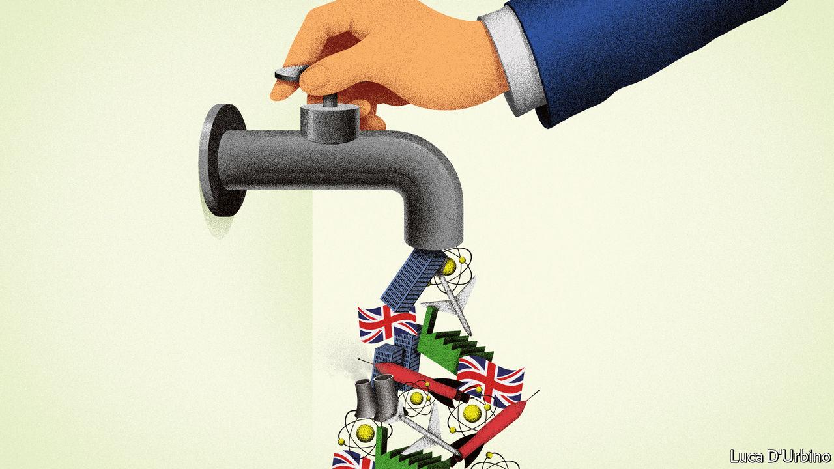

FOR YEARS only left-wingers like Jeremy Corbyn, the former Labour leader, and Bob Crow, a trade-union honcho, were bothered by Europe’s state-aid regime. For Conservative Eurosceptics, it was the best thing about Brussels. Rules prohibiting distortive subsidies to businesses were cast in the European Union’s founding treaty, but it was Margaret Thatcher who gave them teeth. For her they were a means of rolling back the state at home and abroad. She made common cause with Jacques Delors, the architect of the single market. Europe’s ailing economies could only integrate and become competitive, the logic ran, if their governments stopped doping companies on public money.

Control over state aid has since become one of Brussels’ strongest tools, granting the European Commission power to overrule finance ministries and claw back huge payments. Yet Conservative politicians mostly ignored it after the Brexit referendum of 2016. Britain doles out little aid compared with other European countries, and has navigated the rules nimbly, rarely getting hit for infringements. Whereas they despised her plans for a close relationship with the single market and customs union, Tory MPs did not mind Theresa May’s proposal to keep Britain in lock-step with Europe’s state-aid regime, and to uphold the rules even if it left without a deal.

Boris Johnson has abandoned this legacy, to the dismay of Thatcher’s disciples and the EU’s Brexit negotiators. On September 9th the government said it would follow much looser World Trade Organisation (WTO) rules after Brexit. Although it may introduce a tougher system of regulation later on, that will be none of the bloc’s business, it says. David Frost, Britain’s negotiator, sees Brexit as a simple matter of “sovereignty”, and says he cannot accept state-aid provisions stricter than those in the EU’s trade agreement with Canada.

This seems unwise, particularly when the government wants to increase public spending. The EU’s rules are designed to channel subsidies to productive things like research, decarbonisation and training for workers. They stop devolved governments, mayors and local councils embarking on wasteful subsidy races to lure investors, as happens between American states. They impose transparency and reduce cronyism. Britain’s newfound aversion is a “Shakespearean description of how passion can trump reason,” says Pascal Lamy, a former director-general of the WTO. “If you look at the long-term economic thinking of the British, it is more distant from state intervention in the economy than the continent in general.”

Above all, without a strong regime there will be no EU trade deal. The risk of Britain undercutting the single market with subsidised goods has been EU leaders’ greatest concern since the Brexit vote. Its proximity and level of economic integration makes tough measures necessary, they say. Without an agreement, Brussels would have to rely on the anti-subsidy tariffs that it deploys against China and Russia, says Mr Lamy. “I would hate the UK-EU relationship to be based on instruments of this kind.”

Ministers say they don’t want a return to a “1970s approach” of support for unsustainable companies. But leaving the single market and customs union will badly harm the competitiveness of many manufacturers, who will demand the government saves jobs. The Treasury prepared a bail-out fund, known as “Operation Kingfisher”, in case of a no-deal Brexit last autumn.

And crucially, some Tories have woken to the fact that state-aid rules are an obstacle not only to a return to a pre-Thatcherite past, but also to the so-called “Singapore model” of aggressive tax competition. The commission has used state-aid rules to overturn sweetheart tax deals granted to firms such as Amazon and Ikea by Ireland, Luxembourg and the Netherlands. Government support for infrastructure and regulatory holidays can be caught, too, both of which will be tempting to a country trying to attract investment after Brexit. “The government is right to worry that copying EU rules will hamper its ability to move fast and experiment,” says James Webber of Shearman & Sterling, a law firm.

Dominic Cummings, Mr Johnson’s aide, wants Britain to create tech giants to rival China, and to mimic cold-war America by pouring billions into high-risk, high-reward science. What British tech firms really want is to keep cross-border flows of data and people after Brexit, which means getting a deal. State-aid rules do not prevent the government funding research, stresses Alexander Rose, a lawyer at DWF. But they do impose terms and conditions, and Mr Cummings sees bureaucracy as a “cancer”.

A compromise is possible. Michel Barnier, Europe’s negotiator, originally wanted Britain to keep in “dynamic alignment” with the EU’s state-aid rules. Now he suggests that a robust but distinct British regime, coupled with a way of fixing disputes, could suffice. Under such a regime, Britain could innovate. A national regulator and appeals court could handle cases faster than Brussels. Outside the deeply integrated European market, it could argue for a looser regime, since aid to, say, a small bus company would not undermine rival operators on the continent. Ministers could increase the threshold for aid given without approval, simplify the rule book for research and, in contrast to the EU, require the regulator to provide evidence that a subsidy has an effect on trade. Rules on aid for poor parts of the country could be fine-tuned to support Mr Johnson’s fuzzy “levelling up” agenda.

Mr Johnson’s real state-aid problems lie in Britain, not Europe. One is Northern Ireland. Under the divorce treaty, Mr Johnson agreed that trade between the province and the EU falls under European rules. Mr Johnson seems to have belatedly realised this could also catch subsidies or tax breaks granted in the rest of the United Kingdom, and has threatened to break the treaty. The other is Scotland. The Scottish government, which opposed Brexit and seeks independence from Britain, says London has no right to impose a state-aid policy on Edinburgh. The sight of Whitehall bureaucrats vetoing bail-outs to steelworks and shipyards north of the border, after a messy divorce from Europe, would be powerful ammunition for separatists. For the question of whose hand is on the spending tap is not one of dry regulation, but power. ■

This article was downloaded by calibre from <https://www.economist.com/britain/2020/09/19/how-state-aid-became-a-brexit-deal-breaker>

|  |  |  |  |
| --- | --- | --- | --- |
|  | Articles | Sections | Next |

|  |  |  |  |
| --- | --- | --- | --- |
| Previous | Articles | Sections | Next |

#### Call to action

# Why women in England and Wales are having abortions earlier

Rules introduced because of the pandemic mean that terminations can now happen at home

Sep 19th 2020 |

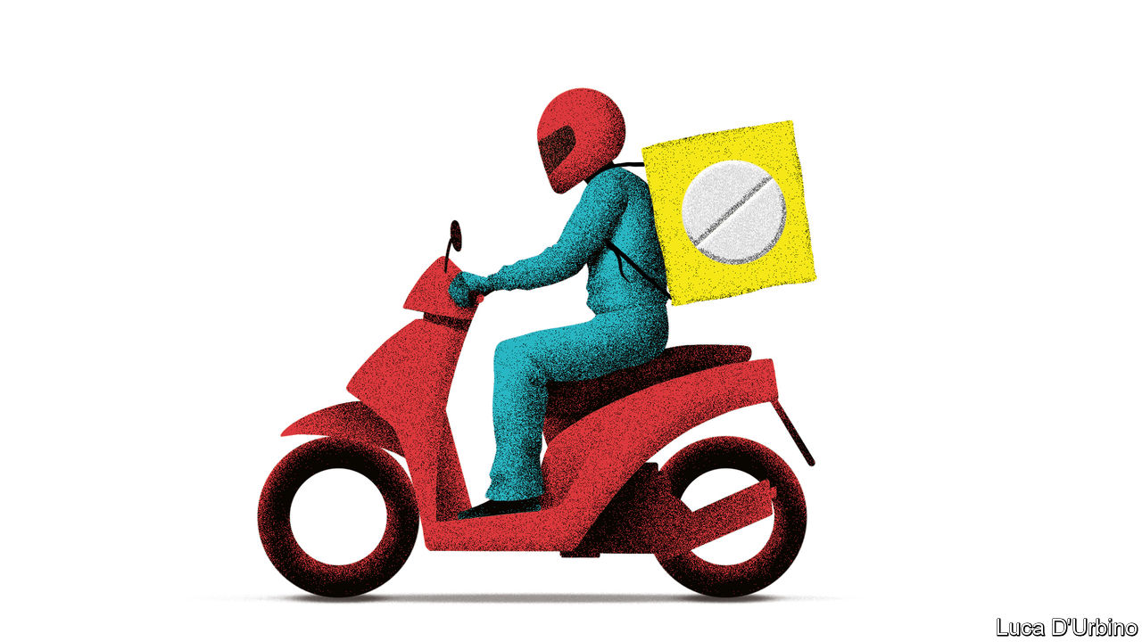

WITHIN A WEEK of discovering she was pregnant in late April, Sylvie (not her real name) knew she wanted an abortion. The pandemic had made her the sole breadwinner, and she had a young daughter to look after. She called Marie Stopes, a charity, which arranged a phone consultation with someone at her local hospital. Four days later a packet of medicine arrived through the letterbox, and she terminated her pregnancy at home with the support of her partner. Abortion is a “horrible thing,” she says. But “in terms of how it was handled, it couldn’t have gone better”.

Sylvie is one of 23,000 women in England and Wales who had an abortion at home between April and June. That this was possible was due to a temporary change in the rules introduced as the country went into lockdown. In normal times, the first of the two pills required for a medical abortion must be taken at a hospital or clinic. But emergency measures, introduced on March 30th to avoid unnecessary hospital visits, designated women’s homes as another place where the pills could be taken, at least until ten weeks of gestation.

As a result of the change, abortions are now happening earlier. Data published on September 10th show that between January and June this year, there were 109,836 abortions in England and Wales. Some 50% of these, including Sylvie’s, were performed before seven weeks, compared with fewer than 40% during the same period in 2019. The proportion performed before ten weeks rose from 81% to 86%. There was also a small uptick in the overall number.

Abortion is usually a safe procedure, but there is a direct correlation between the risk of complication and weeks of gestation, says Sam Rowlands, a doctor at the British Society of Abortion Care Providers, a representative group. That means easing access to early terminations has increased the safety of abortion care, says Edward Morris of the Royal College of Obstetricians and Gynaecologists. Both groups have called for the changes to be made permanent. The government has said it will launch a public consultation on the matter.

The picture is gloomier in those parts of Europe where politicians did not do much to ease access to abortion. Recent research by Abigail Aiken of the University of Texas at Austin looked at enquiries to Women on Web, a Canadian charity that provides pills to women in countries where at-home abortions are illegal. She found that during the pandemic they shot up in Italy (by 68%) and Portugal (by 139%). In Britain they fell to negligible levels.

Sylvie says the new way of doing things also reduced the psychological toll of the procedure. In 2011 she had to wait five weeks for an abortion, by which point she was nearing her second trimester. She lives in rural Cornwall, an area she says is “lacking in health care [providers] and forward thinking”. She remembers being passed “from pillar to post” while attempting to get an abortion. The experience was so bad she made a formal complaint. This time, however, she says the process was “respectful”, “compassionate” and, crucially for her, “private”. ■

Editor’s note: Some of our covid-19 coverage is free for readers of The Economist Today, our daily [newsletter](https://my.economist.com/user#newsletter). For more stories and our pandemic tracker, see our [hub](https://www.economist.com/news/2020/03/11/the-economists-coverage-of-the-coronavirus)

This article was downloaded by calibre from <https://www.economist.com/britain/2020/09/19/why-women-in-england-and-wales-are-having-abortions-earlier>

|  |  |  |  |
| --- | --- | --- | --- |
| Previous | Articles | Sections | Next |

|  |  |  |  |
| --- | --- | --- | --- |
| Previous | Articles | Sections | Next |

#### Flunked

# Britain’s testing system seizes up just when it is needed most

The government insists things will be back on track in a couple of weeks

Sep 19th 2020 |

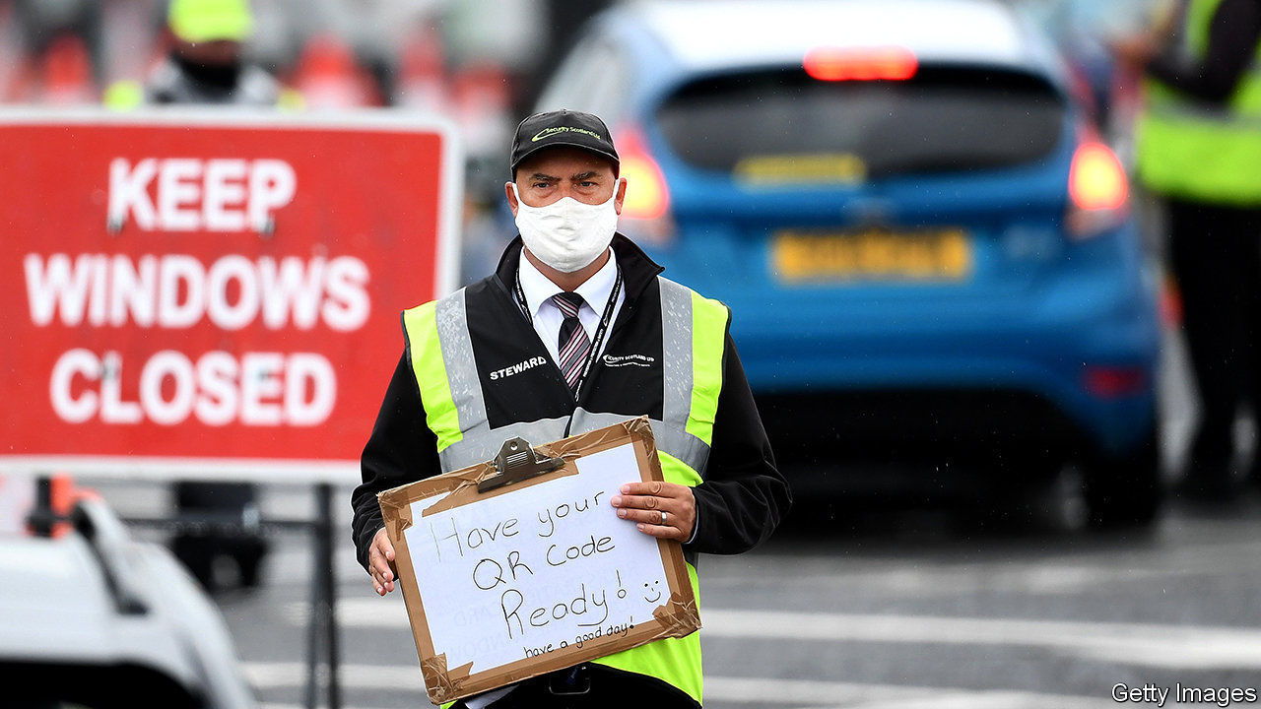

ON SEPTEMBER 14TH Toby’s seven-year-old son woke with a temperature—“not a huge one, but enough to keep him away from school.” As covid-19 guidance dictates, the finance worker went online to look for a test. Yet every type he asked for—at-home, drive-through or in a test centre—returned the same message: no tests available. Until a negative test result is obtained, the whole household has no choice but to isolate.

Toby’s situation is familiar to growing numbers of parents. The return of Britain’s schools has coincided with an inevitable outbreak of sniffles, as well as a less predictable rise in the number of covid cases—and the testing system has proved unable to cope. An enormous backlog of tests has built up. Even in the areas where the disease is most prevalent, people are struggling to get checked. The return of universities over the coming weeks will only add to the pressure.

Britain is now counting more than 3,000 covid cases a day, double the number it was two weeks ago. It is not just in schools that the lack of tests is proving difficult. A number of local authorities have set up testing for public-service workers, to avoid mass self-isolation. Hospitals warn they are suffering from staff shortages. One director of public health reports that he had to intervene to find a test for a 93-year-old and a five-year-old so they could go into hospital for treatment.

The government has been slow to fess up to what exactly has gone wrong. On September 15th Matt Hancock, the health secretary, said the problems lay in laboratories, rather than the centres where swabs are taken. Six enormous “Lighthouse” laboratories enabled a welcome surge in capacity in early summer. But at least one has struggled as students it employs return to university. With backlogs growing, the system as a whole has jammed up. The booking service makes it difficult to allocate what availability there is. “It’s clunky and assumes everyone can drive,” sighs the director of public health.

In the short-term, the government will have to prioritise access to testing. Mr Hancock has said those who need urgent medical care will be at the front of the queue, followed by social care, where he says the government is now sending 100,000 tests a day. The next step may be to prioritise people based on the severity of their symptoms or their vulnerability to the disease. All told, it is a very different situation to mid-July, when the health secretary urged people to get tested if they had “any doubt” about having the virus.

A new Lighthouse laboratory will soon open in Loughborough, providing 50,000 tests a day, which should help to ease the burden. The hope is both to increase the amount of automation in the system and to make use of a greater range of testing technologies. The government has, for instance, bought six endpoint PCR machines, which test only for the presence of the virus rather than its amount. Each can carry out 150,000 tests a day. The challenge now is to build the necessary infrastructure around these machines.

The government thinks current difficulties should not last longer than a couple of weeks. But that is a long time when case counts are rising. Toby’s wife eventually managed to buy a test privately. If all goes well, the family will soon be out of quarantine. Without a functioning state system, others will not be so lucky. ■

Editor’s note: Some of our covid-19 coverage is free for readers of The Economist Today, our daily [newsletter](https://my.economist.com/user#newsletter). For more stories and our pandemic tracker, see our [hub](https://www.economist.com/news/2020/03/11/the-economists-coverage-of-the-coronavirus)

This article was downloaded by calibre from <https://www.economist.com/britain/2020/09/19/britains-testing-system-seizes-up-just-when-it-is-needed-most>

|  |  |  |  |
| --- | --- | --- | --- |
| Previous | Articles | Sections | Next |

|  |  |  |  |
| --- | --- | --- | --- |
| Previous | Articles | Sections | Next |

#### Up(load) the RA

# The Troubles go from H-block to TikTok

Why memes have replaced murals

Sep 19th 2020 |



FEW BUSINESSES can be more certain of success than a paint shop in Belfast. Locals on both sides of Northern Ireland’s sectarian divide love the stuff. Two decades after the “Troubles”, a bloody conflict that ran from 1968-98, the colours of kerbstones and murals are still as useful to passers-by as any map: plenty of green in nationalist areas; lots of red, white and blue in unionist ones. The culture war, at least, goes on.

A new generation, though, has less need of brushes. The children of the ceasefire have TikTok, an app for sharing short videos. There, alongside films of cute puppies and dance moves, are youngsters honouring the Irish Republican Army (IRA), which led a bombing campaign for a united Ireland. One user, in camo and a balaclava, offers an “IRA outfit tutorial”. Another impersonates Bobby Sands, a republican prisoner who starved himself to death in 1981.

The videos mix TikTok staples like strobing lights and quickfire dance routines with tropes more familiar to previous generations of republican propagandists. Rebel songs provide the soundtrack. “There’s a strange mixture of the very local and the international language of TikTok,” says Duncan Morrow of Ulster University.

Some TikTokers are earnest republicans or loyalists. One, an 18-year-old from England who started posting clips during the covid-19 lockdown, proudly recalls her father’s deployment to the province with the British army. Others are Americans with little knowledge of the Troubles, who see similarities between the republican cause and the Black Lives Matter movement.

The fact that such videos find a keen audience hardly presages a return to violence. On the whole, young people in Northern Ireland are much less likely to hold sectarian attitudes than their parents. “These people are behaving like old people,” reckons Peter Shirlow of Liverpool University. “They’re out of step.”

Sometimes the clips are not even taken seriously by those who make them. Many are intended as entertainment, not propaganda, shot by history buffs who would never dream of toting an Armalite. “IrishCasual”, an 18-year-old from the Irish Republic, is at pains to point out that he has English friends. He distances himself from “extremists” who record videos in IRA clobber. His clips, he claims, are educational and fun: “It is TikTok, so you need to bring a bit of comedy.” Whenever he runs out of ideas, he falls back on a meme that will run and run. He will keep dancing, his videos boast, until there is a united Ireland.

This article was downloaded by calibre from <https://www.economist.com/britain/2020/09/19/the-troubles-go-from-h-block-to-tiktok>

|  |  |  |  |
| --- | --- | --- | --- |
| Previous | Articles | Sections | Next |

|  |  |  |  |
| --- | --- | --- | --- |
| Previous | Articles | Sections | Next |

#### Unusual employment

# Why poor Britons in prosperous places are suffering

Wealthy commuters are fine. Their neighbours are not

Sep 19th 2020 | STEVENAGE



MARIA MOVED to Britain from Poland a decade ago. She spent the first four years living in London before cheaper housing drew her to Stevenage, a drab but prosperous commuter town 30 miles north of the capital. Until March this year, she worked in a London sandwich shop, even though the train season-ticket swallowed around a third of her income. She was furloughed in April and recently found out her job would not be coming back. “I’m still getting paid until the end of September,” she says, “but who knows after that? I’ve applied for about 40 jobs so far”.

Economists in America have observed that poor people in prosperous areas have been hit especially hard by the covid-19 downturn. Data released by the Office for National Statistics (ONS) on September 15th suggests the same is true in Britain. The headline figures show a healthy labour market, with the unemployment rate in July just 4.1%, barely higher than in February. But as the government’s furlough scheme, which supported the jobs of more than 9m workers, is tapered back, cracks are beginning to appear.

Analysis of redundancy consultations by the Institute for Employment Studies, a research outfit, suggests that an additional 445,000 jobs will be lost between July and September. Advertised vacancies have bounced back from the record low they hit in April, but are still almost 50% below last year. Samuel Tombs of Pantheon Macroeconomics, a consultancy, fears the ONS is understating the rise in unemployment. Social distancing has disrupted the usual collection of survey data, forcing the ONS to rely more on telephone interviews. As a result, renters, who are less likely to answer the phone, are now being undercounted—and they are more likely than homeowners to have fallen out of work.

The early evidence suggests that unemployment is growing fastest far from the typical job-market black spots. Claims for universal credit, the main out-of-work benefit, rose by 57% between March and July in north-east England, but more than doubled in London and the south-east. In Stevenage, claims have increased by almost 140%. Staff at the town’s job centre can’t remember such a busy time. ONS job numbers show the biggest falls in the south-east. Thus it is areas that previously enjoyed the highest employment rates that are now seeing the steepest drops.

This reflects the pattern of the recession so far. Sectors such as physical retail and hospitality are the most likely to be harmed by social-distancing measures, and have suffered big drops in output. In normal times such sectors do well where people have more disposable income to spend. And the businesses they contain tend to run on thin margins, so even a small drop in revenue can push up unemployment.

The knock-on consequences of the rise in working from home, which has been bigger in London than in other British cities, are being felt across the capital’s enormous commuter belt. The 2,900 jobs being cut by Pret A Manger, a sandwich chain, and the 5,000 from Upper Crust, an operator of train-station food concessions, will be concentrated in the south-east. While the prosperous commuters who reside in places like Stevenage have mostly been shielded from the first wave of economic damage, the same is not true of their poorer neighbours. ■

This article was downloaded by calibre from <https://www.economist.com/britain/2020/09/19/why-poor-britons-in-prosperous-places-are-suffering>

|  |  |  |  |
| --- | --- | --- | --- |
| Previous | Articles | Sections | Next |

|  |  |  |  |
| --- | --- | --- | --- |
| Previous | Articles | Sections | Next |

#### For God’s sake

# What a huge religious monument reveals about Britain

It will dwarf the Angel of the North, another big roadside sculpture

Sep 19th 2020 |

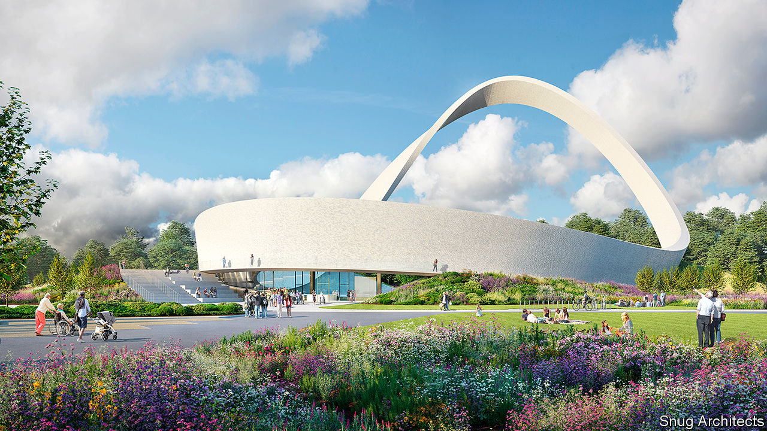

IN ABOUT TWO years’ time, drivers on the M6 motorway will see something new. A giant 51m-high Möbius strip, illuminated at night, will rise just east of Birmingham, in the green belt. Known as the Eternal Wall of Answered Prayer, it is supposed to spark questions about faith—some of which will be answered in an attached visitor centre. Those who see it might ask another question. In a country that is fast becoming less religious and where building on green-belt land is extremely difficult, how did this happen?

“I’d put it down to prayer,” says Richard Gamble, a former Leicester City FC chaplain who has been planning the monument since 2004, when he received a vision while carrying a cross through Leicestershire. There are more earthly explanations, however. The fact that Mr Gamble has won support and permission for his project reveals something about British religion, planning and driving.

Since 1983 the proportion of people who identify as Christian has fallen from 66% to 38%. But the decline in religiosity is not quite even, says David Voas of University College London. Fervent Christianity has held up better than the lukewarm kind, because of the success of evangelical churches and immigration from more pious countries. Mr Gamble has been able to assemble a network of supporters and donors. Lord Edmiston, a successful car importer, Tory donor and evangelical Christian, provided the land.

The Eternal Wall’s huge scale perturbed planning officials, who delicately described its visual impact as “not localised”. Some locals argued that it should not be built on the green belt. But, as the officials understood, the purpose of the green belt is not to preserve greenery. It is to prevent houses from being built. By checking urban sprawl, England’s 16 green belts—which cover 12% of the country—have preserved land on which religious Möbius strips can be erected.

If road-safety inspectors had objected, the wall would have been nixed. As it happens, they have become keener on enormous monuments. Drivers become bored on motorways: traffic accidents are thought to be common in the early morning and mid-afternoon partly because the roads are so quiet. One way of keeping them alert is to build things to look at. These must be big, otherwise drivers will strain to spot them, becoming distracted. The Angel of the North, a sculpture near Gateshead, is an exemplar. But as the Eternal Wall’s backers point out, the angel, at a mere 20m high, is a stripling in comparison to the wall.

This article was downloaded by calibre from <https://www.economist.com/britain/2020/09/19/what-a-huge-religious-monument-reveals-about-britain>

|  |  |  |  |
| --- | --- | --- | --- |
| Previous | Articles | Sections | Next |

|  |  |  |  |
| --- | --- | --- | --- |
| Previous | Articles | Sections | Next |

#### Into the greyzone

# Britain’s armed forces get ready for a revolution

The emphasis is on threats short of open warfare and the technological prowess to combat them

Sep 15th 2020 | RAF WYTON



THE CAVERNOUS space inside RAF Wyton, an airbase near Cambridge, resembles a newsroom. But the stories traded here are heavily classified. The Defence Intelligence Fusion Centre is the world’s only hub where personnel from across the Five Eyes alliance (comprising America, Australia, Britain, Canada and New Zealand) keep a watch on the world’s hotspots. The logo of GCHQ, Britain’s signals-intelligence agency, hangs above one desk. That of America’s Defence Intelligence Agency above another. In a crisis, 1,200 people could fit around the open-plan desks; during a pandemic, things are roomier.

The British government is nearing the end of an “integrated review”, a sweeping reassessment of defence policy that will also consider the country’s foreign, security and aid policies. The starting-point for that effort is the threat that Britain faces. And the intelligence flooding into Wyton from submarines, satellites, human sources and open sources paints a different picture from the one seen in the past, explains Lieutenant-General Jim Hockenhull, the chief of defence intelligence.

The first issue is fancier weapons. He points to Russia’s deep-water submarines, nuclear-armed underwater drones and anti-satellite projectiles. “Russia”, he says, “is pushing the boundaries of science, and international treaties.” Advanced weapons once held only by a clutch of states, such as precision-guided missiles, are in the hands of smaller powers and non-state groups.

A second trend is the rise of new threats. Though Russia is ranked as the biggest military threat to Europe, China is a growing problem. “China poses the greatest threat to world order,” says General Hockenhull, “seeking to impose Chinese standards and norms and using its economic power to influence and subvert.” It would have been unthinkable for a British official to use such language about China a few years ago, but the government’s decision in July to ban Huawei from British 5G mobile networks reflects a hardening stance.

Britain sits at a safe distance from China, but anti-satellite weapons, cyber-attacks and AI-enabled propaganda pay no heed to geography. China’s navy, the world’s largest, is increasingly making forays into European waters. When HMS Queen Elizabeth, an aircraft-carrier, sails for Asia next year, it will head towards waters patrolled by Chinese vessels including the Renhai-class warships that General Hockenhull describes as “the most capable” destroyers of any navy. Chinese weapons, he adds, are “fast eroding Western military advantages”.

Counting warships and missiles is the bread-and-butter of defence intelligence. Perhaps the biggest shift in the threat landscape is the change in how war is waged. Britain’s enemies reject the “traditional binary view of peace and war”, instead waging “continual struggle”, says General Hockenhull. Much of that struggle is in what has come to be called a “greyzone”, below the threshold of open conflict.

That includes familiar skulduggery like disinformation and assassination, but it can involve more muscular interventions. Ben Wallace, Britain’s defence secretary, has pointed to the example of the Wagner group, a mercenary force that serves as a deniable arm of Russian power in several warzones.

Responding to greyzone threats is hard. Provocations, like assassination, hardly justify sending in tanks. That can allow enemies to take a salami-slicing approach, sowing fear or nibbling at territory little by little. Most Western armed forces lack the legal authority to jump into a peacetime crisis with guns blazing—or the disregard for ethics to wield weapons like the nerve agent, Novichok.

What does this mean for Britain’s armed forces? On September 14th Mr Wallace and Britain’s chief of defence staff, General Sir Nick Carter, signalled a “significant change in military philosophy”. In place of “mass and mobilisation”, said Mr Wallace, “this future force will be about speed, readiness and resilience, operating much more in the newest domains of space, cyber and sub-sea”. Mr Wallace, who had earlier criticised Britain’s “sentimental attachment to a static, armoured-centric force”, promised that the future force would be “more forward deployed”, popping up around the world.

Paying for all this will require cuts. A reduction in tank numbers and warplane orders seems likely. Will Jessett, who led the Ministry of Defence’s work on the last defence review, in 2015, says that earlier reviews were too cautious in getting rid of “sunset” capabilities. Britain should “carve out a niche where we could make a distinctive contribution,” he reckons. The Royal Marines, for instance, are developing a “future commando force”, including small units permanently deployed around the world. On September 15th the head of the Royal Air Force promised a “game-changing mix of swarming drones, autonomous remotely piloted and piloted aircraft”.

But the emphasis on greyzone threats, technological solutions and niche capabilities is fraught with risk. The more Britain specialises, the more it will have to rely on allies to fill any gaps. David Blagden of the University of Exeter points out that Russia’s invasion of Ukraine, which is often held up as a canonical example of greyzone war, involved several armoured divisions and veiled nuclear threats—hardly something to be countered by commandos, drones and cyber-attacks. Betting on futuristic weapons while retiring proven capabilities is a “high-stakes gamble”, says Mr Blagden. There is also a political angle. Nimbler armed forces tend to be slimmer ones. That may not go down well with Conservative voters who like their taxes low and their navies large. ■

This article was downloaded by calibre from <https://www.economist.com/britain/2020/09/15/britains-armed-forces-get-ready-for-a-revolution>

|  |  |  |  |
| --- | --- | --- | --- |
| Previous | Articles | Sections | Next |

|  |  |  |  |
| --- | --- | --- | --- |
| Previous | Articles | Sections | Next |

#### Bagehot

# Boris v the blue blob

The list of institutions Boris Johnson is at war with includes the Conservative Party

Sep 17th 2020 |

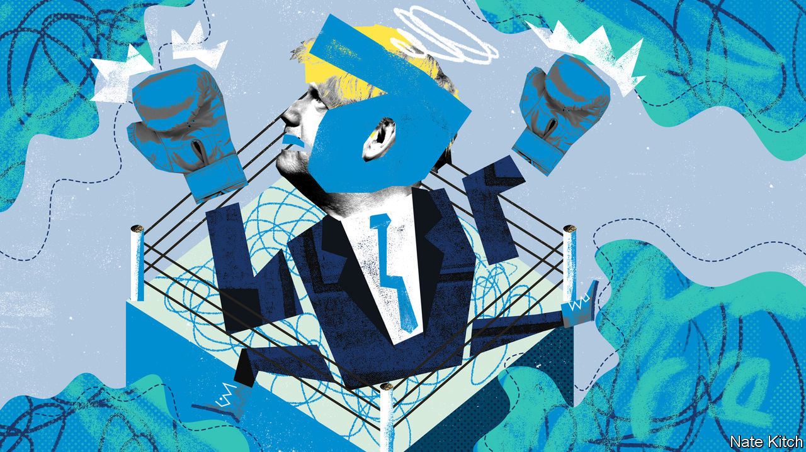

IN A ZOOM call with 250 Conservative MPs on September 11th Boris Johnson pleaded with his party not to return to “miserable squabbling over Europe”. The government handily won the division over the second reading of its controversial internal-market bill, but the squabbling continued regardless. Senior Conservatives fulminated against the legislation. More than 20 Tory MPs refused to back the government on the issue. Even loyal Brexiteers such as Michael Howard and Norman Lamont were indignant

As The Economist went to press, it looked as if the government had backed down. Mr Johnson promised “an extra layer of Parliamentary oversight”—in other words MPs, rather than the government, would have the final say on whether Britain violates international law by overriding the withdrawal bill it agreed with the European Union in January. It is not clear whether this will placate Parliament. It will certainly not placate the EU.

What is clear is that Mr Johnson’s relations with Conservative MPs are dismal. The list of senior Tories who spoke out against the internal-market bill includes five former Tory leaders, two former chancellors, two former attorneys-general, two former Northern Ireland secretaries and the government’s law officer for Scotland, who resigned despite the government’s last-minute climb-down. Tories with legal training are particularly worried because, as well as naturally revering the law, they are bound by their professional oath to uphold it.

The tensions are not confined to the current bill. Several cabinet members have expressed doubts about the “rule of six” (which prevents groups of more than six people gathering). Many heads of select committees are critical of the government. Some 50 backbench MPs publicly called for Dominic Cummings, Mr Johnson’s right-hand man, to resign after he broke lockdown rules; many others expressed the sentiment in private. Everybody is worried about the government’s lacklustre handling of the pandemic.

This is quite some turnaround. It is only nine months since Mr Johnson led his party to an extraordinary election victory, which increased his working majority to 87, shifted the balance of power in his party to Brexiteers, sealed his reputation as a political miracle-worker and supposedly launched a new era in British politics. Why has the conquering hero lost his shine? And why is a party with a bomb-proof majority worrying about defeat over a vital bill?

Rebellion is habit-forming—and the Conservative Party has acquired a serious habit during the Brexit years. These years taught the lethal lesson that disloyalty rather than loyalty can be the path to success. Mr Johnson was himself a serial rebel who resigned as foreign secretary over the withdrawal bill. The cabinet is stuffed with Lazarus-like figures who have either resigned or been sacked or both. And big majorities are double-edged swords: they reduce the pressure to conform (because your vote is unlikely to be crucial) and bring in eccentrics and no-hopers (who will never have a sniff at high office).

The party has also been in power for a decade. This means that there are plenty of people who have nothing to lose from rebelling, either because they have had their turn in office (Damian Hinds), or because they have been chucked out by the current leadership (Sajid Javid) or because they have grown tired of the bridle and whip (Sir Roger Gale). In parliamentary politics, time is the opposite of a healer. It foments resentment, breaks friendships and nurtures revolts. Mr Johnson’s misfortune is that he comes at the end of a long and fractious period of Conservative power.

Messrs Johnson and Cummings have also done their bit to sour relations. Mr Johnson owes his position at the top to his star power, rather than to his record as a party man. But his star power is waning under the pressure of high office. His performance in Parliament has been consistently poor. This week he crumbled before a fusillade from Ed Miliband, Labour’s shadow business secretary. Mr Cummings makes no secret of his belief that most MPs are mediocrities. Sir Charles Walker summed up many MPs’ feelings about Downing Street this week: “If you keep whacking a dog, don’t be surprised when it bites you back.”

## Who’s a good boy?

The government’s decision to stroke the parliamentary dog may help in the short term. But the deeper problem is not parliamentary management. It is the nature of Brexit itself. Previous revolutions of this scale have been carefully prepared. The post-war Labour government could draw on decades of cross-party thinking. “When Labour swept to victory in 1945”, the historian Paul Addison wrote in his study of the subject, “the new consensus fell, like a branch of ripe plums, onto the lap of Mr Attlee.” The Thatcher government could draw on detailed free-market policies prepared by think-tanks like the Centre for Policy Studies, as well as the wisdom of Friedrich Hayek and Milton Friedman. The Brexiteers, by contrast, were united by what they were against rather than what they were for. The Brexit army contains protectionists and free-marketers, fishermen and financiers, single-issue fanatics and philosophical radicals. The government’s troubles stem from its attempt to impose a governing philosophy on this rag-tag army; a philosophy, moreover, that is an eccentric mixture of state interventionism, grands projets and traditional Thatcherism.

Brexit is an inherently revolutionary project that keeps pushing its supporters in unexpected directions. Who would have thought four years ago that Brexit would mean leaving both the single market and the customs union? Who would have thought a couple of months ago that Britain would be locked in a fight with the EU over state aid? The strange sight of Brexit pioneers such as Lords Howard and Lamont denouncing the government is the staple of revolutions down the ages: the eating of children. There will be plenty more Tory children eaten before this revolution has reached its conclusion. ■

This article was downloaded by calibre from <https://www.economist.com/britain/2020/09/17/boris-v-the-blue-blob>

|  |  |  |  |
| --- | --- | --- | --- |
| Previous | Articles | Sections | Next |

|  |  |  |
| --- | --- | --- |
| Britain | Sections | Special report |

International

Deliberative democracy: Some assembly required

.

|  |  |  |
| --- | --- | --- |
| Britain | Sections | Special report |

|  |  |  |  |
| --- | --- | --- | --- |
|  | Articles | Sections | Next |

#### Some assembly required

# Citizens’ assemblies are increasingly popular

Do they work?

Sep 19th 2020 | GLASGOW, PARIS AND ZOOM

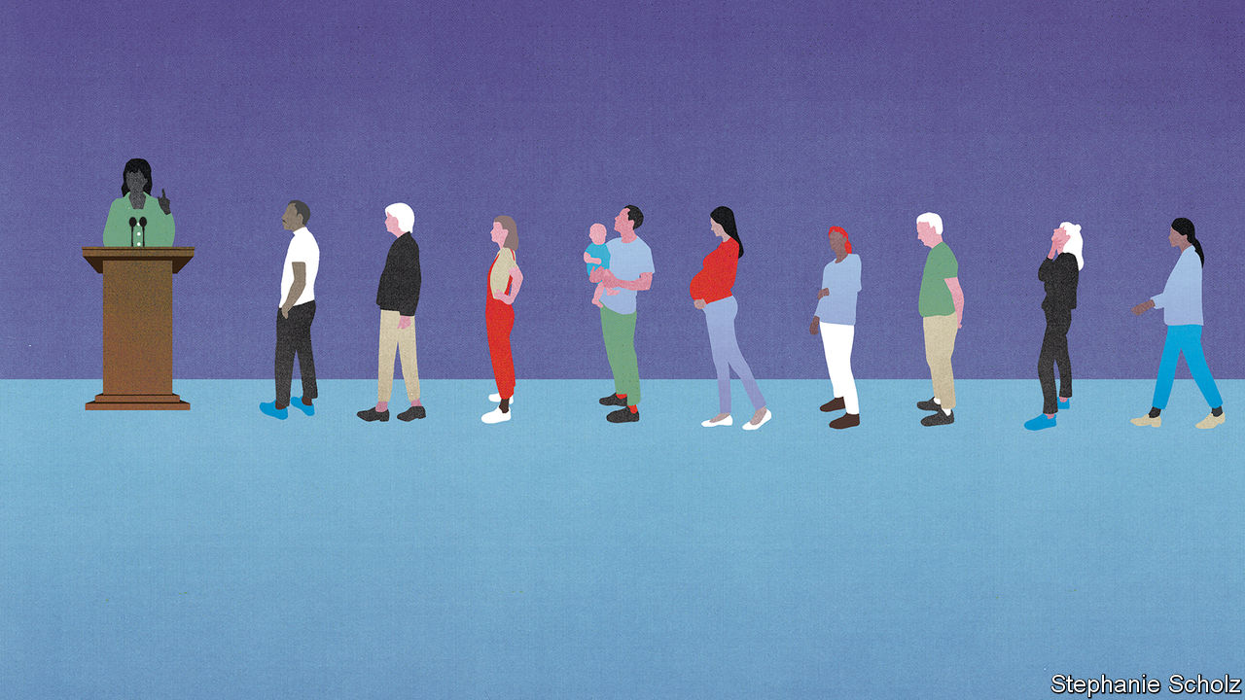

SHIRLEY ISLAM has little faith in politics. Elected representatives “are either bickering on TV, or wasting taxpayer money, or trying to sell something,” says the 48-year-old care worker from West Lothian, in Scotland. “They are all saying the same thing,” she sighs. But she has felt a little more hopeful of late. Her optimism is a result of her involvement in a “citizens’ assembly” in Scotland to debate the country’s future—held first in a conference centre in Glasgow and since September 5th on Zoom. Politics, she thinks, “needs to be in touch with people.” “This is the way forward,” she continues. “It has to be.”

Over the past decade democratic institutions have taken a battering. According to Pew Research Centre, an average of 64% of people across 34 countries do not believe that elected officials care what ordinary folk think. Fully 69% of Britons are dissatisfied with the way democracy is working at home, as are 59% of Americans.

One solution, long favoured by political scientists, is to include more deliberation within democracy. Citizens’ assemblies are an increasingly popular way of doing so. These involve a group of around 100 people, broadly representative of the population (by gender, age and socioeconomic status, say), meeting over several weeks or months to debate tricky topics, such as whether to legalise abortion or how to respond to climate change. In the course of the best-organised assemblies participants hear from experts on all sides and produce recommendations to which their governments have promised to respond.

Several big citizens’ assemblies are under way or have recently concluded. Last year President Emmanuel Macron created a “citizens’ convention on climate” to come up with measures that will enable France to reduce greenhouse gas emissions by at least 40% by 2030. The proceedings, which were disrupted first by national strikes and then by the covid-19 lockdown, concluded in June. The 150 participants called for two changes to the constitution to help preserve the environment and biodiversity, and a law to criminalise “ecocide”. A “climate assembly” in Britain issued its final report, completed via Zoom, on September 10th. “Deliberación País”, a large-scale deliberative process in Chile to debate pension reform and health care, has been postponed to December and will be online only.

Although citizens’ assemblies had been tried in Canada and the Netherlands in the early 2000s, the recent craze started in Ireland. Two citizens’ assemblies have taken place there to discuss a variety of topics. The original impetus was the financial crash of 2007-09, which left many in the country feeling disillusioned with politics and made politicians more willing to experiment, recalls David Farrell of University College Dublin (UCD), who advised the Irish government on the projects. A similar sense of crisis informed the citizens’ convention in France, which was set up in response to the gilets jaunes protests.

The Irish assemblies led to two referendums, on same-sex marriage and on abortion, topics long considered too divisive for politicians even to broach in a country where three-quarters of the population still describe themselves as Catholic. The results were striking. In 2015 same-sex marriage was approved by 62% of the population; 66% voted in 2018 in favour of making abortion available in the first 12 weeks of pregnancy. The citizens’ groups foreshadowed these results.

“Ireland is the Rolls-Royce of citizens’ assemblies,” says Iain Walker of the newDemocracy Foundation in Australia, which has run similar pow-wows in that country. Mr Farrell is more circumspect. Ireland’s convocations were not perfect: at one the supposedly randomly selected citizens, rustled up by a market-research firm, included a couple. At another seven participants turned out to be friends with one of the recruiters. Nonetheless, the fact that the assemblies helped pave the way for significant reforms makes Ireland something of a “beacon”, he thinks.

Ideally the gatherings should resemble the public at large. France selected the members of its assembly at random by telephone. Some 255,000 people were contacted. To the organisers’ surprise 70% said they were willing to take part. Of those, 150 French citizens who reflected the country’s make-up in terms of gender, age, income and place of residence were invited to participate. The minimum age was set at 16 to enable high-school pupils to be involved. Each person was paid €86 ($97 then) a day (the same sum paid in France to those on jury duty). Child-care costs were reimbursed, and the assembly paid directly for hotels and train fares. The budget was over €5m. In order to drum up 120 people for Scotland’s meeting, the teams organising it knocked on some 10,000 doors across the country. Each participant is paid £200 for every weekend they attend; the assembly costs £1.4m ($1.8m).

## The machinery for change

Participants seem to enjoy the process. Isabelle, a finance director from western France, said she initially thought the invitation to take part in the convention there was “a joke”. It turned out to be anything but. The experience, she says, has been “enriching” but also “shocking”, as it has opened her eyes to the climate crisis.

But can deliberation change people’s views? In America James Fishkin, a professor at Stanford and the director of the Centre for Deliberative Democracy, has run a series of “deliberative polls”—similar to citizens’ assemblies but much larger, with 500 or so people involved, totally randomly selected—to see if the process can bridge the partisan divide.

One of Mr Fishkin’s gatherings, in September 2019, demonstrated that Americans could indeed change their opinions. After four days hearing from experts and discussing with their peers five policy areas (immigration, health care, the economy, the environment and foreign policy) those involved concluded that democracy was in fact working rather better than they had thought. On particularly divisive topics, people tiptoed to the centre ground: support for reducing the number of refugees allowed to resettle in America dropped by 15 percentage points, to 22%. Among Republicans it fell by 32 percentage points, to 34%. Meanwhile support for increasing the federal minimum wage fell by 23 percentage points among Democrats, to 59%.

A larger question is whether these processes can change opinions among the broader population. According to research by Mr Farrell, Jane Suiter of Dublin City University and others, those who voted in the referendum to liberalise abortion in Ireland were more likely to have heard of the assembly, suggesting a possible causal relation between the two.

To work well, these assemblies need a clear subject to discuss. Alan Renwick, a specialist in deliberative democracy at University College London, thinks that they are best suited to grappling with large, seemingly intractable problems, such as climate change. But it is also helpful if that topic can be framed as a choice: the subject is fraught, but debating whether abortion should be legalised is more straightforward than trying to paint a picture of Scotland’s future, as the citizens’ assembly there is supposed to do. In Australia, Mr Walker notes, deliberative groups are typically given a question of no more than ten words to discuss. Anything longer than that, the thinking goes, and it becomes harder for people to understand, and easier for politicians to ignore any solutions that might be proposed.

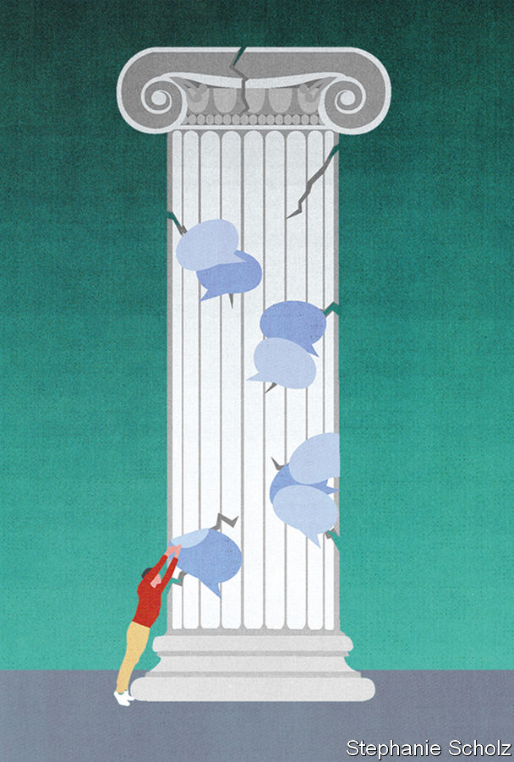

Some worry that the shift online will undermine the value of these meetings—even though, as with many aspects of life, many participants feel it has worked surprisingly well. Most of the assemblies that have moved online this year had an advantage: the members had met in real life before. It is hard to see the process of a “group forming and becoming committed” happening in an online-only forum, says Mr Renwick, without the ability to hobnob over lunches or tea. Ms Islam was nervous about the change. She had to remind herself of how committed she felt to the assembly to gee herself up for the sessions, and has been reading up before the discussions to keep engaged. As more assemblies, such as the one in Chile, are held entirely online, it will become clearer how well they work at a distance.

What is clear is that citizens’ assemblies are most successful when politicians actually listen to them. For a long time, that looked improbable. Matthew Taylor recalls that when he was the head of the prime minister’s policy unit in Britain, he tried to get the two prime ministers he worked for, Tony Blair and Gordon Brown, interested in the idea of assemblies. “On both occasions both the politicians and officials loved the idea, up to the point at which I said, ‘You can’t control the outcome and you will have to respond to it positively. Not to implement it, but to respond to it positively.’”

By contrast, the French government went out of its way to demonstrate its support for the citizens’ assembly. Mr Macron dropped by for an evening sitting in January, and stayed to answer questions for over two-and-a-half hours. In June, he invited the participants to his official residence and gave a speech in the garden in which he promised to put either into legislation, or to a referendum, all but three of the 149 proposals put forward by the assembly. (That pledge was looking shaky on at least one count this week after the president vowed to press ahead with the roll-out of 5G networks, despite the assembly’s proposal for a moratorium.) He also promised €15bn towards the implementation of the proposals.

In Scotland the assembly was set up by Nicola Sturgeon, the first minister. Several participants felt confident that their proposals would be acted on in Holyrood. “I really feel they are going to listen,” said Lynsay Walton, a 61-year-old cleaner. “That’s why I keep coming.” Others were more dubious. “If it is not responded to, it’s a waste of time,” said David Farrell, a joiner.

Not everyone is entirely convinced of the virtues of this kind of deliberative democracy. According to Kevin Elliott of Murray State University in America, however these groups are chosen, there will always be an element of self-selection, as it is not a compulsory process. “You are always extending an invitation that can be refused,” he points out. He worries that citizens’ assemblies are an attempt “to solve the problem of distrust [in democracy] with a technocratic fix”. Samuel Bagg of Oxford University wonders whether, if assemblies are given more power, they will be subject to more influence from lobby groups: a climate assembly lobbied by a fossil-fuel company, and so on.

It is inevitable that, as assemblies proliferate, some will be considered flops. But when they work well, these groups provide elected representatives with a mind-clearing idea of what voters really want. ■

This article was downloaded by calibre from <https://www.economist.com/international/2020/09/19/citizens-assemblies-are-increasingly-popular>

|  |  |  |  |
| --- | --- | --- | --- |
|  | Articles | Sections | Next |

|  |  |  |
| --- | --- | --- |
| International | Sections | Business |

Special report

Business and climate change: The great disrupter

.

Physical impact: A grim outlook

.

Regulation: Costs of carbon

.

Carbon offsets: Cheap cheats

.

Technology: Green machines

.

The future: Directing the disruption

.

|  |  |  |
| --- | --- | --- |
| International | Sections | Business |

|  |  |  |  |
| --- | --- | --- | --- |
|  | Articles | Sections | Next |

#### Business and climate change

# The great disrupter

Climate change is about to upend the corporate world. Firms must react fast, says Guy Scriven

Sep 17th 2020 |

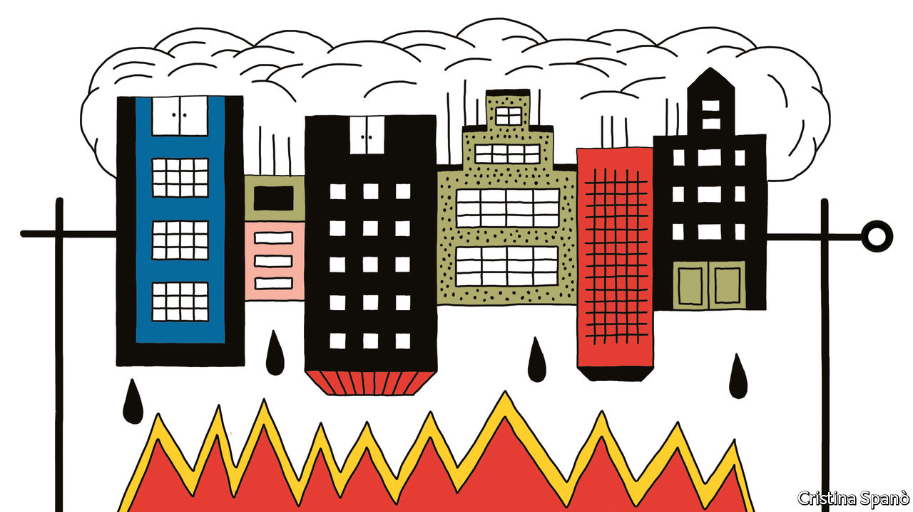

For more coverage of climate change, register for The Climate Issue, our fortnightly [newsletter](https://www.economist.com/theclimateissue/), or visit our [climate-change hub](https://www.economist.com/news/2020/04/24/the-economists-coverage-of-climate-change)

FOR MOST of the world, this year will be remembered mainly for covid-19. Starting in Asia, then spreading across Europe and America before taking hold in the emerging world, the pandemic has infected millions and killed hundreds of thousands. And it has devastated economies even more severely than did the global financial crisis which erupted in 2008.

But the impact of covid-19 has also given a sense of just how hard it will be to deal with climate change. As economic activity has stalled, energy-related CO2 emissions have fallen sharply. This year the drop will be between 4% and 7%. But to have a decent chance of keeping Earth’s mean temperature less than 2°C above pre-industrial levels, net emissions of CO2 and other greenhouse gases must fall to more or less zero by mid-century. And such a drop needs to be achieved not by halting the world economy in its tracks, but by rewiring it.

Ever since the Industrial Revolution 200 years ago, mankind has become increasingly dependent on fossil fuels. Carbon-dioxide emissions from their combustion have grown more or less continuously ever since. As they have accumulated in the atmosphere, the planet has heated up. In 2015 more than 190 countries signed the Paris agreement committing them to try to limit this warming to well below 2°C over pre-industrial levels. Net emissions have grown by 40% over the past 30 years. Meeting the Paris goals will necessitate a 90% fall from the current covid-struck levels over the next 30 years. Yet during that time world population is expected to rise by 2bn and gross product may triple. It follows that the world economy, which still generates over four-fifths of its energy consumption from fossil fuels, must change dramatically.

In 2018, before the pandemic struck, the world emitted greenhouse gases with warming potential equivalent to about 55 gigatonnes. Roughly a fifth of that comes from changes to land use and agriculture. The rest is largely made up of emissions from energy consumption and industrial processes.

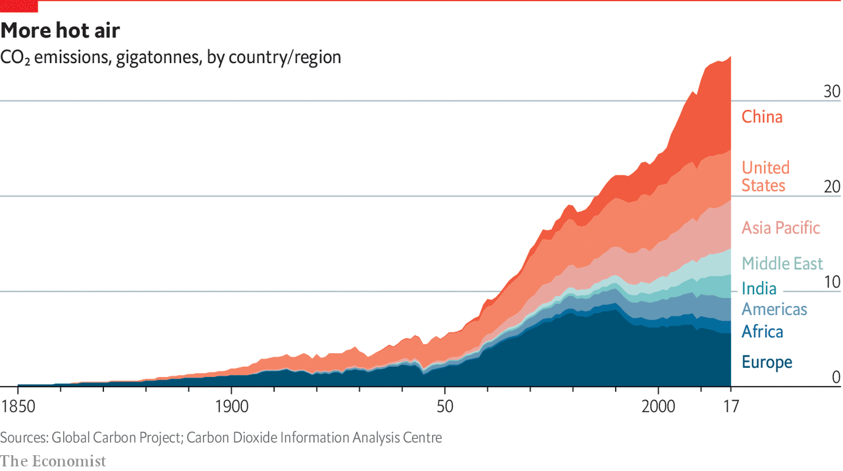

Data from the World Resources Institute, a think-tank, show how these emissions are divided. Buildings (about 17% of the total) and road transport (12%) are the biggest contributors. Other forms of transport also matter, with shipping and flights accounting for 2% apiece. Within industry, iron and steel (8%), chemicals and petrochemicals (6%) and cement (3%) make up big slices of the pie. On a national level, China is the biggest polluter, belching out roughly a quarter of the world’s emissions. America is next, with 12%. The European Union and India produce about 7% each. All told, the world’s 20 most-polluting countries produce roughly 80% of global emissions.

The transition away from fossil fuels is a massive challenge. The International Energy Agency (IEA), an intergovernmental organisation, says $1.2trn of extra annual investment will be needed in the power system alone. Energy use must get smarter, saving both money and emissions. By making the economy greener and more efficient, the hope is to keep below that 2°C threshold. Yet on current trends, a rise of 3°-4°C is looking more likely. And that would make the weather much worse. Weather-related losses are already soaring: between 2017 and 2019 their annual costs averaged $210bn, twice as high as ten years previously, according to Swiss Re, a reinsurer.

The covid-19 pandemic now offers an opportunity to accelerate the reduction of greenhouse-gas emissions. Some governments, particularly in Europe, have been attaching green strings to corporate bail-out packages and are promising to invest more in the low-carbon economy. The virus has also shown that many trips, whether daily commutes or business flights, may not be really necessary. Falls in oil prices mean that cutting fossil-fuel subsidies should become politically easier.

Carbon pricing, which charges a levy on each tonne of CO2, will soon cover a fifth of the world’s emissions. Only complete coverage coupled with a high price can put the world on a low-carbon path. Even so, the patchwork of carbon pricing creates risks for firms with large emissions. Trillions of dollars of assets could become worthless or “stranded” if fossil fuels are squeezed out of the energy system. Carbon-efficient firms can gain an edge over competitors. Engineers, scientists and entrepreneurs are dreaming up clever ways to help.

From a low base, capital is starting to move. Climate-related investing grew by 70% to $579bn between 2013 and 2018, according to the Climate Policy Initiative, a lobby group. Returns on renewables projects are making them ever more competitive with fossil-fuel ones. Yet more is needed. Decarbonising the economy is an enormous task and will be hugely disruptive, but failing to do it will result in a harsher climate and even greater risks for companies. One lesson from the pandemic is that scientists’ warnings about seemingly distant disasters should be heeded.

Why should businesses care about all of this? This special report offers four broad answers. First, companies should worry about the immediate impact of climate change on their operations. Next, they must expect ever more intense regulation, driven both by governments and by the demands of customers and consumers. Third comes the growing risk of litigation over climate change. And fourth is technological change that will create opportunities as well as costs—opportunities that their competitors may be the first to exploit.

For now, though, too few firms are taking climate change seriously. As Rich Sorkin, head of Jupiter Intelligence, a consultancy, argues: “In ten years there won’t be a large entity anywhere on the planet that does not have a handle on its climate risk. Consumers, shareholders and employees won’t stand for it.” A good place to start is with the most obvious physical impact of climate change: that the weather is deteriorating.■

This article was downloaded by calibre from <https://www.economist.com/special-report/2020/09/17/the-great-disrupter>

|  |  |  |  |
| --- | --- | --- | --- |
|  | Articles | Sections | Next |

|  |  |  |  |
| --- | --- | --- | --- |
| Previous | Articles | Sections | Next |

#### Physical impact

# A grim outlook

How worse weather will disrupt businesses and their supply chains

Sep 17th 2020 |

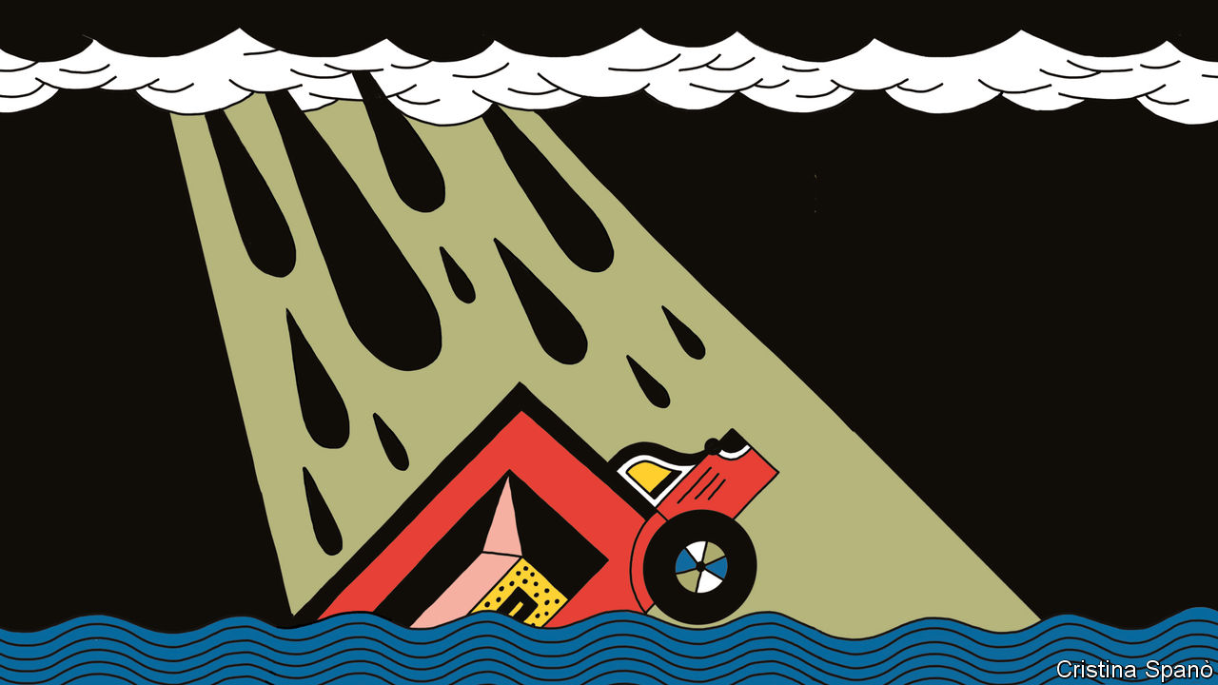

IN 2012, WHEN post-tropical storm Sandy devastated New York, the city was left in darkness. Among the few buildings still lit up was the headquarters of Goldman Sachs, which had a 25,000-sandbag wall and a backup generator. Gary Cohn, then the bank’s president, said one problem was how to get staff into the office in a shut-down city. In 2018, after a storm battered Vancouver Island, falling trees toppled electricity poles. The resulting power cut led to the closure of a water-treatment plant. And last January, when wildfires ravaged Australia’s outback, the toxic air hampered production at a coalmine owned by BHP, a commodity giant.

Businesses have always had to adapt to a changing environment. But climate change is making this far harder. As weather conditions worsen, some companies are responding. But it is impossible to mitigate all the risks. For many firms, the physical impact of climate change will affect them more through disaster-struck suppliers or inundated transport routes than in their own operations.

That indirect impact makes physical risks trickier both to assess and to manage. One result may be shorter supply chains, with more products made close to home. Firms that rely on foreign suppliers may have to spend more to make their imports resilient to the climate. The move towards shorter supply chains is already under way, thanks to trade wars and covid-19. But whereas the pandemic will eventually subside and trade wars should abate, the climate is shifting from stable to less so. “Things will just keep on changing,” says Hauke Engel of McKinsey, a consultancy.

Climate change is clearly making the weather more extreme. Scientists say super-powerful storms have become more common, and there are more days of heavy rainfall or extreme heat. No matter what mankind does, this trend will continue for decades. Global temperatures respond only slowly to changes in the concentration of greenhouse gases in the atmosphere. Deteriorating conditions are locked in for some time.

Even if the goals of the Paris agreement were met and warming limited to below 2°C, the weather would keep getting worse. This may mean, among other things, a 40-80cm rise in sea levels, a 25% increase in dangerously hot days and a 36% jump in the quantity of rainfall over land. And each additional degree of warming increases the impact. Between 1981 and 2010, the average likelihood of a big heatwave (defined as at least four days with maximum temperatures above the 99th percentile of a normal warm season) was 5%. With global temperatures up by 1.5°C over pre-industrial levels that probability rises to 28%. At 2°C it is 49%, and by 4°C 92%. Likewise, floods that in the past might have happened only once in 50 years become more frequent as temperatures rise. One would happen every 42 years with 1.5°C of warming, every 34 years with 2°C and every 19 years with 4°C.

The physical effects of such changes will hurt the world economy, though precisely how much is hard to predict. Most estimates have hefty error margins and forecasts that stretch vaguely to the end of the century. Some analysis of the costs to businesses are more convincing than others, partly because time horizons are shorter. Most assets last for only 10-20 years, so forecasting to the end of the century is unnecessary. And facility-level data give researchers a more accurate grasp of a firm’s climate exposure. The pain will certainly be greater in poorer countries, which have less capacity to adapt and tend to be closer to the equator, where the weather is already harsher.

Two particular pieces of analysis illuminate the threat both by sector and by natural event. Both demonstrate how climate risk is unevenly spread. The first comes from Schroders, an asset manager. Its analysts looked at the physical risks posed to 11,000 publicly listed companies and concluded that climate change could reduce the firms’ value by 2-3% on average. But the numbers vary greatly by industry. Energy and utility sectors stand to lose 4% and 8%, respectively. Property firms could lose up to 9%. For services firms with few physical assets, such as tech and finance, the impact is smaller: less than 0.5% of their value.

As its impact becomes clearer, companies have to take climate change more seriously

In a separate piece of number-crunching, Four Twenty Seven, a climate consultancy, looked at the events that most threaten facilities owned by publicly listed firms. Water stress was the most prominent, affecting 30% of assets. Another 10% were at risk from heat stress and roughly 20% were vulnerable to floods, hurricanes and typhoons. Sea-level rise was the least concerning for businesses, affecting only 3% of assets in the data set.

As its impact becomes clearer, companies have to take climate change more seriously. Partly that reflects growing pressure from regulators, who want them to disclose their climate risks. Doing this is already mandatory for some firms in France. The European Union, Britain and Canada will follow suit. Institutional investors are also pressing for fuller disclosure, a key demand of the Climate Action 100+, a group of investors that includes BlackRock, the world’s biggest asset manager, and Fidelity, one of its rivals. Consumers and customers, especially younger ones, are calling for tougher and faster action on climate change.

More businesses now carry out risk assessments. But they may not be revealing the true extent of their exposure. Disclosures are self-reported, so it is easy for companies to downplay their risks, says Emilie Mazzacurati, of Four Twenty Seven. Firms may also talk up opportunities, such as selling new products to green-minded consumers. Last year the CDP, an environmental charity promoting emissions disclosure, surveyed the self-reported climate risks of 200-odd big firms. Total risks added up to roughly $1trn (5-7% of the firms’ value). But, somewhat suspiciously, the offsetting opportunities were put at more than twice as high.

## Policing themselves

Companies will not always get to mark their own homework. Third-party analysis is improving fast. Climate-risk consultancies are combining asset-level data with climate and econometric models to generate estimates of values at risk. “We now know many firms’ climate risk better than they do,” claims Rohan Hamden, the boss of the Cross Dependency Initiative, a Sydney-based climate-risk firm. Investors are doing similar analysis or hiring consultants. Many say they use analytics to exclude vulnerable firms from specialised climate funds.

A small minority of climate-conscious companies are making their operations more resilient. In every one of the 60-odd geographic regions in which Microsoft operates, it has built two data centres, in case one is struck by an extreme weather event. Kurita Water Industries, a Japanese company, spent $22m moving its offices to a place less exposed to cyclones. Some companies want more sophisticated analysis. A year ago it was acceptable just to model the exposure of a building, says James McMahon, of The Climate Service, a consultancy. Now property companies want to know how flooding will affect rents or their assets’ resale value in ten years’ time.

Defending an office or factory is reasonably straightforward. A thornier problem is supply chains. The world economy promotes efficiency in suppliers and transporters, not resilience. The risk to trading networks from climate change is often overlooked. Transport hubs are key. Airports and seaports process huge quantities of goods. A disaster that downs one can have an outsized impact, says Andrew Coburn of Cambridge University’s Centre for Risk Studies, an academic group. Along with colleagues, he has analysed maritime trade and identified 21 pinch points. These include the Suez canal (which carries 8% of global trade) and the Panama canal (4%), where falling water levels are forcing ships to shed cargo. Similar pinch points exist for air freight.

Another problem is critical infrastructure, such as electricity or telecoms. When power is cut, other services go down as well. Most telecoms towers have backup batteries that last for only four hours. Smartphones run out of power after about ten. After Superstorm Sandy, two-thirds of New York’s petrol stations were unable to dispense fuel because of power cuts.

The more complex a good, the greater the risk of disruption. Industries that rely on many suppliers and layers of manufacturing between the raw materials and the finished product tend to have more supply-chain risk than operational risk, explains Milan Simic of AIR Worldwide, a climate-modelling firm. Three particularly exposed industries are automotive (a single vehicle has approximately 30,000 parts, including the fasteners and screws), consumer electronics and semiconductors.

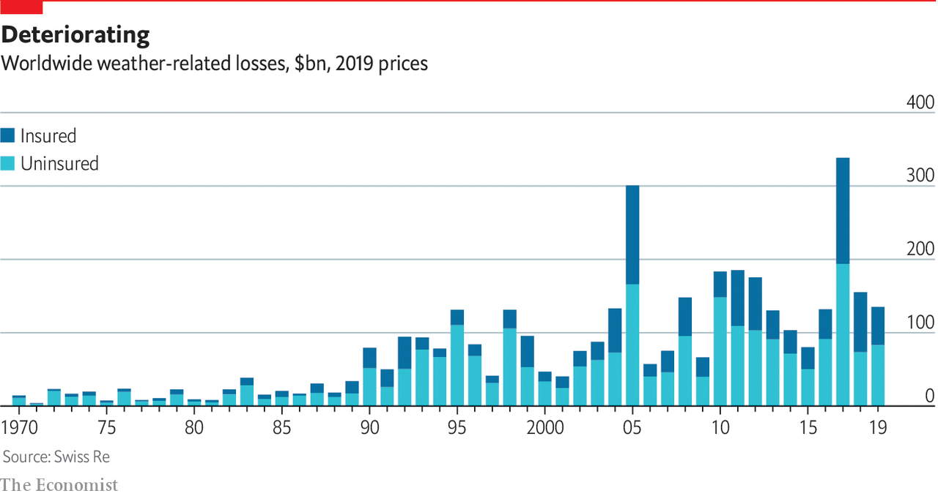

The risks are amplified when suppliers cluster in specialised regions. About 70% of the world’s smartphones are assembled in one region of China. Another sub-region accounts for half of global laptop production. That was a problem when covid-19 struck, because many laptop vendors hold just two weeks’ supply, says Razat Gaurav, the boss of Llamasoft, a supply-chain analytics firm. The risk of these regions being disrupted is rising. Today a one-in-100-year hurricane could bring semiconductor manufacturing to a standstill. By 2040 such an event will become two or even four times more frequent, according to McKinsey.

For companies trying to cope with climate risk in their supply chains, the simplest option is a contingency plan. So far many of these are inadequate, says Mr Gaurav. Backup suppliers are often from the same region, so the risk is not properly spread. Smart management of inventories helps by allowing goods to be sold even if the weather is disruptive. Pharmaceutical companies with bases in Puerto Rico track storms and move their products off the island ahead of hurricane season, says Katherine Klosowski of FM Global, an engineer-cum-insurer. For small products, storage can be cheap. McKinsey estimates that warehousing for semiconductors adds only 1% to the total price.

Another idea is to help suppliers become more resilient. Making factories in South-East Asia sturdier would add roughly 2% to building costs. Unilever owns tea in plantations near Kenya’s Mau forest. It has planted around 1.4m trees nearby to sustain the forest’s natural water supply for the plantations. Even so, there is only so much a company can do in advance. “About 20% of our supply chain resilience is proactive; 80% is reactive,’’ says Marc Engel, the firm’s head of supply chains.

There will inevitably be political pressure on governments to do more, if only because taxpayers often foot the bill for climate damage through disaster recovery schemes. Around two-thirds of weather-related losses are uninsured. In 2017 America’s Congress appropriated $136bn in emergency funds for climate-related disasters. That amounts to $1,000 for every American taxpayer, notes Paul Bodnar, of the Rocky Mountain Institute, a think-tank. City governments like Miami’s have introduced taxes to pay for climate defences. Over the next decade Mr Sorkin expects regions to compete over which can best protect its citizens. “People want to work in safe places, and capital will follow.”

Governments must play an even bigger part in how businesses respond to climate change in future. New climate-friendly rules will determine how quickly companies decarbonise—and how costly it will be for those that fail to do so. For many firms, the regulatory risks associated with climate change may be larger even than the physical ones from more storms and floods.■

This article was downloaded by calibre from <https://www.economist.com/special-report/2020/09/17/a-grim-outlook>

|  |  |  |  |
| --- | --- | --- | --- |
| Previous | Articles | Sections | Next |

|  |  |  |  |
| --- | --- | --- | --- |
| Previous | Articles | Sections | Next |

#### Regulation

# Costs of carbon

Rising regulation will force more firms to decarbonise

Sep 17th 2020 |

SUPPORT FOR solar panels in Georgia came from a surprising point on the American political spectrum. In 2013 Georgia Power, the local electricity monopoly, was reluctant to increase the use of solar panels. That irked Debbie Dooley, a preacher’s daughter and co-founder of Atlanta’s Tea Party, a hard-right Republican faction. She wanted more energy independence, and rooftop solar was one answer. Forming an alliance with the Sierra Club, a green lobby group, she established the Green Tea Party coalition. It helped defeat a bid by Georgia Power to hit rooftop-solar customers with high fees. Since 2013 Georgia’s solar capacity has jumped more than 13-fold.

Politicians of all stripes are introducing green regulations. The Grantham Research Institute at the London School of Economics counts over 1,900 pieces of climate legislation around the world. Almost two-thirds were enacted in the past ten years. That may be good news for the planet, if perhaps not for many firms. By one estimate transition-related regulation, particularly carbon pricing, and technological disruption could reduce the market capitalisation of 1,400 of the world’s biggest companies by 3%, or $1.6trn. And the costs are not evenly spread. For some the figure will be as big as 60%. In anticipation of carbon pricing, a small minority of companies are decarbonising—but too few to save the planet.

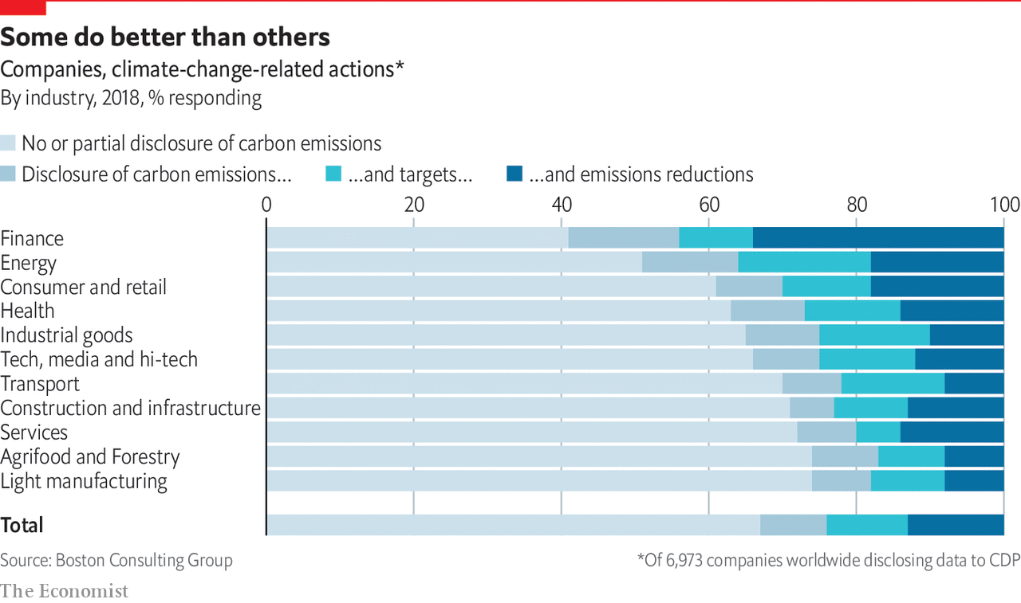

More rules are likely. Urged on by voters, policymakers are setting ever tougher green targets. Over 70 countries have committed to reaching net-zero by at least 2050. The EU proposed a net-zero target in law in March. All but one of the G7 countries have made similar commitments. America is the odd one out. Donald Trump, its president, has dubbed climate change a “hoax”. His administration has rolled-back 68 environmental regulations, according to the New York Times. His scepticism has emboldened other world leaders such as Brazil’s Jair Bolsonaro to pursue environmentally destructive policies. And Mr Trump has begun the process of withdrawing from the Paris agreement.

Joe Biden is promising to make fighting climate change a centrepiece of his presidency

Yet many American states and cities have pushed back. Some have sought to challenge Mr Trump’s rollbacks in court. Others have introduced their own green rules. Thirty of the 50 states have renewable-power portfolios; more than ten have low-carbon fuel standards for cars. Moreover, the polls suggest that Mr Trump’s days in office are numbered. His Democratic opponent, Joe Biden, is promising to make fighting climate change a centrepiece of his presidency. He plans to spend $2trn in four years on low-carbon infrastructure and energy. He wants to join others by going for net-zero by 2050 and emissions-free electric power by 2035. Mr Biden was part of the team that helped negotiate the Paris agreement, which he plans to rejoin.

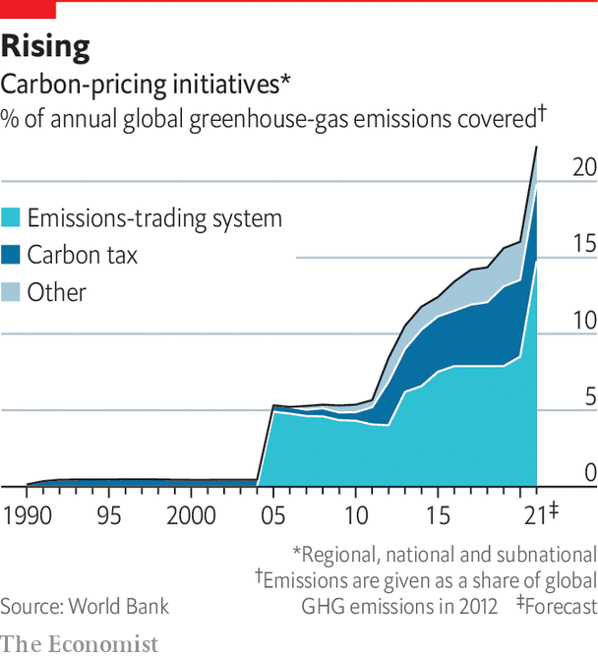

If he is elected, an early test of Mr Biden’s ambitions may be America’s “nationally determined contribution” (NDC). These are decarbonisation plans that countries promised to devise under the Paris agreement. Their cumulative impact is not currently sufficient to meet the Paris goals. But the signatories also agreed to “ratchet up” their NDC ambitions every five years. The first round of updates were due this year. If Mr Biden wins, he could announce a new NDC in early 2021. Climate warriors will hope for national carbon pricing, which Mr Biden supported as vice-president.

Such a move would be a huge boost for carbon pricing everywhere. About half of current NDCs mention the idea. In 2010 about 5% of the world’s emissions were covered by a carbon price. Today, that figure is over 15%. Next year China is expected to roll out the world’s biggest scheme. The EU currently has the next-largest, and plans an expansion. Yet the price of carbon varies enormously. In most cases, it is far below $75 a tonne of CO2, the level the IMF says would be needed to meet the 2°C target. In some places, the price has started to climb. It hit record highs in California and Oregon in late 2019 due to tougher fuel-emissions standards. Having corrected an oversupply problem, the EU price also rose to €24 a tonne in January, up from €8 in 2018.

How might an upsurge in climate regulation affect business? An analysis by Vivid Economics, a consultancy, and the Principles for Responsible Investment, a UN-backed group of investors, offers some answers. The researchers looked at the exposure of 1,400-odd publicly listed companies to “transition risks”—technological and regulatory threats from decarbonisation. Some $1.6trn, or 3.1%, of market capitalisation, would be wiped off the value of the MSCI All Country World Index, a gauge of global stockmarkets. This assumes regulations are enacted from 2020. If policymakers delay five years, even faster decarbonisation will be needed, meaning stricter rules and a sharper revaluation of assets. In such a case, values may fall by 4.5%. The longer policymakers delay, the greater the shock, warns Jason Eis of Vivid Economics.

Whenever it occurs, the shock will be concentrated. In the least-damaging scenario, four-fifths of companies would see their value move up or down by less than 10%. But the impact on the remaining fifth is bigger. The worst-performing 100 firms would lose 43% of their value; the best performers would gain 33%. Energy is the hardest-hit sector, followed by other high-emitting industries such as utilities and mining. Within sectors there are winners and losers too. Companies that embrace low-carbon strategies will do best; heavy polluters will suffer most.

Pressure to cut CO2 emissions comes also from the bottom up. Climate-conscious bosses say consumers are demanding greener products, especially in Europe. A survey by Yale University found that almost a third of Americans claim to have bought products because a company is taking steps to reduce global warming. Over a quarter say they have avoided products sold by firms opposed to such steps. Company boycotts, supercharged by social media, pose rising reputational risk. Some big firms, including Amazon and Nestlé, have changed environmental policies following the threat of mass consumer action.

Sweden may offer a glimpse of the future. Shoppers seem to be turning away from polluting products. Even before covid-19, flygskam (flightshaming) appears to have cut demand in 2019 for European flights from Sweden on SAS and Braathens, two Scandinavian airlines, by 4% and 12%, respectively.

Shrewd firms are preparing for the transition by decarbonising now. Broadly speaking, four approaches have been followed. The first is to sell dirty assets or buy clean ones. Royal DSM, a Dutch chemicals company, cut its carbon emissions by 90% from 2006 to 2019. About half came from selling carbon-intensive business units such as petrochemicals, says Feike Sijbesma, its former boss. Earlier this month the oil major BP bought stakes in two offshore wind projects in America from Equinor, Norway’s state-owned oil giant.

## Or just buy cleaner

A second tactic, used especially by firms with high vehicle or power emissions, is to buy cleaner energy, thus not having to alter business models. The more clean power that firms buy the further costs fall, notes Nigel Topping, an adviser to the British government. Around 260 companies have pledged to use only renewable energy from 2050 or earlier. Since 2008 companies have bought more renewable power than the annual electricity capacity of Vietnam. Green cars are in vogue too. Over 80 firms, including Amazon, have vowed to add many more electric vehicles to their fleets.

A third method is to invest in new low-carbon products. Corporate spending on climate-related investments crept up from $135bn in 2013 to $172bn in 2018, according to the Climate Policy Initiative, an advisory group. Some of this is in-house. Take Maersk, a giant in shipping, an industry that accounts for about 2-3% of global emissions. If Maersk wants its ships to stop all emissions by 2050, it needs the new technology by 2030. It is examining new fuels, from ammonia-based ones to alcohol. “This is a completely new game for us,” says Simon Christopher Bergulf, the firm’s head of regulatory affairs.

Other firms are investing in startups. JBS and Tyson, two meat- sellers, have invested in plant-based protein. Zunum Aero, a Seattle-based outfit, plans to bring a small hybrid-electric aircraft to market. Its backers include Boeing and JetBlue, an airline. Oil majors’ venture-capital arms routinely invest in clean-energy firms. Chevron, Occidental Petroleum and ExxonMobil have all bought into startups trying to suck CO2 from the air.

The final idea is to decarbonise supply chains. Andrew Howard, of Schroders, says that on average 60% of a company’s carbon risk lies in its supply chain, not least because tax-hit suppliers may pass costs back up the chain. But cutting carbon out of supply chains is fiendishly tricky. The first problem is data. Most companies have armies of suppliers, few of which monitor environmental metrics. Next is the difficulty of persuading suppliers to take action. Ikea has a €100m fund to help suppliers buy renewable energy. Scania, a Swedish lorry-maker, trains suppliers on decarbonisation and conducts sustainability audits. Those who continue to fail will lose Scania’s business, says Henrik Henriksson, its boss.

Badgering suppliers is important for two reasons. First, some emissions are outside companies’ control. The Economist estimates that emissions from publicly listed, investor-owned companies account for some ten gigatonnes of greenhouse gases, a fifth of the world’s total. Much of the rest comes from farming, households, governments and state-owned firms. Second, the share of firms shrinking their carbon footprint is small. A report by Boston Consulting Group, a consultancy, and the World Economic Forum says that fewer than 3,000 of the millions of companies around the world reveal their full carbon footprints to the CDP’s emissions-disclosure programme. Around 1,600 of these have set emissions-reduction targets but fewer than 1,000 have actually cut emissions in the past year. The firms that abate are typically those for which it is easiest. Financial firms lowered emissions by 34% in the past year, compared with just 9% in the transport sector.

Among the biggest polluters, decarbonisation efforts are dismal. A report by the Transition Pathway Initiative, a research project set up by asset owners, looked at 238 energy, industrial and transport firms with big carbon footprints. Just 18% are on course to cut their emissions enough to help meet the 2°C target. A study by the Climate Action 100+ found a similar result.

Carbon taxes are not bad news for all firms. Carbon-efficient ones in high-emitting industries will gain an edge. They would pay a small levy under carbon taxes, while large costs would hinder competitors. Take the aluminium industry. Producing one tonne of the metal typically generates about 13 tonnes of CO2. But that figure varies greatly depending on the power source. It can be cut to four tonnes using low-carbon energy to power smelters. All the largest non-Chinese producers now offer low-carbon products.

For firms where change is the hardest, lobbying against climate regulations is quietly taking place. InfluenceMap, a research firm, says that since 2015 lobbying efforts among oil companies have slowed. But the American Petroleum Institute (API), a powerful trade group, increased its lobbying after Mr Trump’s election to encourage regulatory rollbacks. Some oil firms, such as BP and Equinor, have publicly distanced themselves from the API even while retaining membership.

A further explanation may lie in another rising fear: the threat of litigation. Lawsuits have long battered the tobacco industry. Could climate-change prosecutions be next?■

This article was downloaded by calibre from <https://www.economist.com/special-report/2020/09/17/costs-of-carbon>

|  |  |  |  |
| --- | --- | --- | --- |
| Previous | Articles | Sections | Next |

|  |  |  |  |
| --- | --- | --- | --- |
| Previous | Articles | Sections | Next |

#### Carbon offsets

# Cheap cheats

Why are carbon offsets so cheap?

Sep 17th 2020 |

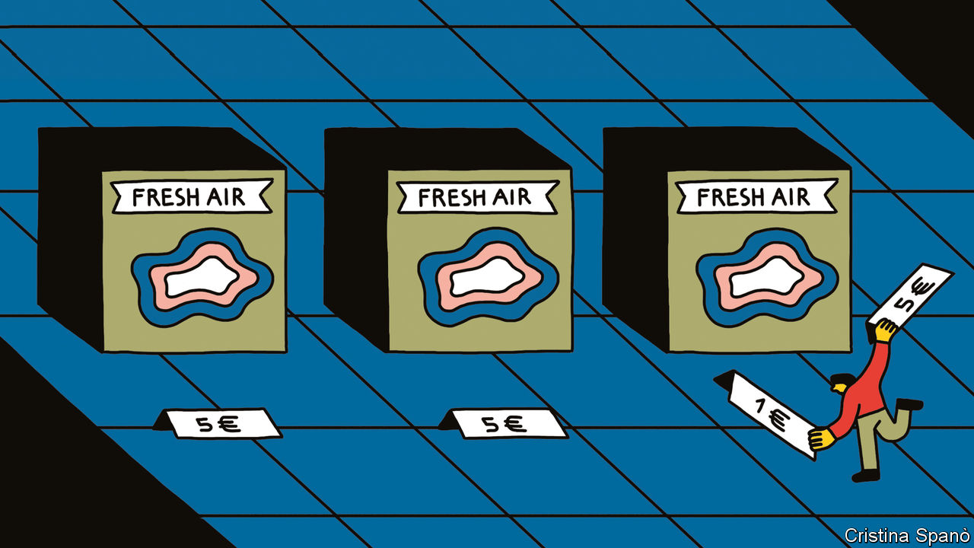

CARBON OFFSETTING is in vogue. The practice involves giving money to a green charity that takes action, such as planting trees or building solar panels, to stop emissions entering the atmosphere or to remove them from it. In 2018 around $296m was spent buying the equivalent of 98m tonnes of CO2 offsets in the “voluntary” market (ie, outside government-mandated schemes). That is roughly twice the volume and value from the year before, and a seven-year high, according to Forrest Trends, a lobby group.

The boom has been aided by corporate demand. In 2019 EasyJet, Shell and other large emitters announced offset buying schemes. These are usually for firms going carbon-neutral (offset all emissions) or working to a net-zero emissions target (reduce emissions, then offset the rest). From 2021 an industry-wide scheme will mean that airlines start offsetting some of the growth in emissions from flights.

But offsets are oddly cheap. The average price in 2018 was $3 per tonne of CO2. The EU’s cap-and-trade scheme charges about eight times that. EasyJet wangled a below-average price, costing £25m, or 6% of pre-tax profits, to offset all its flights. What explains such low prices?

One answer is that big companies are able to buy in bulk, lowering the price. EasyJet says that, had passengers bought offsets individually, the cost would have been about four times higher. For their part, offset suppliers like the certainty of sales, which helps finance long-term projects. But another reason is that many offset projects are ineffective, especially those that offer “avoided emissions” (ie, those that would have happened without the project). It is hard to prove that an offset-financed wind farm would not have found cash elsewhere. (EasyJet says the effectiveness of its offsets is verified by a third party.) A study published by the European Commission in 2016 into one big programme found that 85% of the offsets had no environmental benefits.

The offsets with the hardest-to-measure impacts are also the most popular. Forestry schemes make up half the voluntary market. Yet many claiming to avoid deforestation cannot guarantee that loggers do not just cut down trees somewhere else. Some projects protect trees on unthreatened lands, such as national parks, says Gilles Dufrasne, of Carbon Market Watch, another lobby group. And the trees must remain standing for many years before the CO2 reduction is absorbed. Often that period is 100 years—plenty of time for corporate promises to be forgotten.

This article was downloaded by calibre from <https://www.economist.com/special-report/2020/09/17/cheap-cheats>

|  |  |  |  |
| --- | --- | --- | --- |
| Previous | Articles | Sections | Next |

|  |  |  |  |
| --- | --- | --- | --- |
| Previous | Articles | Sections | Next |

#### Technology

# Green machines

A wave of innovation may help tackle climate change

Sep 17th 2020 |

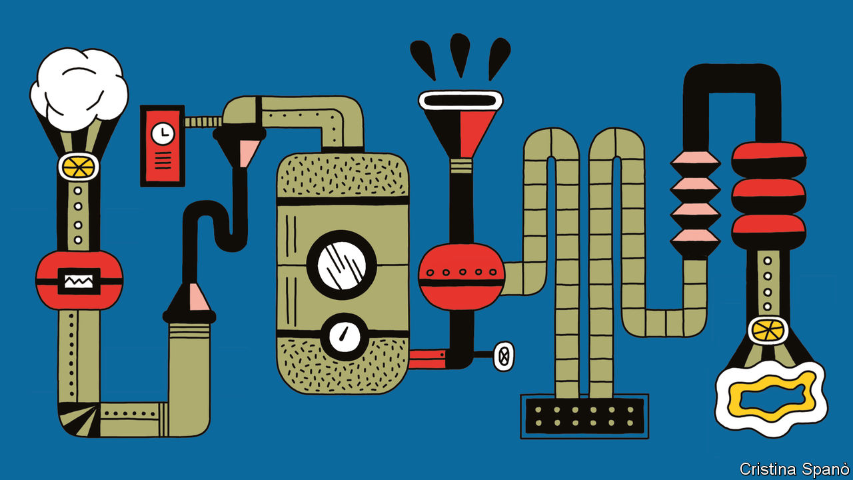

“WE LOOKED for big industries that exist on inertia,” recalls Kathy Hannun. She used to work at Google X, the tech giant’s moon-shot division. Heating with fossil fuels was an example of an industry ripe for disruption. The distribution system is convoluted, argues Ms Hannun. Natural gas or fuel oil is taken from the ground, shipped across the world and piped into houses. But a huge amount of latent energy exists around us. In 2017 she founded Dandelion Energy, an attempt to harness that power by selling heat pumps, refrigerator-sized boxes that take heat from the air or the ground to warm a building. Orders grew fourfold in 2018 and 2019. Further expansion is likely. Last year 20m households purchased heat pumps. To stop the planet from overheating, the IEA reckons that number has to triple by 2030.

Yet that rate of growth may be optimistic without a push from regulators. Heat pumps face similar obstacles to other emissions-reducing measures. The upfront costs are large: some heat pumps cost over $15,000. And installation is disruptive, often taking days or weeks. Heat pumps are just the start: across the world entrepreneurs are busily inventing new technologies and tinkering with old ones. The opportunity is vast. The $1.2trn that the IEA says is needed for energy-system investment represents a 60% increase on current spending. But precisely which technologies and which firms flourish will depend to a large degree on getting the right pattern of regulation, subsidy and pricing.

This is best seen by considering four different places where greenery meets technological change. First comes the adaptation industry, which will thrive regardless, because of the physical risks linked to climate change. For the second, greater energy efficiency, to take off, something of a nudge from regulators will be required. The third, renewables, may need even more help, although prices have been tumbling. And the fourth, carbon removal, is nascent. It is still too expensive to remove a tonne of CO2 from the air and store it safely; the industry must have a high carbon price if it is to be competitive.

Start with adaptation. Even with a sharp, sustained fall in emissions, the weather is certain to keep getting worse. So governments and companies alike will have to spend more on adaptive measures, such as seawalls. The Global Commission on Adaptation, an intergovernmental body, reckons that to avoid the worst consequences of climate change, $180bn of annual investment is needed for a decade.

Infrastructure firms have seen climate-related work pick up since the Paris agreement in 2015. AECOM, an engineering firm, is designing measures to stop floods engulfing Route 37, a coastal road in California, including raising it 150cm (five feet) off the ground. The payback for such measures is high. Often a dollar invested in adaptation yields ten dollars in avoided damage, says David Viner of Mott MacDonald, another engineering firm.

Farming is adapting too. Bayer and Syngenta, two agricultural firms, are developing more resilient crops. A strain of shorter, sturdier corn is being tested by Bayer in Mexico. It needs less water and is less likely to be flattened by a storm. Worse weather will call for more varieties of new seeds. Bayer has spent $100m on a high-tech greenhouse in Arizona. In an automated process, a laser slices off a tiny fragment from an individual seed. The slice’s DNA is analysed while the rest is planted and grows normally. That allows researchers to track the genetic make-up of plants and find out which genes improve the likelihood of storm-survival. Along with other innovations, the process cuts the time when new seed varieties must be tested from two or three years to one.

Next come improvements in energy efficiency. In a scenario where the 2°C goal is met, greater efficiency could cut emissions by seven gigatonnes by 2040, about the same amount as renewables, according to the IEA. Up to a point, it makes economic sense as well. Analysts reckon that most companies can cut their emissions by 10-20% through greater energy efficiency and, in doing so, bring down their costs. That should be a boon for firms that pursue such goals—and those that sell them advice.

Schneider Electric, a French firm, is in the second group. Jean-Pascal Tricoire, its boss, says 70% of its revenue comes from green projects or energy-efficiency ones. Recently it ramped up a distribution centre for Lidl, a supermarket chain, in Finland. Rooftop solar panels, a microgrid and a smart energy-monitoring system were installed. Sensors cut wasted energy by switching off idle lights and machines. Excess heating from air-conditioning is stored for use when the weather cools. The system is so efficient that the surplus heat provides hot water for 500-odd homes nearby. Energy costs fell by 70%; carbon emissions by 40%.

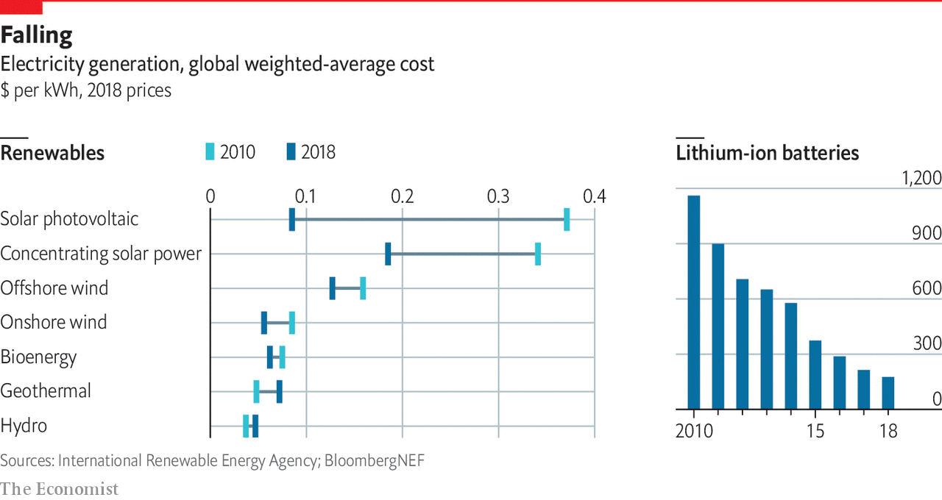

Because decarbonising transport is so pricey, the potential efficiency gains are big. The Energy Transitions Commission (ETC), a global body, estimates that 35-40% of energy use in transport could be profitably saved. Digitisation is one way forward. Scania says the average lorry is only 60% full. One study found that 45 trucks visited a single department store in Copenhagen every day, whereas four fully laden ones could have delivered the same load. The firm is now planning to use GPS-trackers to cut unnecessary journeys. Similar gains can be made at sea. Ships often sail full-steam to get to port, then queue for hours or days before they can moor. PortXchange, a data company, cuts fuel use by alerting boats to port queues in real time.

## A renewable boom

The third area is renewables. In much of the world they are now cheaper than natural gas thanks to plummeting prices. More progress can be expected. Heliatek, a German firm, makes ultra-thin panels that can be printed onto flexible plastic. GE Renewable Energy, an engineering firm, is testing wind turbines as big as the Eiffel Tower. That is good news because a vast increase in renewable electricity will be needed. Adair Turner, chairman of the ETC, says decarbonising the economy will involve a threefold jump from 25 terawatt-hours today to 90 or so by 2050.

Because sunshine and wind are intermittent, better ways of storing energy are needed. Hydrogen and batteries are the frontrunners. Both have drawbacks. For a given volume, they store less energy than fossil fuels. Building the infrastructure to support them is a huge task, which requires much co-ordination (what low-carbon fuels should be available at petrol stations?). And even though the prices of both are falling, costs remain high.

One way to boost the amount of battery storage is through electric vehicles, which seem sure to spread. Because cars are parked 95% of the time, at any one moment a hefty amount of battery power is sitting idle. Enel X, the Italian utility’s innovation arm, is experimenting at its headquarters in Rome. Electric vehicles belonging to a dozen or so employees are hooked up to the grid using special two-way charging points. They provide about one megawatt of electricity, which is enough to serve hundreds of homes. “Electric cars for us are batteries with wheels,” says Eliano Russo, of Enel X.

Hydrogen is another form of storage. A recent report by BloombergNEF, a consultancy, finds that renewable hydrogen could cut up to 34% of global greenhouse-gas emissions from fossil fuels and industry. To do this would require $150bn in subsidies by 2030. That would bring prices down to a level competitive with natural gas in most of the world. Today most of the commercially produced stuff creates CO2 as a by-product. However “green” hydrogen can be made by splitting water into hydrogen and oxygen with clean power. It could then be pumped into existing pipelines and power natural-gas boilers. It could be used to cut emissions from many industrial processes, such as making ammonia. Or it could be stored in fuel cells and used to power vehicles. China is pursuing this idea. It spent a reported $12bn on fuel-cell subsidies in 2018. The share price of PowerCell, a Swedish outfit that makes hydrogen fuel cells, has doubled in the past year. In the same period Canada’s Ballard Power has seen its share price triple, while that of America’s Plug Power has risen fivefold.

The fourth idea is carbon removal. Between 100bn and 1trn tonnes of CO2 will have to be taken out of the atmosphere by 2100 if the 2°C goal is to be reached, according to a range of scenarios examined by the UN’s Intergovernmental Panel on Climate Change. The median value was 730bn tonnes. If carbon removal costs around $100 per tonne of CO2, an optimistic estimate for the foreseeable future, then annual global spending on carbon removals could easily reach $900bn in decades to come.

Many startups are trying to harness nature’s own carbon sequestration. One is Indigo Ag. Last June it launched a platform to pay farmers for absorbing more CO2 in their land. Soil is a natural store of carbon: the organic carbon into which plants transform the atmospheric CO2 is stored there in abundance. Changes in agricultural techniques, such as reduced deep-ploughing, help keep carbon in the soil. Indigo Ag’s first step is to measure the carbon content of soil. It uses an algorithm to crunch reams of data, from satellite imagery to information from tractor-based sensors, and generate estimates with 85% accuracy. Farmers who successfully use carbon-absorbing approaches will be paid for each additional tonne of CO2 sequestered. The firm sells the offset, at around $15-20 per tonne, with a mark-up for its trouble.

That may sound cheap, but it comes with risks. One is how securely the carbon is stored. A heavy storm could release some of it. An alternative source of negative emissions is machines or “direct-air capture” (DAC). Climeworks, a company based in Zurich, makes smart-car sized DAC machines which contain a fan drawing air through a filter, a bit like a sponge. Once saturated, the filter is heated and carbon is captured. Today it costs $600-800 per tonne of CO2 removed. Two other firms pioneering DAC technology, Carbon Engineering and Global Thermostat, also have price points firms deem too high to be commercially viable. And the scale is still too small. But a new facility that Climeworks is planning will suck 4,000 tonnes of CO2 out of the air each year, equivalent to the annual footprint of 600 Europeans.

That plant will be built with Carbfix, an Icelandic startup. Its researchers are trying to accelerate mineralisation, a natural process whereby CO2 is transformed into rock, over hundreds of years. Captured from a geothermal power plant or through DAC, CO2 is dissolved in water and injected into rock formations 500 metres underground. After two years, the carbon becomes rock and is stored in a stable form. Storage costs about $25 per tonne. The next step is to take the process offshore, storing carbon under the ocean. Seabeds are often made of deposits of basalt, the type of rock required. A pilot project will start in the next few years. If successful, it will create almost “limitless storage”, says Edda Sif Aradottir, Carbfix’s boss. The world may need it.■

This article was downloaded by calibre from <https://www.economist.com/special-report/2020/09/17/green-machines>

|  |  |  |  |
| --- | --- | --- | --- |
| Previous | Articles | Sections | Next |

|  |  |  |  |
| --- | --- | --- | --- |
| Previous | Articles | Sections | Next |

#### The future

# Directing the disruption

Companies that fail to tackle climate change face a backlash

Sep 17th 2020 |



THE PRINCIPAL message of this special report is that companies everywhere urgently need to step up their action against climate change. Its physical impact is already causing many of them serious damage. Pushed by voters, especially younger ones, governments around the world are introducing ever tougher regulations. Lawsuits could yet make firms’ lives harder still. And, although new technology can be expected to help with the problem in time, it will not do enough on its own to meet the enormous challenge of climate change.

One place to start is with better carbon-emissions data. Today few companies even know how much greenhouse-gases suppliers belch out. That means they will struggle to calculate the full environmental impact of their products. Where data do exist, they are often self-reported, inconsistent or too out of date to be useful. But work is under way to fix this.

Along with some other firms, Microsoft plans to launch an emissions reporting standard for suppliers later this year, backed up by sustainability audits. “Science tells us where we need to be, but the data tell us where we are now,” says Brad Smith, Microsoft’s president. In January the Rocky Mountain Institute and other research groups started to standardise greenhouse-gas metrics for mining and industrial supply chains. With help from Google, WattTime and CarbonTracker, two lobby groups, are estimating emissions from coal-fired power plants in real time using satellite imagery and whizzy algorithms.

The hope is that better numbers could unleash market forces and consumer choice. Carbon labels, much like food labels, could guide consumers towards greener products, giving firms yet another incentive to decarbonise. However, there are also reasons to be sceptical about the effect of such direct action. Many previous carbon-labelling schemes have failed to gain traction. Persuading firms to adopt them is hard. And consumers are confused by the dizzying array: Ecolabel Index, a green-label directory, counts 457 such labels.

In any case, consumer action on its own can do only so much. One study, led by Daniel Moran of the Norwegian University of Science and Technology, examined the effect on Europe’s carbon footprint of 90 behavioural changes, such as buying low-carbon products and eating less meat. Researchers found that the maximum reduction was 24%. That is an important chunk, but not enough to defeat global warming. The conclusion is that policymakers are needed even more than consumers to push companies towards serious decarbonisation.

## Vote early, vote green

Electorates can, however, make a big difference. If hordes of green voters start turning up at polling stations, they could accelerate the trends set out in this report. They will press political leaders to impose more environmentally friendly regulations and laws. And when the younger generation starts to save and invest, it could press financial firms to back green companies faster than many expect. A recent report by BlackRock estimates that, by around 2035, the wealth held by American millennials (those who were born between 1981 and 1997) will exceed that of baby boomers (born between 1946 and 1964).

This only strengthens the case for every firm to do more now to tackle climate change. The underlying reason for early action lies in two inescapable facts. The world of commerce is deeply interconnected because of international trade. And climate change is a systemic problem. Greenhouse gases are emitted by every firm in the world, either through its own operations or in its supply chain. Its effects will hit every firm directly or indirectly. For different companies this will translate into different costs. But none will be entirely untouched.

Energy transitions are slow, so firms need to act soon. For those business sectors in which mitigation is hardest, such as steel or shipping, coming up with a viable, low-carbon alternative could take many years. Moreover, some carbon-producing assets last a long time. A steel mill built today will probably be pumping out CO2 in 20 years’ time. If companies are to decarbonise by midcentury, many newly built assets will need to be carbon-free by the end of the present decade.

And there is another, more enticing reason to move swiftly. Decarbonising the economy holds many risks but it also offers plenty of opportunities. They lie in developing new technology, becoming more carbon efficient than competitors or selling genuinely green products to consumers. Firms that get ahead of their rivals and seize such opportunities will reap the biggest benefits. They may just help save the planet as well.■

This article was downloaded by calibre from <https://www.economist.com/special-report/2020/09/17/directing-the-disruption>

|  |  |  |  |
| --- | --- | --- | --- |
| Previous | Articles | Sections | Next |

|  |  |  |
| --- | --- | --- |
| Special report | Sections | Finance & economics |

Business

The future of carmaking: Journeys in the Teslaverse

.

Electric altercations: Short circuit

.

Not quite beyond petroleum: A less oily BP

.

Chipmaking: Integrating circuits

.

Sino-American tech tussles: Trump card

.

Bartleby: The only way is ethics

.

The database business: Steam engine in the cloud

.

Schumpeter: The perils of stakeholderism

.

|  |  |  |
| --- | --- | --- |
| Special report | Sections | Finance & economics |

|  |  |  |  |
| --- | --- | --- | --- |
|  | Articles | Sections | Next |

#### Electric cars

# Who will rule the Teslaverse?

The race to make the car of the future is hotting up

Sep 17th 2020 |



A RECENT VIDEO of Elon Musk taking a spin in a new all-electric Volkswagen with Herbert Diess, the German carmaker’s boss, set tongues wagging. VW was forced to deny that a deal with Tesla was in the offing. A deeper bromance between Mr Musk’s firm and his main rival in the market for electric vehicles (EVs) looks unlikely. But the meeting highlights how the car industry is at last taking the impending EV revolution seriously.

Giant new businesses are gearing up to support the switch from petrol to electricity. Besides changing the way cars are propelled, this requires batteries, software to ensure these work in harmony with motors, and data harvested from cars that may one day allow them to drive themselves. Over 250 firms are manufacturing electric motors. Forty-seven battery factories are under construction. Anjan Kumar of Frost & Sullivan, a consultancy, expects total new EV-battery capacity to go from 88 gigawatt-hours in 2019, enough to power Texas for less than two hours if plugged into the grid, to 1,400 gigawatt-hours in 2025. Established carmakers are pondering how to loosen the grip of big tech on software.

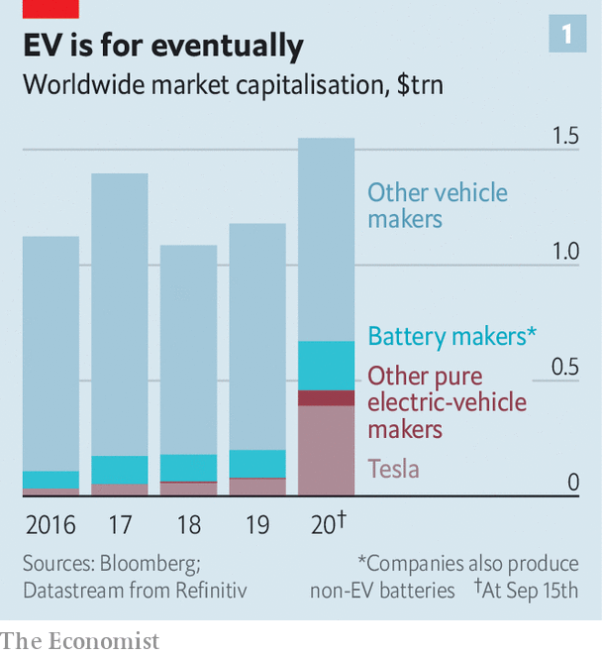

The total market capitalisation of listed makers of exclusively electric cars now exceeds $400bn. Add producers of batteries that go into them, and the EV-industrial complex, which makes fewer than 400,000 vehicles annually, is worth at least $670bn (not counting miners of lithium and other battery minerals). That is nearly three-fifths as much as traditional carmakers, which churn out 86m cars a year, nearly all of them petrol-powered (see chart 1). Call it the Teslaverse.

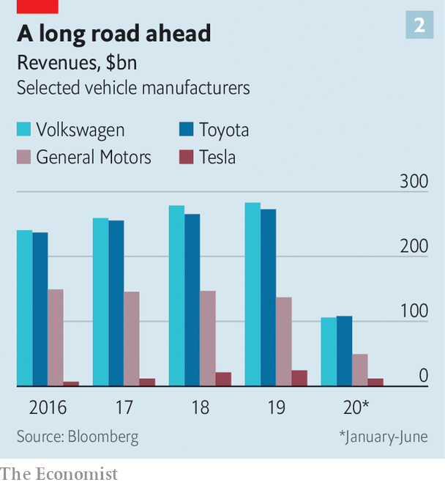

As that moniker suggests, Mr Musk’s firm sits at its centre. In July it overtook Toyota as the world’s most valuable carmaker, and kept accelerating—never mind that it made 370,000 cars against Toyota’s 10m and a fraction of the Japanese firm’s revenues (see chart 2). By August Tesla was worth over $450bn. A market correction lopped a third off its share price but it has since rebounded. What would it mean to take it seriously, as investors appear to be?

Car sales could fall by 25% in 2020 owing to pandemic disruption. But the share of EVs on the road will continue to grow as emissions regulations tighten, the price of batteries falls and the choice of models expands. Next year three in every 100 cars sold will be pure electric or a plug-in hybrid. The share may rise to 20-25% by 2030, equal to 20m new EVs a year.

At the moment Tesla is the “apex predator”, says Adam Jonas of Morgan Stanley, a bank. It has been manufacturing EVs at scale longer than any other carmaker and sells more of them. Its elevated share price translates into the lowest cost of capital in the business. A growing offering, with a lorry and pickup soon to hit the road, will widen its appeal. It attracts the best engineers and possesses in Mr Musk, love him or loathe him, a leader with messianic zeal.

Mr Kumar puts Tesla two to three years ahead of rivals in battery technology. Its batteries have a higher energy density, which means better range and lower costs. On September 22nd Mr Musk is expected to present plans for new production capacity and fresh battery technology. Together, this would extend Tesla’s cost advantage.

The firm’s edge is even more pronounced in software. Rainer Mehl of Capgemini, a consultancy, calls Tesla cars a “shell around the software and applications inside”. Thanks to vertically integrated manufacturing, systems have been interlinked from day one. As Olaf Sakkers of Maniv Mobility, an Israeli fund, explains, big carmakers have outsourced almost all their technology apart from internal-combustion engines to suppliers, and focused on assembly and marketing. This makes for a “bird’s nest of complexity”, says Mr Sakkers. Tesla’s software and mechanics are seamless by comparison.

All this software means Teslas improve with age, thanks to regular “over-the-air” updates with new features, bug fixes and even performance upgrades. This makes up for a sometimes shabby finish and questionable reliability. Other big carmakers are five years behind, says Luke Gear of IDTechEX, a consulting firm.

Tesla also seems to have mostly put what Mr Musk has called “production hell” behind it. As Philippe Houchois of Jefferies, an investment bank, notes, a reputation for delivering models late and over budget has become one for being ahead of time and on budget. A rapidly built new factory in Shanghai began shipping in December and “gigafactories” are under construction in Berlin and Texas that will boost capacity from 700,000 units to 1.3m in 18 months, says Credit Suisse, a bank. Tesla cheerleaders talk of 3m-5m new Teslas annually by 2025, out of a global total of around 85m cars. Mr Musk eventually wants to make 20m a year.

Mr Jonas says that Tesla’s current share price implies it will end up with 30-50% of the car market. This overlooks other sources of revenue: from selling batteries, its operating system or an EV “skateboard” of battery pack and running gear to which others can add a body (and in time more futuristic data and self-driving systems). Even the most wildly optimistic scenarios for Mr Musk’s company, then, leave room in the Teslaverse for others.

Start with the established carmakers. Their lowly valuations may be read as implying they ought to give up trying to make the transition to EVs and quietly fade away. But even firms with the heftiest petrol-driven legacies should not be written off. Chinese carmakers show why. The government prodded them to go electric with tough mandates in the hope of dominating the future market. Around half the world’s EVs are currently sold in China. The likes of Geely and BYD (which also makes batteries) want to expand overseas.

There, big Western carmakers face a slog. Though some suppliers, such as Aptiv, have spun off legacy operations to concentrate on EVs and self-driving technology, most remain bound to the internal combustion engine. And lots of car firms, in particular the German premium ones, must contend with powerful unions fearful of job losses resulting from the move to EVs’ less complex—and thus less labour-intensive—mechanics.

Despite the difficulties, the industry is desperate to make the EV side work. Mr Kumar estimates that 60% of big car firms’ research-and-development spending now goes on EVs, up from 5-10% in 2012. Morgan Stanley reckons big carmakers will invest up to $500bn in EVs over the next five years. According to Bernstein, a research firm, they have been “terrible deployers of capital” but they are “waking up”. Potential big sellers on sale this year include VW’s ID.3 and Ford’s Mustang Mach-E.

## Electric power to the people’s car

VW is leading the charge. It will spend €60bn ($71bn) by 2025 on EVs and digitisation. Carmakers typically develop 2-5% of software in-house. In an effort to reinvent itself as a software company, VW wants to boost its share to 60% by 2025. Other carmakers and suppliers harbour similar ambitions. Daimler’s recent tie-up with Nvidia, a giant chipmaker, should allow remote updates by 2024. Aptiv already offers integrated software.

Big firms could create distinct units to lure outside capital and talent, and take risks, suggests Morgan Stanley’s Mr Jonas. Some already are. General Motors (GM) has the Cruise self-driving arm, BMW has iVentures and Toyota has its Mobility Foundation. Another tactic is to invest in startups. On September 8th GM said it would buy an 11% stake in Nikola, a controversial electric-lorry firm, for $2bn (see article). Ford has backed Rivian, which hopes to crack the lucrative pickup market.

The likes of Nikola and Rivian are examples of another part of the Teslaverse. Although they face some big barriers, notably in manufacturing and distribution, raising money is not one of them. Capital is pouring in, helping cars move off the drawing board and into production. Chinese Tesla copycats have sprung up. In America Lucid Motors unveiled its first car at its headquarters near San Francisco on September 9th, with a Tesla-beating 800km range. One of its biggest backers is Saudi Arabia’s sovereign-wealth fund. Lordstown, Fisker and Canoo are aiming to follow Nikola, which went public in June through a reverse merger and is now worth $13bn. Firms working on next-generation solid-state battery technology, such as QuantumScape, backed by vw and Bill Gates, plan to go public soon.

Several Chinese Tesla wannabes, such as Nio, Xpeng and Li Auto, are already listed in New York. They enjoy the benefit of cheap domestic labour, a huge local market and proximity of battery-makers such as BYD and CATL, the world’s biggest such firm. Nio, which teetered on the brink of collapse in February before a bail-out by the city government of Hefei, where it has a big factory, is now valued at around $24bn.

Carmaking remains a tough business to crack. Assembling bodywork or brakes at scale is different to making gadgets or writing code. Dyson, a British maker of high-tech vacuum cleaners and hand-driers, sunk £500m ($640m) into developing an EV before scrapping the idea. Apple abandoned plans to make a car in 2016, though it is still investing in self-driving systems. Other tech giants are opting instead to invest in startups. In China Baidu, Tencent and Alibaba have backed WM Motor, Nio and Xpeng, respectively. Amazon has put money into Rivian and ordered 100,000 of its electric lorries (in part to show it is serious about reducing its carbon footprint).

To survive in the Teslaverse, companies have to demonstrate they have valuable intellectual property that sets them apart, as many of the upstarts claim. But they must also prove they can sell and maintain their cars, where legacy carmakers have a long track-record. It is too early to divine the winners and losers. Even Mr Musk’s firm could falter. But his vision of an electric future is already emerging victorious.■

This article was downloaded by calibre from <https://www.economist.com/business/2020/09/17/who-will-rule-the-teslaverse>

|  |  |  |  |
| --- | --- | --- | --- |
|  | Articles | Sections | Next |

|  |  |  |  |
| --- | --- | --- | --- |
| Previous | Articles | Sections | Next |

#### Short circuit

# Can Nikola become the next Tesla?

Not if a suspicious short-seller has its way

Sep 17th 2020 |



ONE WAY to try to emulate Tesla’s success is to name your firm after the same person. Nikola, founded in 2014 to make electric and hydrogen-powered lorries, is, like Elon Musk’s carmaker, named after Nikola Tesla, a Serbian-American pioneer of electricity. Nikola’s market value nudged $30bn after it went public in June. Some investors were puzzled that a firm not yet selling vehicles could be worth more than Ford, which sold 5.4m last year. Nikola’s share price fell back over the next two months. It jumped again on September 8th, after General Motors said it would take an 11% stake in the firm.

This time the euphoria was even more short-lived. On September 10th Hindenburg Research, an investment firm (named after the airship disaster from 1937) released a report calling Nikola an “intricate fraud” that had told an “ocean of lies”. Nikola’s shares shed 36% of their value over the next couple of days.

Among other things, Hindenburg alleges that Trevor Milton, Nikola’s boss, made misleading statements when he unveiled the Nikola One, a hydrogen-electric lorry. Mr Milton, Hindenburg said, suggested a demo vehicle was driveable when it was not. A Nikola One shown travelling along a road in a separate video, Hindenburg claimed, was in fact rolling down a hill unpowered. The investment firm also gave short shrift to Nikola’s claims of revolutionary hydrogen and battery technologies, and cast doubt on the expertise of Nikola’s staff.

Nikola described Hindenburg’s report as “a hit job…driven by greed”. It pointed out that Hindenburg had a short position in Nikola’s stock, so it stood to profit if the price of Nikola’s shares fell (as Hindenburg acknowledged in its report). On September 14th Nikola published a statement accusing Hindenburg of “false and defamatory” claims designed to “manipulate the market”. It also appeared to concede that the Nikola One unveiled by Mr Milton had not been driveable and confirmed that the vehicle in the video had indeed been unpowered. But the firm notes that a later model, the Nikola Two, has driven under its own power several times. It characterised itself as an “early-stage” company trying to “prove its concepts”.

On September 11th Mr Milton tweeted a statement that Nikola “intends to bring the actions of the activist short-seller, together with evidence and documentation, to the attention of the US Securities and Exchange Commission”. On September 15th the Wall Street Journal reported that the Department of Justice had taken an interest in the case. General Motors says it is “fully confident in the value we will create by working together” with Nikola. Nikola itself says that all its other partners are sticking with it. Investors appear more jittery. Nikola’s share price is down 27% from the day before Hindenburg’s report.

This article was downloaded by calibre from <https://www.economist.com/business/2020/09/17/can-nikola-become-the-next-tesla>

|  |  |  |  |
| --- | --- | --- | --- |
| Previous | Articles | Sections | Next |

|  |  |  |  |
| --- | --- | --- | --- |
| Previous | Articles | Sections | Next |

#### A less oily BP

# How BP’s newish boss sees the future of fossil fuels

Bernard Looney wants to revive the British oil major’s old slogan and move “Beyond Petroleum”. But not all at once

Sep 19th 2020 |

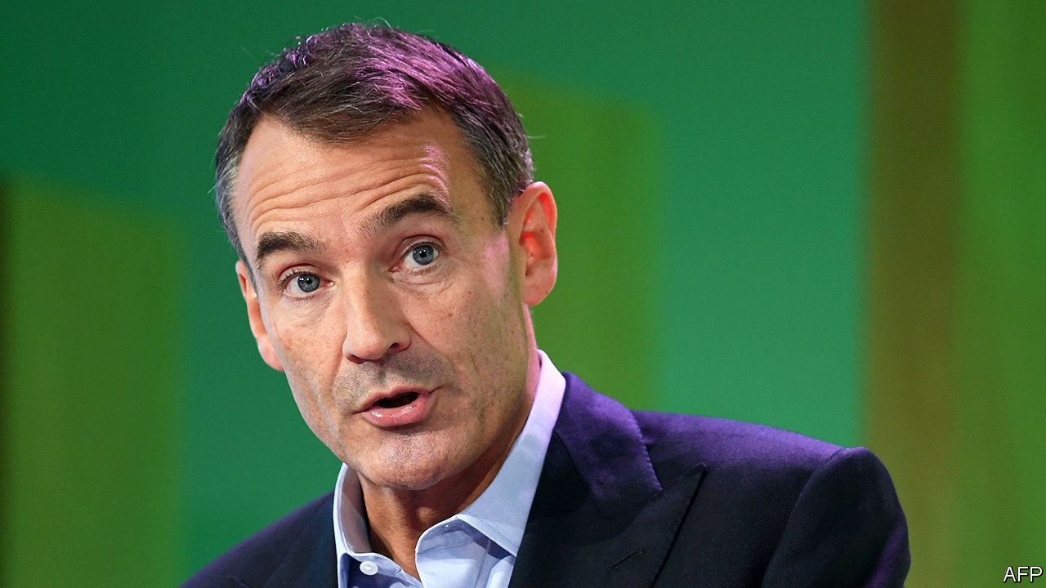

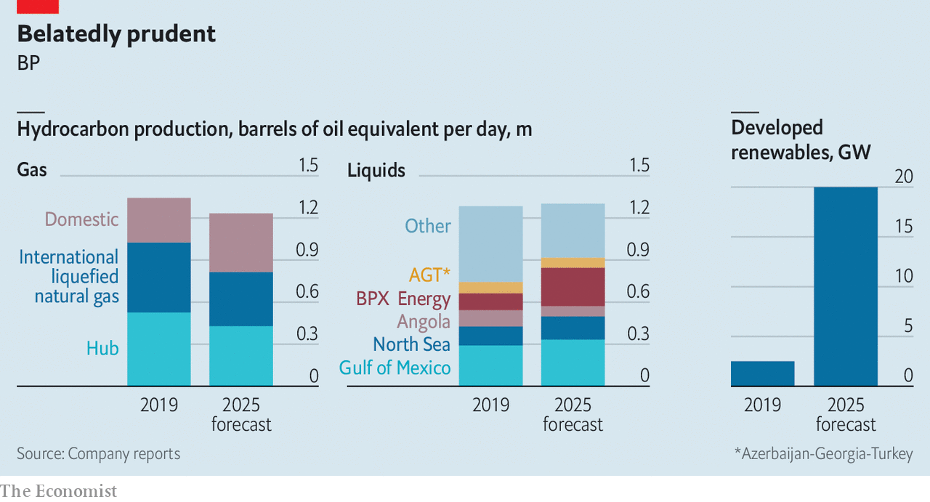

ALL EYES of the oil world were on BP this week for the British energy giant’s annual three-day investor jamboree. Bernard Looney, who became chief executive this year, wants BP at last to make good on its old slogan, "Beyond Petroleum". Annual capital spending on oil, gas and refining projects will fall from around $13bn in 2019 to an average of $9bn in 2021-25. Gas and oil production will remain relatively steady in the short term, before falling as BP ramps up its investments in renewable power. BP’s plan is more ambitious than under Mr Looney’s predecessor, Bob Dudley. It is also by far the most aggressive of any supermajor. That is admittedly a low bar.

For more coverage of climate change, register for The Climate Issue, our fortnightly [newsletter](https://www.economist.com/theclimateissue/), or visit our [climate-change hub](https://www.economist.com/news/2020/04/24/the-economists-coverage-of-climate-change)

This article was downloaded by calibre from <https://www.economist.com/business/2020/09/19/how-bps-newish-boss-sees-the-future-of-fossil-fuels>

|  |  |  |  |
| --- | --- | --- | --- |
| Previous | Articles | Sections | Next |

|  |  |  |  |
| --- | --- | --- | --- |
| Previous | Articles | Sections | Next |

#### Integrating circuits

# How Nvidia’s purchase of Arm could open new markets

It could also be blocked by China

Sep 19th 2020 |



WHEN SOFTBANK, a Japanese technology group, paid $32bn for Arm in 2016, it was the biggest deal in chipmaking history. That record held until September 13th, when Nvidia, a big American chipmaker, announced its intention to buy the Britain-based chip-designer for $40bn.

Although they share an industry, Arm and its prospective owner are very different. Nvidia makes GPUs: pricey, specialised accelerator chips for gamers and artificial-intelligence number-crunching in data centres. Arm licenses blueprints for general-purpose chips used in everything from smartphones to cars and computerised gizmos that make up the “Internet of Things” (IoT). Customers ship more than 20bn Arm-designed chips every year.

Arm’s keystone position was SoftBank’s rationale for buying the firm. But it has languished under Japanese ownership. Revenues have stagnated, and the firm has made a small but persistent loss (see chart). Geoff Blaber at CCS Insight, a firm of analysts, blames a slowdown in the smartphone market, and low margins on IoT gear. Arm’s $40bn valuation is only 25% higher than when SoftBank bought it—and just 5% higher if you deduct the $1.5bn Nvidia has offered Arm employees to stop them from leaving and a mysterious $5bn cash or stock payout that SoftBank may qualify for under some conditions. Meanwhile, Nvidia’s market capitalisation, four years ago not much bigger than what SoftBank paid for Arm, now stands at $309bn. Its sales have surged.

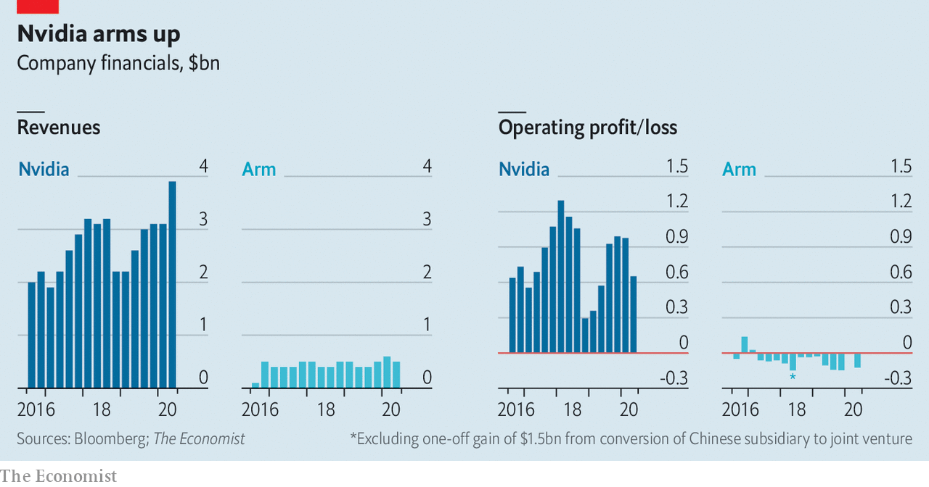

One motive for Nvidia’s purchase is a desire to expand beyond its existing markets. Arm’s technology could help it build its own versions of the general-purpose processors that power the data-centre computers into which Nvidia’s accelerators are installed, a lucrative market dominated by Intel, the world’s biggest chipmaker by revenue. Nvidia, for its part, hopes that baking its GPU expertise into Arm’s designs will make them more attractive to the firm’s customers.

Those customers, which include Apple, Qualcomm and Samsung, have kept a stony silence. Arm’s business model relies on being what Hermann Hauser, one of its founders, has described as “the Switzerland of the semiconductor industry”—ie, not competing with its customers by selling chips or gadgets itself. Nvidia’s purchase will threaten that neutrality if it tweaks Arm’s products to favour its own goals, or gives itself preferential access to Arm designs.

Nvidia has vowed to keep Arm’s business model intact. Having given such public assurances, says Patrick Moorhead, a chip-industry analyst, Jensen Huang, Nvidia’s boss, is unlikely to risk the opprobrium—or possible lawsuits from aggrieved licensees—that could arise from breaking them. But other analysts point out that Arm’s licensing revenues are, by Nvidia’s standards, small beer. If the Arm deal can be used to vault Nvidia into new markets, then cold commercial logic may encourage Mr Huang to push his luck. Custodians of RISC-V, a set of freely available designs, lost no time in noting that it remains independent and free of such conflicts.

Regulatory problems loom, too. Britain’s government is in an interventionist mood and is likely to attach strings, such as keeping Arm’s headquarters in the country. China may also object. It is already upset over American attempts to strangle its technology firms (see article). A takeover by Nvidia would bring Arm—a crucial supplier—firmly under American control. Even in normal times, says Mr Blaber, China might balk at such a prospect. It will be even less keen in the middle of a technological cold war. ■

This article was downloaded by calibre from <https://www.economist.com/business/2020/09/19/how-nvidias-purchase-of-arm-could-open-new-markets>

|  |  |  |  |
| --- | --- | --- | --- |
| Previous | Articles | Sections | Next |

|  |  |  |  |
| --- | --- | --- | --- |
| Previous | Articles | Sections | Next |

#### Oracle’s Trump card

# Who are the TikTok saga’s biggest winners?

As the race to control TikTok enters the final stretch, a White House-friendly tech giant seems to have carried the day

Sep 16th 2020 |

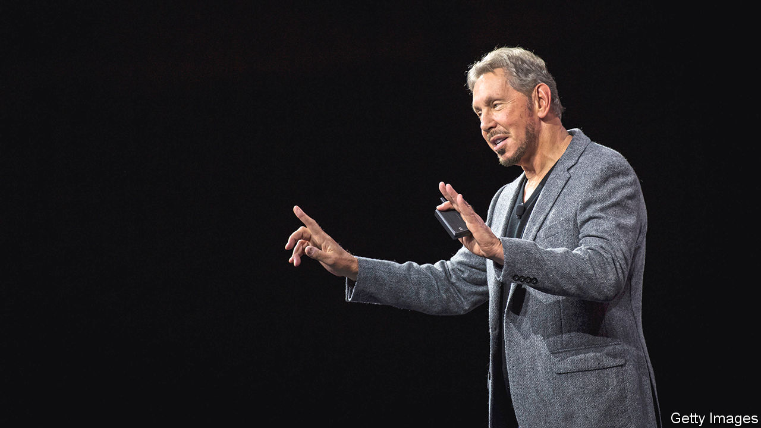

PRESIDENT DONALD TRUMP’S demand in August that ByteDance sell TikTok to an American firm set off a race for the Chinese firm’s trophy asset. Jockeying for the popular short-video app’s American business, with 100m users, was fierce. Microsoft seemed ahead, and got a late fillip when Walmart joined its bid. But the software-and-grocery duo was pipped to the post. On September 14th Oracle, a database firm, signalled it had brokered a deal.

Oracle’s clinching argument in its favour seems to have been its rapport with the White House. Larry Ellison, Oracle’s founder and chairman, hosted a fund-raiser for Mr Trump. The firm’s boss, Safra Catz, served on his transition team in 2016. “She lobbied a lot in Washington and she did a great job,” says a ByteDance investor. Oracle also enlisted the firm’s powerful American venture-capital backers, including Sequoia Capital and General Atlantic.

Details of the planned transaction are still being ironed out. But it looks like a U-turn for Mr Trump, who for months seemed hellbent on a full sale of TikTok by ByteDance—which the Oracle deal is not. His stated reasons concerned national security: the risk of TikTok handing Americans’ data over to China’s Communist Party and of running disinformation campaigns on behalf of China. (TikTok insisted it would never hand users’ data to China and that it has no propaganda role.)

The deal leaves both the president’s supporters and critics of his strong-arming of TikTok scratching their heads. Josh Hawley, a Republican senator from Missouri, called the deal “flatly inconsistent” with Mr Trump’s original executive order, which promised to ban the app unless its ownership changed by September 20th.

Perhaps to help make up for the absence of a clean sale, ByteDance is giving Oracle sway over all of TikTok globally rather than just America, Canada, Australia and New Zealand. Microsoft and Oracle were offering around $25bn-30bn to acquire these four markets. The revised plan is for ByteDance to place global TikTok into a separate company with headquarters in America. ByteDance would remain the majority shareholder. Its American VC investors are expected to come in as minority shareholders alongside Oracle—an arrangement that suits them better than TikTok’s sale to Microsoft, which would have deprived them of meaningful influence over the world’s hottest social-media property.

The Committee on Foreign Investment in the United States (CFIUS), a federal oversight body which has been examining TikTok for months, will assess the transaction by September 20th. It then falls to Mr Trump to give it the formal go-ahead. People close to ByteDance worry that China hawks around him could still derail it.

Chinese majority ownership still rankles. Oracle and ByteDance also have no clear answer to worries about disinformation. And though Oracle will host and process all American data in its computing cloud, and possibly that of TikTok users globally, the deal does not sever TikTok’s links with its Chinese parent. ByteDance will keep supplying, running and updating the algorithm that powers TikTok’s “for you” page. Microsoft argues it would have made a better TikTok steward, for example by continually vetting the algorithm. In an acerbic concession note, the software giant said it will monitor TikTok’s future progress in the areas of “security, privacy, online safety and combating disinformation”.

The fudge may suit Mr Trump fine. Risks associated with banning TikTok have risen. On August 28th China’s commerce ministry invoked its own national-security concerns to block the sale of ByteDance’s algorithm to foreigners. It seemed to dare the president to go for a ban, the legal basis for which has always looked shaky. According to an American diplomat, the executive orders on TikTok were drafted by Peter Navarro, the president’s China-bashing economic adviser. They did not go through the usual vetting process by lawyers and bureaucrats and could contain holes; ByteDance has already filed a lawsuit. Mr Trump’s other advisers also cautioned against a ban that could irk millions of TikTokers in battleground states like Texas and Florida.

The most obvious winner from the farrago is China’s government. Its bureaucrats played the political chess game to perfection, notes a ByteDance investor. The Chinese firm gets to keep some of its prize asset rather than sell it on the cheap. Oracle will benefit, especially if it manages to wrest TikTok’s cloud contract from Google—though the internet giant may challenge such a move in court. Microsoft, which also has a big cloud platform, looks the loser. But given the chaos and uncertainty of dealing with Mr Trump, the runner-up might in time come out ahead. ■

This article was downloaded by calibre from <https://www.economist.com/business/2020/09/16/who-are-the-tiktok-sagas-biggest-winners>

|  |  |  |  |
| --- | --- | --- | --- |
| Previous | Articles | Sections | Next |

|  |  |  |  |
| --- | --- | --- | --- |
| Previous | Articles | Sections | Next |

#### Bartleby

# How do you stop corporate fraud?

The only way is ethics

Sep 19th 2020 |

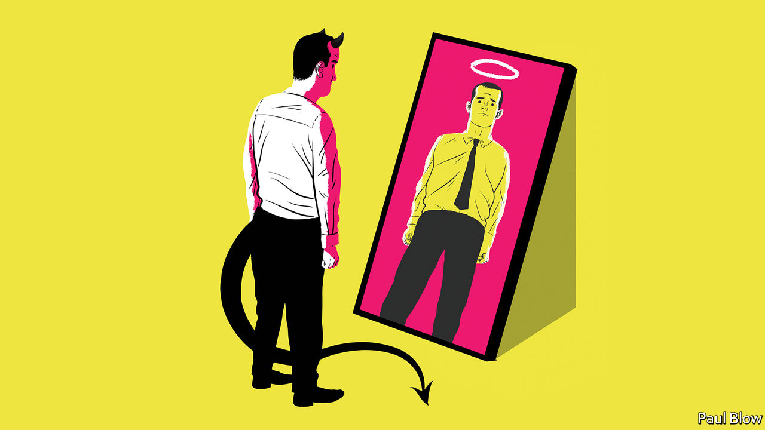

CORPORATE SCANDALS occur with depressing regularity, from the accounting misstatements at Enron in 2001 to fake bank accounts at Wells Fargo, uncovered in 2016. In June Wirecard, a German payments processor, revealed that €1.9bn ($2.3bn) was missing from its accounts. What was remarkable about the affair was that the company’s book-keeping had been the subject of sceptical articles in the Financial Times. Yet the initial reaction of BaFin, the German regulator, was to launch an investigation into the newspaper, not the firm.

It is clearly difficult for people to recognise when a business is heading off the rails. That can be just as true for managers within a business as for people outside it. Executives can be sideswiped by an unnoticed problem in an individual division or a subsidiary; not all scandals make it on to the front pages.

Outright malice is not always the cause. Ethical choices are rarely black or white and individuals are not very good at assessing the purity of their own motivations. In a new book about behavioural biases, “You’re About To Make A Terrible Mistake”, Olivier Sibony of HEC business school in Paris writes that “as soon as there is any ambiguity about a judgment…we reason in a way that is selective enough to serve our interests and yet plausible enough to convince others (and ourselves) that we are not intentionally distorting the facts.” Individuals’ choices are also governed by how others behave; people are more likely to break the speed limit if everyone else is doing so.

Philosophers call morally ambiguous decision-making within such internal and external constraints “bounded ethicality”. Inside companies, it can easily mean that a culture of cheating can spread quickly. A seminal paper* by academics at Columbia and Harvard business schools looked at how, in the light of this problem, companies might reduce cheating within their ranks.

Their first finding was that individuals are more likely to lie, or commit fraud, when they are set excessively difficult and specific goals. Bounded ethicality, the authors argue, can also operate at an unconscious level. Under pressure, people often do not efficiently analyse information that could otherwise keep them on the straight and narrow.

The problem is exacerbated by confirmation bias, a human tendency to seek out facts that back up their pre-existing preferences. Research has found that people given a specific performance target (to reach a 12% annual return over the investment horizon, for example) were more likely to overlook important information about the future performance of investment funds and excessively focus on past performance data.

As a result, the authors suggest, “Organisations might decrease intentional unethical behaviour by defining their goals more broadly and by setting goals at levels that are perceived as fair and relatively attainable by employees.” Another tactic is for managers to signal clearly that ethical issues may arise, so that people take them into account when making decisions. In one study, drivers were found to be more honest in reporting their car mileage when they signed an ethics code of conduct at the top of a mileage form (before they entered the distance on the form) than at the bottom (after the figure had been recorded).

The Columbia and Harvard researchers conducted a test asking people to act as financial advisers and pick from a range of funds. One part of it used the raw data from funds operated by Bernie Madoff, convicted in 2009 for defrauding investors. The participants did not know the data came from a fraudulent fund. But they did see its high returns and the opaque way it operated. One group was simply asked to recommend a fund; another group was asked to consider which fund made them most suspicious before making their recommendation. The result of this intervention was to decrease the proportion of individuals recommending Mr Madoff’s funds to their clients from 68% to 51%.

This figure is still staggeringly high, of course. It might have been reduced further, the academics suggest, if participants could have asked more questions and got more information. Too often, people rush to judgment, which leads them to play down the risks they are taking and the corners they are cutting. And that means scandals are inevitable.

* “Reducing bounded ethicality: How to help individuals notice and avoid unethical behaviour,” by Ting Zhang, Pinar Fletcher, Francesca Gino and Max Bazerman

This article was downloaded by calibre from <https://www.economist.com/business/2020/09/19/how-do-you-stop-corporate-fraud>

|  |  |  |  |
| --- | --- | --- | --- |
| Previous | Articles | Sections | Next |

|  |  |  |  |
| --- | --- | --- | --- |
| Previous | Articles | Sections | Next |

#### Steam engine in the cloud

# How Snowflake raised $3bn in a record software IPO

But competition in the database business is heating up

Sep 15th 2020 | SAN FRANCISCO



CATCHING SNOWFLAKES is fun. It has become lucrative, too. Investors scrambled for shares in Snowflake, a maker of database programs, as it went public on the New York Stock Exchange on September 16th. The eight-year-old firm more than doubled its valuation the first day of trading, from $33bn to over $70bn, making its initial public offering the largest ever for a software firm. Even Warren Buffett, abandoning his customary tech-shyness, got in on the action. The legendary investor’s conglomerate, Berkshire Hathaway, put $735m into the firm, through a separate private placement and by purchasing shares from a former chief executive—a stake that is now worth $1.56bn.

The excitement shines a light on an obscure corner of information technology: software for managing corporate data. This database market already generates $55bn a year in sales (see chart). It is expected to expand rapidly as data become, if not the new oil, then at least an input for most companies. And it is changing in intriguing ways—not all of them good for Snowflake.

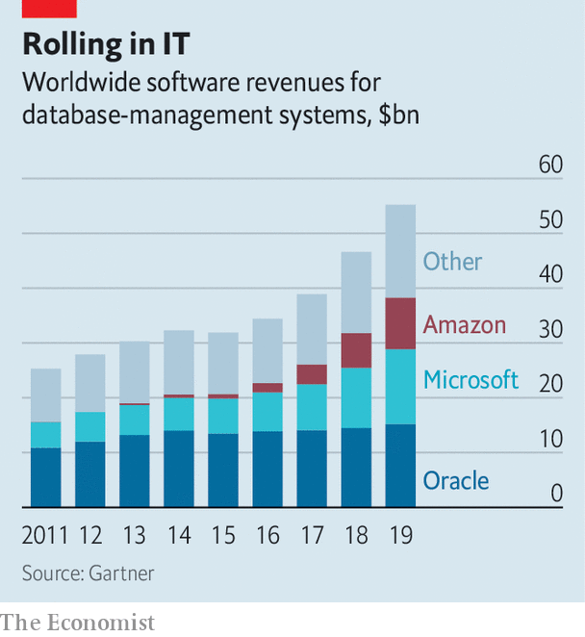

A database used to be best understood as a digital steam engine. Before electricity came along, a factory’s machines sat near a single power source. Similarly, corporate applications—programs that keep track of a firm’s finances or its supply chain, say—were built around databases housing all of a firm’s important information. Hard disks were pricey and had limited capacity so the best way to store it was in lean “relational” databases. Max Schireson, who used to run MongoDB, a database-maker, and now works for Battery Ventures, an investment firm, likens these to “a parking garage where, to save space, you put all the seats in one place, the tyres in another and so on”. The industry became dominated by a few firms, with Oracle leading the pack.

As storage got cheaper and data volumes exploded, though, startups erecting new kinds of digital car park proliferated. Many focus not on tracking specific transactions but on analysing all manner of data to glean relevant knowledge about a business, such as where certain products sell best. These more cluttered “data warehouses”, as they are known, were pioneered in the late 1970s by a firm called Teradata. Their latest iterations are “data lakes”, which take in all sorts of unstructured information, including text and pictures.

Snowflake has gone a step further. It was one of the first firms to lift database systems from companies’ in-house data centres and into the computing clouds, the biggest of which are operated by Amazon, Google and Microsoft, a trio of tech giants. Snowflake’s customers can add capacity as needed—and pay depending on their use rather than a fixed price for a software licence, as was typical for relational databases. Better yet, its “multi-cloud” service works across the three big computing clouds, so customers need not get locked into any one of them. Recently Snowflake has also added features that let customers share and sell data, setting itself up as a data exchange of sorts.

This has convinced many that Snowflake could be the next Oracle. The firm is certainly on a roll. Although it has yet to make money, its losses, of $171m in the six months to July, have declined as revenue has more than doubled year on year, to $242m. On current trends sales could reach nearly $1bn in the next 12 months.

Despite these promising numbers, and the market’s blessing, Snowflake has its work cut out. The company’s uniqueness will not last much longer, says Donald Feinberg of Gartner, a research firm. Rival firms, in particular the big cloud providers, have been beefing up competing products and have even dabbled with the multi-cloud. A few startups are already offering cheaper and more flexible “open source” alternatives such as ClickHouse, a particularly zippy data-management system sold by a startup called Altinity.

Other challengers are building more specialised digital repositories. Data generated by websites, for instance, are often stored on “document-oriented” databases that, in the garage analogy, keep cars intact rather than strip them for parts. MongoDB is the market leader in this segment. Confluent, another startup, is big in “streaming” databases that garner information from sources like sensors. These are more akin to a motorway service station: data are quickly checked to see if action is needed.

Much as today’s assembly lines are driven by dispersed electric motors rather than a single steam engine, then, corporate IT systems will increasingly rely on sundry specialised databases, predicts Zane Chrane of Bernstein, a broker. That—and the fact that data will increasingly be analysed in real time, rather than saved in a conventional database—will limit the power and profits of any single supplier. So Snowflake is unlikely ever to become as dominant as Oracle. Snowflakes fly high in a flurry. They also melt.■

This article was downloaded by calibre from <https://www.economist.com/business/2020/09/15/how-snowflake-raised-3bn-in-a-record-software-ipo>

|  |  |  |  |
| --- | --- | --- | --- |
| Previous | Articles | Sections | Next |

|  |  |  |  |
| --- | --- | --- | --- |
| Previous | Articles | Sections | Next |

#### Schumpeter

# What is stakeholder capitalism?

Beware a new world of near-impossible trade-offs

Sep 19th 2020 |

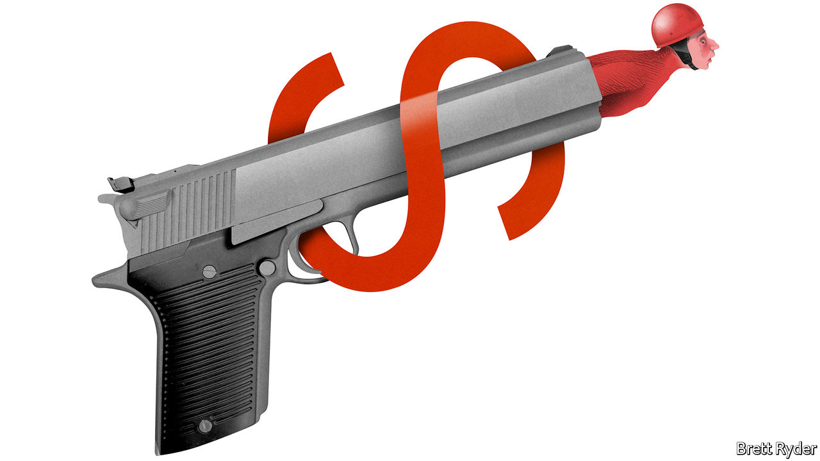

“WHEN DID Walmart grow a conscience?” The question, asked approvingly in a Boston Globe headline last year, would have made Milton Friedman turn in his grave. In a landmark New York Times Magazine essay, whose 50th anniversary fell on September 13th, the Nobel-prizewinning economist sought from the first paragraph to tear to shreds any notion that businesses should have social responsibilities. Employment? Discrimination? Pollution? Mere “catchwords”, he declared. Only businessmen could have responsibilities. And their sole one as managers, as he saw it, was to a firm’s owners, whose desires “generally will be to make as much money as possible while conforming to the basic rules of the society”. It is hard to find a punchier opening set of paragraphs anywhere in the annals of business.

It is also hard to find a better example of their embodiment than Walmart. Listed on the stockmarket the year Friedman’s article was published, it morphed from Sam Walton’s hometown grocery store into the “beast of Bentonville”, with a reputation for low prices as well as beating up suppliers and bossing staff. Its shareholders made out like bandits; since the early 1970s, its share price has ballooned by a factor of more than 2,000, compared with 31 for the S&P 500 index of large firms. Yet in recent years the company has mellowed. It now champions green energy and gay rights. The Globe’s tribute appeared shortly after Doug McMillon, its chief executive, reacted to savage shootings in Walmart stores by ending the sale of some ammunition and lobbying the government for more gun control. This year he became chairman of the Business Roundtable, a coven of American business leaders who profess they want to abandon Friedman’s doctrine of shareholder primacy in favour of customers, employees and others.

In partisan America, riven by gender, race and income inequality, such “stakeholderism” is all the rage. But there is pushback. To celebrate the half-centenary of Friedman’s essay, the University of Chicago, his alma mater, held an online forum at its Booth School of Business in which advocates of his creed argued that giving bosses too much latitude may make things worse for stakeholders, not better. The crux of the problem, they pointed out, was the near-impossibility of balancing the competing interests of stakeholders in any way that does not give God-like powers to executives (what Friedman called the all-in-one “legislator, executive and jurist”). Usefully, some provided data to support their arguments.

Start with Walmart’s ammunition bans—a firecracker lobbed into one of America’s most divisive issues. The retailer portrayed them as mere safety measures, but the National Rifle Association, a lobby group, said they pandered to “anti-gun elites” and predicted customers would boycott Walmart. Indeed some did. Marcus Painter of Saint Louis University has crunched smartphone data measuring foot traffic before and after the restrictions. He found that on average monthly store visits to Walmart in heavily Republican districts fell by up to 10% compared with rival stores; in strongly Democratic areas they rose by as much as 3.4%. Moreover, the apparent Republican boycott continued for months. (Walmart did not respond to requests for comment.)

It is possible that the retailer’s stance helped win over new (perhaps wealthier) consumers. It may even have benefited Walmart’s bottom line—and shareholders. Yet it also showed that amid increasingly polarised politics, what is good for one set of stakeholders may be anathema to another. Whether it is Hobby Lobby, a Christian chain of craft stores from Oklahoma, denying staff contraceptive insurance on religious grounds, or Nike supporting an American football player’s decision to protest against police brutality, some stakeholders will always object to what is done on behalf of others. There are more quotidian trade-offs. A General Motors shareholder who is also an employee may want higher salaries rather than higher profits; a dollar spent on pollution control may be a dollar less spent on worker retraining. But weighing up the costs and benefits to different groups is fraught with difficulty.

Some bosses claim they can do this, keen to win public praise and placate politicians. But they are insincere stewards, according to Lucian Bebchuk, Kobi Kastiel and Roberto Tallarita, of Harvard Law School. Their analysis of so-called constituency statutes in more than 30 states, which give bosses the right to consider stakeholder interests when considering the sale of their company, is sobering. It found that between 2000 and 2019 bosses did not negotiate for any restrictions on the freedom of the buyer to fire employees in 95% of sales of public firms to private-equity groups. Executives feathered the nests of shareholders—and themselves.

## Talk is cheap

Such hypocrisy is rife. Aneesh Raghunandan of the London School of Economics and Shiva Rajgopal of Columbia Business School argued earlier this year that many of the 183 firms that signed the Business Roundtable statement on corporate purpose had failed to “walk the talk” in the preceding four years. They had higher environmental and labour compliance violations than peers and spent more on lobbying, for instance. Mr Bebchuk and others argue that the “illusory hope” of stakeholderism could make things worse for stakeholders by impeding policies, such as tax reform, antitrust regulation and carbon taxes, if it encourages the government blithely to give executives freedom to regulate their own activities.

To be sure, trade-offs are an inevitable part of shareholder capitalism, too: between short- and long-term investors, for instance. But stakeholders outnumber shareholders, making for more disparate interests to balance. Moreover, by investing in funds linked to corporate values, or by directly influencing boards, shareholders can show that their goals increasingly extend beyond profit maximisation to broader societal welfare. Shareholders retain primacy, as they should, but they are free to push for different trade-offs if they prefer. ■

This article was downloaded by calibre from <https://www.economist.com/business/2020/09/19/what-is-stakeholder-capitalism>

|  |  |  |  |
| --- | --- | --- | --- |
| Previous | Articles | Sections | Next |

|  |  |  |
| --- | --- | --- |
| Business | Sections | Science & ... |

Finance & economics

The world economy: The 90% economy, revisited

.

China’s recovery: One-armed fighter

.

International trade: Continuity candidate

.

Climate finance: The meaning of green

.

One-woman show: Women on Wall Street

.

European stock exchanges: Shotgun wedding

.

Buttonwood: McJobbers and brokers

.

Free exchange: Altered vistas

.

|  |  |  |
| --- | --- | --- |
| Business | Sections | Science & ... |

|  |  |  |  |
| --- | --- | --- | --- |
|  | Articles | Sections | Next |

#### The 90% economy, revisited

# Is the world economy recovering?

A recovery is taking shape—but it is extraordinarily uneven

Sep 16th 2020 |

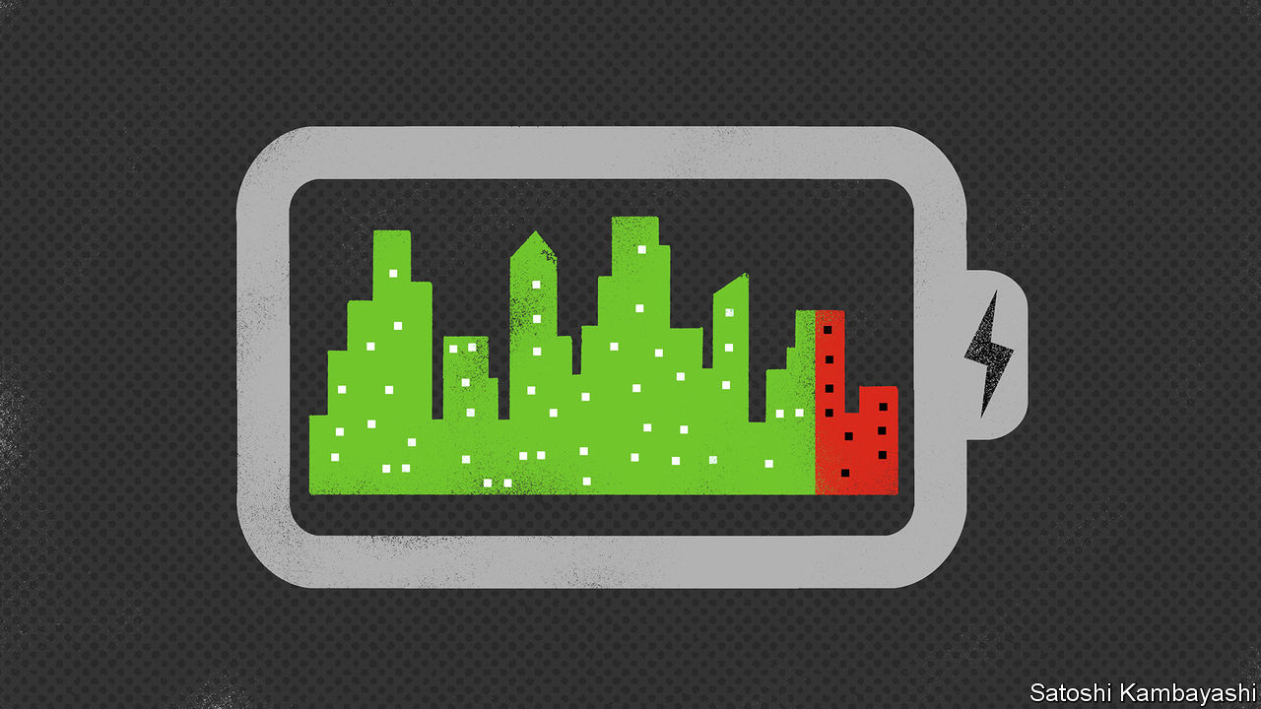

Editor’s note: Some of our covid-19 coverage is free for readers of The Economist Today, our daily [newsletter](https://my.economist.com/user#newsletter). For more stories and our pandemic tracker, see our [hub](https://www.economist.com/news/2020/03/11/the-economists-coverage-of-the-coronavirus)

THE WORST day of the covid-19 pandemic, at least from an economic perspective, was Good Friday. On April 10th lockdowns in many countries were at their most severe, confining people to their homes and crushing activity. Global GDP that day was 20% lower than it would otherwise have been (see chart 1). Since then governments have lifted lockdowns. Economies have begun to recover. Analysts are pencilling in global GDP growth of 7% or more in the third quarter of this year, compared with the second.

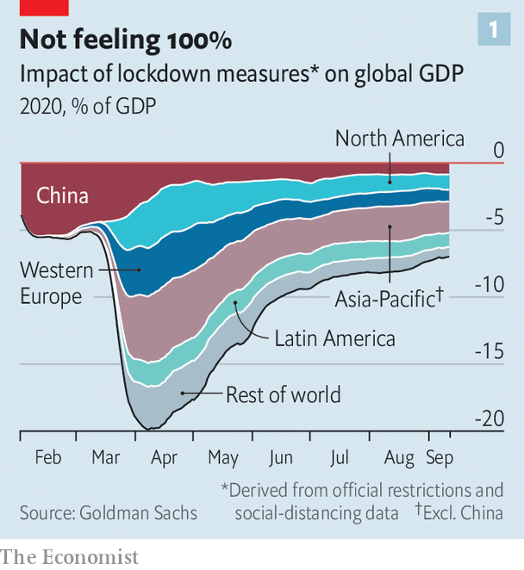

That may all sound remarkably V-shaped, but the world is still a long way from normal. Governments continue to enforce social-distancing measures to keep the virus at bay. These reduce output—by allowing fewer diners in restaurants at a time, say, or banning spectators from sports arenas. People remain nervous about being infected. Economic uncertainty among both consumers and firms is near record highs—and this very probably explains companies’ reluctance to invest (see chart 2).

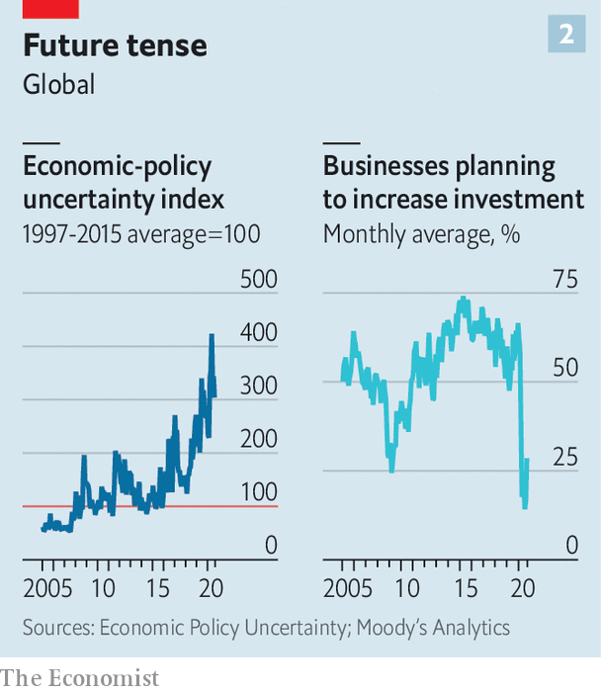

Calculations by Goldman Sachs, a bank, suggest that social-distancing measures continue to reduce global GDP by 7-8%—roughly in line with what The Economist argued in April, when we coined the term “90% economy” to describe what would happen once lockdowns began to be lifted. Yet although the global economy is operating at about nine-tenths capacity, there is a lot of variation between industries and countries. Some are doing relatively—and surprisingly—well, others dreadfully.

Take the respective performance of goods and services. Goods have bounced back fast. Global retail sales had recovered their pre-pandemic level by July, according to research by JPMorgan Chase, another bank. Armed with $2trn-worth of cash handouts from governments since the virus struck, consumers across the world have stocked up on things to make it bearable to be at home more often, from laptops to dumbbells, which partly explains why world trade has held up better than economists had expected. Global factory output has made up nearly all the ground it lost during the lockdowns.

Services activity is a lot further below its pre-pandemic level, largely because such industries are vulnerable to people avoiding crowds. The number of diners in restaurants remains 30-40% lower than normal worldwide, according to data from OpenTable, a booking platform. The number of scheduled flights is about half what it was just before the pandemic struck.

The variation in economic performance between countries is even more striking. It is common for growth rates to diverge in downturns. But the size of this year’s collapse in output means that the differences between countries’ growth rates are enormous. On September 16th the OECD, a club of mostly rich countries, issued fresh economic forecasts. Like other forecasters—such as the Federal Reserve, which on the same day published new projections for the American economy—it has become less gloomy in recent months.

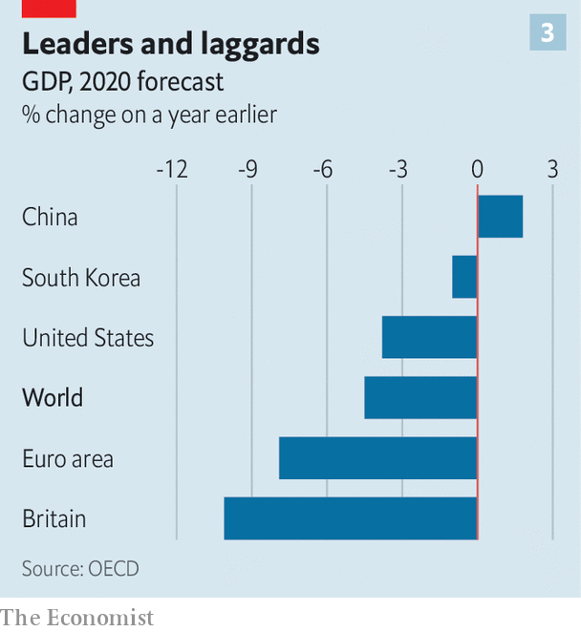

Still, the growth gap between best and worst performers in the G7 group of countries in 2020 is expected to be 6.7 percentage points, far wider than that during the last global downturn a decade ago. Of the big economies, only China is set to expand in 2020 (see article). Some countries, such as America and South Korea, face a downturn but hardly a catastrophic one (see chart 3). Britain, by contrast, looks to be in line for its deepest recession since the Great Frost of 1709.

Some economists contend that the huge gap between countries is a statistical mirage, reflecting different methods of computing GDP figures. In Britain, for instance, the way statisticians tot up government spending means that school closures and cancelled hospital appointments have a bigger impact on GDP than elsewhere. But this effect is small—the bulk of the fall in output has come from the private sector.

Instead, performance comes down to three factors. The first is industrial composition. Countries such as Greece and Italy, which rely on retail and hospitality, always looked more vulnerable than, say, Germany. Its large manufacturing sector has benefited from the global goods recovery.

Second is confidence, which appears to be determined by a country’s experience under lockdown. Britain’s poor economic performance is likely to be related to the government’s poor handling of the pandemic. Britons seem more nervous than other Europeans about venturing outside.

The third factor is stimulus. America’s lawmakers may be unable to agree on a top-up, but they have already enacted the world’s largest rescue package, relative to the size of its economy. The OECD thinks it will be one of the better-performing rich countries this year.

What next for the 90% economy? Some authorities have been forced to order further lockdowns. But others may be able to calibrate social-distancing measures better without jeopardising output. That might bring the world closer to, say, a 95% economy. Indeed, the OECD expects global GDP to recover further this year.

It may be tempting to think that a vaccine, if it could be rolled out widely enough, would quickly restore normality. But there will be scars. Firms’ reluctance to invest today will mean less productive capital in the future. A growing number of American workers believe they will not be returning to their old jobs. Reallocating redundant resources towards more productive firms will take time. The Fed’s rate-setters reckon unemployment will not return to its pre-pandemic rate of 4% until 2023; analysts at Goldman Sachs think it will do so only in 2025, even though they are optimistic that a vaccine will soon be widely distributed. Much as the disease itself has long-lasting effects, the covid-induced downturn will leave the world economy feeling subpar for some time to come. ■

This article was downloaded by calibre from <https://www.economist.com/finance-and-economics/2020/09/16/is-the-world-economy-recovering>

|  |  |  |  |
| --- | --- | --- | --- |
|  | Articles | Sections | Next |

|  |  |  |  |
| --- | --- | --- | --- |
| Previous | Articles | Sections | Next |

#### One-armed fighter

# What is fuelling China’s economic recovery?

Industry had a head start, but consumption is starting to pick up

Sep 19th 2020 | SHANGHAI

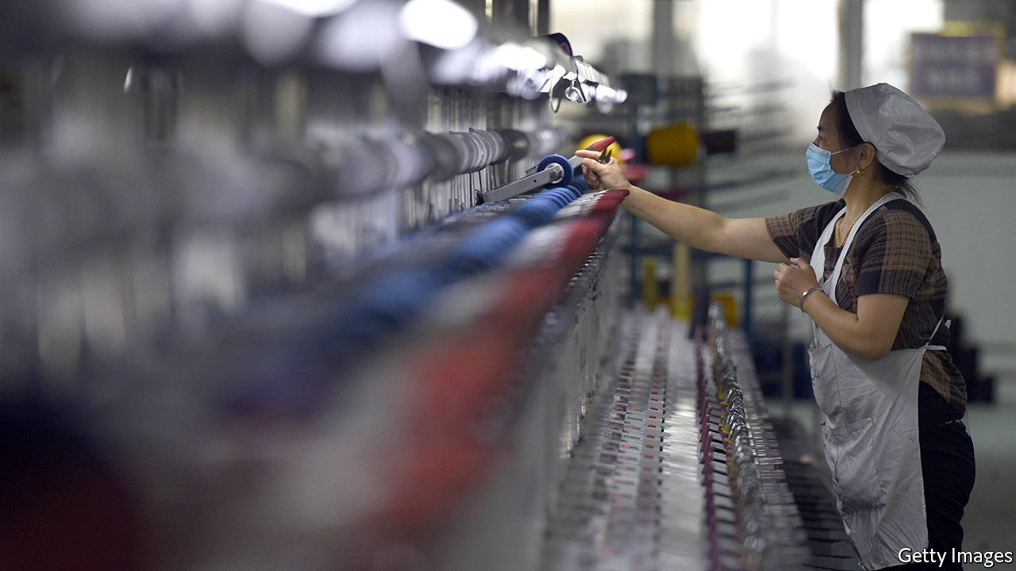

“THE EIGHT HUNDRED” is an unusual Chinese film for its depiction of Nationalist soldiers as heroes in a grinding battle against Japanese invaders in 1937. The Nationalists, or Kuomintang, fought a long on-off civil war against the Communist Party and so are typically portrayed as villains and stooges on Chinese screens. From a global perspective, the film is unusual for a different reason. It is that rarest of things in these covid-clouded times: a box-office hit. Released a month ago, it has pulled in nearly 3bn yuan ($440m), propelling Chinese cinemas to their best showing by far since January, when the country went into near-total lockdown.

Many of China’s factories reopened as early as February, but it is only now, nearly eight months on, that the broader economy is approaching its normal trajectory. Based on a batch of activity data published on September 15th, China is on track to expand by roughly 5% in the third quarter compared with a year earlier, a smidgen below the 6% growth rate that it reported in the second half of 2019, before covid-19 erupted. That puts it well ahead of all other big economies in the scale of its recovery.

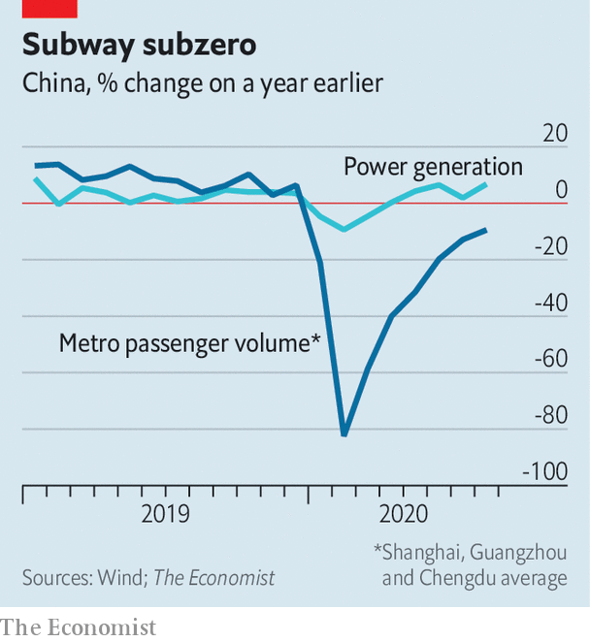

But the shape of China’s recovery is unbalanced. The supply side of the economy had a head start over the demand side, and has maintained a big lead. Industrial output rose by 5.6% year-on-year in August, while retail sales rose by just 0.5%. A range of alternative measures underline this gap. Power generation rose strongly in August thanks in part to resilient factory activity. The number of underground journeys, by contrast, levelled off at about a tenth below normal, indicating that some people are still wary of venturing into crowded places (see chart). Some analysts worry that these imbalances are spilling into the global economy as excess production ends up abroad. China’s share of world merchandise exports hit a record high of more than 13% in the second quarter, according to data from CPB World Trade Monitor.

A key question is thus whether the uneven growth is simply the ephemera of the covid-19 economy or whether it points to a more fundamental problem. The answer is probably a bit of both. Weak consumer spending has long been a feature of China’s economy. Household consumption was just 39% of GDP last year, well below the global average of 63%. The pandemic has shone a harsh light on one explanation: a threadbare social safety-net. During the depths of China’s lockdown, just 3% of the roughly 80m people without jobs collected unemployment insurance. As low-income earners have a higher propensity to spend, the lack of support weighs on consumption more generally.

Some of the extreme unevenness of the recovery will not last, however. The government prioritised reopening factories over restarting the rest of the economy because of its calculations about how to control the pandemic. That was the right call. It is easier to maintain strict health protocols in factories, which can be managed as semi-closed environments, than in shopping malls, where people come and go.

Encouragingly, a closer look at the data for August suggests that China’s consumers may be starting to close the gap with its producers. In month-on-month terms, retail sales grew a little more quickly than industrial output—the first such outperformance in half a year. The demand rebound would be even stronger except for the social-distancing rules still in place. Cinemas, for example, can sell tickets for only half their seats. “The Eight Hundred” is climbing the box-office charts with one arm tied behind its back. ■

This article was downloaded by calibre from <https://www.economist.com/finance-and-economics/2020/09/19/what-is-fuelling-chinas-economic-recovery>

|  |  |  |  |
| --- | --- | --- | --- |
| Previous | Articles | Sections | Next |

|  |  |  |  |
| --- | --- | --- | --- |
| Previous | Articles | Sections | Next |

#### Continuity candidate

# How would Joe Biden change America’s trade policy?

Less than America’s trade partners might hope

Sep 19th 2020 | WASHINGTON, DC

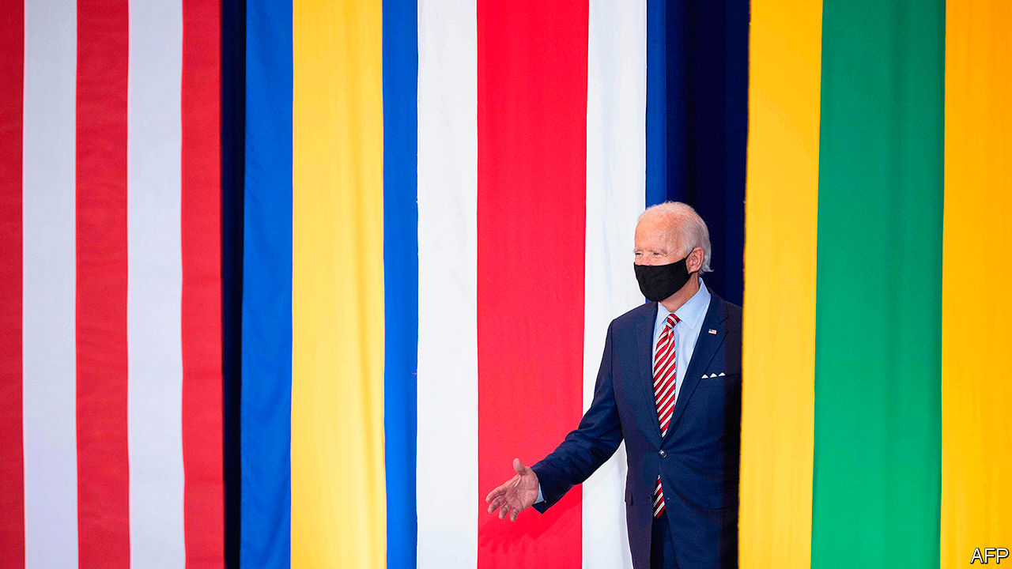

ON THE SUBJECT of trade policy, America’s Democratic presidential nominee, Joe Biden, has been sounding rather like President Donald Trump. He claims that “economic security is national security”, promises to create millions of manufacturing jobs and pledges to reduce America’s dependence on China. On September 9th he published his “Made in America” plan, only for the White House to tell Fox News that it would host its own “Made in America” day on October 5th. America’s trading partners hoping for change may dismiss Mr Biden’s tough talk as campaign chatter. That would be unwise.

Mr Biden would bring some changes, of course. Policy would be more consistent. Trade officials in Mexico and the European Union (EU) could stop following presidential tweets so avidly. Having slammed Mr Trump’s “empty” agreement with China, Mr Biden seems unlikely to strike shallow, transactional deals. In fact, despite his reputation for liking them, he may not agree to any at all. They can wait, he has said, until after “we have invested in Americans”.

Trading partners may hope that America stops applying new tariffs. They should manage their expectations. Mr Biden is no “Tariff Man”, as Mr Trump once proclaimed himself to be. But he has pledged to restrict imports from China that are deemed to be a national-security threat. Countries that do not live up to their environmental obligations could face a carbon-adjustment fee in the form of tariffs or quotas.

Mr Biden sees as big a role for the government in supporting American manufacturing as Mr Trump does, perhaps a reflection of the fact that industrial policy is now in favour across the political spectrum. Mr Biden’s plans to strengthen “Buy American” rules would make it harder for the government to buy foreign cement, steel and equipment. Peter Navarro, Mr Trump’s trade adviser, would be proud.

Robert Lighthizer, America’s chief trade negotiator, reportedly expressed his unhappiness with the Agreement on Government Procurement, an international deal designed to prevent governments from imposing restrictions on how public funds are spent. Mr Biden promises to rewrite the rules, so that America and its allies can “use their own taxpayer dollars to spur investment in their own countries”.

Moreover, Mr Biden has committed himself to using a broader range of tools than Mr Trump’s tariffs. He plans to spend $300bn of public funds to support research into artificial intelligence, electric vehicles and 5G. A “clawback” provision would make companies shipping jobs overseas hand back the subsidy. Some governments will see this as unfair: foreign companies facing subsidised competitors will find it as difficult to break into the American market as if they were facing tariffs. Others will take it as permission to hand out subsidies of their own. Either approach will breed tension. Mr Biden has pledged to fight back against countries undercutting American manufacturing using “unfair subsidies”.

Mr Biden’s silence on two matters has led to foreign suspicions of yet more continuity. The first relates to the World Trade Organisation (WTO), which the Trump administration has hobbled by breaking its system of solving trade disputes. (A WTO judgment on September 15th that American tariffs on Chinese imports broke its rules will not whet the administration’s appetite for a fix.) The EU, which sees dispute settlement as integral to the rules-based trading system, wants to repair the mechanism. Mr Biden has not yet said if he will join in.

The other matter is what Mr Biden will do with the tariffs imposed by Mr Trump. He has criticised them without pledging to remove them. Strategy might play a role: a Biden administration may want to dangle tariff reductions in return for concessions abroad. To America’s trading partners, that would feel rather familiar. ■

Dig deeper:  
Read the [best of our 2020 campaign coverage](https://www.economist.com/us-election-2020) and our [presidential-election forecast](https://projects.economist.com/us-2020-forecast/president), then sign up for Checks and Balance, our [weekly newsletter](https://www.economist.com/checksandbalance/) and [podcast](https://www.economist.com/podcasts/2020/09/04/checks-and-balance-our-weekly-podcast-on-american-politics) on American politics.

This article was downloaded by calibre from <https://www.economist.com/finance-and-economics/2020/09/19/how-would-joe-biden-change-americas-trade-policy>

|  |  |  |  |
| --- | --- | --- | --- |
| Previous | Articles | Sections | Next |

|  |  |  |  |
| --- | --- | --- | --- |
| Previous | Articles | Sections | Next |

#### The meaning of green

# What is the point of green bonds?

A new study finds little evidence that they directly cut carbon or lower costs

Sep 19th 2020 |

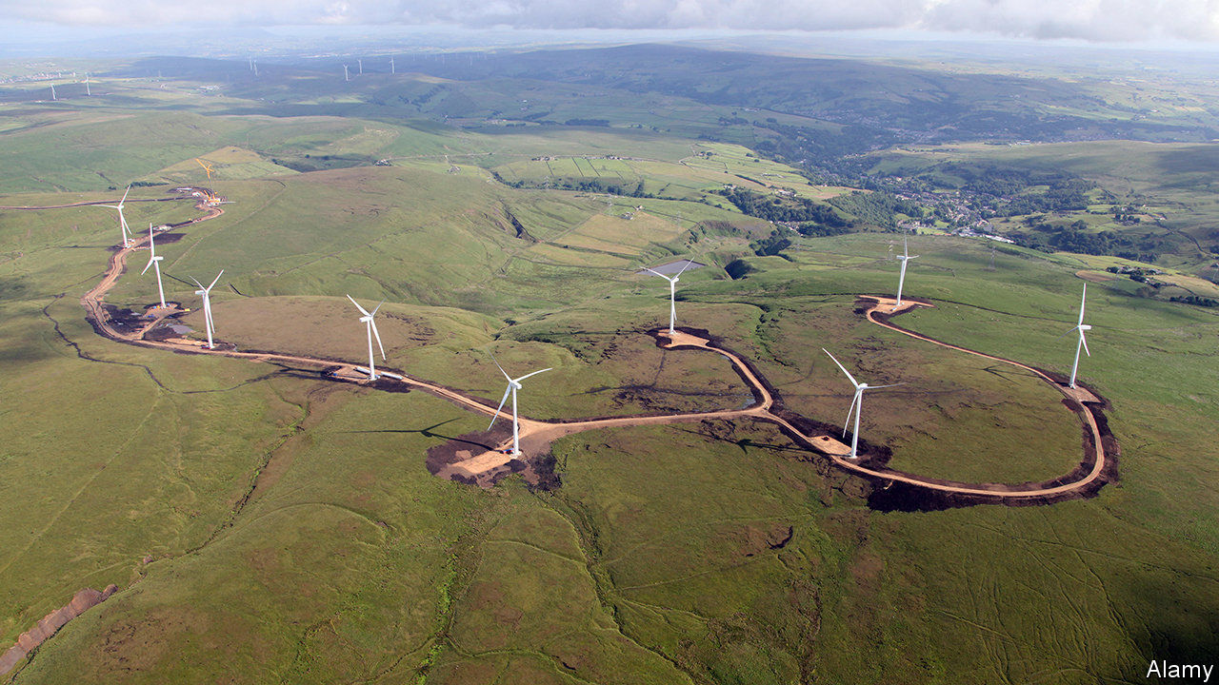

GREEN BONDS are the stars of climate finance. These instruments, which channel funds raised towards environmentally friendly projects, raised $271bn in 2019, according to BloombergNEF, a consultancy. That is only about 4% of total bond issuance worldwide, but it easily makes green bonds the most popular form of eco-friendly debt. Covid-19 has only slightly slowed the rise. On September 2nd Germany issued green paper for the first time. The European Commission is mulling using them to fund just under a third of its €750bn ($888bn) stimulus package.

Yet a new study by the Bank for International Settlements, a club of central banks, raises questions about the purpose of green bonds. Researchers looked at 200-odd large firms that issued them in 2015-18. They found that firms that issue the most tend to be cleaner in the first place—ie, they produce the least carbon for a given amount of revenue. Over 70% of issuers have a carbon intensity equivalent to a consumer-staples firm, such as Procter & Gamble, or lower. Large polluters rarely issue such bonds for fear of being accused of greenwashing, and because the bonds would be excluded from green funds.

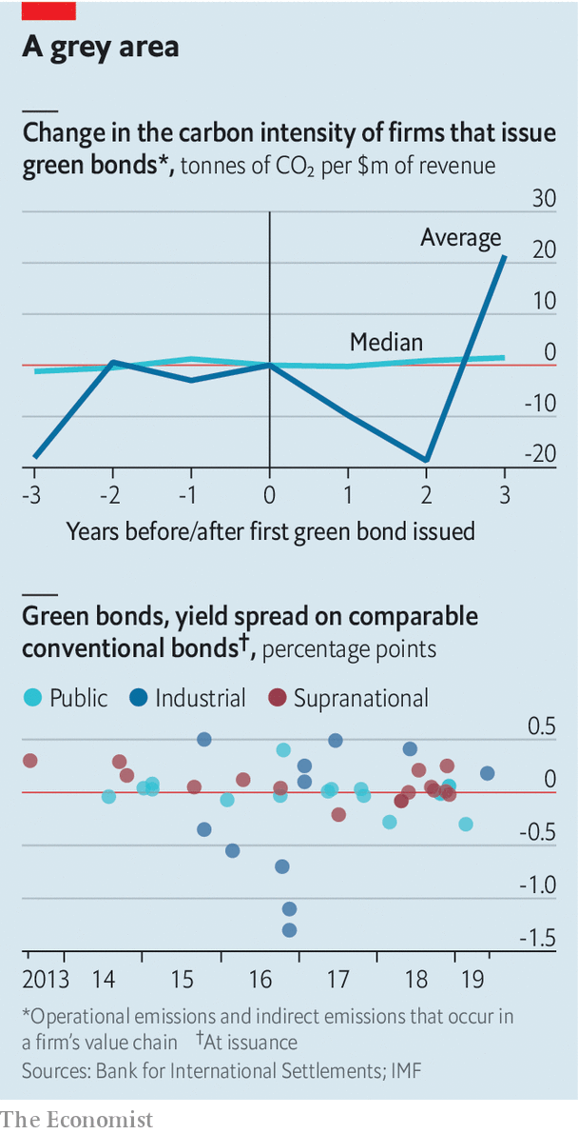

Another finding was that green-bond issuance did not seem to lead to decarbonisation. In the years after issuance, the average carbon intensity oscillates wildly, but the changes are not statistically significant. Moreover, though some issuers claim that tapping the green-bond market lowers their cost of borrowing, data from the IMF suggest a discount is rare (see chart).

If green bonds cut neither costs nor carbon directly, then what are they for? Proponents still see benefits. Some green bonds fund worthy projects that do not reduce carbon footprints, such as improving water management. This is the case for at least a fifth of the stock of green bonds by value, reckons HSBC, a bank. Moreover, many bonds are used to refinance genuinely green projects. So the reduction in carbon dioxide may have happened before issuance, argues Sean Kidney of the Climate Bond Initiative, a non-profit group.

For issuers, one advantage is reputational. Issuing a green bond sends virtuous signals to regulators. Chris Kaminker of Lombard Odier, a bank, argues that the green label may also attract a wider pool of lenders than conventional bonds.

Green bonds can also make life easier for institutional investors pressed by clients to become more climate-conscious. They could invest directly in green projects, which often take the form of infrastructure. But a failed project may default on its repayments to direct investors. Green-bondholders face less risk; the issuer must pay even if the project fails. Issuers also typically disclose the details of projects, such as their size and location. Such morsels are otherwise hard to come by.

Investors seeking to encourage decarbonisation could turn to newer instruments. Big polluters can use the proceeds of “transition” bonds to decarbonise. In March Cadent Gas, a British firm, raised a €500m note to reduce leakages from its pipeline, among other things. “Sustainability-linked” bonds tie interest payments to the achievement of a target. The first of these was issued by Enel, an Italian electricity firm, last year, and is linked to increasing the share of renewables in its generation capacity.

So far there have only been a handful of issuances of these newer sorts of bonds. Expanding the market will take time, as investors become familiar with them. For now, climate-conscious investors may have to stick with green bonds—and doing less good for the planet than they may have claimed to their clients. ■

For more coverage of climate change, register for The Climate Issue, our fortnightly [newsletter](https://www.economist.com/theclimateissue/), or visit our [climate-change hub](https://www.economist.com/news/2020/04/24/the-economists-coverage-of-climate-change)

This article was downloaded by calibre from <https://www.economist.com/finance-and-economics/2020/09/19/what-is-the-point-of-green-bonds>

|  |  |  |  |
| --- | --- | --- | --- |
| Previous | Articles | Sections | Next |

|  |  |  |  |
| --- | --- | --- | --- |
| Previous | Articles | Sections | Next |

#### Women on Wall Street

# How many of America’s top companies have a female CEO?

Jane Fraser, Citigroup’s next boss, joins an elite group

Sep 19th 2020 |

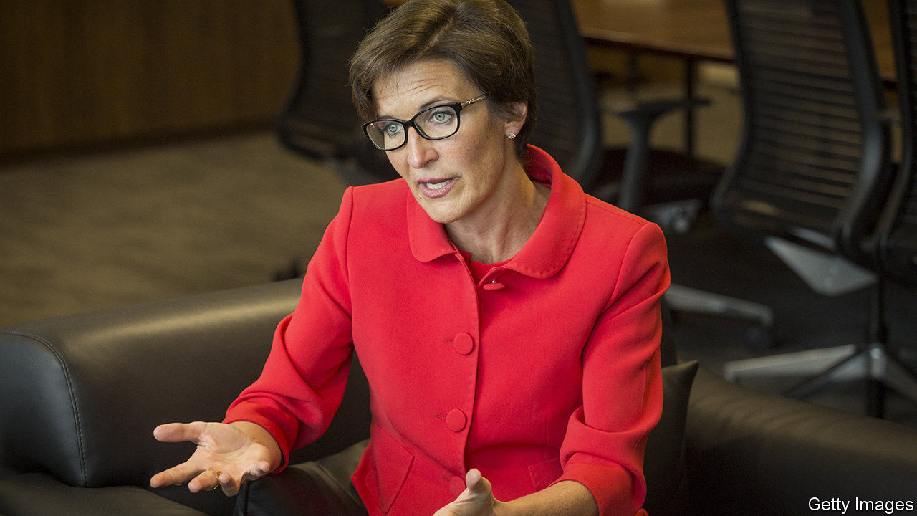

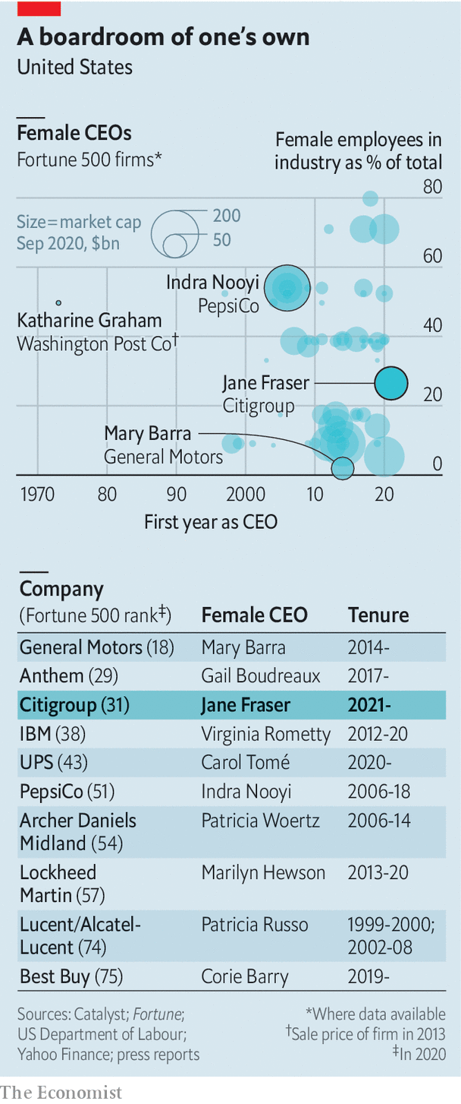

ON SEPTEMBER 10TH it was announced that Jane Fraser would succeed Michael Corbat as chief executive of Citigroup, a bank, in February 2021. Ms Fraser will be the first woman at the helm of a top-ten American lender. She joins an elite group: just 37 of the Fortune 500 companies are headed by women. Things have at least got better. When Ms Fraser began her first banking job in 1988, only three big American firms were run by women.

This article was downloaded by calibre from <https://www.economist.com/finance-and-economics/2020/09/19/how-many-of-americas-top-companies-have-a-female-ceo>

|  |  |  |  |
| --- | --- | --- | --- |
| Previous | Articles | Sections | Next |

|  |  |  |  |
| --- | --- | --- | --- |
| Previous | Articles | Sections | Next |

#### Shotgun wedding

# Who will buy Borsa Italiana?

Euronext is not the highest bidder, but it is the most politically expedient choice

Sep 19th 2020 | BERLIN



IN AN AUCTION, the highest bidder usually walks away with the asset on sale. Yet considerations that are not purely commercial are likely to determine who wins the London Stock Exchange’s auction of Borsa Italiana. The LSE is selling the Italian stock exchange in order to ensure regulatory approval of its takeover of Refinitiv, a financial-data provider that it agreed to buy last year for $27bn. The bidder least likely to upset European politicians and regulators seems likely to prevail, rather than the one offering the most dosh.

There are three suitors on the scene. The highest bidder is reportedly Switzerland’s SIX, a Zürich-based stock exchange which brings a big war chest and a strong credit rating to the party. (A spokesman for SIX did not confirm the offer.) The mooted price is €3.4bn ($4bn)—and could go higher. Deutsche Börse, Germany’s main stock exchange, made a non-binding offer to buy Borsa Italiana on September 11th. Euronext followed suit with its offer on September 14th. The Paris-based exchange, which has already hoovered up bourses in Amsterdam, Brussels, Dublin, Lisbon and Oslo, has teamed up with Cassa Depositi e Prestiti Equity (CDP), a bank controlled by the Italian state that invests the country’s postal savings, and Intesa Sanpaolo, Italy’s biggest bank, to buy Borsa.

The LSE has owned both the Milan-based exchange and MTS, the Borsa group’s bond-trading platform, since 2007. It had no plans to sell until the European Commission in June began sniffing around its planned takeover of Refinitiv. Brussels frets that a combined firm could wield significant market power in the electronic trading of European sovereign bonds and derivatives. The commission’s investigations have wrecked many a European merger. So, in order to satisfy regulators, the LSE has put the Borsa group, which includes MTS, on the block. And with the commission due to conclude its antitrust review by December 16th, LSE wants to agree on a sale quickly.

Euronext is the most likely victor, according to Ian White at Autonomous, a financial-research firm. Michael Werner, an analyst at UBS, a bank, agrees, and adds that Deutsche Börse is the least likely to win. MTS provides LCH, a clearing-house owned by LSE, with around €45m of revenue a year. LSE will therefore be keen to ensure MTS continues to use the clearing-house after the sale. As Euronext owns 11% of LCH, the odds are it would keep doing so. Deutsche Börse, by contrast, would probably divert clearing business from LCH to Eurex, its subsidiary. For its part, Euronext has been an active buyer of European exchanges in recent years. Mr Werner thinks it can make the most of any synergies.

Euronext’s trump card, though, is its decision to partner with the Italian state: CDP would own 8% of Borsa. Earlier this year Italy’s government extended its “golden-power” law, which entitles it to intervene in deals in strategically important sectors, such as financial infrastructure.

Politicians have made their intentions clear. The populist Five Star movement, which is part of the ruling coalition, wants Borsa to be brought back under Italian influence. The Northern League, a right-wing party, warns against a sale to foreigners. Consob, the financial regulator, is headed by Paolo Savona, a Eurosceptic notorious for his aversion to Germany. Binding offers are expected next month, but insiders say LSE could make a decision even sooner. With Rome on its side, the deal is Euronext’s to lose. ■

This article was downloaded by calibre from <https://www.economist.com/finance-and-economics/2020/09/19/who-will-buy-borsa-italiana>

|  |  |  |  |
| --- | --- | --- | --- |
| Previous | Articles | Sections | Next |

|  |  |  |  |
| --- | --- | --- | --- |
| Previous | Articles | Sections | Next |

#### Buttonwood

# Can you make money from the Big Mac index?

Arbitrageurs have long sought to exploit the idea of purchasing-power parity

Sep 19th 2020 |



THIS WEEK Hong Kong’s monetary officials stepped into the foreign-exchange markets after dusk to defend the city’s long-standing peg to the dollar. Given everything the financial hub has faced in recent months—protests, a pandemic and punitive American sanctions—you might assume it is battling to prop its currency up. You would be wrong. The city’s monetary authority has been forced to sell Hong Kong dollars repeatedly since April to stop the currency strengthening too much.

This resilience must be a little uncomfortable for prominent speculators, like Kyle Bass of Hayman Capital Management, a hedge fund, who have predicted a catastrophic devaluation. But it will be no surprise to followers of our Big Mac index. The tongue-in-cheek guide to the fair value of currencies showed that the Hong Kong dollar was undervalued by almost 54% in July. That suggests no urgent need for it to fall.

The Big Mac index is a simple illustration of purchasing-power parity (PPP), the notion that the fair value of a currency should reflect its power to buy goods and services. It took HK$20.50 to buy a Big Mac in Hong Kong in July and $5.71 to buy one in America. The exchange rate that would equalise their burger-buying power was therefore HK$3.59 to the dollar. That is substantially stronger than the actual exchange rate of HK$7.75.

What practical guidance, then, can the Big Mac index offer to currency speculators? Economists reckon that modest deviations from fair value halve every one to three years or so. Suppose that an investor had bought the most undervalued currency in our index, which we publish each January and July, and then sold it two years later. How would they have fared?

Not well, is the short answer. Imagine that our hypothetical punter invested $10 each time. Of the past 15 completed bets, ten would have lost money (ignoring interest and inflation). The investor would have bought the Indian rupee in January 2013 only to see it fall by 13% against the dollar over the next two years. Ukraine’s hryvnia was the most undervalued currency in July 2014, after which it proceeded to halve in value. For a total outlay of $150, our punter would have ended up with less than $138 (although they could have made another $20 or so in interest on their currency deposits, over and above the cost of borrowing in dollars).

Although not great for an investor’s wealth, these results are not quite as damaging to the idea of PPP as they first appear. Deviations from PPP can narrow in two ways: through fluctuations in the exchange rate or via movements in prices. In India, for example, the price of a Maharaja Mac (which McDonald’s serves in place of a beefy Big Mac) rose much faster than that of an American Big Mac from January 2013 to January 2015. That rise in price more than made up for the fall in the rupee, leaving India less undervalued. The same is true in four of the other nine losing currency bets.

Believers in PPP also accept that rich countries tend to be more expensive than poor ones, because their wages are higher even in parts of the economy that are not terribly productive. So The Economist also calculates an adjusted Big Mac index, which shows whether a burger is cheaper or dearer than you would expect given a country’s level of GDP per person.

Is this adjusted index a better guide to currency speculators? A similar strategy of buying the cheapest currency in the index and selling it two years later would have paid off on 12 out of 15 occasions since July 2011. In all but one case (buying Russia’s rouble in January 2016), though, gains would have been small. That is because the most undervalued economy in this version of the index is, more often than not, Hong Kong. And despite hedge-fund histrionics, betting on its currency against the dollar typically poses little risk—and offers little reward.

This Big Mac back-test is mostly a bit of fun. But the results are broadly in line with more sophisticated research. In 2011 Gianfranco Forte of the University of Milano-Bicocca, Jacopo Mattei of the University of Ferrara and Edmondo Tudini of Bocconi University showed that simple PPP-based trading strategies yielded respectable, if unspectacular, returns (although their test did not include currencies as edgy as the hryvnia). “Few empirically literate economists take PPP seriously as a short-term proposition,” Ken Rogoff of Harvard University once pointed out, but most believe it has some anchoring power over the long run. It gives investors something to chew on. But it’s not fast food.

This article was downloaded by calibre from <https://www.economist.com/finance-and-economics/2020/09/19/can-you-make-money-from-the-big-mac-index>

|  |  |  |  |
| --- | --- | --- | --- |
| Previous | Articles | Sections | Next |

|  |  |  |  |
| --- | --- | --- | --- |
| Previous | Articles | Sections | Next |

#### Free exchange

# How does today’s tech boom compare with the dotcom era?

Tech stocks are reliving the heady days of the 1990s. Productivity looks wildly different

Sep 19th 2020 |

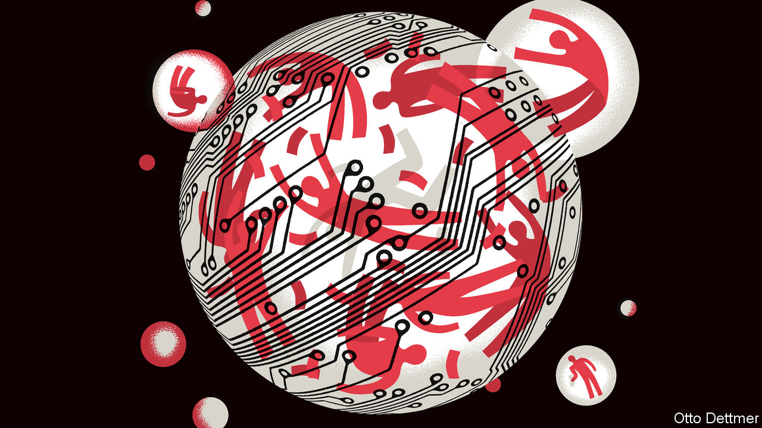

IN TROUBLED TIMES people take comfort in the familiar. Covid-19 has upended many things, but tech-stock prices have proved impressively invulnerable. The Nasdaq, a tech-heavy stock index, has leapt by 25% since the beginning of 2020, taking its total rise over the past decade to over 400%. Were it not for a handful of tech giants like Apple and Microsoft, the S&P 500, another share-price index, would be down so far this year. Not since the boom of the late 1990s have technology firms inspired such exuberant trading. For punters the comparison should be a sobering one; after a peak in March 2000 the Nasdaq crashed, eventually losing 73% of its value. But the economic differences between the two eras should be more unsettling than any market similarities.

The two booms do share features beyond their stock-price trajectories. Both were sustained by inflows of new money. In the late 1990s discount brokerages and online-trading platforms drew in amateur punters looking to profit off the seemingly one-way market. Today, an army of small-timers trade shares and derivatives on new platforms like Robinhood. In the 1990s raging bulls justified high prices by declaring the dawn of a new economy, built on more powerful computers, fancy software and the internet. Today’s optimists cite the potential of everything from cloud computing and artificial intelligence to electric vehicles and blockchain. At first glance the economic performance seems similar too. In the late 1990s the unemployment rate fell to 4% and pay soared. On the eve of the pandemic, America’s jobless rate stood at a half-century low and wage growth, after a dismal decade, had accelerated to its best pace since 2008. According to figures published by the Census Bureau on September 15th, real median household income grew by a very healthy 6.8% in 2019.

Yet in critical ways the two episodes look profoundly different. As the 1990s dawned economists were hunting in vain for the efficiency-enhancing effects of new technology. Robert Solow, a Nobel prize-winning economist, quipped in 1987 that “you can see the computer age everywhere but in the productivity statistics.” By mid-decade that was no longer the case. Output per hour worked in America rose by more than 3% a year in 1998-2000, a feat the economy had not pulled off since the early 1970s. Growth in total factor productivity (a measure of the efficiency with which capital and labour are used, often treated as a proxy for technological progress) rose by about 2% a year from 1995 to 2004, according to Robert Gordon of Northwestern University. That was a sharp pickup from the average pace of 0.5% in 1973-95, and nearly matched the rate achieved during the heady growth years of 1947-73.

Productivity in the 2010s, by contrast, looks pitiful. Annual growth in labour productivity has not risen above 2% since 2010. Growth in total factor productivity, according to data gathered by John Fernald of the Federal Reserve Bank of San Francisco, has been more dismal than ever: just 0.3% on average from 2004 to 2019. If you take the 2010s alone, the average falls to just 0.1%.

Strong labour productivity growth in the 1990s enabled wages to rise without squeezing corporate profits. While the dotcom boom is often remembered for the enormous valuations achieved by profitless upstarts with no clear path into the black, after-tax corporate profits during the decade rose from 4.7% of GDP in 1990 to 6.7% in 1997, before closing the decade at 5.6%. Corporate profits actually declined as a share of GDP during the 2010s, albeit from a much higher level than that prevailing in the 1990s: from 10.4% in 2010 to 9.0% in 2019. More telling, however, is the way in which firms responded to profit opportunities during the two decades. Investment in computer equipment, software and R&D leapt during the 1990s, by 1.5 percentage points of GDP over the decade. In the 2010s, despite the much higher level of profits, investment rose by just 0.7 percentage points of GDP.

The exuberance that powered soaring stock prices in the late 1990s, if in some cases irrational, occurred alongside tech-powered structural change. The uptick in productivity was at first driven by advances in computer-making. As prices tumbled and capabilities soared, other firms began investing in new equipment. Productivity gains began to spread across the economy, helping firms streamline manufacturing and transforming critical industries. These persisted, and even accelerated, for some years after the market crashed. Though many dotcom darlings disappeared, the digital infrastructure built during the boom remained. So did a number of firms that came in time to dominate the corporate landscape. In March 2001 The Economist grimly assessed the prospects of Amazon, a struggling retailer that had lost 90% of its market value in the crash, noting that “even if such companies survive, they are unlikely to resemble the businesses they once were.” (Holding Amazon through the crash proved a smart bet; its stock now trades at about $3,100, up a tad from under $10 in 2001.)

## Only nineties kids will remember productivity

Some of today’s high-flyers will in time prove to be good investments. Optimism about the real economy requires a bit more faith. There are grounds for hope. Some economists reckon that hard-to-measure “intangible” investment—such as time spent re-engineering business processes—takes up a growing share of firms’ energies. If so, both investment figures and future economic prospects could be undersold.

Both output per hour and total factor productivity accelerated in 2019. Though it remained well short of the 1990s, this uptick might presage an economic transformation in the making. And the covid-19 pandemic has imposed constraints on business activity, which might in turn accelerate tech-driven restructuring. The possibility has probably contributed to the surge in tech stock prices since March. For now, technology valuations are based, to a far greater degree than in the 1990s, on what could be rather than what is. Invest accordingly. ■

This article was downloaded by calibre from <https://www.economist.com/finance-and-economics/2020/09/19/how-does-todays-tech-boom-compare-with-the-dotcom-era>

|  |  |  |  |
| --- | --- | --- | --- |
| Previous | Articles | Sections | Next |

|  |  |  |
| --- | --- | --- |
| Finance & economics | Sections | Books & arts |

Science & technology

Planetary science: A sniff of life?

.

Biodiversity: We started the fire

.

Cloud computing: Better down where it’s wetter

.

Cyber-power: Digital dominance

.

|  |  |  |
| --- | --- | --- |
| Finance & economics | Sections | Books & arts |

|  |  |  |  |
| --- | --- | --- | --- |
|  | Articles | Sections | Next |

#### Planetary science

# Scientists find possible signs of life in the clouds of Venus

The discovery of phosphine in the planet’s atmosphere could redirect the search for life beyond Earth

Sep 14th 2020 |



OF EARTH’S TWO planetary neighbours, Mars and Venus, it is Venus which shines brighter in the sky, comes closer in space, and is more similar in size and physical structure—almost Earth’s twin. But over the past 60 years it has been Mars that has held most attention. There are currently six operational spacecraft in orbit around it and two others are on its surface; more are on their way. Venus is observed by a single, small, ageing satellite. Yet following a new discovery made with telescopes on Earth, it is Venus which arguably now looks more likely to harbour the thing that planetary science cares most about: life.

The telescopes—the James Clerk Maxwell Telescope (JCMT) in Hawaii and ALMA in Chile—work not in visible light, but radiation that lies in between infrared and radio waves. The hot depths of Venus’s atmosphere give off a fair bit of radiation at these wavelengths. The molecules in the cooler air above absorb some of it as it passes out into space; the specific wavelengths absorbed depend on the molecules doing the absorbing. A team of scientists now report in Nature Astronomy that one of the molecules appears to be phosphine (PH3), composed of phosphorous and hydrogen.

This is a striking anomaly. In an atmosphere composed mostly of carbon dioxide, like Venus’s, phosphine should be able to survive only briefly before chemistry destroys it. For it to be persistent—the observers reckon it makes up perhaps 20 parts per billion of the atmosphere—something must be producing it.

On Earth, where there are on average a few parts per trillion of phosphine in the atmosphere, its presence seems to be almost entirely because of chemists (among other things, it is a potentially deadly by-product of badly run meth labs) and microbes. That means it has strong potential as a biomarker.

The discovery in the 1960s that the surface of Venus was far hotter than the ovens used to sterilise surgical instruments seemed to rule out any chance of life there. Still, a few scientists wondered if there might be life above the searing surface. The water droplets in Earth’s clouds contain living bacteria; though Venus’s clouds are incredibly acidic, might they too be inhabited by some sort of super-hardy bug?

## From the farthest planets to the nearest

The idea of detecting life through an otherwise inexplicable anomaly in a planet’s spectrum dates back to the 1960s, when it was given voice by James Lovelock, a British chemist and inventor. After astronomers started discovering exoplanets (planets that orbit other stars) in the late 1990s, they also began hypothesising what anomalous gases they could look out for as potential signs of life.

A few years ago, astrobiologists led by Sara Seager of MIT got interested in phosphine. Though it is not clear how microbes make it, or something which decomposes into it, its association with life is pretty clear (penguin guano seems rich in the stuff, for example). There seem to be no appreciable mechanisms for making it abiotically either in the depths of the Earth or through the photochemical reactions driven by sunlight which create other short-lived gases in the atmosphere.

In 2017 Jane Greaves of the University of Cardiff, thinking along similar lines, used the JCMT to look for phosphine lines in the atmosphere of Venus—not an exoplanet, but much easier to study. She and her colleagues saw something in the appropriate part of the spectrum; but the signal was weak. Dr Greaves decided to pursue the idea further using the more powerful ALMA, an array of 66 antennae in the Atacama desert. Those observations, made last year, provided a significantly better signal-to-noise ratio.

After the first observations, Dr Greaves’s team and Dr Seager’s heard about each other and pooled their resources. Dr Seager’s team has worked out that any microbial metabolism producing phosphine would probably work best in a very acidic environment—rather like that of Venus, where much of the cloud deck is almost pure sulphuric acid. Dr Seager, Dr Greaves and some of their colleagues developed a new model for how such life might function, with cells reproducing in the cloud droplets and turning into desiccated spores as the droplets fall towards the surface. Rising winds then bring some of these spores back up to the clouds, where they get absorbed into—or possibly catalyse the creation of—new droplets in which to reproduce once again. This hypothesis is being published in Astrobiology, a journal.

This speculation is fascinating, but also of a sort which might raise alarm bells. The team did not look at the whole spectrum dispassionately to see what was there; it sought out a feature that could be explained by phosphine, a molecule in which at least some of the scientists were already invested, and found what they were looking for. What is more, as they say in their paper, “we emphasise that the detection of PH3 is not robust evidence for life, only for anomalous and unexplained chemistry.”

Two things need to happen before things get truly exciting. Other teams need to make their own observations, ideally at other wavelengths. And a really thorough search for ways of making phosphine without biology under the conditions seen on and above Venus needs to draw a blank.

The team behind the latest detection has done some of this latter work, arguing that the phosphine cannot come up from volcanoes, drift down from comets, or be made in mid-air through photochemistry. But the chemistry that happens on surfaces can be very different from what happens in mid air, and Venus’s atmosphere, as well as offering extremes of temperature, pressure and acidity, has surfaces to spare, both in its cloud decks and in the hazes that float above and below them. Imaginative chemists should have a field day working through ever more abstruse possibilities.

On the issue of independent observations, the history of methane on Mars provides a cautionary tale. In 2004 scientists using three Earth-based telescopes and a spacecraft orbiting Mars all thought they had detected what appeared to be the spectral signature of methane in the planet’s atmosphere. It was a classic Lovelock anomaly. Chemical models insist that methane does not last all that long in the Martian atmosphere, so these observations suggested there had to be a continuous source of the gas. And on Earth most, though not all, methane is produced by microbes. What was more, there was an increasingly widespread belief that, although there is now only a smidgen of water on the surface of Mars, there might be plenty more below it, perhaps in deep aquifers. On Earth microbes are found many kilometres below the surface. Maybe Mars had a similar “deep biosphere”?

Maybe. But if so, there is currently no persuasive evidence that it is producing methane. In 2018 the European Space Agency’s Trace Gas Orbiter started to examine Mars’s atmosphere with much more sensitive instruments than had been used before. It has seen no evidence of methane at anything like the level previously claimed.

## If you can make it here...

The chain of reasoning which made a deep Martian biosphere plausible applies to theories about life above Venus, too. In the distant past, when it had a thicker atmosphere, Mars clearly had running and standing water at its surface, at least sporadically. As Mars lost its atmosphere its surface became ever more arid and frigid. That put evolutionary pressure on any microbes previously living in those surface waters to migrate deeper and deeper into the still warm and moist subsurface.

The surface of Venus, too, has dried out over its history—but through heating, not cooling. For billions of years the Sun has been growing brighter. On Venus this eventually triggered what atmospheric scientists call a “runaway greenhouse effect”, boiling away its seas. If there had been microbes in the surface waters of Venus before this catastrophe, evolution would have urged them not into the depths, as it did on Mars, but into the skies, where even today the temperature remains bearable and water remains liquid, though admittedly in droplets not oceans.



Should Mars have Venus envy?

It is a beguiling story of life finding a way, first suggested as a possible explanation for some oddities in the way the clouds absorb ultraviolet which could, with a significant exercise of the imagination, be taken to imply microbes. The way to find out for sure would be to go and take a closer look. NASA has not launched a mission to Venus since the 1980s, though two are being considered: VERITAS would be an orbiter intended to map the surface; DAVINCI+ would have a chemistry lab that would descend through the atmosphere.

The next confirmed mission to Venus is the Indian Shukrayaan-1 orbiter, pencilled in for launch in 2023, which should leave enough time to put on a phosphine-optimised instrument. Meanwhile, Dr Seager has secured a grant from Breakthrough Initiatives, a research programme funded by Yuri Milner, a Russian billionaire, to investigate the scientific case for life on Venus and the technical challenges of a potential exploratory mission.

Carl Sagan, who wrote a rather remarkable article about the possibility of balloon-like creatures in the clouds of Venus in the 1960s, is well remembered in astrobiological circles for the dictum that “extraordinary claims require extraordinary evidence”. Planetary observations are full of anomalies: you cannot invoke extraterrestrials willy nilly to explain them, creating what David Grinspoon, an astrobiologist, calls “aliens of the gaps”. No one is yet saying life exists on Venus, and the current claim can command attention simply by being intriguing, which it definitely is.

But it may be that the first half of Sagan’s dictum needs re-examining, as far as the hunt for life is concerned. Not long ago scientists had almost given up on finding life anywhere in the solar system beyond Earth. Now astrobiologists are investigating the possibility of life on, in or above Saturn’s moon Titan, or in the ice-covered ocean of one of the planet’s other moons, Enceladus. Jupiter’s moon Europa is also a possibility. And there is always Mars.

If science finds life on or in any of those bodies, the idea that its presence is in itself extraordinary will take a knock. If they find it over hellish Venus, life will come to look yet less like an odd exception. Indeed, at the microbial level at least, life may turn out to be quite ordinary. But that will make it no less wonderful. In some ways, it may make it more so.■

This article was downloaded by calibre from <https://www.economist.com/science-and-technology/2020/09/14/scientists-find-possible-signs-of-life-in-the-clouds-of-venus>

|  |  |  |  |
| --- | --- | --- | --- |
|  | Articles | Sections | Next |

|  |  |  |  |
| --- | --- | --- | --- |
| Previous | Articles | Sections | Next |

#### Biodiversity

# Natural disasters quicken an already precipitous global loss of species

Two new reports highlight how badly countries have been missing their biodiversity targets

Sep 19th 2020 |



TROPICAL WETLANDS should be soggy and green, not lands of flaming vegetation. Yet the world’s largest tropical wetland, Brazil’s Pantanal, has been burning for weeks, in the largest blazes to take hold in the region since records there began in 1998. The consequences for one of the planet’s most diverse ecosystems are haunting. Blackened, starving jaguars wander amid the ashes, paws burnt through to the bone. They are the lucky ones. The charred remains of dead caimans, tapirs and monkeys bear testament to the less fortunate. Farther north in the Amazon, more than 20,000 fires were detected in the first two weeks of September, more than burned in the whole of September 2019.

In both regions, fires are set by farmers seeking to clear wild land for agriculture, encouraged by lax government policies. Deforestation in the Amazon is drying out the entire region, making the fires worse, and stymying “flying rivers” that carry moisture evaporated off the Amazon’s treetops downwind to the Pantanal.

## Blazing anomaly

Rainfall over the Pantanal this year has been at its lowest since 1973. Last year’s wet season was delayed, adding to the drought. On top of all this are the impacts of climate change. These are difficult to tease apart from natural climate variations in the Pantanal, but warmer temperatures and decreased rainfall in the region is consistent with some model results. Brazil’s National Institute for Space Research reports that there have been at least 15,000 fires in the wetlands since January, triple the number recorded over the same period in 2019 and a whopping 12-fold increase over the same period in 2018. A separate analysis by researchers from the Federal University of Rio de Janeiro suggests that, by September 6th, the fires had burned through a record 23,490 square kilometres—17% of the Pantanal’s total area.

This region is home to more than 1,000 species of birds, mammals and other vertebrates, almost 3,500 species of plants, and more than 9,000 species of insects and other invertebrates. It is not known how they will recover from the fires, but there are likely to be long-term impacts. Fire-adapted grasses will regrow much faster than tree species. Trees that are scorched, but which nonetheless survive, are less likely to make fruit next year, which will have knock-on effects on the remaining animals that rely on them for food.

## Losses, tracked

This is the ugly face of biodiversity loss. Earlier this week the UN Convention on Biological Diversity released its fifth report on biodiversity, an assessment of progress made towards a set of international goals intended to halt the global loss of species. The 20 targets were adopted by the 196 nations that are party to the Convention in 2010, and were due to be met by 2020. Yet none have been. Metrics for many of the targets have stagnated or worsened.

There are some bright spots. In the 2010s the global rate of deforestation declined by a third compared with the previous decade and protected areas grew. Where good fisheries-management policies have been introduced, such as Chile, South Africa and Indonesia, the biomass of marine fish stocks has rebounded. The rate of extinction in birds and mammals is estimated to have been halved compared with a scenario without action.

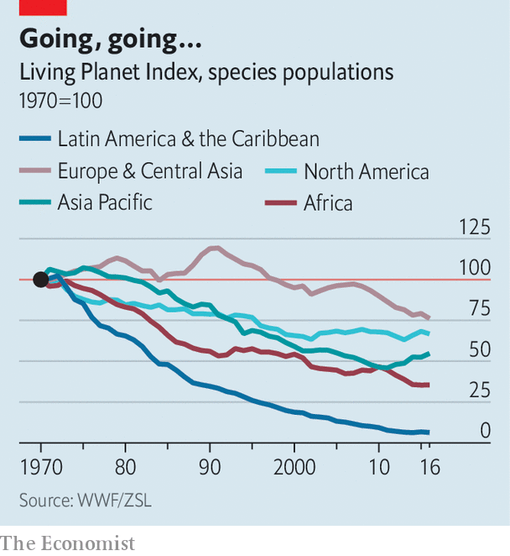

But these efforts are still thin on the ground, as shown by the Living Planet Report, published last week by the WWF, an environmental group. The biennial assessment of the state of global biodiversity tracked data from 20,811 populations of 4,392 animal species. It found that animal populations worldwide shrank by an average of two-thirds between 1970 and 2016. The falls were greatest in the tropics. In Latin America and the Caribbean animal populations fell by 94%, on average, during the period (see chart).

Humans destroying wild ecosystems in favour of mining, urbanisation or, as in the deforestation in Brazil, agriculture, are a primary culprit. Invasive species are another factor. But undoubtedly the most important emerging threat to species is the destabilisation wrought by climate change. Around the world it is altering ecosystems, changing mating seasons and affecting food supplies.

Before humanity hit pause on its priorities to deal with a global pandemic, ecologists and politicians were due for another UN biodiversity summit in October in Kunming, China. Covid-19 has delayed that meeting until May 2021. Parties to the UN Convention on Biological Diversity would do well to look to Brazil and take note of what is at stake. ■

For more coverage of climate change, register for The Climate Issue, our fortnightly [newsletter](https://www.economist.com/theclimateissue/), or visit our [climate-change hub](https://www.economist.com/news/2020/04/24/the-economists-coverage-of-climate-change)

This article was downloaded by calibre from <https://www.economist.com/science-and-technology/2020/09/19/natural-disasters-quicken-an-already-precipitous-global-loss-of-species>

|  |  |  |  |
| --- | --- | --- | --- |
| Previous | Articles | Sections | Next |

|  |  |  |  |
| --- | --- | --- | --- |
| Previous | Articles | Sections | Next |

#### Cloud computing

# Davy Jones’s data-centre

Building server farms underwater is less crazy than it sounds

Sep 19th 2020 |

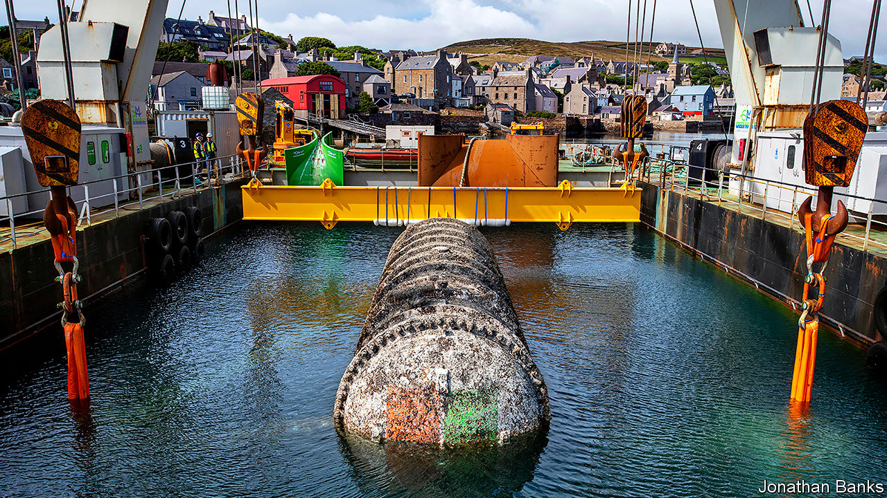

EARLIER THIS year a ship hauled a large, barnacle-covered cylinder sporting a Microsoft logo from the seas off the Orkney islands. Inside were a dozen server racks, of the sort found in data-centres around the world. Sunk in 2018, and connected to the shore by cable, the computers had spent the past couple of years humming away, part of an experiment into the feasibility of building data-centres underwater.

On September 14th Microsoft revealed some results. The aquatic data-centre suffered equipment failures at just one-eighth the rate of those built on land. Being inaccessible to humans, the firm could fill it with nitrogen instead of air, cutting down corrosion. The lack of human visitors also meant none of the bumping and jostling that can cause faults on land.

Microsoft hopes some of the lessons can be applied to existing, land-based data-centres. In the longer term, though, it notes that building underwater offers advantages beyond just reliability. Immersion in seawater helps with cooling, a big expense on land. Data-centres work best when placed close to customers. Land in New York or London is expensive, but nearby sea-floor is cheap. More than half the world’s population lives within 120 miles (192km) of the sea. Ben Cutler, the engineer in charge of the project, says submarine data-centres could be co-located with offshore wind farms as “anchor” customers. The cylinder fits in a standard shipping container, so could be deployed to remote places like islands, or even disaster areas to support relief efforts. Water and electronics, it seems, do sometimes mix.■

This article was downloaded by calibre from <https://www.economist.com/science-and-technology/2020/09/19/davy-joness-data-centre>

|  |  |  |  |
| --- | --- | --- | --- |
| Previous | Articles | Sections | Next |

|  |  |  |  |
| --- | --- | --- | --- |
| Previous | Articles | Sections | Next |

#### Digital dominance

# A new global ranking of cyber-power throws up some surprises

America rules digital national security, China is not far behind

Sep 19th 2020 |

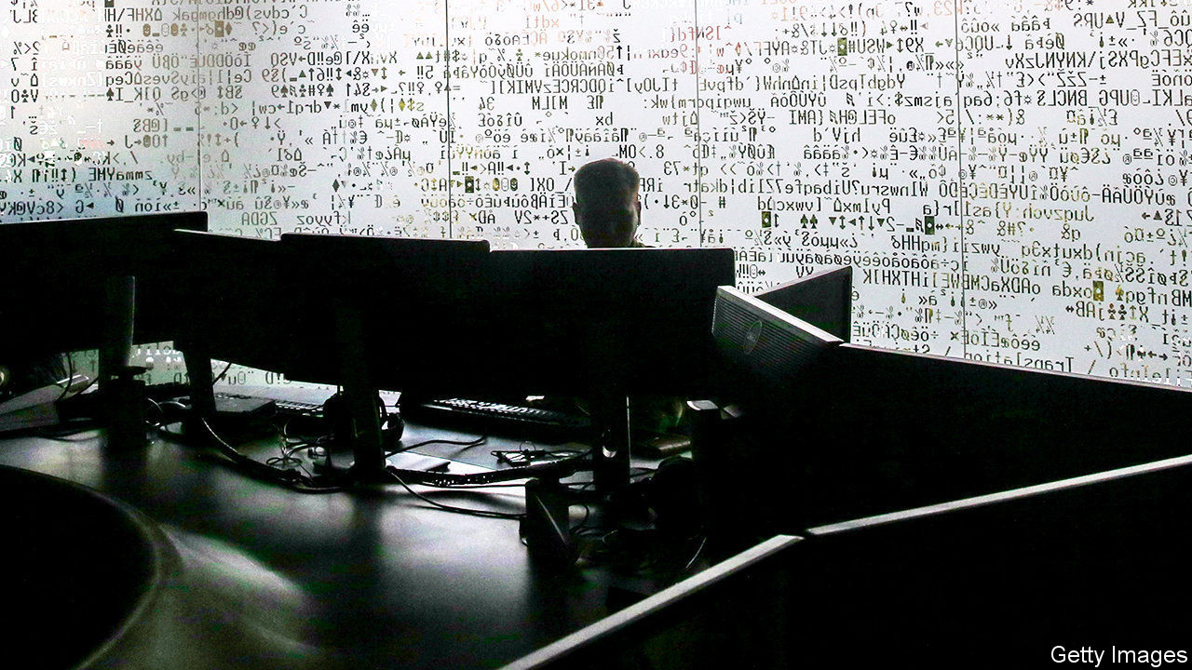

CHINA HAS the world’s largest army. Russia wields the most tanks. America owns the fanciest satellites. But who has the most cyber-power? A new National Cyber Power Index by the Belfer Centre at Harvard University ranks 30 countries on their level of ambition and capability. Offensive cyber-power—the ability to do harm in or through computer networks—is one measure. But so too are the strength of a country’s defences, the sophistication of its cyber-security industry and its ability to spread and counter propaganda (see chart).

That America stands at the top of the list is not surprising. Its cyber-security budget for fiscal year 2020 stood at over $17bn and the National Security Agency (NSA), its signals-intelligence (SIGINT) agency, probably gets well over $10bn. The awesome scale of America’s digital espionage was laid bare in leaks by Edward Snowden, a former NSA contractor, in 2013, which showed the agency hoovering up vast amounts of the world’s internet traffic and trying to weaken encryption standards.

China, in second place, has demonstrated a voracious appetite for commercial cyber-espionage abroad and an iron grip on the internet at home. Britain, whose National Cyber Security Centre has parried over 1,800 cyber-attacks since its creation in 2016, is third. Britain is currently setting up an offensive National Cyber Force staffed jointly by spies and soldiers. Russia, whose spies interfered with America’s last election, is in fourth place.

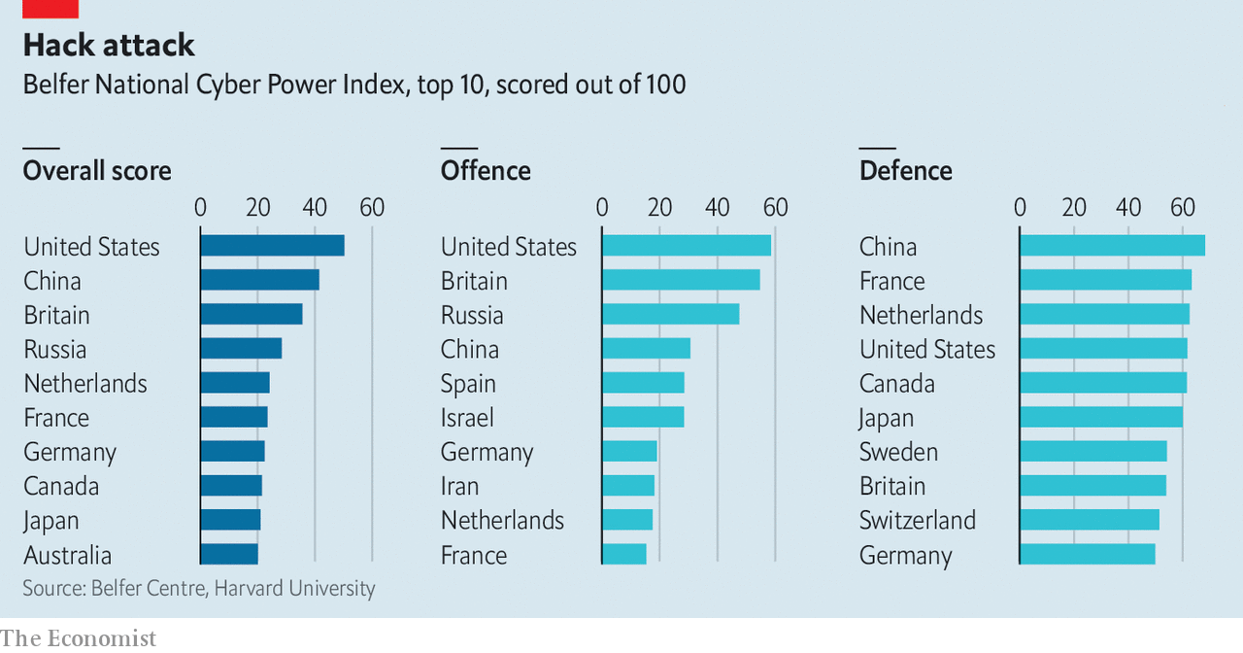

The big surprise is the Netherlands in fifth place, ahead of France, Germany and Canada. Dutch expertise in analysing malware is particularly sharp, says a Dutch insider, who points out that this is handy both for spotting attacks and mounting them. The cybercrime team of the Dutch police has proved adept at apprehending online criminals. And in 2014 the small but world-class group of hackers working for Dutch intelligence managed to penetrate a computer network used by the SVR, Russia’s foreign intelligence service—including CCTV cameras in the building—allowing them to watch as the Russians hacked America’s State Department.

Measuring cyber-power is fraught with difficulty, warns Marcus Willett, a former deputy director of GCHQ, Britain’s SIGINT agency. Many experts are puzzled by Israel’s relatively low ranking on the Belfer index, despite its hacking prowess; its secrecy may be one reason for this. “Warships in the Antarctic can easily be seen,” says Mr Willett, “yet a piece of code inserted into a power plant is hard to detect.” Though some states acknowledge their offensive capabilities—America and Britain boast of smashing Islamic State networks in Iraq and Syria, partly as a signal to Russia and China—most shy away from doing so.

Many countries outsource the dirtiest work to deniable proxies, like “hacktivists” and criminals. And whereas procuring a warship or missile is expensive and time-consuming, potent malware can be stolen or bought online. WannaCry, a ransomware attack mounted by North Korea in 2017, used a hacking tool, EternalBlue, which had leaked out of the NSA.

A forthcoming study of cyber-power by Mr Willett and his colleagues at the International Institute for Strategic Studies (IISS), a think-tank, concludes that, although stealing things and disrupting networks is important, what matters most over the longer term is control of digital infrastructure, such as the hardware that runs mobile telecommunications and key apps. Dominance there will be crucial to economic strength and national security, says the IISS. On that measure, “only China is currently positioned to be able to make the jump to join the US in the first rank.” ■

This article was downloaded by calibre from <https://www.economist.com/science-and-technology/2020/09/19/a-new-global-ranking-of-cyber-power-throws-up-some-surprises>

|  |  |  |  |
| --- | --- | --- | --- |
| Previous | Articles | Sections | Next |

|  |  |  |
| --- | --- | --- |
| Science & ... | Sections | Economic & ... |

Books & arts

Africa goes pop: From Nollywood to Netflix

.

Banlieue cinema: The dancer and the dance

.

Richard Wagner: A hateful beauty

.

Energy and politics: Maps about chaps

.

Johnson: Cawfee break

.

|  |  |  |
| --- | --- | --- |
| Science & ... | Sections | Economic & ... |

|  |  |  |  |
| --- | --- | --- | --- |
|  | Articles | Sections | Next |

#### From Nollywood to Netflix

# African entertainers are wowing global audiences

Never before have so many burst into the global mainstream at the same time

Sep 19th 2020 | JOHANNESBURG



“I SWEAR TO make sure you never forget about me,” sings Burna Boy on the opening track of “Twice as Tall”, which was released last month. These days there is little chance of that. The Nigerian musician’s fifth album, an evocative blend of contemporary sounds, score-settling and social commentary, topped the streaming charts in dozens of countries. It was streamed 5m times in the hour after it came out.

Burna Boy is one of the biggest stars associated with Afrobeats (also known as Afropop): an umbrella term for what is less a genre than a movement, encompassing influences such as Caribbean soca and dancehall, electro hip-hop, jùjú music (based on Yoruba rhythmic percussion) and auto-tune heavy pop. Other prominent artists include Davido, WizKid, Mr Eazi and Tiwa Savage. All have record deals with major Western labels, clock up tens of millions of listens on streaming sites and attract thousands of fans to concerts. Afrobeats artists have collaborated with the likes of Drake, Stormzy and Beyoncé, who last year curated an album featuring a host of African talent.

Boosted by “Black Panther” (2018), a superhero smash-hit set in a fictional African kingdom, African film and television are also drawing a broader audience. Nollywood, as Nigeria’s film industry is known, is increasingly renowned for the quality of its output as much as its quantity. Netflix recently bought the rights to Nigeria’s two highest-grossing films, “The Wedding Party” (2016) and its sequel (2017), as well as the much-praised “Lionheart” (2018). This year it released its first original African-made show, “Queen Sono”, a spy drama set mostly in Johannesburg, created by Kagiso Lediga, a South African writer-director. Next came “Blood & Water”, set in Cape Town, which became one of Netflix’s ten most popular shows in over 50 countries.

Previous African entertainers have enjoyed global success. Fela Kuti, Youssou N’Dour and Hugh Masekela sold records far beyond, respectively, Nigeria, Senegal and South Africa. In the 1970s Senegalese films such as “Touki Bouki” (1973) wowed overseas audiences. But never before have so many African artists burst into the global mainstream together. The momentum extends to literature: this week Tsitsi Dangarembga, a Zimbabwean writer, and Maaza Mengiste, who was born in Ethiopia, were shortlisted for the Booker prize for fiction.

Africa has long been seen as an importer of culture, say Matthias Krings and Tom Simmert, two academics, in a recent paper. The battered minibuses on the streets of capital cities attest to that, emblazoned as they are with the names of English Premier League footballers or American hip-hop stars. But increasingly there are posters of African pop stars on the walls of American, British or French teenagers’ bedrooms, too. African countries are exporting more of their cultural output. As Davido says of Afrobeats, “It’s our new oil.”

The moment has been a long time coming. In the 1980s and 1990s it was harder for African artists to win attention. Making music, films and TV was expensive; at home, widespread piracy made it difficult to earn money. Abroad, African music was often relegated to catch-all “world music” shelves in record shops, next to Peruvian pan pipes. The only references to the continent on mainstream Western radio shows may have been “Africa” by Toto, a weird if catchy song, or the members of Band Aid bellowing inaccurately about its lack of snow in “Do They Know It’s Christmas?”

From the 2000s changes in technology began to level the global playing field. Cheap kit let Afrobeats producers make high-quality recordings; software meant sounds could be more easily mashed together. Blogs such as notjustok.com helped broadcast music and generate followings. The market for song excerpts as ring tones provided a new source of income. For their part, film-makers benefited from fans uploading segments to YouTube. Then came streaming services such as Spotify and Apple Music, as well as Netflix and IROKOTV, which hosts Nollywood films.

Two other powerful trends have encouraged the spread of African pop culture: demography and diasporas. The median age on the continent is under 20. Like the post-war baby-boomers, such a large cohort of young people may have been bound to sway global tastes. Meanwhile first- and second-generation African populations in the West have sharply expanded.

The number of immigrants from sub-Saharan Africa in America shot from 265,000 in 1990 to 2m in 2018 (375,000 are Nigerians, the largest single group). Between 2001 and 2011 the African-born population of England and Wales rose from 800,000 to 1.3m (the Nigerian contingent more than doubled). “Once you blow in Nigeria you almost automatically blow in London,” says Joey Akan, founder of Afrobeats Intelligence, a newsletter. Since it remains hard to make money in Nigeria, he adds, its artists must reach the diaspora.

## Home thoughts from abroad

African migrants and their children are far from just passive consumers, especially when it comes to music. A London-born DJ of Ghanaian parentage, DJ Abrantee, is credited with popularising the term Afrobeats in 2011. Several well-known Afrobeats artists come from the diaspora, for example the British-born acts J Hus, Fuse ODG and NSG. Davido was born in Atlanta.

The clout of Nigerians, both on the continent and in the West, has led to some grumbling. Ghanaian artists sometimes say Nigerians play down the influence of their genres, such as hiplife and azonto, on Afrobeats. In 2015 Kenyan artists took to the streets to demand local radio stations play more of their music. Beyoncé’s album included few east Africans, noted musicians from the region. Western packaging can add to the impression that there is little happening outside Lagos. Popular “Afrobeats” streams heavily feature Nigerians.

Such worries about “Nigerianisation” in part reflect the sheer number of Nigerians (over 200m) and the role of Lagos as a creative hub. But other sounds are attracting more attention, too, for example South African house styles, gqom and amapiano. Even if these are quickly adapted by enterprising Nigerians, that stimulates interest in the original music. High-profile festivals and playlists may be dominated by Nigerians but they increasingly showcase others, such as Nasty C from South Africa, Navy Kenzo, a Tanzanian duo, or Innoss’B, a Congolese singer-songwriter.

A more piercing critique, at least of the African-made shows on Netflix, is that consumers in the rest of the world are not getting an authentic sense of African lives. “Queen Sono” is “a Hollywood spy drama copy-pasted into Johannesburg with a black female protagonist”, argues Tsogo Kupa, a South African writer and film-maker. “Blood & Water” comfortingly mimics the tropes of American teen dramas.

Yet their creators should be cut some slack. Many Westerners remain deeply ignorant about Africa. Last year the Africa Narrative, an initiative based at the University of Southern California, published a study of 700,000 hours of American TV aired in March 2018. It found that just 14% of references to Africa were positive; in 44% of cases, no particular country was specified. And even if the Netflix shows are bland, they contain telling details and asides. The first episode of “Blood & Water” makes a brief mention of the horrors of Belgian Congo—not something found in “Gossip Girl”. The films Netflix has bought are generally better than the TV shows. “Cook Off”, a Zimbabwean romcom, deliciously captures the country’s gallows humour.

If African artists still have work to do, so do cultural gatekeepers in the West. The Grammy awards still consign Afrobeats to “world music”. The application of “Lionheart” for an Oscar for best international film was turned down because most of the dialogue is in English (with a smattering of Igbo). In response, Genevieve Nnaji, who directed and stars in it, observed: “We did not choose who colonised us.” ■

This article was downloaded by calibre from <https://www.economist.com/books-and-arts/2020/09/19/african-entertainers-are-wowing-global-audiences>

|  |  |  |  |
| --- | --- | --- | --- |
|  | Articles | Sections | Next |

|  |  |  |  |
| --- | --- | --- | --- |
| Previous | Articles | Sections | Next |

#### Banlieue cinema

# A bold French film stirs controversy in America

“Cuties” has attracted attention from Ted Cruz and QAnon

Sep 19th 2020 | PARIS



LIKE ANY 11-year-old girl starting at a new school, Amy (Fathia Youssouf) just wants to fit in. The conservative Muslim teachings of her Senegalese mother’s world impose a creed of pudeur, or modesty. Passing the laundry room of her high-rise block in a banlieue of Paris, Amy is dazzled by a different universe. She glimpses Angelica (Médina El Aidi-Azouni), dressed in a crop top and practising hip-swivelling dance moves as her washing spins.

“Mignonnes” (“Cuties”) is about Amy’s painful quest to join Angelica’s dance gang. It is a powerful, disturbing story of belonging, female liberty, hysterical giggling and conflicting cultures, but also of the hyper-sexualisation of pre-teens. Inspired by much-“liked” video clips on social media, the pre-adolescent Amy naively urges the girls into ever-more explicit choreography. The Franco-Senegalese director, Maïmouna Doucouré, who won a Sundance award for the film, says she wanted to explore “dangerous” social pressures through the eyes of girls, but not to “judge” them.

Others have decided to judge, however. A low-grossing independent movie in French would ordinarily go unnoticed in America. But Netflix, which acquired the American distribution rights, has provoked a backlash. Ted Cruz, a Republican senator, wrote to the attorney-general asking him to determine whether the film “violated any federal laws against the production and distribution of child pornography”. A “cancel Netflix” petition, backed by QAnon conspiracists, is circulating online.

Netflix has apologised for the “inappropriate artwork” it initially used. It was far from the film’s French publicity shot, which showed the girls in a carefree moment of sorority. Yet the row raises a thorny question: when does a film about a troubling phenomenon become complicit in what it seeks to condemn? During dance scenes, the camera lingers uncomfortably on the children’s bodies in ways that shock and haunt the viewer. The political hijacking of the debate, though, leaves little space for subtlety. Which for a strong debut feature film by a young black female director is a shame.

This article was downloaded by calibre from <https://www.economist.com/books-and-arts/2020/09/19/a-bold-french-film-stirs-controversy-in-america>

|  |  |  |  |
| --- | --- | --- | --- |
| Previous | Articles | Sections | Next |

|  |  |  |  |
| --- | --- | --- | --- |
| Previous | Articles | Sections | Next |

#### A hateful beauty

# Opera, Nazism and Richard Wagner’s painful legacy

Alex Ross is no Wagner apologist. In “Wagnerism” he instead offers a “passionate ambivalence”

Sep 19th 2020 |



Wagnerism: Art and Politics in the Shadow of Music. By Alex Ross.Farrar, Straus and Giroux; 784 pages; $40. Fourth Estate; £30.

HITLER CASTS as long a shadow over Richard Wagner as Wagner casts over art. So argues Alex Ross, the music critic of the New Yorker, in his gigantic new book, “Wagnerism”. Fifty years after the German composer’s death in 1883, his operas became “the chief cultural ornament of the most destructive political regime in history”. Yet, says Mr Ross, the Nazis made use of Wagner “only when he was shorn of his ambiguities, and even then his presence in mainstream Nazi culture was less pronounced than many accounts let on”.

The author is no apologist. He probes Wagner’s anti-Semitism, which included a vile essay of 1850 called “Jewishness in Music” as well as caricatures such as the dwarves in the “Ring” cycle. In Wagner’s lifetime, “Parsifal” was perceived by the writer Paul Lindau as “Christianity in Music”—the Christianity, that is, “of the Spanish Inquisitor, which burns heretics while the pure voices of children praise God’s mercy”. By the end of the 19th century, Mr Ross recounts, scholars were arguing that as well as containing anti-Semitic stereotypes, the operas embody what one critic has called an “aesthetics of anti-Semitism”.

Through the Meister’s family and various unsavoury boosters, Mr Ross traces the links between the Third Reich and Bayreuth, Wagner’s eventual home and the spiritual abode of his music. But the book is more than either a prosecutor’s brief or a case for the defence. Instead Mr Ross offers a “passionate ambivalence” as he charts Wagner’s vexed legacy, which loomed over Modernism and fin de siècle Europe.

The use of heroic characters, massive scale, Nordic myth and leitmotifs appealed to contemporaries like Nietzsche and Baudelaire, novelists such as J.R.R. Tolkien, and generations of film-makers. Not everyone applauded: Tolstoy described “Siegfried” as a “stupid puppet show not even good enough for children”. But, love him or hate him, Wagner has been unavoidable. Mr Ross ranges widely over his impact—sometimes too widely. A plunge into “Finnegans Wake” by way of opera is soporific.

Hitler admired Wagner as a musician first and a thinker second. In the early 1920s he kept a stack of the composer’s records in his flat in Munich. Yet, says Mr Ross, his enthusiasm was more intoxicated than insightful. The Führer seemed to overlook Wagner’s preoccupation with love. The “Ring” critiques power; for all its Aryan overtones, “Parsifal” elevates compassion. Wagner’s heroes struggle with remorse—hardly a Nazi virtue. Missing all this, Hitler blathered about hearing “the rhythms of the primeval world”.

Beyond his unyielding anti-Semitism, Wagner himself was politically incoherent. He flirted with anarchism, socialism, communism, pacifism and Utopianism, drifting left as he grew older (the funeral music from “Siegfried” was played at a concert commemorating Lenin’s death). Nazi leaders had to be seen at the theatre in Bayreuth, but opera’s narrow appeal, as well as Wagner’s mixed-up views, limited his music’s value in Nazi propaganda.

Still, Wagner provided the soundtrack and iconography of the Nazi war machine—and eventually of warfare itself. In a fascinating passage on “Apocalypse Now”, Francis Ford Coppola’s film of 1979, Mr Ross describes the famous role of “Ride of the Valkyries” in a sequence depicting a helicopter attack on a Vietnamese village. “A grand indictment of American hubris is intended”, he writes, “yet the visceral impact of the film-making saps its capacity for critique.” A later film, “Jarhead”, shows young troops revelling in the scene. Real-life American vehicles blared the music during missions in Grenada and Iraq.

How far art and artist can be separated is an age-old question. In Wagner’s case, the art can itself be racist and bombastic. His avowed prejudice taints it further—for some, unforgivably. For others, the power of his operas overrides such objections. By presenting an honest assessment of the problem, “Wagnerism” supplies, if not answers, then at least the right questions. ■

This article was downloaded by calibre from <https://www.economist.com/books-and-arts/2020/09/19/opera-nazism-and-richard-wagners-painful-legacy>

|  |  |  |  |
| --- | --- | --- | --- |
| Previous | Articles | Sections | Next |

|  |  |  |  |
| --- | --- | --- | --- |
| Previous | Articles | Sections | Next |

#### Energy and politics

# Daniel Yergin’s new survey of the world of energy

Though brisk and authoritative, “The New Map” is not in the same league as “The Prize”

Sep 17th 2020 |

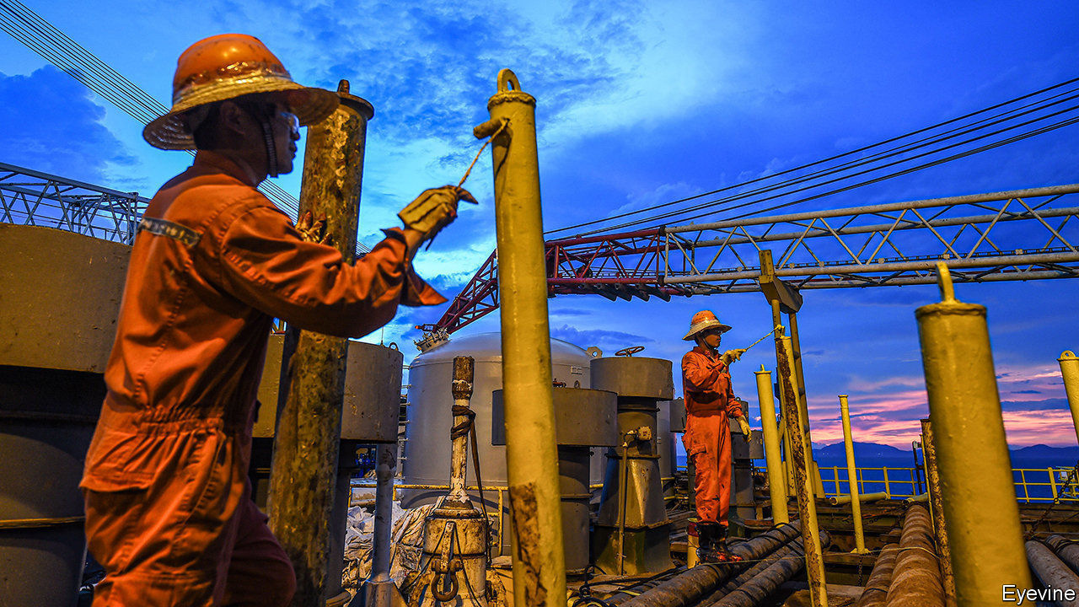

The New Map: Energy, Climate and the Clash of Nations. By Daniel Yergin. Penguin; 512 pages; $38. Allen Lane; £25.

ON ITS PUBLICATION in 1991 Daniel Yergin’s “The Prize: The Epic Quest for Oil, Money and Power” quickly attained the status of a classic. A massive narrative history, it wove the story of oil through the previous century’s economic, political and military events deftly and exhaustively. It was also well timed. The fall of the Soviet Union, a clear punctuation point, made it a good moment at which to take the measure of one of modern history’s most important threads. And with the first report of the Intergovernmental Panel on Climate Change just a year old, and the signing of the UN Framework Convention on Climate Change just a year in the future, the great issue of the 21st century was only just beginning to make itself felt.

Mr Yergin’s new book is not in the same league; nor does it pretend to be. As the use of the word “map” in the title gives notice, it is a much more schematic undertaking. Less than half the length of “The Prize”, it has a larger number of chapters, each picking off a particular topic. A place, an event or a man is normally evoked to introduce or situate the subject; the relevant issues are judiciously explained; a conclusion is reached, often buttressed by the words of an apposite CEO, minister, admiral or whoever. Thus the book breezily takes the reader through the developments of the past few decades in the oil business and energy more generally, with an eye to political repercussions. With sections on America, Russia, China, the Middle East, the car industry and climate politics and policy, at its best it is both brisk and authoritative, an impressive combination.

But it is also rather limited. The mostly geographic structure keeps out some important stories: Australia, which over the past two decades has become the world’s biggest exporter of both coal (in terms of value) and liquefied natural gas, turns up almost entirely as “and Australia”, concluding lists of other countries. Europe, which as a user of energy and a driver of policy matters a great deal, is handled better, but only in its relations with fossil-fuel producers, who remain, as in “The Prize”, Mr Yergin’s main concern. His interest in Europe’s attempts to conquer the “green commanding heights” of a post-fossil-fuel world—an ambition phrased as a play on the title of another book by Mr Yergin, which tackled free markets and globalisation—is limited.

It is greater, though, than his interest in climate change per se. Mr Yergin treats this overwhelming geophysical disruption almost entirely in terms of the way it is mediated through politics and policies, European and otherwise. In his outlook it acts purely through prices, regulations and subsidies, not through changed landscapes, displaced populations or rising seas. The idea that, as an externality of fossil-fuel use, it is already and always a part of the economy does not get a look in (the book has no room for economists of climate change such as William Nordhaus or the late Martin Weitzman). The question of what the Earth will actually be like in 2050—when Mr Yergin expects half of all cars sold still to be powered by fossil fuels—is not addressed.

In his essay “The Climate of History: Four Theses”, the historian Dipesh Chakrabarty argued that a world in which the environment as a whole is increasingly a human construction requires a new form of history, transcending the kind in which people and nations play out their dramas in front of immutable scenery. As Mr Chakrabarty’s second thesis has it: “The idea of the Anthropocene...severely qualifies humanist histories of modernity/globalisation”. The need to meld narratives of the human and no-longer-natural worlds would seem to apply in spades to an author writing about fossil fuels. That Mr Yergin has neither met nor, really, engaged with the challenge does not render his work worthless; limited perspectives have their place. But it is to be hoped that more ambitious treatments of the subject for the general reader will soon follow. ■

For more coverage of climate change, register for The Climate Issue, our fortnightly [newsletter](https://www.economist.com/theclimateissue/), or visit our [climate-change hub](https://www.economist.com/news/2020/04/24/the-economists-coverage-of-climate-change)

This article was downloaded by calibre from <https://www.economist.com/books-and-arts/2020/09/17/daniel-yergins-new-survey-of-the-world-of-energy>

|  |  |  |  |
| --- | --- | --- | --- |
| Previous | Articles | Sections | Next |

|  |  |  |  |
| --- | --- | --- | --- |
| Previous | Articles | Sections | Next |

#### Johnson

# Pride, prejudice and the story of New York English

Some Americans look down on New York accents. New Yorkers don’t care

Sep 19th 2020 |

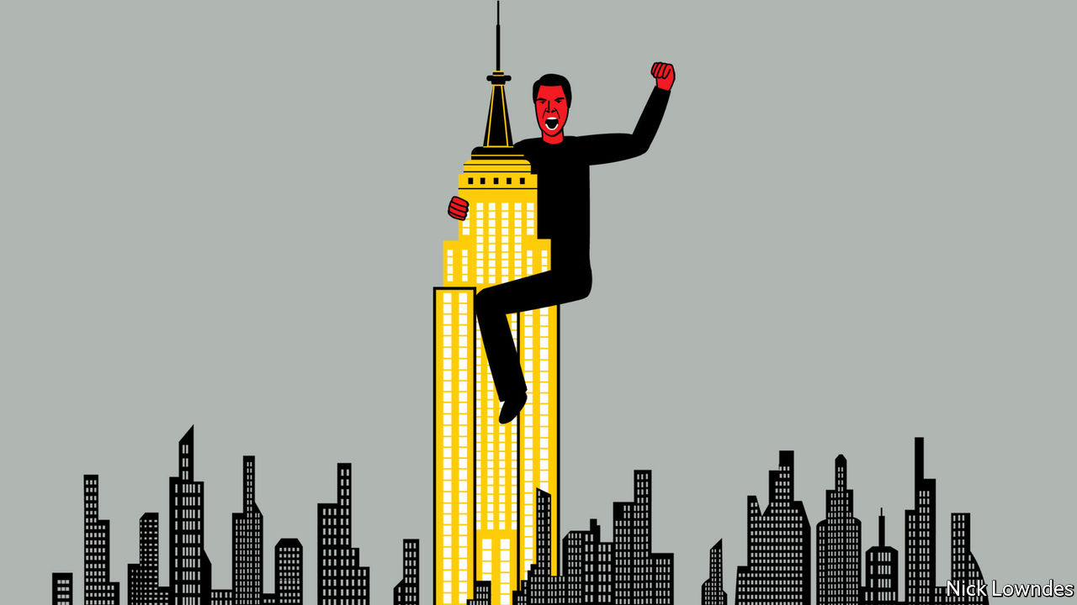

THE MOST effective form of birth control known to man, said Lewis Grizzard, is a Bronx accent. The late newspaper columnist from small-town Georgia enjoyed teasing northerners. But it is hardly just American southerners who take digs at New Yorkers’ English. “Coffee Talk”, a venerable sketch on “Saturday Night Live”, a long-running comedy show filmed in the city, featured few memorable jokes per se, instead leaning heavily on exaggerated vowels like those in “cawfee” and “tawk”. The accent itself was the punchline.

There are, in fact, many New York accents: African-American and Puerto Rican New Yorkers do not talk like Woody Allen. The city has been replenished by a constant stream of immigration (foreign and domestic) since its founding. When Nicolas Heller, a film-maker, recently held a competition on Instagram to find the best New York accent, hundreds of entries were submitted, reflecting that whole rich spectrum. As an account of the contest in the New York Times put it, New York English is not a single accent but rather “a baseline indignation…as if the speaker can’t quite believe there’s even a need to have the conversation”.

In her new book, “You Talkin’ to Me?”, E.J. White of Stony Brook University celebrates the disputatious, never-let-them-call-you-a-sucker language that is New York English. Ms White reckons a conversational manner that might be called “assertive” by, say, polite Britons, is, for New Yorkers, not rude but the opposite: a sign of engagement, and therefore of warmth. Patient, slow-paced styles can, to the New Yorker, seem aloof.

In New York, as in Britain, accent signals class. The Cawfee Tawk accent, in particular, is working-class, but there was once an aristocratic New York speech which it echoed. Like the working-class kind, this was r-less: think of upper-class Franklin Roosevelt’s “the only thing we have to feah…” It shared the round vowel of “toity-toid’ (“thirty-third”); Teddy Roosevelt, Franklin’s distant cousin, said “burn” a bit like “boin”. But high-class New Yorkers also shared traits with British speakers, such as keeping the t-sound in “butter” (“buddah” in Cawfee Tawk).

In elocution classes in the mid-20th century, many Americans were still taught a version of English that in some ways mimicked upper-class New Yorkers. But then, Ms White argues, people elsewhere began to see the city as an alien immigrant entrepôt. This dragged down the image of the city’s accent; Teddy Roosevelt’s “boin” became associated with the poor. The locus of “true” American speech, in the popular mind, became the Midwest, with its hardy northern European Protestants and their r-laden speech. This is why today’s “General American” sounds more like Nebraska than New York. Ms White notes that in the recent “Avengers” films, Captain America, though brought up in Brooklyn in the 1930s, speaks General American. Clowns and villains tawk like Brooklyn; superheroes, never.

William Labov, a linguist, pioneered the field of sociolinguistics by rigorously studying the New York accent, not least in an experiment he conducted in 1962. He went to a high-class department store (Saks), a middle-class one (Macy’s) and a working-class one (S. Klein, now defunct). In each he asked where to find an item he knew was on the “fourth floor”.

Sure enough, the “r” in both words was least often pronounced in S. Klein, and most in Saks, even though the employees all came from the same social milieu. New Yorkers know how their accent is perceived; those working in Saks buttoned up their English. So did many participants when Mr Labov asked them to repeat themselves, pronouncing the “r” the second time around as his “Excuse me?” made them self-conscious. A recent recreation of Mr Labov’s experiment looked at episodes of “Say Yes to the Dress”, a television show that followed shoppers at a New York bridal store. Sure enough, assistants emphasised their “r”s when serving customers with bigger budgets.

In many countries, the speech of the grandest or most powerful city is the most prestigious—think of Parisian French. Yet many Americans despise the accent of their country’s biggest city. New Yorkers don’t care. Mr Labov introduced the idea of “covert prestige”: that even derided accents and dialects have a value to their speakers, as a key to their identity and a store of values and connections. New Yorkers may sometimes sound as if they hate each other. Deep down they know they live not in the capital of the United States, but of the world.

This article was downloaded by calibre from <https://www.economist.com/books-and-arts/2020/09/19/pride-prejudice-and-the-story-of-new-york-english>

|  |  |  |  |
| --- | --- | --- | --- |
| Previous | Articles | Sections | Next |

|  |  |  |
| --- | --- | --- |
| Books & arts | Sections | Graphic detail |

Economic & financial indicators

Economic data, commodities and markets

.

|  |  |  |
| --- | --- | --- |
| Books & arts | Sections | Graphic detail |

|  |  |  |  |
| --- | --- | --- | --- |
|  | Articles | Sections | Next |

# Economic data, commodities and markets

Sep 19th 2020 |

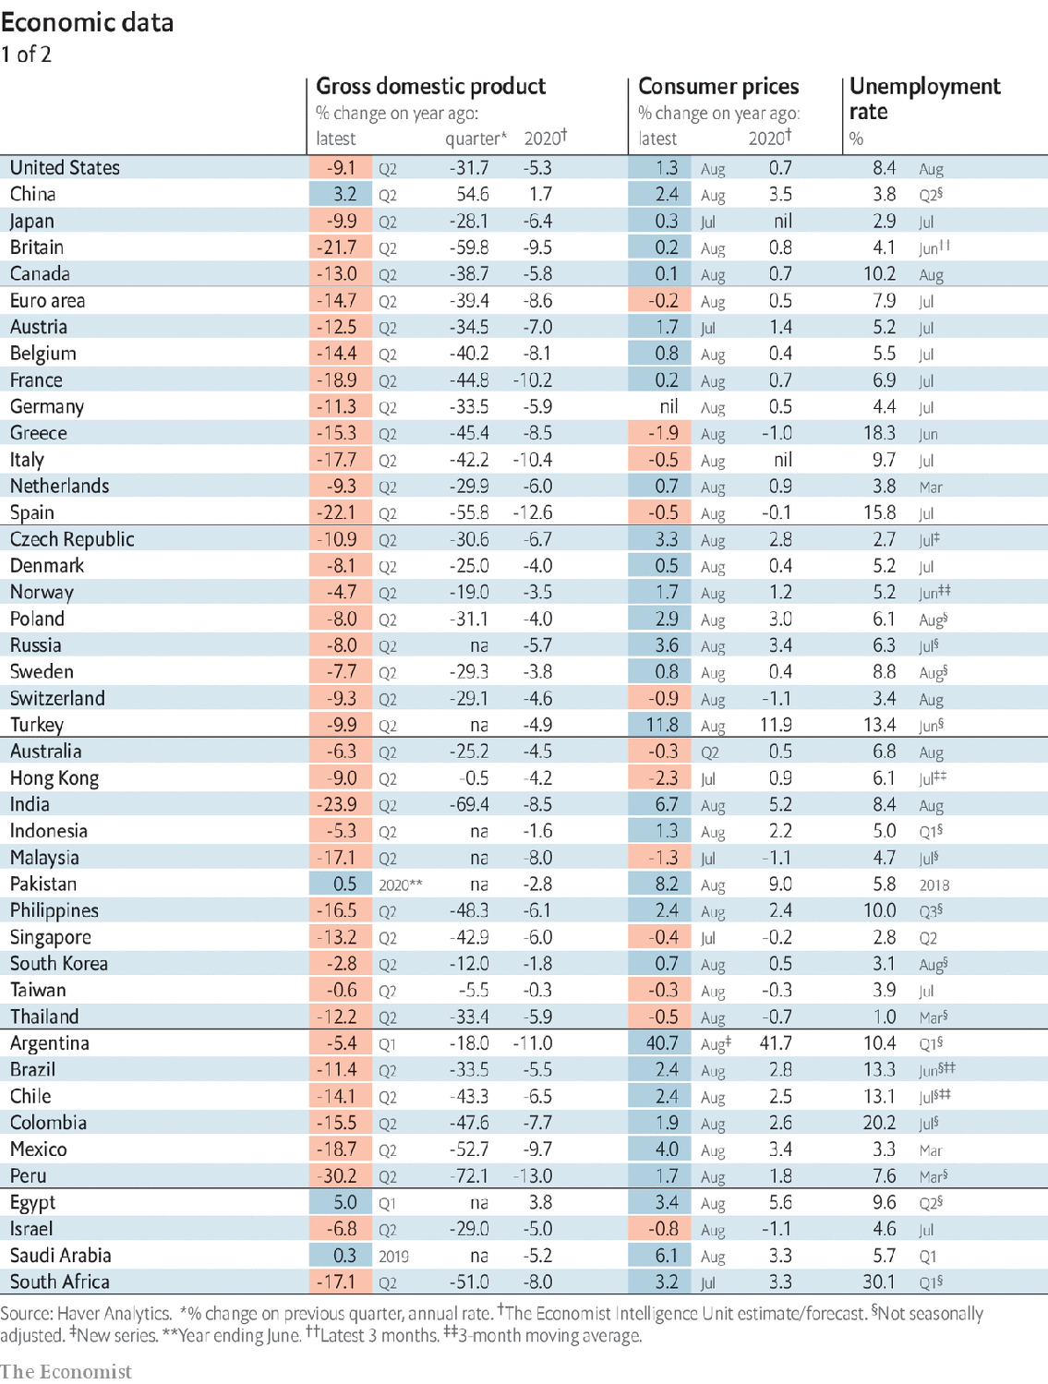

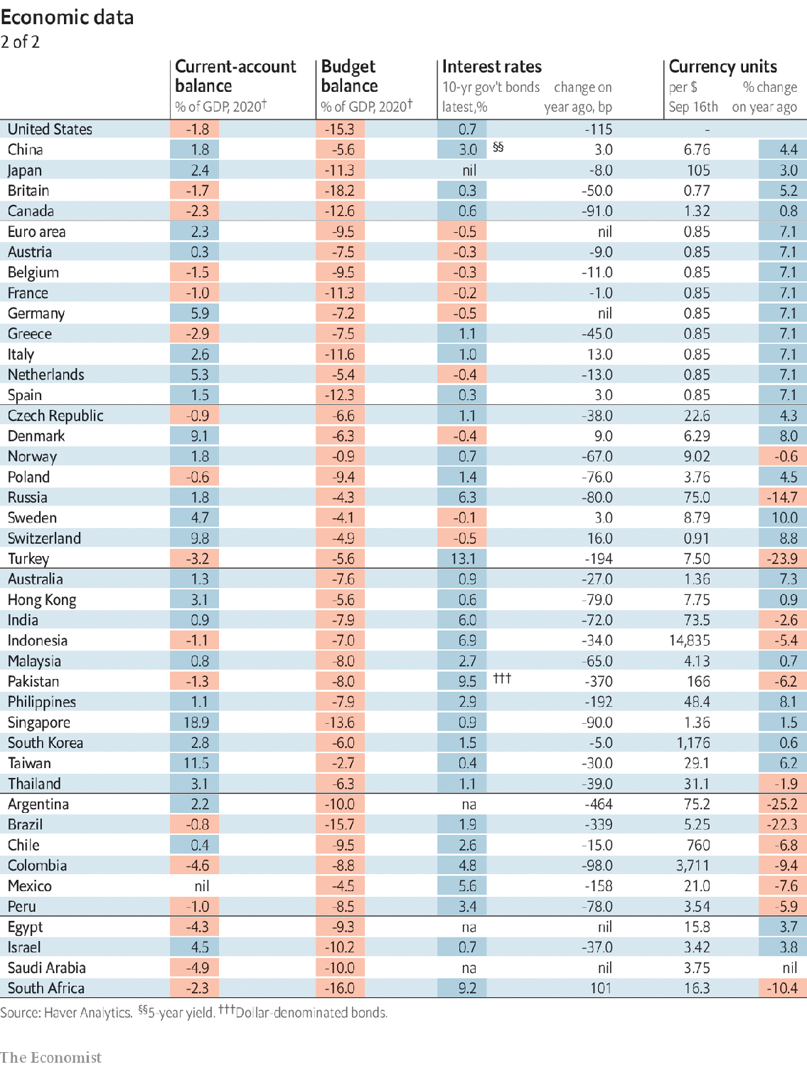

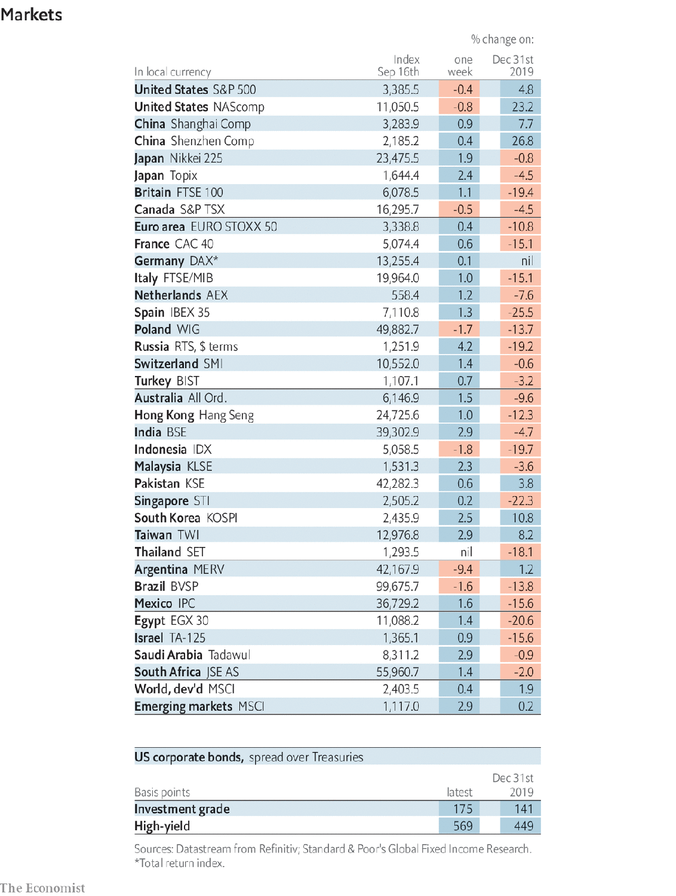

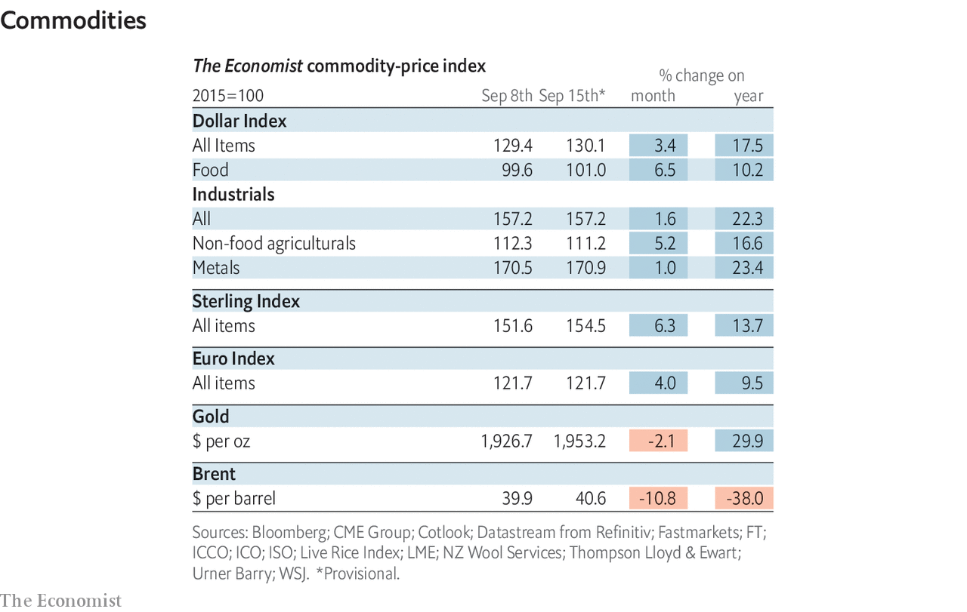

This article was downloaded by calibre from <https://www.economist.com/economic-and-financial-indicators/2020/09/19/economic-data-commodities-and-markets>

|  |  |  |  |
| --- | --- | --- | --- |
|  | Articles | Sections | Next |

|  |  |  |
| --- | --- | --- |
| Economic & ... | Sections | Obituary |

Graphic detail

Investing: Value judgment

.

|  |  |  |
| --- | --- | --- |
| Economic & ... | Sections | Obituary |

|  |  |  |  |
| --- | --- | --- | --- |
|  | Articles | Sections | Next |

#### Value judgment

# The age-old strategy of buying cheap shares is faltering

Shares of value firms have underperformed the market since 2010

Sep 19th 2020 |

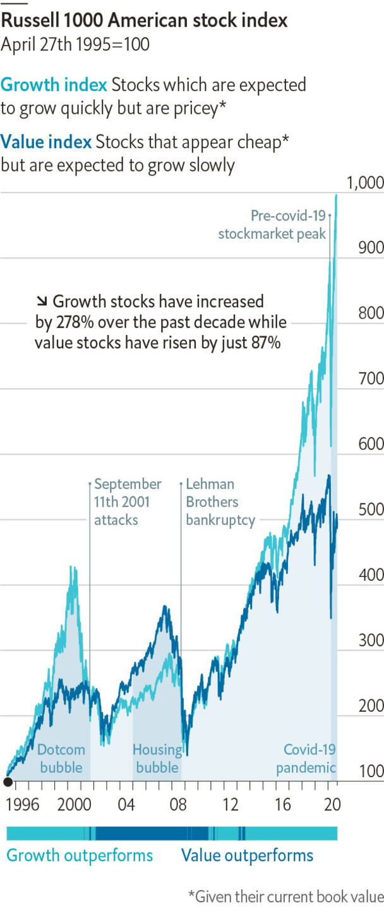

FOR MORE than a century scores of investors have prospered through “value investing”, or buying shares in firms which appear cheap given their “fundamentals”. Warren Buffett, an eminently quotable value investor, summarised the approach succinctly: “Whether we’re talking about socks or stocks, I like buying quality merchandise when it is marked down.”

Although many value investors, including Mr Buffett, have done well in the long run, they have had a rougher time over the past decade. You can gauge just how pricey a stock is by looking at its price-to-book ratio, which measures how much the market thinks a company is worth relative to the net assets on its balance-sheet. Since 2010 the Russell 1000 value index, which tracks American stocks with low price-to-book ratios and low expected earnings growth, has risen by just 87%, compared with 171% for the market overall. Rather than falling back down to earth as value investors might have predicted, shares in the priciest American companies in 2010 have for the most part kept soaring.

According to AQR Capital Management, an investment firm, the price-to-book ratio of the most expensive third of American stocks was around five times that of the cheapest third in 1967. That ratio has climbed steadily ever since 2015, and hit a record high of 12 times in March, when their analysis ended.

The pandemic has only widened the gap between the most and least expensive stocks. Much to the surprise of many financial commentators, shares in big American firms are actually up on the year. A closer inspection reveals a bifurcation in the market. While shares in fast-growing companies with high price-to-book ratios have risen by around 20% since early January, shares in value firms are down by over 10%.

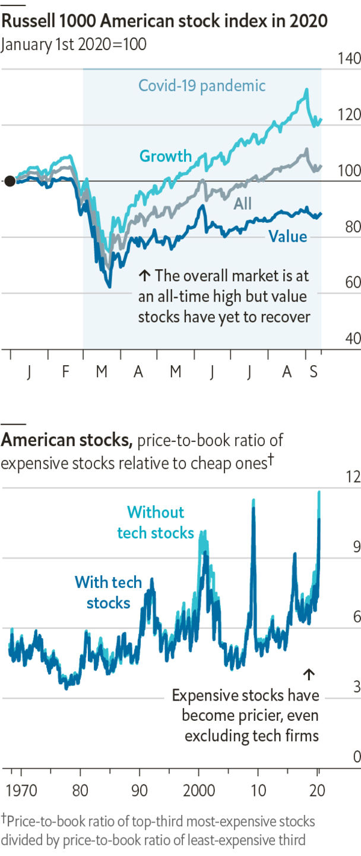

One obvious explanation for all this is the rise of tech firms, which are difficult to analyse using standard valuation tools. For instance, measures like book value may not accurately capture companies’ intangible assets, such as the strength of their brands or the value of their intellectual property. Moreover, unlike value firms, big tech companies tend to form natural monopolies which protect them from competition, boosting their prospects.

Yet the tech theory crumbles under careful scrutiny. AQR’s data show that pricey stocks have outperformed, even when excluding tech firms or the biggest 5% of companies by market capitalisation. Nor can the inadequacy of book value be blamed, since investors also appear to be willing to bid up shares in companies with high price-to-earnings ratios.

It is possible that investors are simply overvaluing glitzy growth firms. Value stocks have been trampled before. They also severely underperformed growth stocks in the late 1990s and early 2000s, during the dotcom boom. Established firms simply did not hold the same allure as up-and-comers like Yahoo and Cisco, which seemed destined to take over the world, until they didn’t. Tech stocks gyrated wildly earlier this month, suggesting that investors are getting antsy about their high valuations. Redemption for the value-investing faithful may yet come. ■

Sources: Refinitiv; AQR

This article was downloaded by calibre from <https://www.economist.com/graphic-detail/2020/09/19/the-age-old-strategy-of-buying-cheap-shares-is-faltering>

|  |  |  |  |
| --- | --- | --- | --- |
|  | Articles | Sections | Next |

|  |  |  |
| --- | --- | --- |
| Graphic detail | Sections |  |

Obituary

Joan Feynman: Getting to know the Sun

.

|  |  |  |
| --- | --- | --- |
| Graphic detail | Sections |  |

|  |  |  |  |
| --- | --- | --- | --- |
|  | Articles | Sections | Next |

#### Getting to know the Sun

# Joan Feynman died on July 22nd

The astrophysicist who studied auroras and prevailed against prejudice was 93

Sep 19th 2020 |



IN THE DUSTY Spanish town of Tordesillas in 1494, Spain and Portugal divided the unclaimed world between them. The moment is famous. Less well known is that around 1963, she at Columbia, he at Caltech, Joan Feynman and her brother Richard divvied up the universe. She took auroras, the Northern and Southern Lights that shimmer through the night sky in the highest latitudes. He, nine years older and fast becoming a world star in physics, took all the rest, which was fine with her.

The arrangement was serious. When, many years later, Richard was asked to look into auroras, he said he would have to ask Joan’s permission. She said no. They were hers, and besides, he had started the fascination. One night when she was small he dragged her out of bed, made her get dressed and took her to the golf course in Far Rockaway, near their house. Auroras did not normally come down to lower latitudes, but here was one. As she stared at a sky that was dancing with red, gold and green lights, he told her that no one knew how they happened, which was true back then. The mystery, with the lights, lodged in her head for good.

After years of looking into it, she found the answer. Auroras happened when particles from the solar wind, the stream of free electrons and heavy ions flowing out of the Sun, penetrated the magnetosphere that protected the Earth. The magnetic fields of the Earth and the solar wind, bound in different directions, intersected, and the colours were caused by solar particles colliding with oxygen and nitrogen in the Earth’s upper atmosphere. During coronal mass ejections, when huge flares of material were flung out of the Sun at speeds of up to 1,500km a second, auroras increased in frequency and range on the Earth. The faster the speed, the greater the geomagnetic disturbance.

Her studies expanded, fuelled by data sent back by Explorer 33 in 1966, to cover as much as possible of the Sun’s behaviour: its 11-year sunspot cycles, its 88-year Gleissberg cycles, its strange peaks and troughs of activity. Most usefully for the Space Age, she found that coronal mass ejections could be detected by the presence of helium in the solar wind. They also came in groups. If these storms could to some extent be predicted, spacecraft could be designed to resist them better. In short, that night walk in childhood had led her to a lifetime of considering the interplay between the Earth and its giant, vital, fluctuating star: a star it faced with its magnetosphere flattened on the day-side like a shield, while on the night-side of Earth the magnetosphere relaxed, with a wide, long, open tail. That shape, too, she had discovered.

Yet she might never have done any of this work. At every turn people tried to put her off science as a career. Women couldn’t do it, her mother said. Their brains were too feeble. At Syracuse University, where her thesis was on absorption of infra-red radiation in crystals, she was told to write one on cobwebs, more useful for cleaning her house. When she tried, after graduating, to place an ad in the New York Times for a research job, she was told only men could do so, in the men’s section.

Marriage and children therefore seemed inevitable as well as desirable, but full-time housewifery drove her to misery and then depression. Science was her life. Now it seemed mostly confined to her kitchen, observing how long it took to heat the baby food, or showing her elder son, as she baked, how to mix an acid with a base in a bottle to get an explosion. There were shades of her upbringing here, in a family jumping with curiosity, where everything—a napkin rolling across the table, a bug on a leaf, the wonder that the heavy waffle-iron was made of atoms—had been investigated. The how and why of everyday science still delighted her, but even part-time research was hard to fit in. And all the while the shining Sun reminded her what she should be working on.

The one person who had always encouraged her was Richard. Though she constantly doubted herself, ready to shrink into some background role, he told her to aim for the top. As soon as she could talk he had challenged her with sums and made her his assistant in his bedroom-lab, to throw switches and hold her finger in a spark-gap to feel the little shock. Bringing her water at night, he would whirl the glass around to show the magic of centrifugal force. On her 14th birthday, feeding her fascination with the night sky, he gave her a college textbook on astronomy. It was hard going, but on page 407 came a revelation as good as the aurora, or almost. Below a figure of a spectrum was a reference to a work by Cecilia Payne-Gaposchkin on stellar atmospheres—a woman, a married woman at that, doing science. So the world was not closed to her. It could open. She just had to persist and, over 60 years, she did.

Increasingly she was interested not simply in the science of Earth-Sun relations, but in their history. From 1985, working at the Jet Propulsion Laboratory in Pasadena, California, she studied observations of auroras from ancient China and medieval Europe, when people feared they portended war, famine, the return of spirits or the work of devils. She consulted records, kept methodically for centuries, of water levels in the Nile, to trace the impact of the Sun on the climate of north Africa. Though the Sun was in a historically stable phase, and had been for billions of years, to her eye it still showed considerable, often strange, variation—variation which, she thought, might explain the relative tardiness of Homo sapiens to take up agriculture, waiting until, round 10,000BC, the climate stabilised.

To those who asked why, in her late 80s, she went on researching, her answer was partly that she still had plenty of questions. How, for example, did the Sun end up with a cycle of 88 years? And why did it act in the unexpected ways it did? The beauty of auroras was beguiling. But with one extra-high-speed ejection, as it had shown from time to time, the Sun could disable Earth’s communications. And it was also possible, with only a small bout of laziness, that it could turn the golf course in Far Rockaway—that golf course where Richard had told her, “Nobody knows”—back into the ice rink it had been 12,000 years before. ■

This article was downloaded by calibre from <https://www.economist.com/obituary/2020/09/19/joan-feynman-died-on-july-22nd>

|  |  |  |  |
| --- | --- | --- | --- |
|  | Articles | Sections | Next |